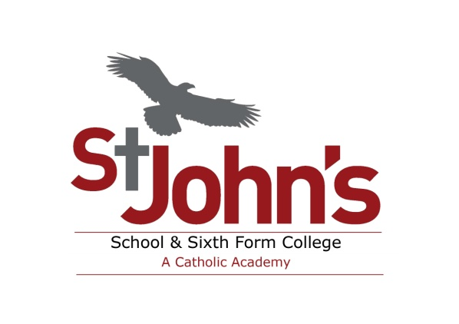
Person Specification

Post Title: Health & First Aid Officer

ATTRIBUTES | ESSENTIAL | DESIRABLE
Qualifications & Training | - Enhanced DBS certificate (can be processed on appointment)  - Recognised first aid qualification(s)  - Strong administration and organisational skills  - Computer literate | - More specific defibrillator, diabetes, etc training  - IOSH Managing Safety  - Experience of working with children of relevant age in a learning environment  - Experience of working a medical or nursing capacity
Relevant Experience | - Recent and relevant experience of working in a similar role  - An effective team player who can work and think independently.  - Willing to work flexible hours, if required, to support the school’s extra-curricular and out of hours activities.  - Strong interpersonal skills  - Enthusiasm and willingness to learn new skills  - An effective decision maker  - An effective communicator
Skills, Knowledge & Personal Attributes | - Enjoy working with and supporting children  - Show initiative when identifying and prioritising tasks  - Have a good attendance and punctuality record  - Be able to work effectively as a team  - Willing to work with other schools and the wider community | - Knowledge of health and first aid in the workplace and practical application thereof.  - Knowledge of the education system
Special Requirements | The post holder will be expected to have the following competencies:  Core  - Acting Positively.  - Behaving Ethically.  - Team working.  - Striving for Excellence.  - Managing personal learning and development.  Role Specific  - Communicating.  - Planning and prioritising.  - Influencing others.  - Controlling emotions.  - A clean, current driving licence.  - Discretion and diplomacy | - A willingness to use own transport on School business (with insurance for business use).

NB: In addition to the candidate’s ability to perform the duties of the post, the interview will also explore issues relating to safeguarding and promoting the welfare of children. If you are shortlisted any relevant issues arising from your application and reference will be discussed at interview. The successful applicant will be subject to an enhance DBS check.

