Swanlea School
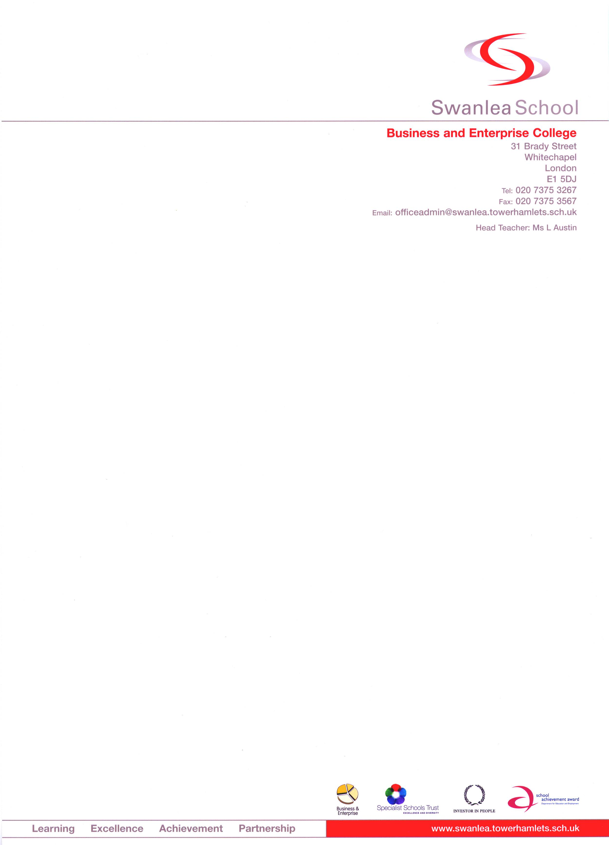
31 Brady Street
London, E1 5DJ
Tel: 0207 375-3267
Fax: 0207 375-3567
Respect | Aspire | Achieve
Website: www.swanlea.co.uk
Email: officeadmin@swanlea.co.uk
Job Description
MID DAY MEALS SUPERVISOR

Purpose | As part of a team of Mid-day Supervisors, reporting to the Senior Supervisor, to be responsible for the supervision and control of pupils in given areas of the school during the mid-day break. Depending on the area of the school allocated, duties may include responsibility of the orderly conduct of pupils taking the school meal and/or that of pupils in and around the school buildings (including toilets). Assistance to kitchen staff in serving food or taking food related items to serving areas etc. may be required in order to maintain a speedy, organised lunch service for the pupils.
Reporting To | - Senior Mid day Supervisor
Salary/Grade | - Grade 1A2 (term time only)
Disclosure | - Enhanced
DUTIES
General | - To patrol the school building dealing with incidents of unruly behaviour and referring matters to the Senior Supervisor when necessary.  - Assisting, as directed, with the maintenance of orderly arrangements both for the taking of the school meal and the use of the buildings and other areas.  - Supporting the Authority's policies regarding school meals provision (i.e. healthy eating and ethnic meals, etc.)
Specific Duties | Lunchtimes: 12.15pm-1.45pm - either  - Supervising the exit and re-entry of students.  - Working the cash free tills  - Welcoming visitors  - Supervision of toilets and general playground areas.  - Supervising the Restaurant, helping serve food if required  - Cleaning of tables, collection of new trays/cutlery, emptying full bins
- Whilst every effort has been made to explain the main duties and responsibilities of this post, each individual task undertaken may not be identified.
- Employees will be expected to comply with any reasonable request from a manager to undertake work of a similar level that is not specified in this job description.
- Employees are expected to present themselves and to act in a professional manner at all times.
- The school will endeavour to make any necessary reasonable adjustments to the job and the working environment to enable access to employment opportunities for disabled applicants or continued employment for any employee who develops a disabling condition.
Person Specification

- An ability to relate to young people in a firm but friendly and calm manner.
- An ability to exert authority in ensuring that young behave and are safe.
- An ability to communicate well with adults and young people.
- Some experience of working with young people is desirable but not essential.
- An ability to value all the cultures represented in the school and to promote equal opportunities.
- A minimum of 5 GCSEs at grades A*-C including English & Maths

The successful candidate must be able to work flexibly, according to the school’s needs.

Signature: …………………………………………….. Date: …………………………

