Primary PE Teacher
HASTINGS SCHOOL MADRID
Part of the Cognita Global Group of Schools

1175 students | 50 nationalities | 6 sites | 1 school

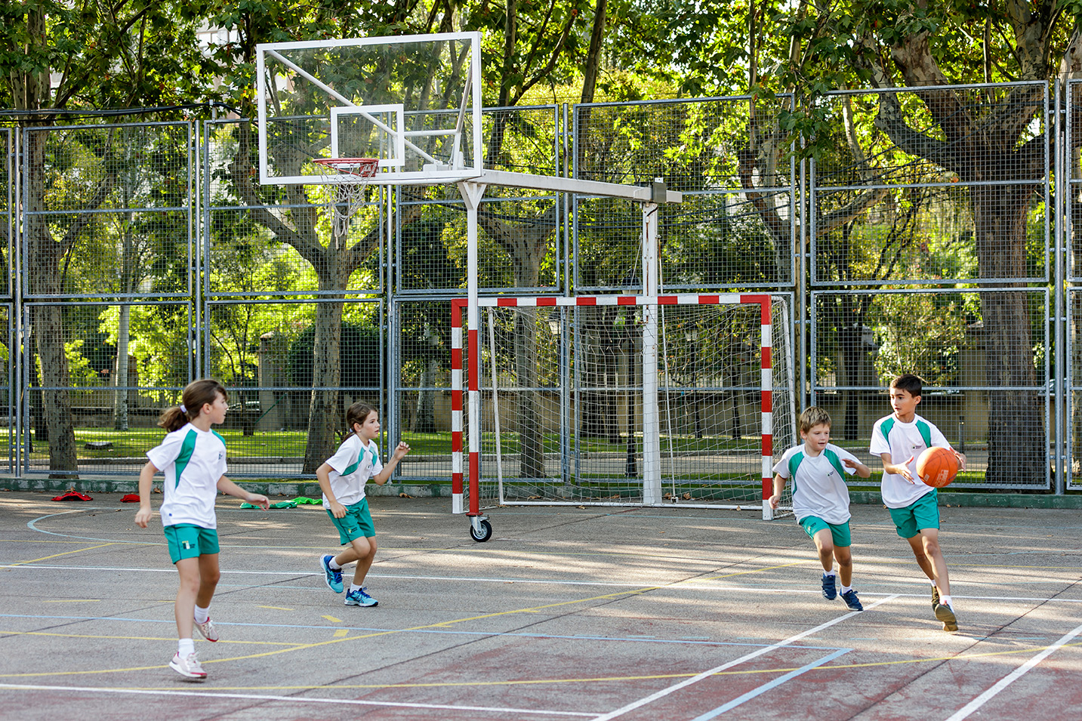

Contract type
and term
Full time. Permanent

Start date
September 2021

Hastings School is looking to appoint a full time Primary PE Teacher from September 2021.

We are looking for someone who is passionate about teaching PE to younger pupils (3-11 years) and is excited to teach in one of the best international schools in an amazing city. The successful candidate will hold a relevant degree and a UK approved PGCE or international equivalent. Please see Job Description for details.

Achieve more than you believe possible

Hastings School aims to provide a high-quality education within a culture of care. It is a school that is growing rapidly with an expanded Early Years and Primary campus opening in September 2021.
As part of the Cognita Group, staff are able to access considerable professional development opportunities and share best practice with colleagues in other schools.

About Madrid
Most teachers who come to Madrid choose to stay as it offers a superb quality of life with wonderful weather, culture, sport, food and people (something for everyone!). You can even find skiing during the winter only one hour north. It is a great base from which to explore Spain and Europe and the cost of living is lower than the UK.

We offer a competitive salary and 100% remission for staff children and support with relocation (legalities in Spain and accommodation).

Candidates should complete and send in the attached application form, including the contact details of 3 referees and a concise cover letter through TES or by email to: recruitment@hastingsschool.com. The closing date is 25th May 2021, but early applications are encouraged - we reserve the right to appoint prior to this deadline. Further details will be sent to short-listed candidates only. Interviews will be held at the end of May.
- Safeguarding Cognita schools are committed to safeguarding and promoting the welfare of children and young people and expects all staff, volunteers and other third parties to share this commitment. Safer recruitment practice and pre-employment checks will be undertaken before any appointment is confirmed.

- Diversity Cognita’s success depends on our people. With 80+ schools in eleven countries and our employees representing over 30 nationalities, the scope of our difference is a source of pride. We believe this diversity positively promotes global citizenship and reflects the value of contribution irrespective of one’s personal characteristics and/or background.

- Equal opportunities
Cognita is committed to preserving and promoting equality of opportunity in all aspects of the conduct of its business.
No member of staff or any applicant for employment with Cognita will be discriminated against, harassed or victimised because of their personal characteristics. Cognita expects all staff to comply with the letter and the spirit of its policy.

