RTA/swh

March 2019

Dear Colleague

We are delighted that you are considering applying for the position of Curriculum Leader of History at The Ruth Gorse Academy. This is an exciting opportunity for a candidate who is keen to be at the forefront of our organisational change. The GORSE Academies Trust continues to demonstrate exceptional opportunities for the students within the Trust through the quality of its provision at Primary, Secondary and Post-16 level and through its initial teacher training programme. In June 2017, The Ruth Gorse Academy was rated as Outstanding in all categories in their OFSTED inspections.

As a city, Leeds continues to struggle regarding the educational achievement of communities in areas of greatest socio-economic challenge. It is our determination to use the free schools initiative to change this unacceptable situation and to ensure that we establish in an area of extreme poverty an exceptionally effective 11-16 academy.

Our mission statement sums up the aspiration of our academy: ‘Dare to achieve beyond what you are today’. The Ruth Gorse Academy ensures that students receive an outstanding education that focuses on aspiration, high expectations and personalisation. Together these non-negotiable values instil in young people a self-belief that enables students to access the highest standard of further educational provision and employment. We believe that every child is unique; through retaining this focus in all aspects of our work we strive ensure that all young people receive an exceptional educational experience that is personalised to them.

We are seeking to appoint a Curriculum Leader of History who will play an integral role in the creation and delivery of an exciting History curriculum. A positive outlook and high standards of personal presentation are very important. Our students receive outstanding pastoral care, support and guidance and we would expect any successful candidate to be of a mind-set where they believe anything is possible. Clearly, working in our academy will be demanding as well as very rewarding. We assure you that as our colleague you will be of great value and importance, an importance reflected in the quality of the professional development we are able to provide. If successful, you will enjoy the support and professional expertise that being a part of The GORSE Academies Trust affords.

We look forward to hearing from you.

Yours sincerely
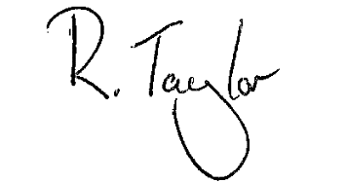

Rebekah Taylor
Principal

