WALTHAMSTOW SCHOOL FOR GIRLS
“Neglect not the gift that is in me”

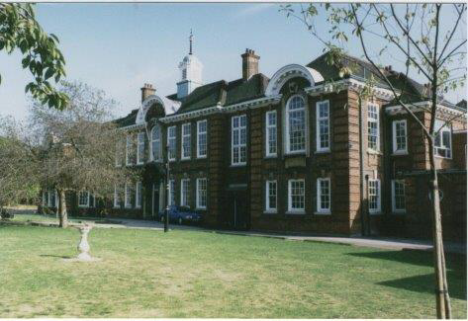

Information for applicants for the post of
Receptionist / Administrative Assistant
September 2017

September 2017

Dear Applicant
Thank you for requesting an application pack for the post of Receptionist / Administrative Assistant at Walthamstow School for Girls.
Walthamstow School for Girls is a high achieving, oversubscribed multi-cultural school which is regularly in the top 5% nationally for progress and the top 10% nationally for attainment. We have an ambition to become ‘world class’ and a commitment to work with other professionals both locally and nationally. In 2015 we won the national High Aspiration Award for the progress made by disadvantaged students and have won SSAT Achievement and Progress awards annually since 2014. Our students are ambitious and hard-working, they embrace the opportunities offered to them and this is highlighted by our exceptional examination results. They are a delight to work with.
We offer excellent facilities to both staff and students. Our acclaimed architect designed site is a pleasure to work in and is well served by transport connections, being just ten minutes’ walk away from Walthamstow Central tube and overground station and five minutes’ walk from the popular Walthamstow ‘village’, and creative and restaurant quarter. We pride ourselves on working hard to retain our role as an important part of the local community. Examples of this commitment can be seen in our weekly Greensheets. Our staff are inclusive and friendly, with social and wellbeing events organised on a regular basis. Other incentives for staff include membership of a child care voucher and cycle to work scheme.
The school is committed to safeguarding and promoting the welfare of children. We are committed to Safer Recruitment practices and procedures and shortlisted applicants will be questioned about their commitment to the safeguarding of young people. The successful candidate will be subject to an enhanced DBS clearance.
Thank you for taking an interest in this position. I do hope that having read more about the school you will decide to apply for the post. I look forward to receiving your application. Please note that it will not be possible to give feedback to unsuccessful applicants, other than those called for interview. Thank you for your understanding.

Ms Meryl Davies
Headteacher

The History of Walthamstow School for Girls
In January 1890, a circular stated that a “school for girls” was to be opened. Walthamstow was described as a pleasant suburb on the borders of Epping Forest. Hoe Street was almost a country road, with a few houses on either side and meadows in which were sheep, cattle, hawthorn and wild roses.
Miss Hewett was the first Headmistress, at the age of 27 until she retired in 1924. There were 49 girls, whose ages ranged from 7-16 years. At this time there were only five teachers, two of whom were graduates. The School’s original Staff Book gives details of the first one hundred teachers. Of them 30 remained at the school for ten years or more, 22 giving over twenty years’ service. Until 1944 all the teachers were women and not married.
The original building was in West Avenue Road and when the numbers grew the school moved to Church Hill House, where a church now stands. At this time there were also boys up to the age of 13 years at the school. It was in September 1913 that 243 girls came into the present building with the Greek Theatre being added in the 1920s. However in July 2008 the whole school moved off site for a period of four school terms to facilitate the building and refurbishment programme that has resulted in the unique blend of traditional and state of the art facilities found at the school today.
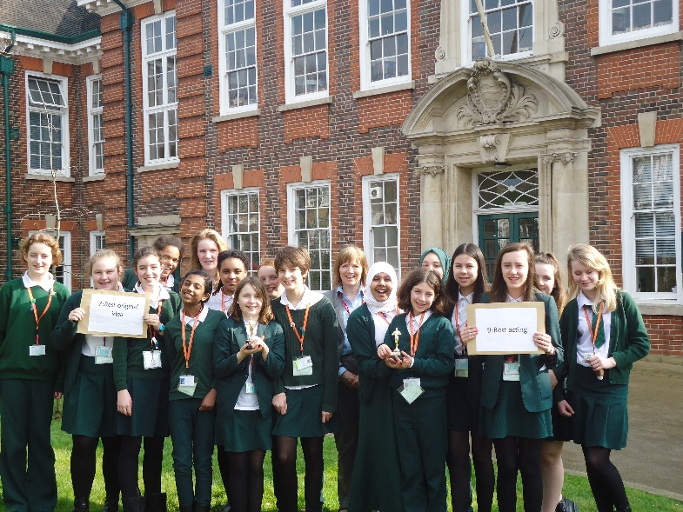
Walthamstow School for Girls is a place of high achievement. Effective teaching and learning are at the heart of our school. The school motto “Neglect not the gift that is in thee” underpins all the school’s work. Every girl is expected, encouraged and supported to achieve her very best academically and our pastoral system supports our students’ academic and social experiences.
Our role is to educate tomorrow’s women through a range of activities and opportunities to be confident, secure and happy individuals as they prepare for further education, careers and future lives.

WALTHAMSTOW SCHOOL FOR GIRLS
JOB DESCRIPTION

JOB TITLE: Receptionist / Administrative Assistant
GRADE: Scale 3
REPORTING TO: Administrative Manager
LINE MANAGEMENT: -

JOB PURPOSE
To be part of a team to carry out a range of administrative, reprographic and reception duties. At all times to work to raise the public image of the school and provide a welcoming, courteous reception to all school visitors.

MAIN DUTIES
General Administrative duties
- To be responsible for the reception of visitors to the school, ensuring they are welcomed in a polite, friendly and efficient manner and provide hospitality as required.

- To deal with student issues efficiently and effectively.
- To open, sort and dispatch incoming post, logging, weighing and sending of outgoing post.

- To accept delivery of orders, liaising with the Finance Office accordingly and arranging for packages to be delivered to the correct rooms/staff.

- To provide typing and general administrative support to staff across the school, under the direction of the Administrative Manager.
Additional Administrative duties:
- To assist with Human Resources and recruitment administration as required by the Human Resources Manager.

- To assist with SPL filing and Pastoral Administration.

- To produce detention letters and upkeep the detention data base.

- To assist with the administration of the Free School Meal register.

- To be responsible for checking levels of office stationery and ordering replacements as required.

- To provide support for the Media Resources Officer as required.

- To assist in the input of student data, including student behaviour reports.

- To be responsible for supplying refreshments as necessary.

Other requirements:
- Be aware of and comply with policies and procedures relating to child protection, equal opportunities, behaviour for learning, health, safety and security, confidentiality and data protection, reporting all concerns to the appropriate person.

- Contribute to the overall ethos/work/aims of the school.

- To administer first aid on site if necessary and in accordance with current guidelines, including responsibility for the accident book, forms and escorting students to hospital in the event of an emergency under the Headteacher’s direction.

- To be flexible and work according to needs which may involve assisting other areas which are commensurate with the grading of the post.

- There is an expectation to attend all key school events out of hours as directed in the school calendar e.g. Opening Evenings, all Faculty and Staff Meetings and relevant twilight Inset sessions.

Sept 2017

This school is committed to safeguarding and promoting the welfare of children and young people and expects all staff and volunteers to share this commitment.

Walthamstow School for Girls
Receptionist / Administrative Assistant
Person Specification

Experience
- Relevant work experience | Essential
- Experience of working on own initiative. | Essential
- Experience of the use of a wide range of computer software (e.g. word processing, spreadsheets, databases). | Essential
- Knowledge/experience of Education sector and/or schools. | Desirable
- Special abilities / aptitudes
- Flexibility and ability to work as part of and to contribute to the school administrative team. | Essential
- Interpersonal skills - dealing with parents, students, colleagues and outside agencies. | Essential
- Ability to deal sensitively and in confidence with a wide range of issues relating to working practices. | Essential
- Ability to communicate effectively at all levels both verbally and in writing. | Essential
- Ability to work effectively under pressure and to manage own workload. | Essential
- Ability to type quickly and accurately. | Essential
- Ability to work methodically, ensuring attention to detail. | Essential
- Numeracy skills. | Essential
- Other job specific requirements
- Commitment to the Authority’s Equal Opportunities Policy and acceptance of their responsibility for its practical application.  - First Aid qualification | Essential  Desirable
- Education and Training
- Good General Standard of Education. | Essential

Disqualifying Factors
Indication of sexist, racist or anti-disability attitudes or any other inconsistent with the Authority’s Equal Opportunities Policy.

September 2017

This school is committed to safeguarding and promoting the welfare of children and young people and expects all staff and volunteers to share this commitment.

That the school provides opportunities for each girl to feel confident to strive to push beyond their current capabilities to achieve through hard endeavour and a belief that anything is possible.

What do you value most
about our school?
A sample of responses from a survey of parents (February 2016)

The diversity of all the students and accepting all religions, cultures and traditions.
The sense of community; the high standards and expectations set by the school; the holistic approach to learning for the girls; the extra curriculum activities which supports learning and the fact that the staff team is a good diverse one.

The value placed on education for young women, standards of behaviour expected, opportunities for activities which extend my daughter's understanding and interests, diverse community.

High-quality learning environment and culture: comprising motivated, well-behaved pupils, strong and inspiring teachers and good resources.

The professionalism and reputation over such a long number of years.

It is welcoming, my daughter quickly settled into school life. It has high expectations of students but these are adapted for each individual so each is encouraged to do the best they can.

