School of Health and Social Care
Health and Social Care Lecturer
January 2019
Riverside College is a highly popular and successful further education college conveniently located in Widnes and at the hub of the Mersey Gateway, within easy reach of Liverpool, Manchester and Chester. We currently cater for over 3,000 16-18 students, 600 full time adults, 700 apprentices, and deliver a range of Higher Education and part time adult courses.

The School of Health and Social Care offers a simulated hospital ward on both sites, which will inform and support the students by using a realistic working environment. This provides the opportunity to understand the requirements of the sector and prepares them for work placement.

You will also be working in our brand new IDEA Centre, which opened on 19th May 2017. The IDEA Centre is a state of the art building which educates students using some of the most advanced industry standard equipment and methods. The centre offers the students the opportunity to measure their vital signs before, during and after exercise amongst other things.

The School of Health and Social Care offers the following programmes:
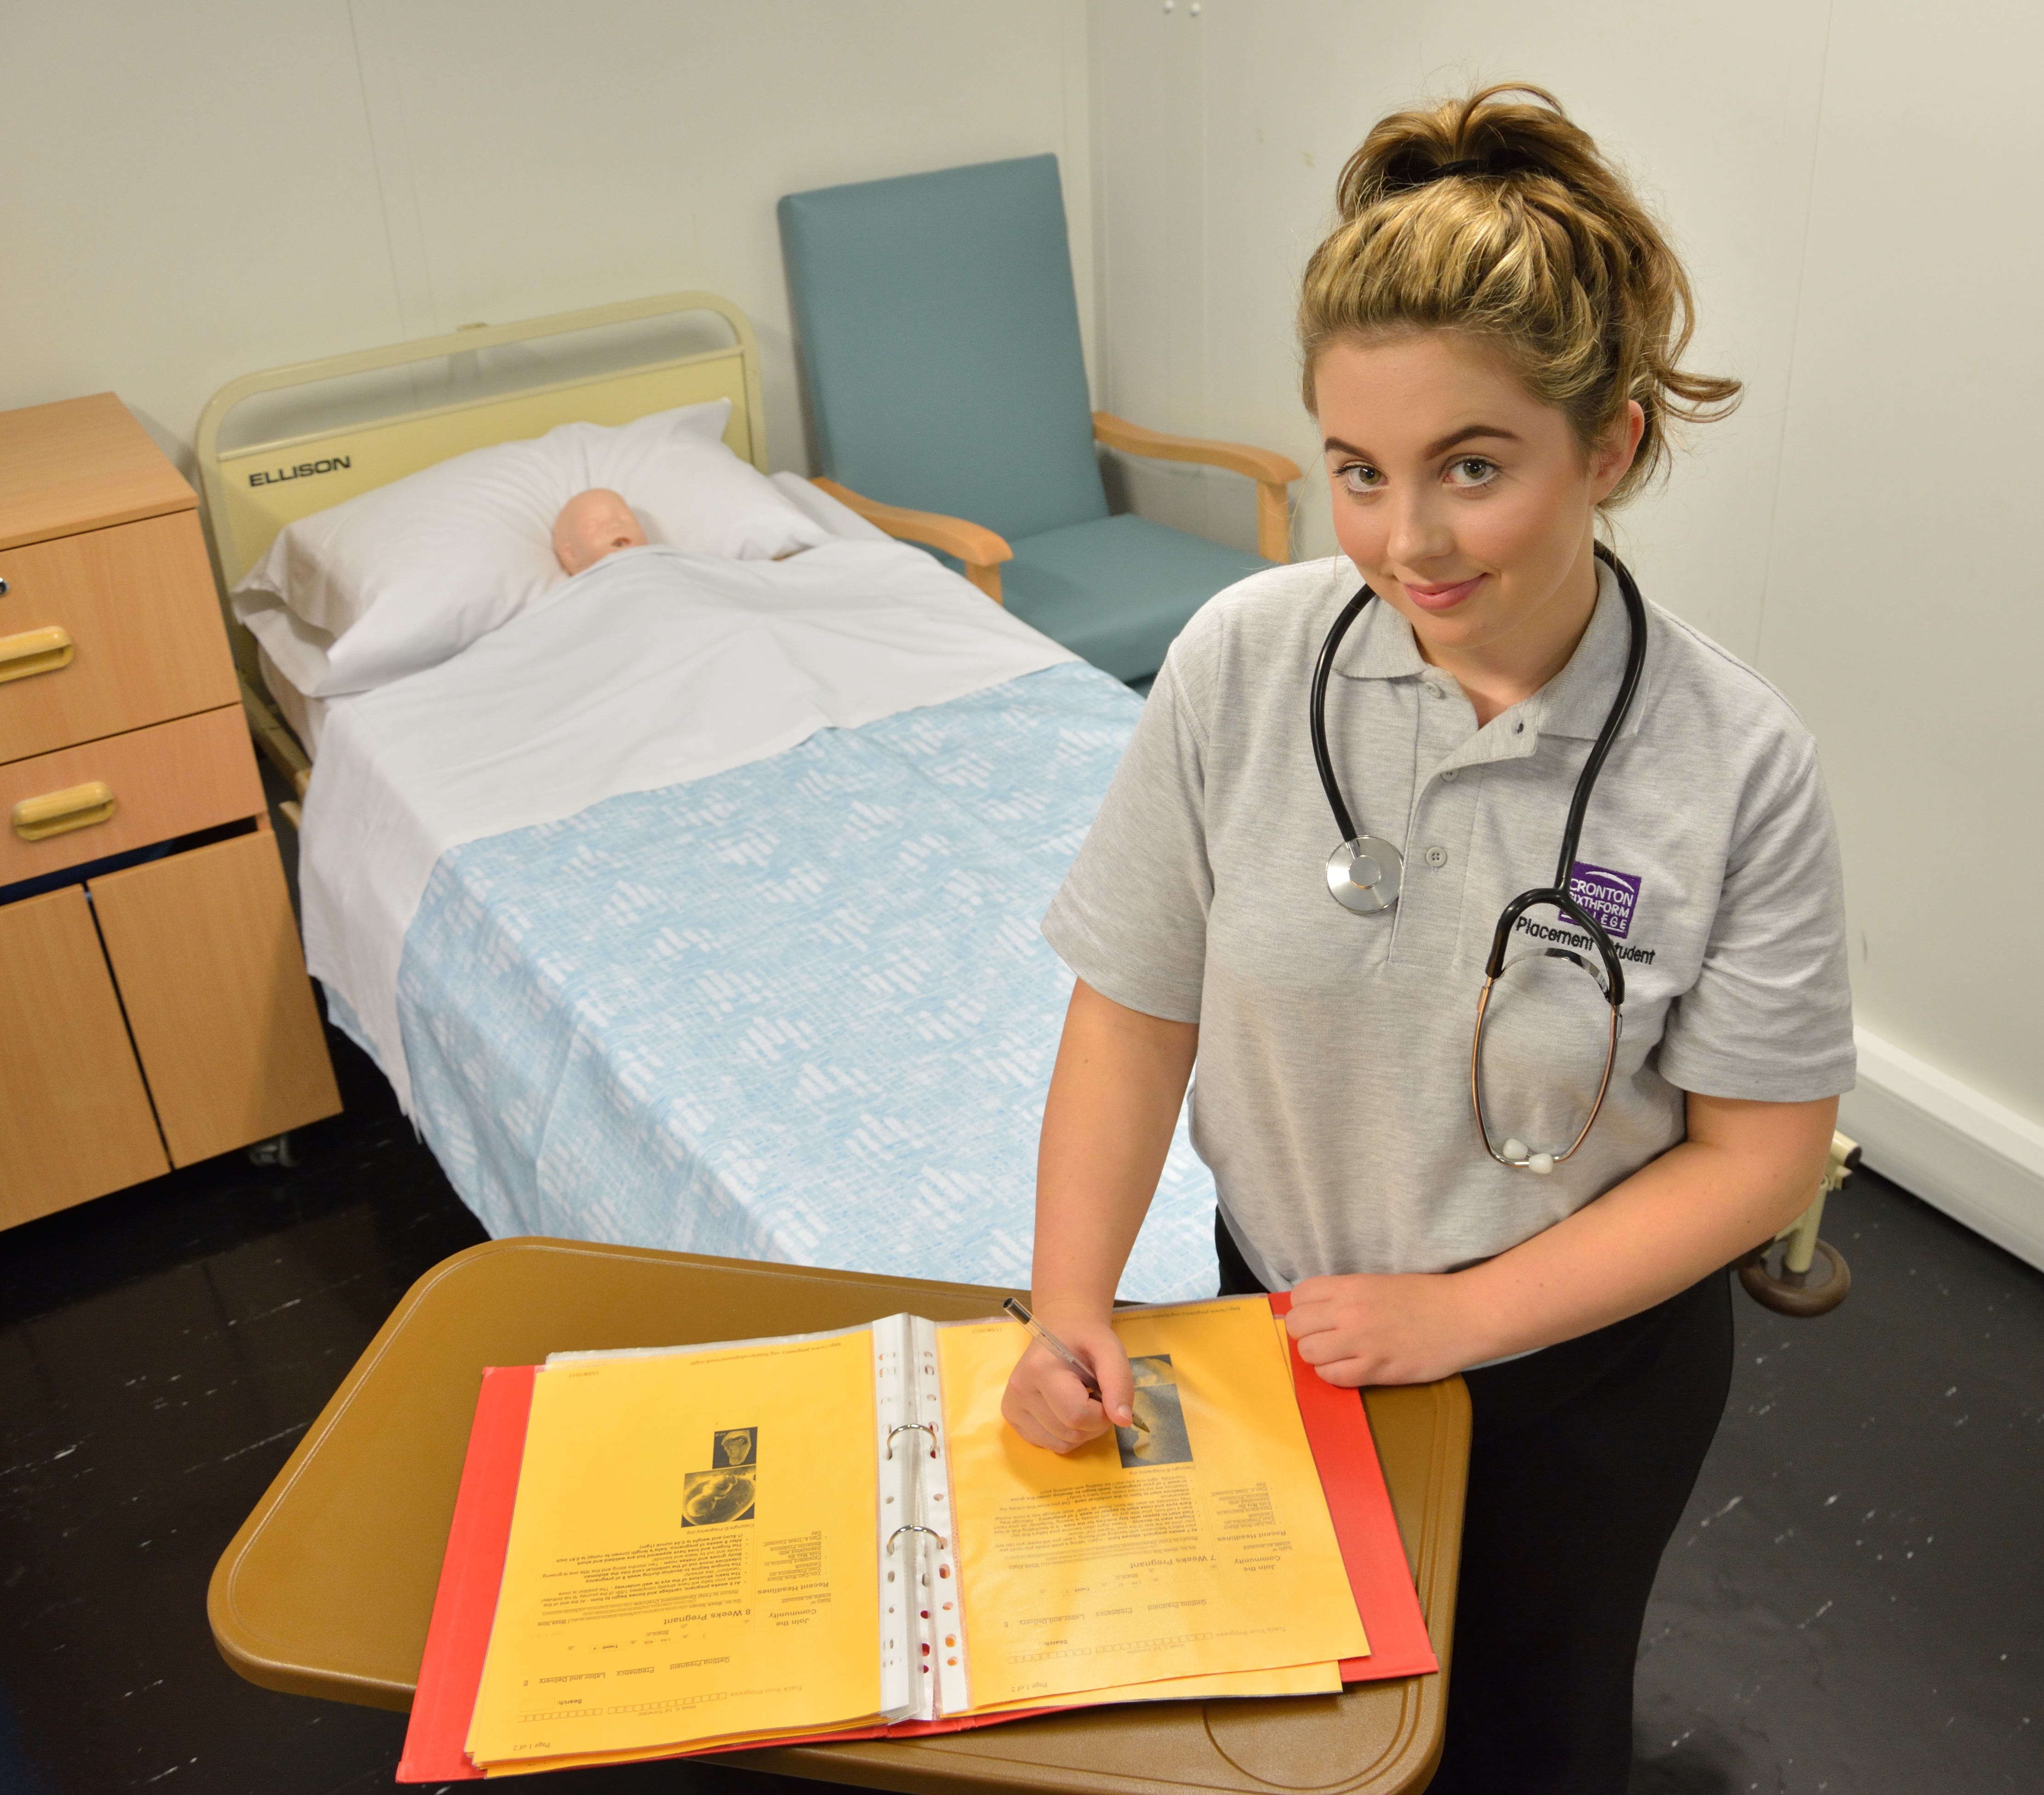
- Apprenticeships at all levels
- Health and Social Care Level 1
- Health and Social Care Level 2 NQF
- Health and Social Care Level 3 Extended
- (Health and Social Care Pathway)
- Health and Social Care Level 3 Extended
- Diploma (Health Studies Pathway)
- Counselling Level 2 & 3
- Counselling Foundation Degree
- Various Health related short courses

We have a prestigious Nursing Cadet Programme in partnership with Warrington and Halton NHS Trust and Chester University. This is a bespoke course offering practical rotation placements within the Trust, alongside academic and clinical training with the College, Trust and University and have recently secured a contract to deliver 150 Apprenticeships with a regional healthcare provider.

The College has celebrated many recent successes with the Department for Education performance tables, published in January 2018 ranking the college as 3rd in the country on three vocational performance measures.

Over recent years, significant investments have been made in teaching and learning and support for students, which we believe are key to our success and include:

- 99.4% A Level pass rate and 81% high grades

- 100% Vocational pass rate and 75% triple distinction and distinction star * grades

We require a strong Health and Social Care Lecturer, with the ability to deliver outstanding provision. You will be expected to have sound knowledge of current pedagogical practice with a proven track record of improving progress and attainment. The successful candidate will demonstrate a detailed understanding of current curriculum developments in Health and Social Care.
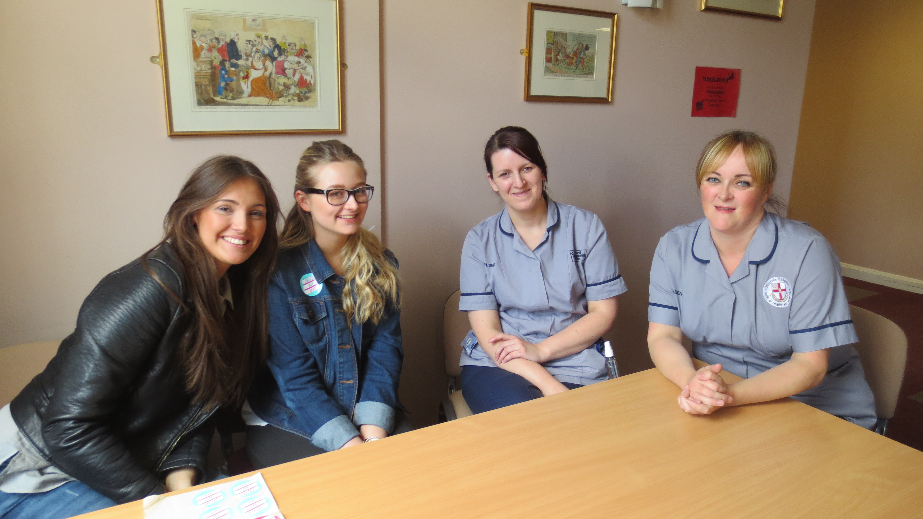
Riverside College is committed to:

- Providing learning experiences of outstanding quality

- Investing in teaching, learning and assessment

- Offering students distinctive and valuable opportunities to develop personally and professionally and academically

- Supporting every individual student to reach their full potential

Thank you for your interest in Riverside College. If you would like further information or an informal discussion please contact Jo Burton, Head of Health and Social Care on 0151 257 2800.

