St Fidelis Catholic Primary School
Class Teacher
Key Stage 1 or 2 |  |  | September 2019
St Fidelis is a high performing school in the London Borough of Bexley. The school employs specialist teachers for music and PE who work alongside our class teachers to ensure every child receives a broad and balanced curriculum.  You will work alongside a year group leader in our two-form entry school to plan, teach and assess children’s academic development so that every child makes progress.  You will be articulate and positive, able to work in an atmosphere characterised by our mission of compassion, challenge and excellence.  You can apply for this position by completing an application form or if you would like an initial confidential conversation with the Head Teacher, Mark Hannon, please email: head@st-fidelis.bexley.sch.uk  or phone:  07763 142903  Visits to the school are always welcome and you should phone the school office on:  01322 337752. |  | 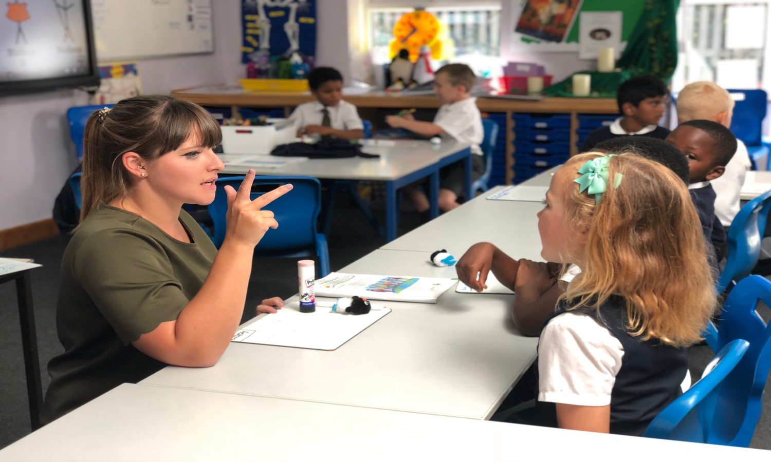
 |  | 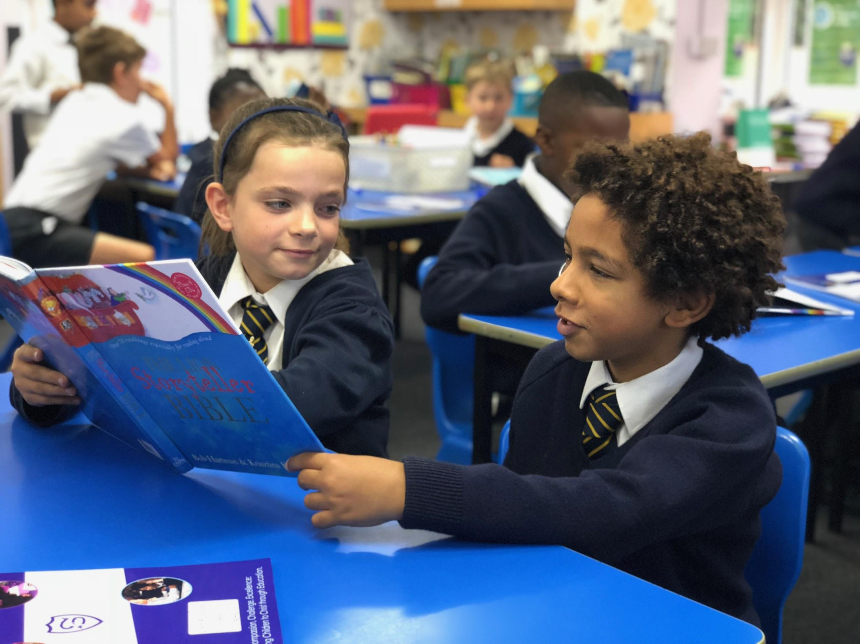
St Fidelis Catholic Primary School  Bexley Road  Erith  DA8 3HQ |  | www.st-fidelis.bexley.sch.uk  admin@st-fidelis.bexley.sch.uk  01322 337752
The closing date for applications will be Monday 25th February 2019
St Fidelis is committed to safeguarding and promoting the welfare of children.
All offers of employment are subject to an Enhanced DBS check.

