Teacher of English
Application pack

Cheltenham Bournside School
and Sixth Form Centre
Empowering lives through learning
Contents

Page 3 Welcome
Page 5 Mission, vision and values
Page 6 Employment benefits
Page 7 Support as a new member of staff or a
Newly Qualified Teacher (NQT)
Page 10 Department information
Page 11 Job description

Welcome
Thank you for your interest in this post. Choosing the right school in which to teach is a big decision and the aim of this application pack is to provide you with sufficient information to support you in that process.
I have been fortunate enough to spend the past seven years of my career at Bournside and it is a truly remarkable place. Having taught and led in a variety of other schools across the county and country, when I drive or cycle to school each day, I know that I am very privileged to be coming to a very special place of work and in the short section that follows, I hope to elaborate on why.

We are very optimistic about our future and the successful applicant for this post will join the school during a very exciting phase of our development. Our school is oversubscribed and as such, in support of the local area, we recently expanded from a nine-form to ten-form entry school. This transition began in September 2018 with our first cohort of year 7 students and will continue for the next four years until all main school year groups have a roll of 300 in September 2022.

The construction of our £2.4M state of the art ‘Alan Turing Maths Hub’ is now complete. This outstanding facility comprising 12 modern, light and airy classrooms, provides the perfect environment to support students in nurturing their love of this key subject. When you walk around our school site it is almost impossible not to be impressed by the high quality resources and facilities that we have. This is not by chance; significant time and meticulous planning goes into securing additional funding to ensure that in these times of national financial constraint, our school is able to offer our students and staff the very best in terms of resources and facilities.

One of the things that makes the school so special is the shared vision that exists between staff, students, parents and governors. This vision is visible the minute you enter the main school Reception and it permeates throughout the school almost everywhere you look. The vision is not simply a series of words; it is a sound-piece to many conversations that take place daily within the school. Our vision is very simple: we empower lives through learning.

We do this by living our five core values, which underpin our work together and form the basis of my leadership of the school. We are: purposeful, proud, respectful, curious and supportive. In my conversations with staff and students, there are two things that I refer to frequently: ‘our school’ and ‘pride’. I’m sure you would agree that these go ‘hand in hand’, however, this is something that every member of staff who works at the school must embrace and actively promote.

If you decide to apply for a position with us, you will be joining a committed team of over 150 staff who make it their business to do just that, in support of giving our students the very best chance of realising their potential and empowering their lives.

Welcome (cont)
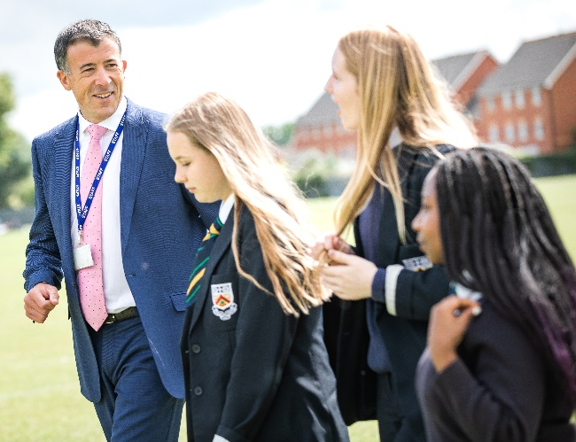
As you will see from our website, from
September 2019 in tutor groups only, the school
moved from traditional ‘year groups’ to
‘mixed-age tutor groups’. This coincided with
the launch of a new house system, which last
happened 47 years ago! Our aim through this
process was to nurture an enhanced sense of
family and community between our students,
further improve home/school communication,
provide opportunities for older students to act
as role models for younger students and
conversely for younger students to have
meaningful conversations with older students about school life and future aspirations. There is much to be excited about at Bournside over the coming years and it is a privilege being able to lead the school and work with so many committed professionals in achieving our shared vision.

I would strongly encourage you to take the opportunity to come to visit our school prior to submitting an application. The application window has deliberately been constructed to allow sufficient flexibility for prospective candidates to do this. All visits will consist of a tour of the school site with an appropriate school leader, providing you with the opportunity to see our wonderful school, meet our students and ask any questions that you may have in support of your decision making. If you would like to arrange a visit, please contact Karen Hanley, Deputy Headteacher by email (kjh@bournside.gloucs.sch.uk) or telephone (01242 235555) to make an appointment. In addition to this, a wealth of information about our school can be found on our website and specifically, the vacancies section contains a range of useful materials that you may find helpful, such as ‘why work at Bournside?’, ‘meet the Headteacher’, ‘what our new staff say’, case studies documenting the school’s support for professional development and a collection of short video clips.
Beyond this, if you would like to apply for the post, please do so by completing an application form and writing a supporting statement, the link for which can be found on the vacancies section of our website. Your supporting statement should be a maximum of two sides of A4 and should outline how you feel your experience, skills and attributes will enable you to make a significant impact in the advertised post. The deadline for applications is 3:00pm on Monday 24th February 2020.
I look forward to hearing from you.

Gareth Burton
Headteacher

Our mission

We have high aspirations for every individual and support each other to be the best they can be

Our vision
Empowering lives through learning

Our values
Purposeful
We persevere to achieve our goals and aspirations
Proud
We celebrate everyone’s effort and achievements
Respectful
We care about each other and believe in equality and kindness
Curious
We have enquiring minds and are not afraid of challenge
Supportive
We make a positive difference to each other’s lives

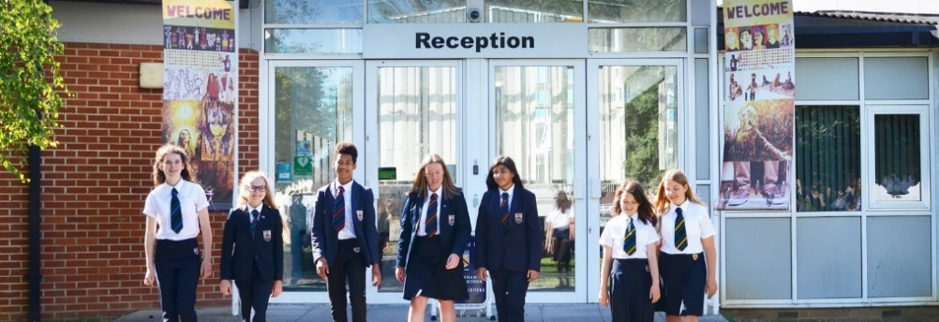

Employee benefits

Incentives
- Provision of all necessary IT equipment.
- Childcare vouchers.
- Cycle to work scheme.
- Time off in-lieu for staff who offer revision sessions during the Easter and Whitsun holiday periods to year 11 and/or year 13 students.

Lifestyle and wellbeing
- On-site parking facilities and cycle storage.
- Free access to the school’s fitness suite.
- A smart marking policy which ensures that students benefit from their teachers’ dynamism and energy in lessons, rather than being exhausted through over-work.
- Two ‘collapsed’ INSET days, served as twilight CPD sessions and resulting in two additional days of holiday per academic year.
- A comprehensive range of staff social events throughout the year.
- Whether it is a quick cappuccino and a bacon roll for breakfast or a hearty winter soup and a warm baguette for lunch, our state-of-the-art dining centre offers excellent facilities and is open between 7:30am and 4:30pm each day.

Professional Development
- A designated period each fortnight to engage in the Self-Reflective Practitioner Programme; an internal CPD programme designed to give all teachers the necessary time to reflect and refine their practice.
- Support to complete further academic study and professional qualifications.
- Access to high quality in-house and external leadership development programmes, tailored to a wide variety of levels of experience.
- Opportunity to be trained as an accredited ‘Apple Teacher’.

Support as a new member of staff
or a Newly Qualified Teacher (NQT)
Lucy Hemsley, our Assistant Headteacher, oversees the provision for all new staff joining the school and our superb NQT programme. Below is some information from Lucy regarding the high level of importance that we place on supporting new members of staff and NQTs in their transition to Bournside.
- Inclusion Support and SEN
- ICT
- Health and Safety procedures
- Educational visit procedures
- The school library
In addition to this training, you will be allocated a mentor – this is likely to be the same person as your line manager. Your mentor will meet with you on a weekly basis for the first month and fortnightly for the next two months. After this, meetings may be monthly or half-termly. Your mentor will ensure that as a new member of staff you have access to the Bournside ‘Staff Quick Reference E-Handbook’ and you have somebody to talk with to support you throughout your first year.

Your mentor is the first port of call for support and advice. The job of the mentor is to go through the induction list and ensure that all aspects are covered. Although many of the aspects will have been covered during the induction day, it is important that they can be revisited at any point. The meetings should cover aspects of the role; how well you are getting on, what difficulties you might
be experiencing and generally ensuring you are supported so you can fulfil your role within the school. Your mentor will also undertake a three-month review with you.
New members of staff
As part of my role as Assistant Headteacher, I oversee new staff inductions for your first year of teaching with us.
The purpose of this is to ensure that staff, new to Cheltenham Bournside School, are effectively supported in understanding and coping with your new role.
As a new member of teaching staff you will be invited to an induction day prior to starting at the school. This is a full day of training in the term prior to starting which will provide information and training, and important aspects of school life which are needed immediately by new employees.
Topics included are:
- School Behaviour Code including rewards and sanctions
- Being a tutor including assemblies
- Use of electronic registration and laptops
- Procedures in the Sixth Form
- School Leadership Structure – who to see for what
- Duties
- School communication and meeting systems
- Induction procedures, performance management and professional development

As a new member of staff, you will be joining a school that is forward-thinking in its approach to Continuing Professional Development (CPD). We have a personalised menu for teaching staff that incorporates a variety of activities that engage staff with sharing best practice and ensuring teaching and learning is the best it can be. These opportunities include whole staff training options, peer observations, teaching and learning forum sessions, personal planning and development time, departmental development time, focused workshops, and time for performance management and review.
NQT Programme
I oversee the NQT induction year and I would be your induction mentor for the year. In addition to my support, you will be assigned a personal mentor who will be based in your subject area. The purpose of this is to ensure you are, as a new member of staff to Cheltenham Bournside School, effectively supported in understanding and coping with your new role.
As a new member to the teaching profession, you will be invited to an induction day prior to starting at the school.
This is a full day of training in the term prior to starting which will provide information and training, and important aspects of school life which are needed immediately by new employees. Topics included are:
- School Behaviour Code including
rewards and sanctions
- Being a tutor including assemblies
- Use of Electronic Registration and laptops.
- Procedures in the Sixth Form
- School Leadership Structure – who
- to see for what
- Duties
- School communication and meeting systems
- Induction procedures, performance management and professional development
- Inclusion Support and SEND
- ICT
- Health and Safety procedures
- Educational visit procedures
- The School Library
In addition to this training, you will be allocated a mentor – this is likely to be the same person as your line manager. The role of the mentor is to provide you with regular professional review meetings and help to oversee the holistic view of your progress as a NQT, which includes looking at teaching, planning, your role as a tutor, progress made, contributions to extra curriculum provision of the school, marking and they will observe you teaching every 6-8 weeks.
The approach throughout the year should be a collaborative approach. The Newly Qualified Teacher is part of the process of action planning focusing on areas/activities for development. Your mentor will ensure that as a new member of staff, you have access to a Bournside Staff Handbook and you have somebody to talk with to support you throughout your first year.

In my role as induction tutor, I will meet with you to complete your 3 formal assessments that form part of your NQT year. These formal assessments consist of a lesson observation prior to end-of-term assessment and a formal assessment meeting. As a newly qualified teacher, you will also have a reduced timetable for the first academic year.
As a resource, we use an online tracker aligned with the Teacher Standards which is owned by the NQT and they can use this with their mentor as a tool for recording evidence and tracking areas/activities for development throughout the year.
What our 2018-19 NQTs said:
“As a well-supported NQT in a vibrant and forward-thinking school, I have been given fantastic opportunities to develop schemes of work and provide whole school initiatives to further improve teaching and learning.”

“I’ve been given the opportunity to develop schemes within my department, also take responsibility of how the department budget is spent and opportunities to contribute to extracurricular school life in a stimulating and supportive environment.”

“I always knew my NQT year would be hard work, which is why I am so happy that I got the post at Bournside. The level of support has been exemplary. In addition, the students here are fantastic and being a large school means you gain a range of experience.”

Your mentor will ensure that as a new member of staff you have access to a Bournside Staff Handbook and you have somebody to talk with to support you throughout your first year

As a new member of staff, you will be joining a school that is forward-thinking in its approach to Continuing Professional Development (CPD). We have a personalised menu for teaching staff that incorporates a variety of activities that engage staff with sharing best practice and ensuring teaching and learning is the best it can be. These opportunities include whole staff training options, peer observations, teaching and learning forum sessions, personal planning and development time, departmental development time, focused workshops, and time for performance management and review.

Whether you would be joining us as an NQT or not, I hope this information has given you a flavour of the support you can expect in your first year at Bournside

The English department
The English Department at Bournside is led by Diane Duncan and below are a few thoughts from her about her department.
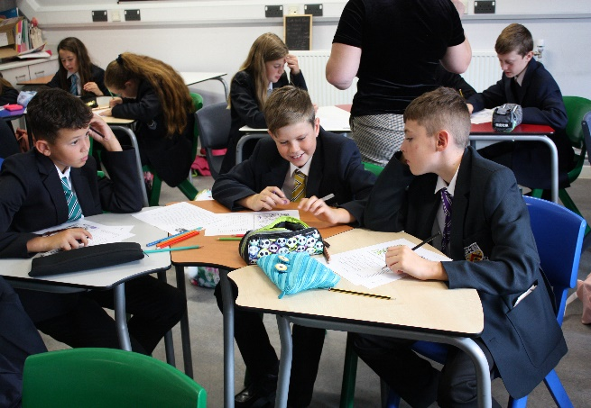
The English Department at Bournside is successful, dynamic and innovative. We are a dedicated and hard-working team of eleven enthusiastic teachers. We constantly strive for improvement and we work collaboratively with our students to make learning count in every lesson.
Our resources are outstanding: a laptop and iPad for each English teacher, a set of laptops for exclusive use in the Department and a new teaching block equipped with interactive whiteboards in each classroom. We have redesigned our curriculum, investing in a wealth of resources to inspire a love of learning in English. We are proud of our knowledge and resource-rich curriculum and we are keen to further extend our teaching of cultural capital through our high-quality texts. Our team is very strong and supportive. To add to our team, we are looking for excellent classroom practitioners who have experience of teaching across all 3 key stages.
Key Stage 3: Differentiation is a real strength and we take pride in our ability to provide a stimulating KS3 curriculum based on the principle of ‘stretch and challenge’ for all students. We have high expectations and set ambitious standards of attainment alongside a clear emphasis on excellent attitude to learning. In Year 7 & 8, English is taught in mixed-ability groups. Year 9 operates a similar structure but with two ‘high-flier’ sets and the rest as mixed-ability groups. Our Year 9 students study a pre-GCSE-curriculum using some of the core KS4 texts and skills. We work closely as a team to provide interesting, challenging lessons that support and challenge students to become more independent learners as they move towards GCSE.
Key Stage 4: We follow the AQA English Language and Edexcel English Literature courses with all students entered for both GCSEs. We have structured our KS4 curriculum from September 2020 so that each course is taught separately within 9 taught teaching hours across the two subjects. This allows us to develop depth of subject knowledge alongside highly-focused literary and linguistic skills. Our curriculum at KS4 follows the principle of ‘thinking is learning’ and we aim to enable all students to become confident, critical-thinking readers and writers.
A-Level English: We currently have over 60 students taking one of our English courses at Sixth Form, either Edexcel English Language and Literature or Edexcel English Literature. As with KS3 and KS4, we pride ourselves on the quality of teaching and resources we provide our students with at A-Level.
For more information about the department and/or the posts on offer, please contact Mrs Diane Duncan, Head of Department via email – dmd@bournside.gloucs.sch.uk.

Cheltenham Bournside School
and Sixth Form Centre

Classroom Teacher - Job Description

Post: Classroom Teacher

Responsible to: Head of Department

Purpose:
We aim for every student to develop the knowledge, skills and self-confidence to become the best they can be. We do this by being open, energetic, outgoing, friendly, safe, supportive, healthy, professional and self-aware.

Duties

PART ONE: Academic

1 Set high expectations which inspire, motivate and challenge students

- establish a safe and stimulating environment for students, rooted in mutual respect
- set goals that stretch and challenge students of all backgrounds, abilities and dispositions
- demonstrate consistently the positive attitudes, values and behaviour which are expected of students.

2 Promote good progress and outcomes by students

- be accountable for students’ attainment, progress and outcomes
- analyse students’ data and exam performance to inform planning and intervention
- plan teaching to build on students' capabilities and prior knowledge
- guide students to reflect on the progress they have made and their emerging needs
- demonstrate knowledge and understanding of how students learn and how this impacts on teaching
- encourage students to take a responsible and conscientious attitude to their own work and study.

3 Demonstrate good subject and curriculum knowledge

- have a secure knowledge of the relevant subject(s) and curriculum areas, foster and maintain students’ interest in the subject, and address misunderstandings
- demonstrate a critical understanding of developments in the subject and curriculum areas, and promote the value of scholarship
- demonstrate an understanding of and take responsibility for promoting high standards of literacy, articulacy and the correct use of standard English, whatever the teacher’s specialist subject.

4 Plan and teach well-structured lessons

- impart knowledge and develop understanding through effective use of lesson time
- promote a love of learning and children’s intellectual curiosity
- set homework according to the School timetable and plan other out-of-class activities to consolidate and extend the knowledge and understanding students have acquired
- reflect systematically on the effectiveness of lessons and approaches to teaching
- contribute to the design and provision of an engaging curriculum within the relevant subject area(s).

5 Adapt teaching to respond to the strengths and needs of all students

- to differentiate appropriately, using approaches which enable students to be taught effectively
- have a secure understanding of how a range of factors can inhibit students’ ability to learn, and how best to overcome these
- demonstrate an awareness of the physical, social and intellectual development of children, and know how to adapt teaching to support students’ education at different stages of development
- have a clear understanding of the needs of all students, including those with special educational needs; those of high ability; those with English as an additional language; those with disabilities; and be able to use and evaluate distinctive teaching approaches to engage and support them.

6 Make accurate and productive use of assessment

- know and understand how to assess the relevant subject and curriculum areas, including statutory assessment requirements
- make use of formative and summative assessment to secure students’ progress and use this to inform parents according to the school’s reporting procedures
- use relevant data to monitor progress, set targets, and plan subsequent lessons
- give students regular feedback, both orally and through accurate marking within the agreed time, and encourage students to respond to the feedback
- follow the School’s Assessment and Feedback policy.

7 Manage behaviour effectively to ensure a good and safe learning environment

- have clear rules and routines for behaviour in classrooms, and take responsibility for promoting good and courteous behaviour both in classrooms and around the School, in accordance with the School’s Behaviour policy
- have high expectations of behaviour, and establish a framework for discipline with a range of strategies, using positive redirection, using the Ladder of Consequences and rewards consistently and fairly
- to register students every lesson within the first 10 minutes, ensure that they arrive punctually to lessons, that they are following the school’s uniform policy and are equipped to learn
- manage classes effectively, using approaches which are appropriate to students’ needs in order to engage and motivate them
- maintain good relationships with students, exercise appropriate authority, and act decisively when necessary.

8 Fulfil wider professional responsibilities

- make a positive contribution to the wider life and ethos of the School including extra-curricular as appropriate
- develop effective professional relationships with colleagues, knowing how and when to draw on advice and specialist support
- deploy Teaching Assistants effectively as a 2nd adult in the classroom
- take responsibility for improving learning and teaching through appropriate professional development and the school’s Self-Reflective Practitioner Programme, responding to advice and feedback from colleagues
- to comply with the Performance Management and Review Policy
- communicate effectively with parents with regard to students’ achievements and well-being
- to keep up to date and comply with all school policies and procedures
- to act in accordance with relevant examination board guidance
- to attend weekly staff briefings, scheduled staff meetings, PTCs, open evenings and other professional meetings according to the school’s published annual calendar.

9 Visible Consistency

- stand outside the entry point to the classroom, welcoming students into your learning environment
- begin each lesson with an activity that students can self-start and readily engage in
- plan all lessons around a key question(s) which is shared with all students
- check uniform at the end of every lesson.

PART TWO: Pastoral

- to be a Form Tutor to an assigned group of students
- to promote the general progress and well-being of individual students and of the Tutor Group as a whole
- to liaise with Heads of Year and Assistant Heads of Year to ensure the implementation of the school’s Pastoral System
- to register students, ensure that they arrive punctually to school, that they are following the school’s uniform policy and are equipped to learn with the appropriate equipment
- to challenge poor attendance and punctuality in accordance with the attendance policy
- to reward good attendance and punctuality in accordance with the attendance policy
- to accompany students to assemblies and remain with them, as detailed in the SQREH
- to monitor the academic and pastoral progress of students intervening when appropriate following reporting windows
- to monitor PAM on a daily basis and discuss issues with students and reinforce the praise as outlined on praise postcards etc.
- to consistently apply the Ladder of Consequences through applying the school’s sanctions and rewards system, keeping up to date records with regard to incidents involving students
- to communicate, as the first point of contact, with parents of students over issues related to student progress and behaviour, including participation in the school’s reporting process
- to alert the appropriate staff to problems experienced by students and to participate in the process of resolving these
- to deliver the tutorial programme in line with the agreed plan and as directed by the relevant HOY
- to set a good example in terms of dress, punctuality and attendance.

PART THREE: Personal and professional conduct

A teacher is expected to demonstrate consistently high standards of personal and professional conduct. The following statements define the behaviour and attitudes which set the required standard for conduct throughout a teacher’s career.

Teachers uphold public trust in the profession and maintain high standards of ethics and behaviour, within and outside School, by:

- treating students with dignity, building relationships rooted in mutual respect, and at all times observing proper boundaries appropriate to a teacher’s professional position
- having regard for the need to safeguard students’ well-being, in accordance with statutory provisions and adhere to the school’s Health and Safety policy and Child Protection and Safeguarding policy
- showing tolerance of and respect for the rights of others
- not undermining fundamental British values, including democracy, the rule of law, individual liberty and mutual respect, and tolerance of those with different faiths and beliefs
- ensuring that personal beliefs are not expressed in ways which exploit students’ vulnerability or might lead them to break the law.

Any teacher who leads or is a supporting member for a trip or visit, should abide by the school’s code of conduct for school trips and visits, which can be found in Public Documents.

Other duties and responsibilities:

Carry out other duties that the Headteacher may reasonably request.

Cheltenham Bournside School and Sixth Form Centre

Cheltenham Bournside
School and Sixth Form Centre
Warden Hill Road Cheltenham Gloucestershire GL51 3EF

t

