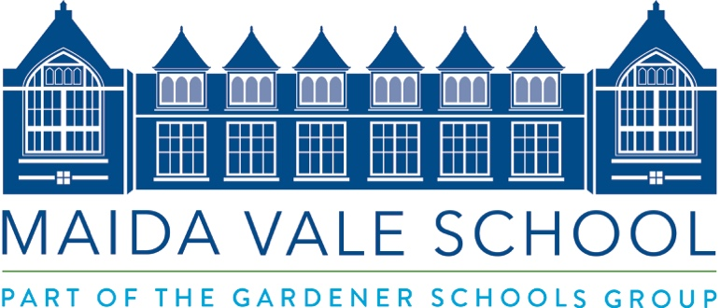

Office Manager and Head’s PA
Full-Time Permanent

Maida Vale School values creativity, problem-solving, and curiosity in both the classroom and beyond. We strive for innovation and promote warmth and friendliness while encouraging high aspirations: our pupils aim high and achieve well. MVS, in its fourth year, is growing and continues to establish its reputation as a positive, progressive, kind, and tolerant academically selective school.

We are looking for a full-time Office Manager & Headmaster’s PA. The successful candidate will be flexible and proactive in their approach. The role requires an individual excited at being involved in the development of this project with the energy to make it a success.

The Office Manager and Headmaster’s PA is central to the smooth running of the Headmaster’s office and key to the successful operation of the school. The postholder will be a central point of contact for communications, internal and external, and will closely assist the Headmaster with operational planning and decision making. At the heart of the school, it is essential that the Office Manager a is committed to the school and its values.

Main duties:
- To ensure the efficient leadership and management of the school’s secretarial and administrative support.
- To organise and manage the School Admin Team allocating and keeping an oversight of duties.
- Take part in the interviewing and training of new office staff where appropriate.
- To line manage and ensure the appraisal of appropriate support staff.
- To liaise with Senior Leadership Team, facilitating effective SLT meetings by ensuring agenda and relevant reports are prepared and circulated beforehand, actions are updated, and reminders are sent.
- To assist in reception duties as required by staff breaks and rotas.
- To ensure that parent, pupil, and staff details are up to date on iSAMS.
- To assist in the administration of new teaching staff appointments.
- To initiate, oversee and manage teaching and other employee adverts and assist in preparation of interview documentation.
- To work closely with the SLT to ensure that the school’s Safer Recruitment and safeguarding policy and procedures are followed.
- To liaise with the Group HR Advisor to ensure compliance with Safer Recruitment policy.
- To be responsible for and manage the single central register for the school.
- To be responsible for ordering school office stock and managing the relevant Admin budget, and to reconcile and control purchases from the school credit card.
- To ensure that annual and termly calendars are accurate and published on time.
- To liaise with the Head of Marketing to contribute to the school’s website appropriate information regarding staff, uniform, calendar, policies, and other admin items.
- To manage and administer MySchoolPortal including management of forms and payments for trips and sundries.
- To ensure that reception is constantly staffed, personally attending to reception duties as needed, including agreed non-term time periods.
- To oversee the management of school mail, both internal and incoming/outgoing, and establish effective systems and procedures.
- To supervise the operation of the franking machine used for postage.
- From time to time, you may be required to assist in other duties in support of other activities, these duties will not, when considered in total, be to an extent which changes the overall character of your job.
- To undertake further job-related training.
- To be aware of and comply with policies and procedures relating to child protection, disabled access, health, safety, and confidentiality, reporting all concerns appropriately.

Other Duties

- To assist with school key events within the academic year as required.
- To work within school policies and procedures.
- To contribute to the provision of positive relationships with staff, students, parents, and outside agencies.
- To attend training and participate in personal/performance and professional development as required.
- To take care of their own and other people’s health and safety.
- To be aware of and respect the confidential nature of issues.

Hours of Work
Normal hours of work will be 08:30 – 17:30, Monday to Friday.

There will be some occasions when there will be a need to work later in the evenings or a need to be present during an evening or weekend function.

Maida Vale School is committed to safeguarding and promoting the welfare of children and young people and expects all staff and volunteers to share this commitment. All positions are subject to an enhanced DBS check.

To apply, please use the staff application form on our website (www.maidavaleschool.com) and email to recruitment@maidavaleschool.com

Closing Date – 9am Friday April 5th. Interviews are likely to be held on Monday 8th April or Tuesday 9th April.

