October 2017

Dear Colleague,

MATHEMATICS TEACHER
Thank you for showing an interest in the above vacancy.
Alsager School is a fantastic place to work with motivated and well behaved students, a committed and experienced governing body, dedicated staff and supportive parents. Children of all abilities make impressive progress throughout the key stages. We are one of the highest performing schools in Cheshire East, our progress data puts us in the top 25% of schools nationally and in February 2016 Ofsted graded the school as Outstanding.
I hope that the attached details will help to introduce you to our Mathematics Department.
In 2017, 79% of pupils achieved 9 – 4, 55% 9 -5 and 25% 9 – 7 in GCSE Maths. The Maths results for the last four years have been very impressive indeed. However, I would strongly urge you to get more of a ‘feel’ for the life of Alsager School by visiting our website www.alsagerschool.org We hope this information will encourage you to apply.

In order to ensure the future successful development of our school, we are keen to appoint only staff of the highest ability or with the greatest promise. Working at Alsager School is demanding but the rewards are commensurate in a school with strong leadership, dedicated staff, supportive parents and pleasant, friendly and highly motivated pupils. The School is proud of its supportive ethos and the person appointed can expect much help, guidance and support from colleagues.

If you wish to make an application, please complete all sections of the enclosed form. In addition, we would ask you to submit a supporting letter. It will help our shortlisting, and therefore your application, if your letter follows the format described below:

- Relevant Experience: outline how your experience to date prepares you to meet the requirements of the person specification. NQTs should expand upon their teaching practice.
- Teaching Style: your philosophy and approach to teaching your subject.
- Information and Communication Technology: please provide a brief summary of how you use ICT to enhance your teaching.
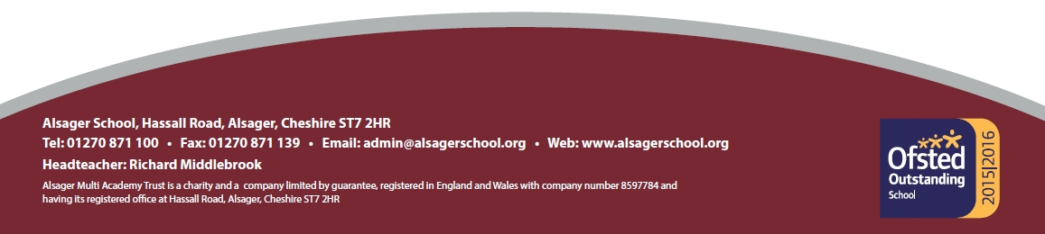
- Personal Qualities: the personal qualities you would bring and the contribution you would make to Alsager School.
- General Statement: any other relevant things you wish to say in support of your application. This section is optional.

Your completed application should be received in school no later than 12 noon on Monday, 16th October 2017. Please ensure the correct postage requirements for your application if you decide to submit your application by post.

Interviews will be held on Wednesday, 18th October. Accordingly, if you have not heard from us by then, I’m afraid in this instance your application has not been successful. Unfortunately costs preclude us from informing applicants personally.

If you require any further information or wish to discuss any issues, please do feel free to contact me. In the meantime, good luck with your application. I look forward to reading your response and to possibly meeting you in the near future.
Yours sincerely,

Liane Young

Liane Young
Assistant Headteacher

