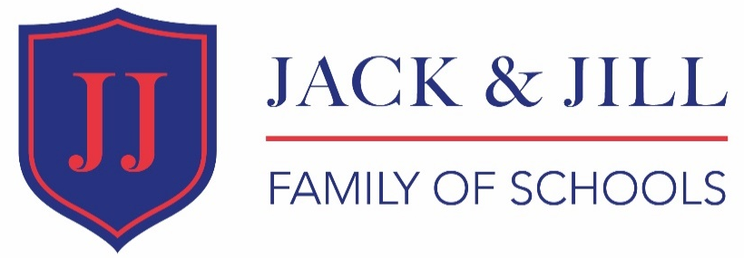

Position | Digital Learning Lead
Location | All 3 Schools
Reporting To | Deputy Principal
Hours | Up to 2 days per week
Contract Type | Fixed term (initially to end of Summer Term 2020)
Salary | Competitive
Start Date | December 2019/January 2020
Jack and Jill Family of Schools

The Jack & Jill Family of Schools is a group of schools that has been providing education for children since 1951 and is now one of the few remaining family-run educational establishments in the UK.

All Jack and Jill schools focus on achieving high standards in both behaviour and performance within the close supportive ‘family’ environment and through a broad academic curriculum. Emphasis is placed upon acceleration in literacy and numeracy as well as development of effective working practices, diligence and the sheer joy of learning – a ‘tradition of excellence’ established over many decades.

The Jack & Jill Family of Schools achieved Ofsted ‘outstanding’ in all areas’ in its latest inspection December 2017.

It is comprised of three schools:
- Jack & Jill Nursery and Reception (Twickenham)
- Nightingale House Pre-Preparatory School (Hampton)
- Clarence House Preparatory School (Hampton Hill)

Safeguarding

The Jack & Jill Family of Schools is committed to safeguarding and promoting the welfare of all stakeholders. To meet this responsibility, we follow a rigorous selection process. All successful candidates will be subject to an enhanced Disclosure and Barring Service check.

Structure Chart
Principal
!
Deputy Principal
!
Digital Learning Lead

Purpose of Role
To support digital learning throughout the Family of Schools, in line with the School Development Plan.

The job holder will identify suitable apps/software packages for use within the school’s ICT systems and opportunities to use digital resources to enhance the quality of teaching and learning within the School’s innovative curriculum, ensuring best practice in the use of any digital resource.

Responsible for training and supporting staff in the use of online and digital resources.

Job Content
This job description may be amended at any time following discussion between the line manager and the member of staff to meet the requirements of the Family of Schools
1. Strategic Direction

Work with the IT Department and the Teaching and Learning Teams to identify opportunities to use digital resources to enhance the quality of teaching and learning within the Family of Schools.

2. Supporting Learning

Identify and support digital learning within the School, ensuring that staff are aware of the resources available and are fully trained in the use of them. Monitor the effectiveness of all digital resources.

3. Working with others

Engage with the IT Department and the Teaching and Learning team to ensure a cohesive approach to digital learning.

Motivate and support staff to use digital resources. Challenge and develop staff to set high standards in the use of resources and secure continual improvement.

Hold training and coaching sessions in the use of digital resources.

4. Safeguarding

The job holder has due regard for safeguarding and promoting the welfare of the children and will be required to follow the child protection procedures outlined in the school’s safeguarding policy.

The post holder is required to place online safety as the highest priority in recommending, promoting and introducing new practice.

5. Other duties

Other duties at an appropriate level may be required. Whilst every effort has been made to explain the main duties and responsibilities of the role, there may be other duties to ensure the success of the school.

What we can offer
The position of Digital Learning Lead is a new position from December 2019/January 2020 and an exciting opportunity for an individual with excellent digital technical skills and knowledge to develop this within a STEM focussed school environment.

The opportunity to work flexibly and be part of a Family of Schools that caters for children from the age of two up to the end of KS2.
Person Specification

The criteria below will be assessed by the application form (A), task (T), interview (I).

The task will include a presentation during the interview and an exercise to observe a lesson and recommend digital enhancements.

Attributes | Essential | Assessment Criteria
Qualifications | - Degree level or equivalent and evidence of up to date CPD | A
Experience | - Extensive technical experience of digital learning, ideally within an education setting  - Experience of running training sessions & supporting others on digital resources, including ability to train non-technical staff members on technical matters  - Able to write intuitive how-to guides and documentation "Essential"  - Experience with the following platforms:  - iOS/Android educational ecosystem/apps and platform (essential)  - Microsoft Office 365 educational suite (desirable)  - Cloud-based learning platforms (desirable)  - SharePoint Online and One Note for classrooms (desirable) | A, T  A, T  A, T  A, T  A, T  A, T  A, T
Knowledge | - Extensive technical knowledge of ICT systems (see above)  - Knowledge of apps and resources suitable for education and the ability to be discerning in their adoption and application  - Understanding of teaching, ideally in an EY and primary setting,  The job holder is not required to be a qualified teacher | I, T  I, T  A, I
Leadership | - Experience of developing, monitoring and evaluating the effectiveness of digital learning  - Evidence of inspiring and motivating colleagues to use digital resources | A, I  A, I, T
Vision | - Supports our belief that a school curriculum requires focus, coherence and rigour  - Passion for STEM learning opportunities  - Evidence of successfully implementing digital resources and practices in a commercial or education environment | I  I  I
Other Skills and Abilities | - Excellent oral and written communication skills and good listening skills  - Approachable and promotes positive working relationships  - Excellent IT skills, | I, A, T  I  A, I
Behaviour | - Demonstrates high standards of personal integrity, loyalty, discretion and professionalism  - A calm, patient and reassuring manner | I  I
Safeguarding | - Commitment to safeguarding and welfare of all stakeholders | I

Application Process

To apply for the post, please complete the following documents and return to HR: hr@jackandjillschool.org.uk
- Application Form (found on website)
- Cover Letter including why you feel you have the key skills to meet the requirements of this role and how your ethos would fit the role and our school
If invited for interview, this will include a structured interview and a presentation. Interviews are likely to take place during w/c 25 November.
CLOSING DATE: 15 November 2019.
hr@jackandjillschool.org.uk

