RECRUITMENT PACK
Teacher of Music with the ability to teach Drama
TMR/UPR
Required: January 2019
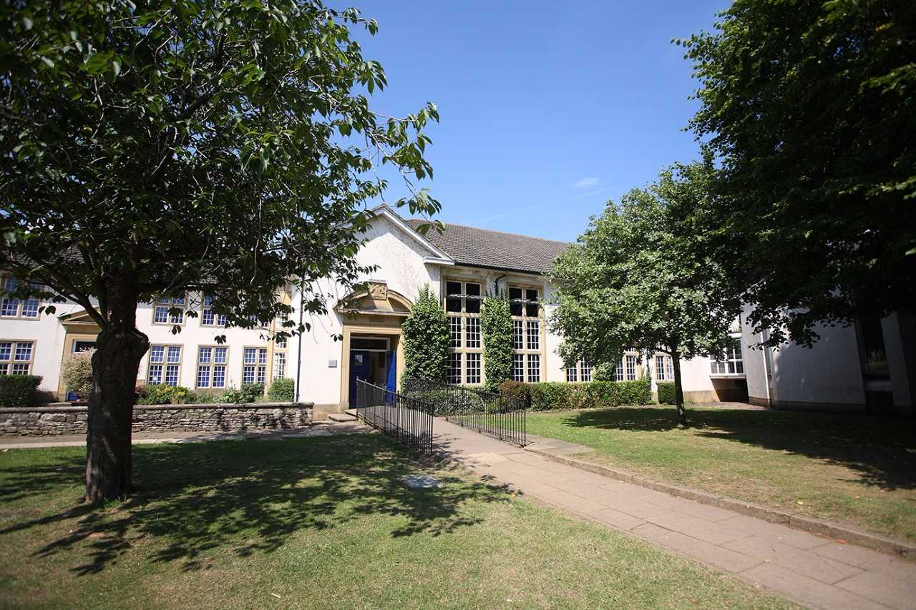

Introduction from the Headteacher

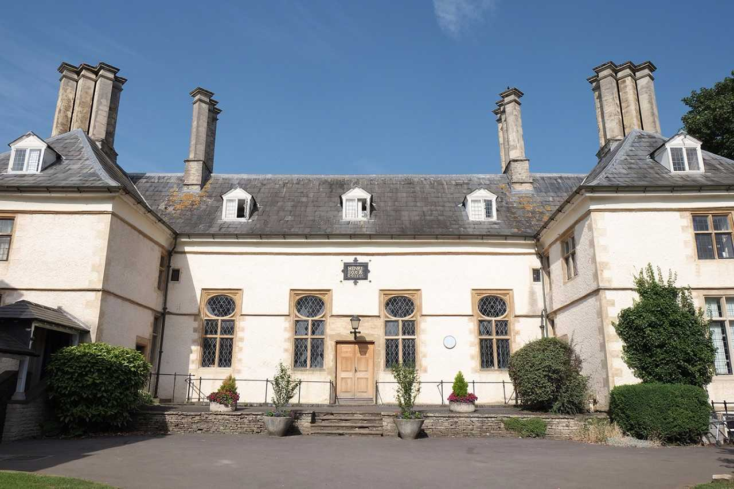
The Henry Box School is a successful, thriving mixed comprehensive school of over 1,200 students situated on Church Green in the historic market town of Witney. The school was founded in 1660 by local man, Henry Box, and the beautiful original school building is still in daily use in the centre of our attractive site. We are proud of our history and tradition and very excited about our future.

The school was inspected by Ofsted in November 2017 and was judged as ‘good’ in every category. The GCSE examination results in 2018 were good, with excellent ‘A’ Level results.

At The Henry Box School, we are fortunate to have fantastic staff, both teaching and support, experienced and supportive governors, and students who have positive attitudes and are keen to learn. Students and staff enjoy respectful relationships, and above all we are a very happy school.

Professional Development is central to our work and we offer opportunities and support for all staff to develop their skills. From our excellent NQT programme through to our ‘Future Leader’ programme, we are committed to recruiting and retaining the best. Being the lead school in our multi academy trust, we can also offer the opportunity for colleagues to develop their careers beyond one school if this is their area of interest.

The Henry Box School is committed to promoting the welfare of children and young people and expects all staff and volunteers to share this commitment. The appointment will be subject to enhanced DBS clearance, satisfactory references and other relevant pre-employment checks.

All staff at The Henry Box School have a responsibility to co-operate with and follow all Health and Safety requirements in accordance with the school Health and Safety Policy.

If you are interested in working in a forward thinking organisation, then Henry Box could well be the place for you. Our commitment to learning, leadership and literacy can found in our latest Ofsted report attached.

Further information about the role is given below.

Yours sincerely
W J Hemmingsley
Headteacher

About the role
Position: Teacher of Music with the ability to teach Drama
Working Hours: Full Time
Required: January 2019

We are looking for a well-qualified, committed and enthusiastic Teacher of Music with the ability to teach Drama to join our successful 11-18 comprehensive school. This is an excellent opportunity for a talented and well qualified teacher to join a strong and successful Performance and Creativity Faculty. Applications are welcome from NQTs or experienced teachers. Visits to the school are welcome, by prior arrangement.

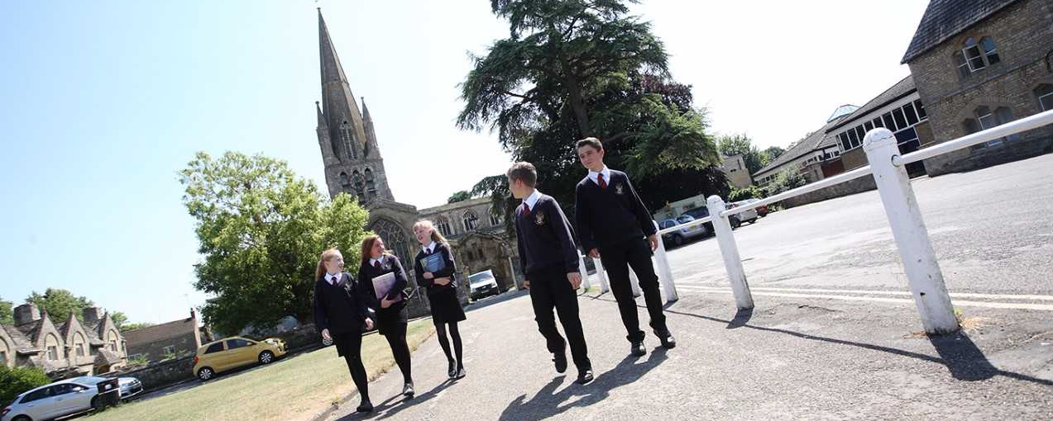

Performance and Creativity Faculty
The Music Department consists of two teachers within a Performance and Creativity faculty of five subjects, which includes Drama.
Music has always played an important part in the life of the school and we are looking for an energetic, enthusiastic and committed colleague to join the Music Department. Music is well established with GCSE and A Level courses and a broad extra-curricular programme. The department is well-resourced in a modern music centre.
All students in Years 7, 8 and 9 study Music for an hour a week and a group of up to 30 go on to GCSE each year. A level teaching is shared with the other secondary school in Witney, Wood Green.
The Music Department boasts 2 large teaching/rehearsal rooms, computer suite and A-level teaching room, along with 7 practise rooms and a recording studio. Both teaching rooms have enough keyboards for a Key Stage 3 class to work in pairs and an equal number of tuned and un-tuned percussion instruments.
The department has a rich and varied extra-curricular life and apart from the performances at school, there are several opportunities each year to play or sing out in the community (eg primary school fayres, Lord Mayor’s reception etc.).
The Department runs an orchestra, swing band, string group, senior and junior choirs, all of which are well attended by students in all year groups. Students in all year groups are also encouraged to make music independently during lessons and at lunchtimes. The Music Department also puts on a musical production every other year in collaboration with the Drama Department and has, in the recent past, produced ‘Jesus Christ Superstar’, ‘Beauty and the Beast’ and ‘Oliver’. Students take part in many concerts throughout the year, including a Christmas Celebration, Key Stage 4 Concert and a Summer Concert. In addition, the department has organised several very successful foreign tours for students of all ages.
The Oxfordshire LA Music Service supports the school with peripatetic instrumental tuition and a significant number of our students are involved in Saturday Music Schools and in the County Youth Orchestras and Choir.
We are looking for an inspiring teacher with good classroom skills who possesses energy and drive to satisfy the enthusiasm of our students and harness and develop their talents in all sorts of music.
Drama plays a significant role in the life and ethos of the school. It is taught as a standalone subject throughout Key Stages 3, is a GCSE option at KS4 and an A Level option at KS5. Our students follow the AQA specifications at both GCSE and A Level.
We believe that Drama offers students the chance to develop imaginatively, physically and artistically. Besides confidence building and the exploration of the important values in social, moral, spiritual and cultural education, Drama provides students with the opportunity to develop higher level thinking skills, analytical skills, social and communication skills, creative thinking, problem solving, emotional intelligence and the general knowledge of how to make sense of themselves and the world around them. All of these skills are of benefit in other areas of the curriculum and to their future working life!
Students have one sixty minute lesson of Drama per week throughout Key Stage 3 where they are introduced to the various disciplines of Drama and Theatre Arts, with direct links to the demands of GCSE. Schemes of work explore both vocal and physical skills, dramatic techniques and live theatre evaluation. Our aim is to encourage students to experiment so that they become confident in these areas, lose the ‘fear of being wrong’ and to use the vocabulary of Drama to evaluate the work of others and themselves.
Alongside the subject lessons, we have a large number of students who dedicate themselves to taking part in enrichment activities including school shows, Drama clubs, and theatre trips. Regular events in the school calendar are the whole school musical, Rock Challenge and the ‘Bard @ the Box’ Shakespeare festival all taking place in alternate years. The musical is a joint project with the music department; in recent years these have included Jesus Christ Superstar, Beauty & the Beast & Oliver!, with High School Musical coming up in 2018. In addition to productions, the department hasY7 & Y8 Drama clubs taking place on a Tuesday & Thursday lunch time respectively, which are run by our GCSE (Y10) Drama Ambassadors. The department also ensures that each year group has the opportunity to attend a theatre trip each year.
The faculty benefits from having a large Drama Centre with standard lighting system and dimmer board. There is a small office and a large cupboard for costumes and props. There are also rostra blocks, small staircases, flats, a wide variety of texts, and a projector. The second Drama teaching room adjoins the school hall which has a traditional school stage, equipped with a full lighting and sound system.
The faculty currently consists of two specialist Drama teachers and one non-specialist. The department works very closely, giving mutual support through discussion and the sharing of resources.

Selection Criteria

Essential
- Qualified Teacher Status
- Ability to teach KS3, KS4 and KS5
- Effective behaviour management
- Ability to work as part of a team
- Knowledge of planning, assessment and record-keeping
- Commitment to further training and development
- Conscientious, enthusiastic and positive
- The ability to relate well to students, staff and parents
- Willingness and ability to be an effective tutor, if required

Desirable
- Ability to teach KS5
- Willingness to teach PSHE
- Willingness to contribute to extra-curricular activities
- Evidence of improving practice by identifying and meeting CPD needs

JOB DESCRIPTION: TEACHER (MPR and UPR)

Post Title: Teacher of Music with the ability to teach Drama
Purpose: To raise standards of attainment and achievement of learners

Reporting to: Faculty Leader and Assistant Faculty Leader where appropriate

This job description should be read in conjunction with the current School Teachers’ Pay and Conditions Document and the provisions of that document will apply to the post holder. You will be expected to carry out the professional duties of a teacher as outlined in the School Teachers’ Pay and Conditions Document currently in operation, or any subsequent legislation.

Liaising with: School Leaders, Faculty Leaders, House Leaders and relevant staff with cross-school responsibilities, relevant support staff

Working Time: Full Time Disclosure Level: Enhanced
Salary: TMR/UPR

TEACHING

SET HIGH EXPECTATIONS WHICH INSPIRE, MOTIVATE AND CHALLENGE PUPILS
- establish a safe and stimulating environment for pupils, rooted in mutual respect
- set goals that stretch and challenge pupils of all backgrounds, abilities and dispositions
- demonstrate consistently the positive attitudes, values and behaviour which are expected of pupils

PROMOTE GOOD PROGRESS AND OUTCOMES BY PUPILS
- be accountable for pupils’ attainment, progress and outcomes
- be aware of pupils’ capabilities and their prior knowledge, and plan teaching to build on these
- guide pupils to reflect on the progress they have made and their emerging needs
- demonstrate knowledge and understanding of how pupils learn and how this impacts on teaching
- encourage pupils to take a responsible and conscientious attitude to their own work and study

DEMONSTRATE GOOD SUBJECT AND CURRICULUM KNOWLEDGE
- have a secure knowledge of the relevant subject(s) and curriculum areas, foster and maintain pupils’ interest in the subject, and address misunderstandings
- demonstrate a critical understanding of developments in the subject and curriculum areas, and promote the value of scholarship
- demonstrate an understanding of and take responsibility for promoting high standards of literacy, articulacy and the correct use of standard subject content, whatever the teacher’s specialist subject
- if teaching early reading, demonstrate a clear understanding of systematic synthetic phonics
- if teaching early mathematics, demonstrate a clear understanding of appropriate teaching strategies

PLAN AND TEACH WELL STRUCTURED LESSONS
- impart knowledge and develop understanding through effective use of lesson time
- promote a love of learning and children’s intellectual curiosity
- set homework and plan other out-of-class activities to consolidate and extend the knowledge & understanding pupils have acquired
- reflect systematically on the effectiveness of lessons and approaches to teaching
- contribute to the design and provision of an engaging curriculum within the relevant subject area(s)

ADAPT TEACHING TO RESPOND TO THE STRENGTHS AND NEEDS OF ALL PUPILS
- know when and how to differentiate appropriately, using approaches which enable pupils to be taught effectively
- have a secure understanding of how a range of factors can inhibit pupils’ ability to learn, and how best to overcome these
- demonstrate an awareness of the physical, social and intellectual development of children, and know how to adapt teaching to support pupils’ education at different stages of development
- have a clear understanding of the needs of all pupils, including those with SEN; those of high ability; those with EAL; those with disabilities; and be able to use and evaluate distinctive teaching approaches to engage and support them

MAKE ACCURATE AND PRODUCTIVE USE OF ASSESSMENT
- know and understand how to assess the relevant subject and curriculum areas, including statutory assessment requirements
- make use of formative and summative assessment to secure pupils’ progress
- use relevant data to monitor progress, set targets, and plan subsequent lessons
- give pupils regular feedback, both orally and through accurate marking, and encourage pupils to respond to the feedback

MANAGE BEHAVIOUR EFFECTIVELY TO ENSURE A GOOD AND SAFE LEARNING ENVIRONMENT
- have clear rules and routines for behaviour in classrooms, and take responsibility for promoting good and courteous behaviour both in classrooms and around the school, in accordance with the school’s behaviour policy
- have high expectations of behaviour, and establish a framework for discipline with a range of strategies, using praise, sanctions and rewards consistently and fairly
- manage classes effectively, using approaches which are appropriate to pupils’ needs in order to involve and motivate them.
- maintain good relationships with pupils, exercise appropriate authority, and act decisively when necessary

FULFIL WIDER PROFESSIONAL RESPONSIBILITIES
- make a positive contribution to the wider life and ethos of the school
- develop effective professional relationships with colleagues, knowing how and when to draw on advice and specialist support
- deploy support staff effectively
- take responsibility for improving teaching through professional development, responding to advice & feedback from colleagues
- communicate effectively with parents with regard to pupils’ achievements and well-being

PERSONAL & PROFESSIONAL CONDUCT
- Uphold public trust in the profession and maintain high standards of ethics and behaviour, within & outside school
- treating pupils with dignity, building relationships rooted in mutual respect, and at all times observing proper boundaries appropriate to a teacher’s professional position
- having regard for the need to safeguard pupils’ well-being, in accordance with statutory provisions
- showing tolerance of and respect for the rights of others
- not undermining fundamental British values, including democracy, the rule of law, individual liberty and mutual respect, and tolerance of those with different faiths and beliefs
- ensuring that personal beliefs are not expressed in ways which exploit pupils’ vulnerability or might lead them to break the law.
- Have proper and professional regard for the ethos, policies and practices of the school in which they teach and maintain high standards in their own attendance and punctuality
- Have an understanding of, and always act within, the statutory frameworks which set out their professional duties and responsibilities.

In addition for UPR (STPCD)
- the teacher is highly competent in all elements of the relevant standards
- the teacher’s achievements and contribution to an educational setting or settings are substantial and sustained

General Responsibilities
- taking appropriate responsibility for one’s own health, safety and welfare and the health and safety of pupils, visitors and work colleagues in accordance with the requirements of legislation and locally-adopted policies; including taking responsibility for raising concerns with an appropriate manager

Additional duties
- play a full part in the life of the school community, to support its distinctive mission and ethos, and to encourage and ensure staff and students follow this example
- to promote and lead extra-curricular activities in line with the traditions and expectations of the school within the context of a life work balance

Other Specific Duties
- undertake the role of Form Tutor if required
- share in supervisory duties according to the school’s published rotas
- keep up to date with school information e.g. the weekly bulletin, staff handbook and to clear your pigeon hole daily
- participate in any arrangements within an agreed national framework for the appraisal of your performance and that of other teachers
- continue personal development as agreed
- engage actively in the appraisal process
- whilst every effort has been made to explain the main duties and responsibilities of the post each individual task undertaken may not be identified
- employees will be expected to comply with any reasonable request from a line manager to undertake work of a similar level that is not specified in this job description
- employees are expected to be courteous to colleagues and to provide a welcoming environment to visitors and telephone callers
- the school will endeavour to make any necessary reasonable adjustments to the job and the working environment to enable access to employment opportunities for disabled job applicants or continued employment for any employee who develops a disabling condition.
- undertake any other duty as specified by STPCD not mentioned in the above

For all staff - You have specific responsibilities under Health & Safety / Child Protection legislation to ensure that you:

- take reasonable care for your own health and safety, and that of others affected by what you do, or do not do
- cooperate on all issues involving health and safety
- use work items provided for you correctly, in accordance with training and instructions
- do not interfere with or misuse anything provided for your health, safety or welfare
- report any health and safety concerns to your line manager as soon as practicable
- report any safeguarding children / child protection concerns to a senior member of staff
- attend safeguarding training as requested

This job description is current at the date shown, but, in consultation with you, may be changed by the Headteacher to reflect or anticipate changes in job commensurate with the grade or job title.

The Application Process
We are seeing to appoint the best possible candidate and our recruitment process will reflect our desire to undertake all possible measures to achieve this.

Applicants should download the teaching staff application form from our website.

In addition to the completed application form please submit a letter of application that is no more than two sides of A4.

All applications will be acknowledged upon receipt. Shortlisting will take place shortly after the closing date and candidates will be notified further only if they are successful in being shortlisted. The date for interviews and associated assessment activities will be confirmed in due course.

If you decide you want to be part of our dynamic team, we look forward to receiving your completed application form by our closing date.

Closing date: Thursday 19th November 2018 at 9am.

In the meantime, if you have any queries about this role, please do not hesitate to contact Abbie Muchecheti (HR Manager) on 01993 848166 Monday to Friday 8.00am – 4:00pm (email jobs@millacademy.co.uk).

