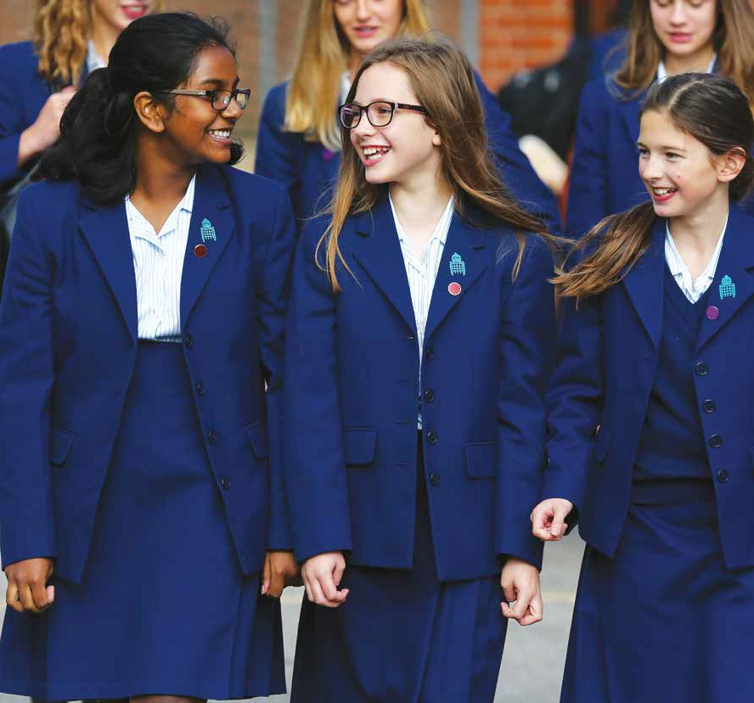






Teacher of French

Part Time
Maternity Cover (2 terms)

For September 2018

Information for Applicants

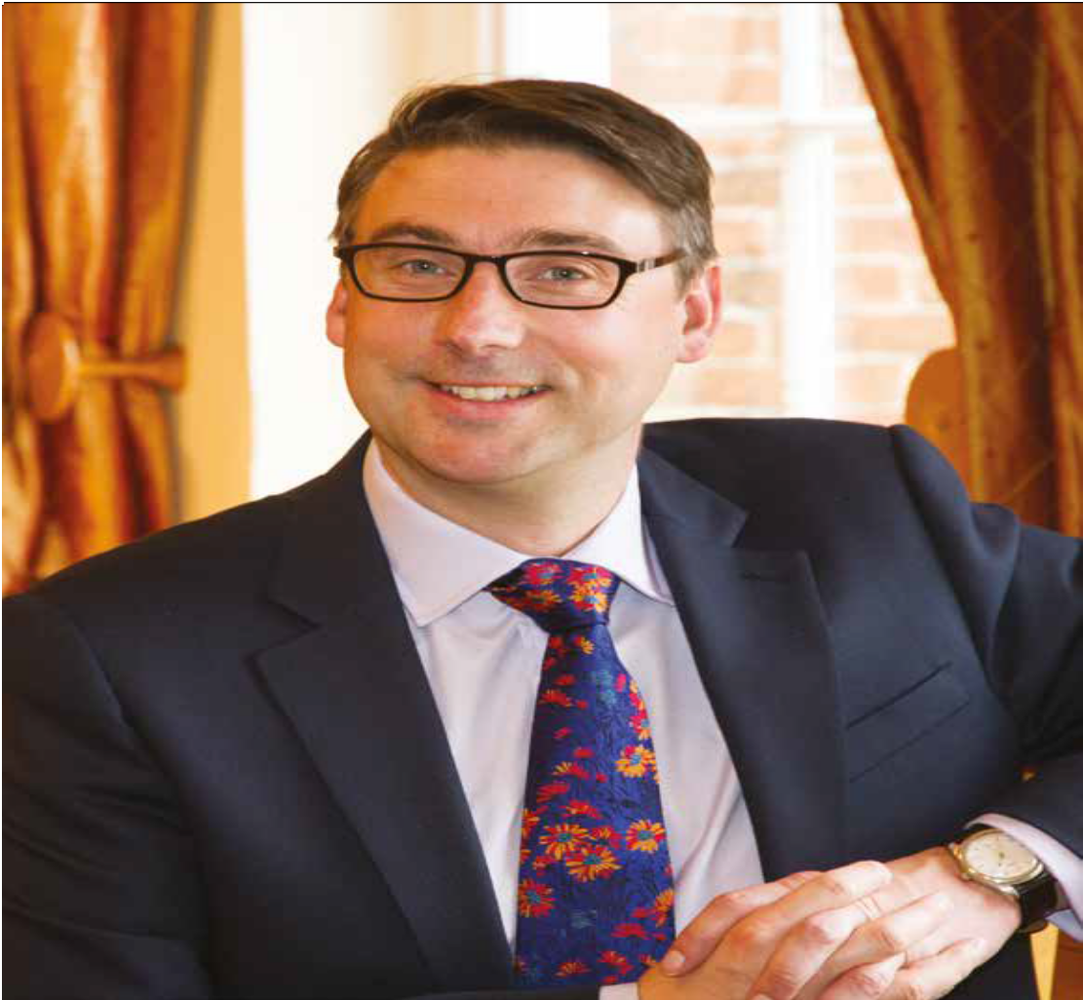



King’s High School

A message from the Head Master

I am delighted that you are taking the time to find out more about joining the King’s High community.

This brochure can only give you a glimpse of our wonderful school; however, I hope it conveys the exciting opportunities offered at King’s.

As a leading school for girls, we take pride in offering a broad and well-rounded education. The girls here are characterised by their commitment to their studies, the enjoyment they take in pursuing their extracurricular interest to the full, and the important contributions they make to the local and wider community.

King’s is an exceptionally dynamic and vibrant environment in which to work. Our expert staff show great commitment to the girls both in the classroom and in their wider endeavours, delighting in their many and varied successes.

I therefore very much hope that you will be inspired by what you discover about us and that you will wish to be a part of this exciting community; I look forward to receiving your application.



Richard Nicholson
Head Master

The School
Founded in 1879, King’s High School provides independent, single sex, day education for approximately 615 girls aged 11 to 18. The school is renowned for its friendly and welcoming atmosphere, founded on a distinguished academic tradition tailored to individual girl’s needs by a highly qualified and motivated staff. We pride ourselves on the outstanding academic and creative performance of our pupils.

We value friendship, involvement, intellect, creativity, spirit and maturity. Girls are encouraged to follow their interests and excel in subjects they enjoy. Our aim is for our girls to develop into happy, confident and compassionate young women with the ability to reason, analyse, learn independently and exercise good judgement.

The school has remained on the same town site in the heart of Warwick for 138 years. The main building, Landor House, is of historical interest. It is the birthplace of the writer Walter Savage Landor and remained in his family for 80 years before being given to the school in the late 19th Century.

Recent enhancements to our school site include: the Sixth Form Centre and St Mary’s Building (opened by Dame Judi Dench in 2006); the Creative Arts Centre (opened by Old Girl Catherine Bott in 2009) and the Dining Room (opened by Miss Prue Leith in 2011). In September 2012, we were pleased to begin using our newly refurbished food technology facilities and a new, additional, science laboratory. Most recently we have been extremely pleased to open our newly renovated library, which includes an Innovation Centre.

In September 2016, the Governors announced ‘Project One Campus’, a £30 million development which will see King’s High relocated to the Myton Road campus joining Warwick School and Warwick Prep School on the same site. It is planned that the new main school building along with the shared Sixth Form Centre will be completed for September 2019, with the remainder of the campus ready for September 2020. Please visit www.projectonecampus.co.uk for further information.

Please visit our website to find out more about the school: www.kingshighwarwick.co.uk

The Foundation
King’s High School and sister school Warwick Prep work as one school under a single leadership structure. Together with Warwick School we form the Warwick Independent Schools Foundation.

The Role

We are seeking to appoint an outstanding and innovative French teacher to join an ambitious and exciting department in a thriving school.

The successful candidate will be able to teach French to an extremely high standard in KS3 and KS4, inspiring a genuine interest in the subject, and contributing with enthusiasm to the busy co-curricular life of the department and school.

This is an excellent opportunity for a qualified and innovative practitioner to develop their skills in a successful department.

The candidate will be an excellent communicator with strong inter-personal skills. They will be articulate and tactful with excellent subject knowledge.

The role is part time and temporary maternity cover for September 2018. The successful candidate will be expected to teach approximately 0.4 of a timetable; over three or four days in the week.

The department enjoys excellent links to the schools within the Warwick Independent Schools Foundation and is extremely well resourced. The department consists of four full and six part-time teachers who work collaboratively to ensure the very highest standards of teaching and learning.

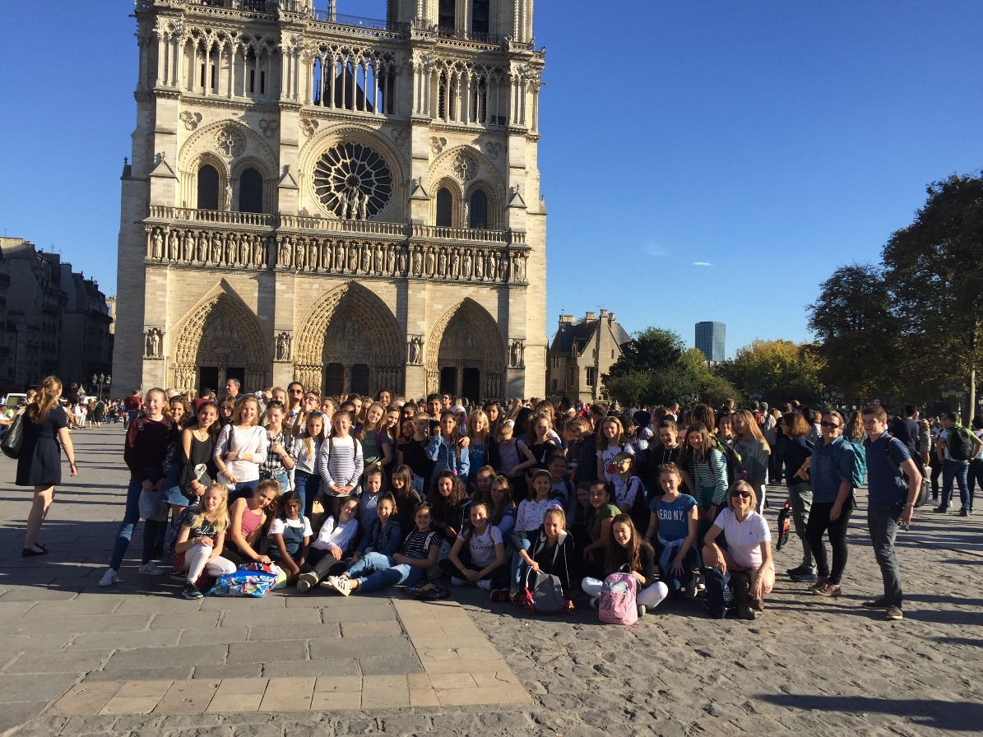

3

Job Description

Reporting to Head of Modern Foreign Languages the post holder is required:

- To plan, prepare and teach lessons as required by the department.
- To set homework and mark written work regularly and ensure that the correct procedures are followed.
- To supervise and mark school examinations and course work for public examinations.
- To assess, record and report on the development, progress and attainment of pupils and to communicate this information to parents via written reports and Parents’ Evenings.

- To review methods of teaching and programmes of work and participate in arrangements for further training and professional development.
- To contribute to departmental extra-curricular activities.
- To keep records of attendance at lessons as required.
- To encourage as much use as possible of the school libraries and other resources.
- To invigilate and undertake administration associated with public examinations.

- To maintain good order and discipline among pupils and safeguard their health and safety.
- To attend Departmental, Year, Staff, Parents’ and Inset meetings.
- To attend assemblies.
- To provide cover for absent staff, especially within the department, and to carry out other duties as required.
- To adhere to school policy on safeguarding and update training as required.
- To ensure the safeguarding and well-being of children and young people at the school in accordance with school policies.

Further Details

The Employer is the Warwick Independent Schools Foundation.

Salary
This is a part-time temporary position and the Warwick Independent Schools Foundation has its own salary scale and salary will be determined according to qualifications and experience.

Staff Lunches
Lunches are provided, free of charge.

Child Protection
The school’s Child Protection Policy is included in this pack. An interview will include questions about safeguarding children. The appointment will depend on satisfactory DBS clearance.
The Warwick Independent Schools Foundation is committed to safeguarding and promoting the welfare of children and young people and expects all staff and volunteers to share this commitment. Any concerns should be reported in accordance with the Foundation’s Child Protection policy.

Safeguarding
All staff are required to:
- adhere to the School Policy on safeguarding and undertake training as required;
- ensure the safeguarding and well-being of children and young people at the school, in accordance with School policies.

Appointment Method
Interviews and lesson
Appointment Timetable
31 January 2017 (12 noon)
Deadline for submission of applications (on the standard application form)

ASAP thereafter
Notification of outcome to short-listed candidates & interviews

The Application Form
This must be completed in full before the application can be considered. Any discrepancies or anomalies in the information provided or issues arising from references will be discussed at the interview.
If you have any queries about the completion of the form, please contact Mrs Diane Ralphs (Head Master’s PA) d.ralphs@kingshighwarwick.co.uk

Enclosures
- Application Form
- Equal Opportunities Policy
- King’s High School Child Protection Policy
- Recruitment of Ex-Offenders Statement

Person Specification

 | Essential |  | Desirable | Method of  assessment
Qualifications | - A highly qualified graduate  - Qualified Teacher Status or a willingness to achieve this. |  | - Additional qualifications at a higher level | Contents of the Application Form  Copies of qualifications.
Experience | - Outstanding classroom practitioner  - Background of teaching very able pupils with significant success. |  | - Teaching in a selective academic school  - Experience of teaching girls  - Teaching at KS3 and KS4 | Contents of the Application Form  Interview  Professional references
Skills | - Ability to communicate effectively, in clear English, with colleagues, pupils and parents, including in written reports.  - Effective behaviour management strategies.  - Differentiation  - Ability to prioritise and make decisions  - Excellent time management and organisational skills  - Outstanding use of ICT in the classroom and to develop resources |  |  | Contents of the Application Form  Interview  Professional references
Knowledge | - Up to date knowledge of ICT specifications and pedagogy  - Subject knowledge of the highest order including VB.net and Python programming languages  - Understanding of the factors that influence girls’ learning |  | - Understanding of how to use Assessment for Learning to develop pupils into independent learners  - Up to date knowledge of ISI requirements for subject departments | Contents of the Application Form  Interview  Professional references
Personal competencies and qualities | A wholly professional attitude to include:  - Commitment to high standards and achievement and to raising these standards  - Commitment to own professional development  - Support for school aims and policies  - Ability to lead the invigilation team  - Ability to be positive and enthusiastic  - Ability to cope with pressure/ workload  - Tact and discretion, Loyalty, initiative, flexibility  - Adaptability, confident and dependable  - Soundness of judgement  - Time management | - Demonstrate being articulate, presentable, co-operative, reliable, customer responsive with a “can do” attitude with good communication skills both on phone and in person that allows effective communication at all levels  - Creates good rapport with staff parents and pupils Ability to prioritise  - Ability to organise self and work independently  - Ability to listen  - Ability to work in a team  - Sense of humour |  | Interview  Professional references  Task performance
Safeguarding Children, Young People and Vulnerable Adults | - A commitment to the safeguarding and well-being of children and young people at  the school, in accordance with school’s policies  - A willingness to adhere to the school’s policy on safeguarding and to undertake  training as required |  |  | Contents of the Application Form  Interview  Professional references  Successful DBS Clearance

Although Qualified Teacher Status is preferred, we would also welcome applications from NQTs and subject specialists. They should be able to demonstrate their potential to attain the skills detailed below and if appointed would be supported by the School to complete their professional qualifications.



Independent Day School for Girls 11 – 18 years
King’s High School, Warwick CV34 4HJ t: 01926 494485 f: 01926 403089
e: enquiries@kingshighwarwick.co.uk

www.kingshighwarwick.co.uk

