June 2017

Dear Applicant

Thank you for your enquiry regarding the post of Data Manager at Alexandra Park School. We are a confident, well-established learning community with an excellent reputation within the local area. We are consistently the most oversubscribed school in the Borough and our examination results are some of the best in North London. Our success is built on great staff. This is a key post in our school and recruiting and training the right person is important to us. The successful candidate will start with us in September and will work alongside our current Data Manager who will be retiring at the end of October. This period will provide a valuable opportunity to learn and understand our data and reporting systems.

Alexandra Park School is an exciting and rewarding place to work. There is very strong staff morale and a real commitment to ‘go the extra mile’ for our students. We are classed as an Outstanding School and we have also been designated a National Teaching School. More than 80% of our students leave with 5 good GCSEs including English and Maths and our progress is positive and our attainment is high. Our sixth form is classed in the top 5% for performance. For more information on the school do visit our website on www.alexandrapark.school

I look forward to receiving your application for this post by 26th June 2017 at midday. Please contact Sue Levi, HR Manager on 020 8826 4929 or email: slevi@alexandrapark.school if you require any further information or would like to visit the school. The successful candidate will be required to undergo pre-employment checks and an enhanced DBS check.

Please note, we reserve the right to bring the deadline forward depending on application numbers; therefore, we would urge candidates to submit an application as early as possible. If you are shortlisted for interview, we will contact you by telephone or email. We regret that we cannot acknowledge every application.

Good luck with your application and thank you for considering Alexandra Park School.

Yours sincerely
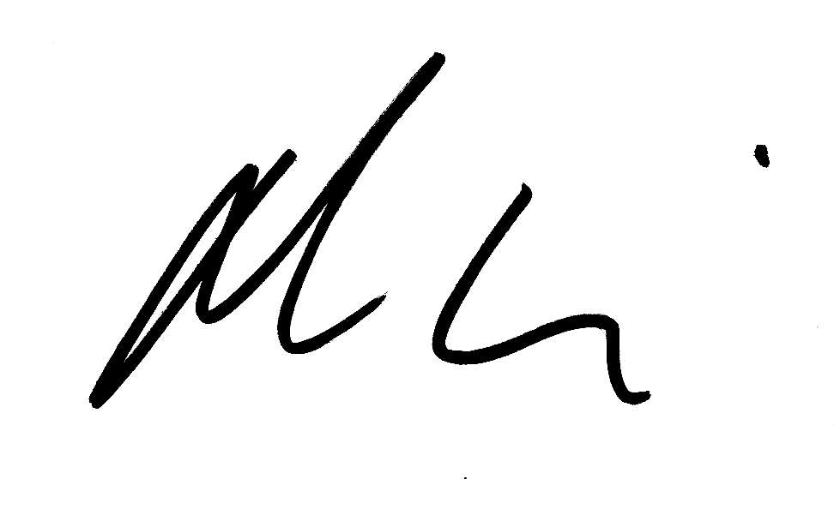

Michael M^{c}Kenzie
Headteacher

