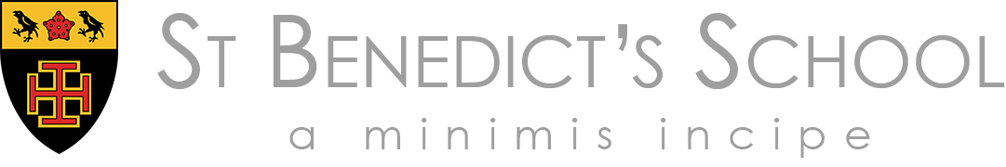

Teacher of Physics

The Post

The post becomes vacant in September 2019.

The successful candidate will be:

- a graduate in Physics or a related discipline and will preferably hold qualified teacher status
- able to demonstrate a proven record of excellence in the classroom practice
- expected to teach throughout the school up to and including A level
- ambitious, energetic, enthusiastic and able to plan independently and collaboratively for the further development of the department in line with the agreed aims of the school
- expected to work closely with the Director of Science to promote Physics both in and out of the classroom
- expected to have outstanding inter-personal skills and to command the respect of pupils, colleagues and parents
- empathetic to the Catholic and Benedictine ethos of the school
- contribute to the pastoral life of the school
- committed to his/her own professional development and, in particular, to the use of ICT as a tool for teaching and learning
- be expected to make a contribution to the co-curricular life of the school

Science at St Benedict’s

Teaching for the AQA GCSE course commences in Year 9 with each of the three sciences taught separately. In Year 9 pupils will have four lessons per fortnight in each science after which they are now able to choose which they wish to continue to study for GCSE. From September 2017, pupils in Year 10 and 11 will have six lessons per fortnight. All pupils in Years 7 and 8 are taught a co-ordinated science course by one of the science team in seven and six lessons per fortnight respectively. The CASE programme is also taught throughout these years.

The three Heads of Science, whilst having full autonomy for their own departments, work closely as team to ensure continuity for the pupils. There is also a Science Co-ordinator (for Years 7 and 8). The current Head of Physics, Chris Bowles, has the added responsibility of Director of Science.

A-level: Physics is a popular and successful option in the Sixth Form. On average 20-30 students choose the subject on an annual basis. There are usually two teaching groups in each of the year cohorts. Students follow AQA Physics for A-level.

Results at all levels are consistently high.

There are presently four full time physicists (including the Heads of Physics and Computing). In the wider Science Faculty there are four chemists and five biologists. Each department has its own full time technician.

All the science Laboratories and preparation rooms provide excellent facilities for teaching and learning. There are two labs dedicated to Physics. There are nine laboratories in total.

There is an extensive co-curriculum science programme. The School plays an active role in National Science and Engineering Week.

The School is situated conveniently to make use of the resources provided by museums and universities in London. There are Middle and Upper School trips to the Science Museum and the Natural History Museum. In addition, Sixth Form students attend seminars and lectures at the Royal Institute and other scientific institutions.

Please see our Recruitment Pack for a full description of the School’s Strategic Plan and significant opportunities for your professional development at St Benedict’s.

Remuneration

Applications are welcome from newly qualified, recently qualified or experienced teachers. Remuneration will depend on experience and qualifications, and will be reviewed annually.

The successful candidate will be required to sign a St Benedict’s School Contract. This will include the requirement of one full terms’ notice of departure. He/she will also be subject to the new Criminal Disclosure Regulations; a criminal record will not necessarily be a bar to obtaining the position.

Children of teaching staff are entitled to a fee discount.

Applications and Timetable

Candidates must apply using the enclosed application form. This must be completed in full and include the names, addresses and telephone numbers of TWO referees one of whom, if appropriate, should be your current employer.

Closing Date for completed applications: Wednesday 24th April 2019 at 12 noon.

Interviews will take place during w/c 29th April 2019 - if you have not heard by that time, you may assume your application has been unsuccessful.

The successful applicant will take up the post on 1st September 2019.

A visit to the School is welcome either before or after application. It can be arranged by phoning Mrs Ruth Wynne, the Headmaster’s PA on 0208 862 2010.

