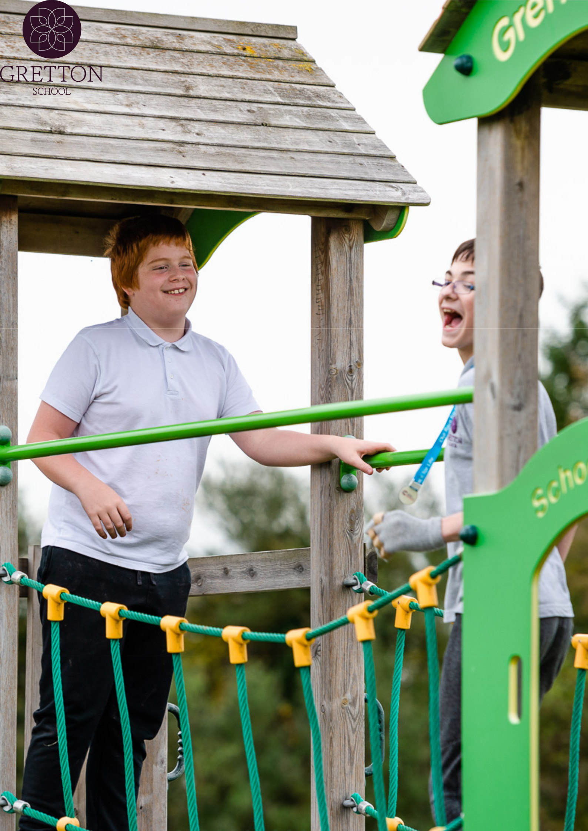

Deputy Designated Safeguarding Lead Recruitment Pack
About Gretton School

Gretton School welcomes autistic children and young people aged from 5-19 years old, as weekly boarders or as day students.

Every student at Gretton has a diagnosis of autism with the ability to achieve at high levels and every student is different.

As autism specialists, we understand that consistent daily routines and staffing helps to keep anxiety at a minimum and ensures that our students feel safe and confident in their surroundings

We have a high staff to student ratio and classes are small and personal – we know each of our students really well and employ the best strategies to support them in their everyday school life.

"Gretton is such a fun place to work, no two days are the same and there is a real family

vibe with all the staff that work here!"

- Boarding Staff

"Staff help each other and students interact. It's a happy little family!" - Teaching Staff
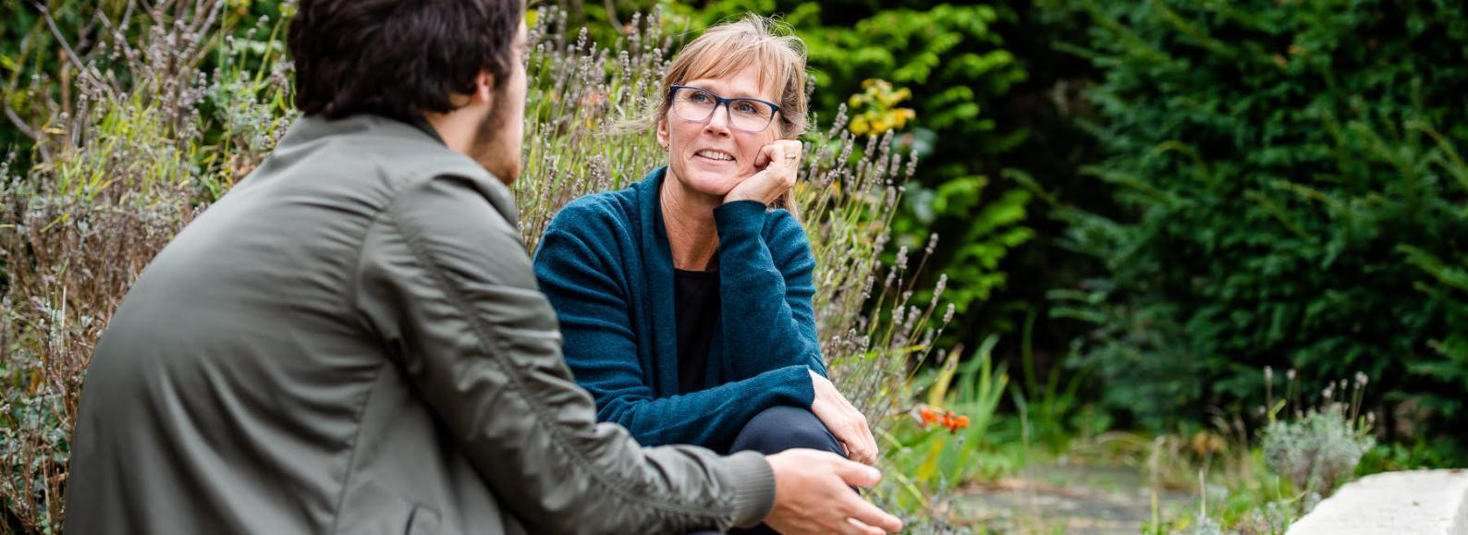
A Note from The Headteacher

Welcome to Gretton School; a forward thinking and inclusive autism specialist school where the children and young people are at the centre of everything the staff team do.

The team here at Gretton are highly skilled and trained in all aspects of their roles, particularly autism, and are actively supported by broad clinical and therapeutic disciplines ensuring a holistic approach to the achievement of wide ranging developmental, social, communicative, sensory and academic outcomes.

Gretton offers an integrated model of education, care and therapy which dovetail to ensure that students are challenged effectively to make their next steps whilst feeling safe and supported.

The breadth of experiences and curricula offered ensure that every student is able to maximise their progress and the facilities are specifically tailored with autism in mind. We have further plans to develop our campus environment to increase the offer of further specialist areas.

We are committed to equipping our students with independence, an awareness of safety and self-reliance, as well as developing the social skills they need to thrive in an ever more complex society.
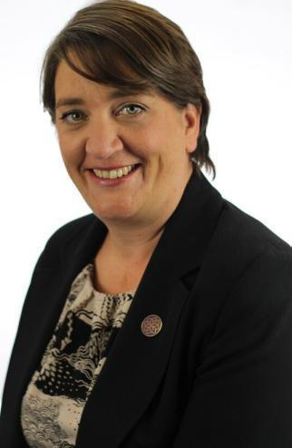

I hope that once you have read through this recruitment pack, you will arrange a visit to the school, where you can not only see, but feel the positive culture here at Gretton.

Beth Elkins
Job Description

Salary: £27,000 to £30,000, depending on experience

Hours: Monday - Friday, 8am-4pm (except Tuesdays to 5pm), Term Time only.

Start date: 27th August 2024

Aim of the post
The main purpose of this role is to support the Designated Safeguarding Lead by triaging and responding to all safeguarding and child protection matters arising at the school and supporting all other staff in dealing with any child protection concerns that arise.The Deputy Designated Safeguarding Lead will be responsible for mandatory recording, reporting and responding to duties on all matters relating to safeguarding, effectively and efficiently creating a culture of safety across the school in line with the most recent and updated national guidance. This role will report to the Designated Safeguarding Lead accordingly.
The Deputy Designated Safeguard Lead will attend meetings for identified children, represent the school’s views and positions and liaise with professionals, both internal and external to the school, in accordance with Safeguarding procedures.
The Deputy Designated Safeguard Lead will also support in the training of staff across school and uphold the principles outlined in the document ‘Keeping Children Safe in Education’, ensuring a quick response to any amendments and additions to this document as required.
The Deputy Designated Safeguard Lead will be responsible for the reporting on complex cases, where CAMHS might be involved, where there might be a Team around the Family or where the family are in receipt of Social Care support. They will be required to complete timely referrals and access external support for learners and their families. The Designated Safeguarding Lead will be required to prepare reports on matters relating to complex cases and ensure all stakeholders are kept informed.
Main Duties
In line with the most recent version of Keeping Children Safe in Education and the School’s Safeguarding and Child Protection Policies, the Deputy Designated Safeguarding Lead will:
Reporting
- The Designated Safeguarding Lead will be responsible for referring cases of concern or suspected abuse to the local authority children’s social care.
- The Deputy Designated Safeguarding Lead will be responsible for referring cases to the Channel programme where there is a radicalisation concern.
- Support the Designated Safeguarding Lead in referring cases to the Local Authority Designated Officer and/or the Disclosure and Barring Service where a person is dismissed or left due to risk or harm to a child.
- Support the Designated Safeguarding Lead in referring cases where a crime may have been committed to the police.
- Keep detailed, accurate and secure written records of concerns and referrals ensuring these are completed in a timely manner through our MyConcern platform.
- Ensure that all concerns reported through the Safeguarding procedures within school are handled with the utmost confidence and in line with mandatory safeguarding processes, working in conjunction with the Local Authority designated safeguarding teams and professionals, where required
- Ensure regular reporting of safeguarding cases to Designated Safeguarding Lead (and Headteacher in their absence) and participate in decision-making and actions where required to ensure the safeguarding of all children and young people within the school
Liaising with Staff and Professionals
- Support the Designated Safeguarding Lead in ensuring staff can access and understand the school’s child protection and safeguarding policy and procedures (especially new and part time staff)
- Participate in the multidisciplinary team within school, offering support from a safeguarding perspective and discuss cases accordingly at regular meetings.
- Support attendance monitoring from a safeguarding perspective and work with colleagues to ensure visibility and action for learners where this is a concern.
- In line with safeguarding procedures, lead on and complete Early Help Assessments (EHA), Social care referrals & CAMHS referrals. Where the EHA covers all members of the family, this may include liaison with other siblings’ schools/ pre-schools. This may require being the Lead Professional for the TAF/TAC (following on from the EHA) and attending additional meetings in order to ensure the correct support is in place for the family.
- Attend social care, Child Protection conferences and professional meetings
and liaise with outside agencies connected to students across the school.
- Follow up actions from professional meetings as above & liaise with class
staff.
- Guide staff to support parents with strategies regarding students’ needs at home.
- Act as a source of support, advice and expertise for staff.
- Support the Designated Safeguarding Lead, when required, by attending and contributing to child protection case conferences effectively when required to do so.
- Attend annual reviews where appropriate, Child in Need or Child Protection meetings to represent the safeguarding team and ensure sharing of information in relation to complex cases.

Continuous Professional Development
- Undergo regular training to develop and maintain the knowledge and skills required to carry out the role and as directed by the school.
- Refresh knowledge and skills at least annually so remain up to date with any developments relevant to the role.
- Obtain and seek access to relevant, up to date resources.
- Undertake Refresher Designated Safeguarding Lead training every 2 years as currently required.
- Ensure a clear understanding of Local Authority thresholds for all those that we work with.

Cross-school Responsibilities
- Maintain the schools MyConcern.
- Support the Designated Safeguarding Lead in ensuring the school’s child protection policies are known, understood and used appropriately.
- Work with the School Leadership Team to ensure the school child protection policy is reviewed annually (as a minimum) and the procedures and implementation are updated and reviewed regularly.
- Support the Designated Safeguarding Lead in ensuring the safeguarding policy is available and easily accessible to everyone in the school community.
- Support the Designated Safeguarding Lead in ensuring that parents have read the safeguarding policy, and are aware that referrals about suspected abuse or neglect may be made, and the role of the school in this.
- Link with the local safeguarding children board (LSCB) to make sure staff are aware of training opportunities and the latest local policies on safeguarding.
- Encourage a culture of listening to children among all staff, ensuring that children’s feelings are heard where the school puts measures in place to protect them.

Additional Duties Include:
- Be an identified First aider, with associated training updates as required.
- Be a Medication Administrator as part of wider school team.
- When learners arrive to or leave the school, work with the Designated Safeguarding Lead to securely receive or transfer their child protection/safeguarding file(s) from/to their new school as soon as possible, separately from the main pupil file.
- Support the school to follow best practice in Safer Recruitment.
- Assist the Designated Safeguarding Lead in producing safeguarding reports to the governing board.
- Model best practice and uphold the principles of confidentiality and data protection at all times.
- Any other duties commensurate with salary as required by the Designated Safeguarding Lead and School Leadership Team.

School wide responsibilities
- To understand and implement the duties and responsibilities arising from the Children Act 2004 and working together in relation to child protection and safeguarding.
- To report any concerns regarding safeguarding and child protection to the Designated Person immediately.
- To attend appropriate courses and disseminate skills learnt to the rest of the staff.
- To undertake such other duties and responsibilities that may be required from time to time.

Safeguarding recruitment statement
- Gretton School is committed to safeguarding and promoting the welfare of children and young people, and expects all staff to share this commitment.
- Applicants must be willing to undergo child protection screening, including enhanced checks with employers and the Disclosure & Barring Service.
- We aim to be a fair employer and are committed to equal opportunities. Gretton School does not discriminate against employees on the basis of any protected characteristic and actively welcomes a rich and diverse workforce.
Person Specification

 | Essential | Desirable
Experience, Skills and Knowledge | - A good honours degree or equivalent  - Experience of working with children and young people with a range of special educational needs  - Evidence of recent and relevant training and CPD linked to safeguarding and child protection  - Excellent and highly proficient ICT Skills, (Google Suite, Email, Databases) | - Direct work experience and a qualification with SEN/Autism education  - Knowledge and understanding of students with a PDA profile  - Working Knowledge of MyConcern
- Evidence of strong team work and collaborative working in a similar setting

- Excellent Communication Skills
- Excellent organisational skills

- Ability to respond efficiently and rapidly to safeguarding concerns and direct action and intervention in a timely manner to bring about action for change

- Experience of chairing meetings, preparing reports and presentations and analysing data

- Experience of attending and representing an organisation at Child in Need and Child Protection meetings

- Experience of managing Early Help referrals and cases to a satisfactory conclusion

- Able to demonstrate flexibility with working pattern based on the needs of the school at the time, specifically in relation to safeguarding referrals or serious concerns.

What Our Staff Say...

"I get out of bed every morning because of the young people I work with, but I stay in school through all the challenges because of the team of staff constantly acting as a safety net for each other. By working around staff who care about each other, students are invited into conversations and shown examples of positive relationships. I’ve never felt more supported, and I can’t recommend working here enough."

"The school is like a big family and I feel privileged to be part of it. The class sizes are very small and so we know each student as a person."

"It's a very personal place and therefore attracts very special people to work here. The staff are incredibly calm and caring and think carefully and creatively about how they can best help the students on their academic, social and emotional journeys."

"I have the utmost respect and admiration for our staff body who are the backbone and help make Gretton the special place that it is.”

"Not only does the school provide great challenges and opportunities for teachers in terms of curriculum development and planning but also it provides a great sense of pride and achievement in your work. In the twenty years that I’ve been a teacher, I’ve not worked anywhere where you feel so valued for your skills and ideas."
