

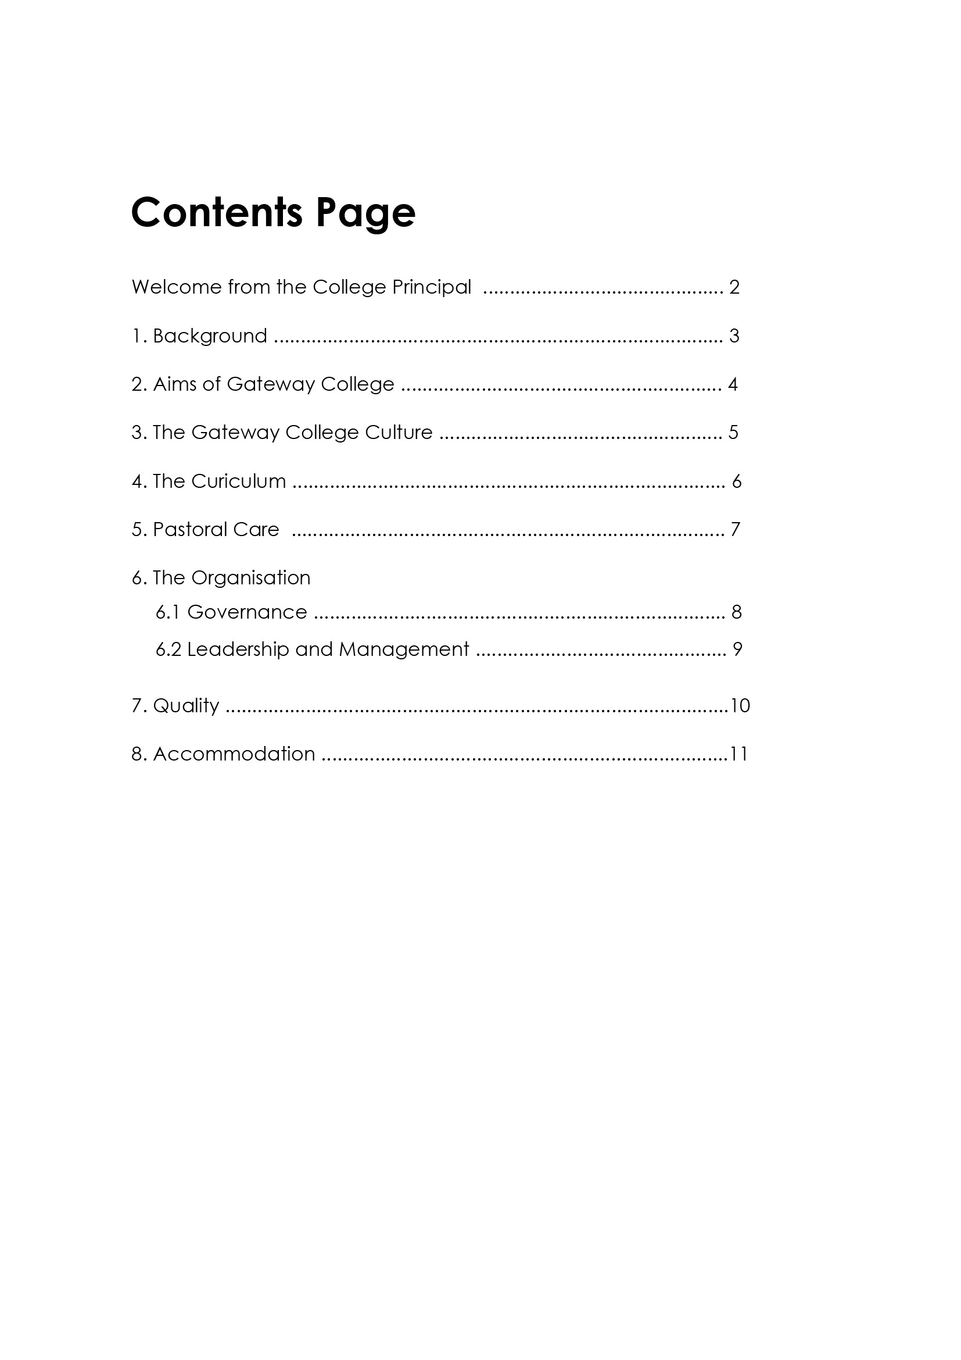

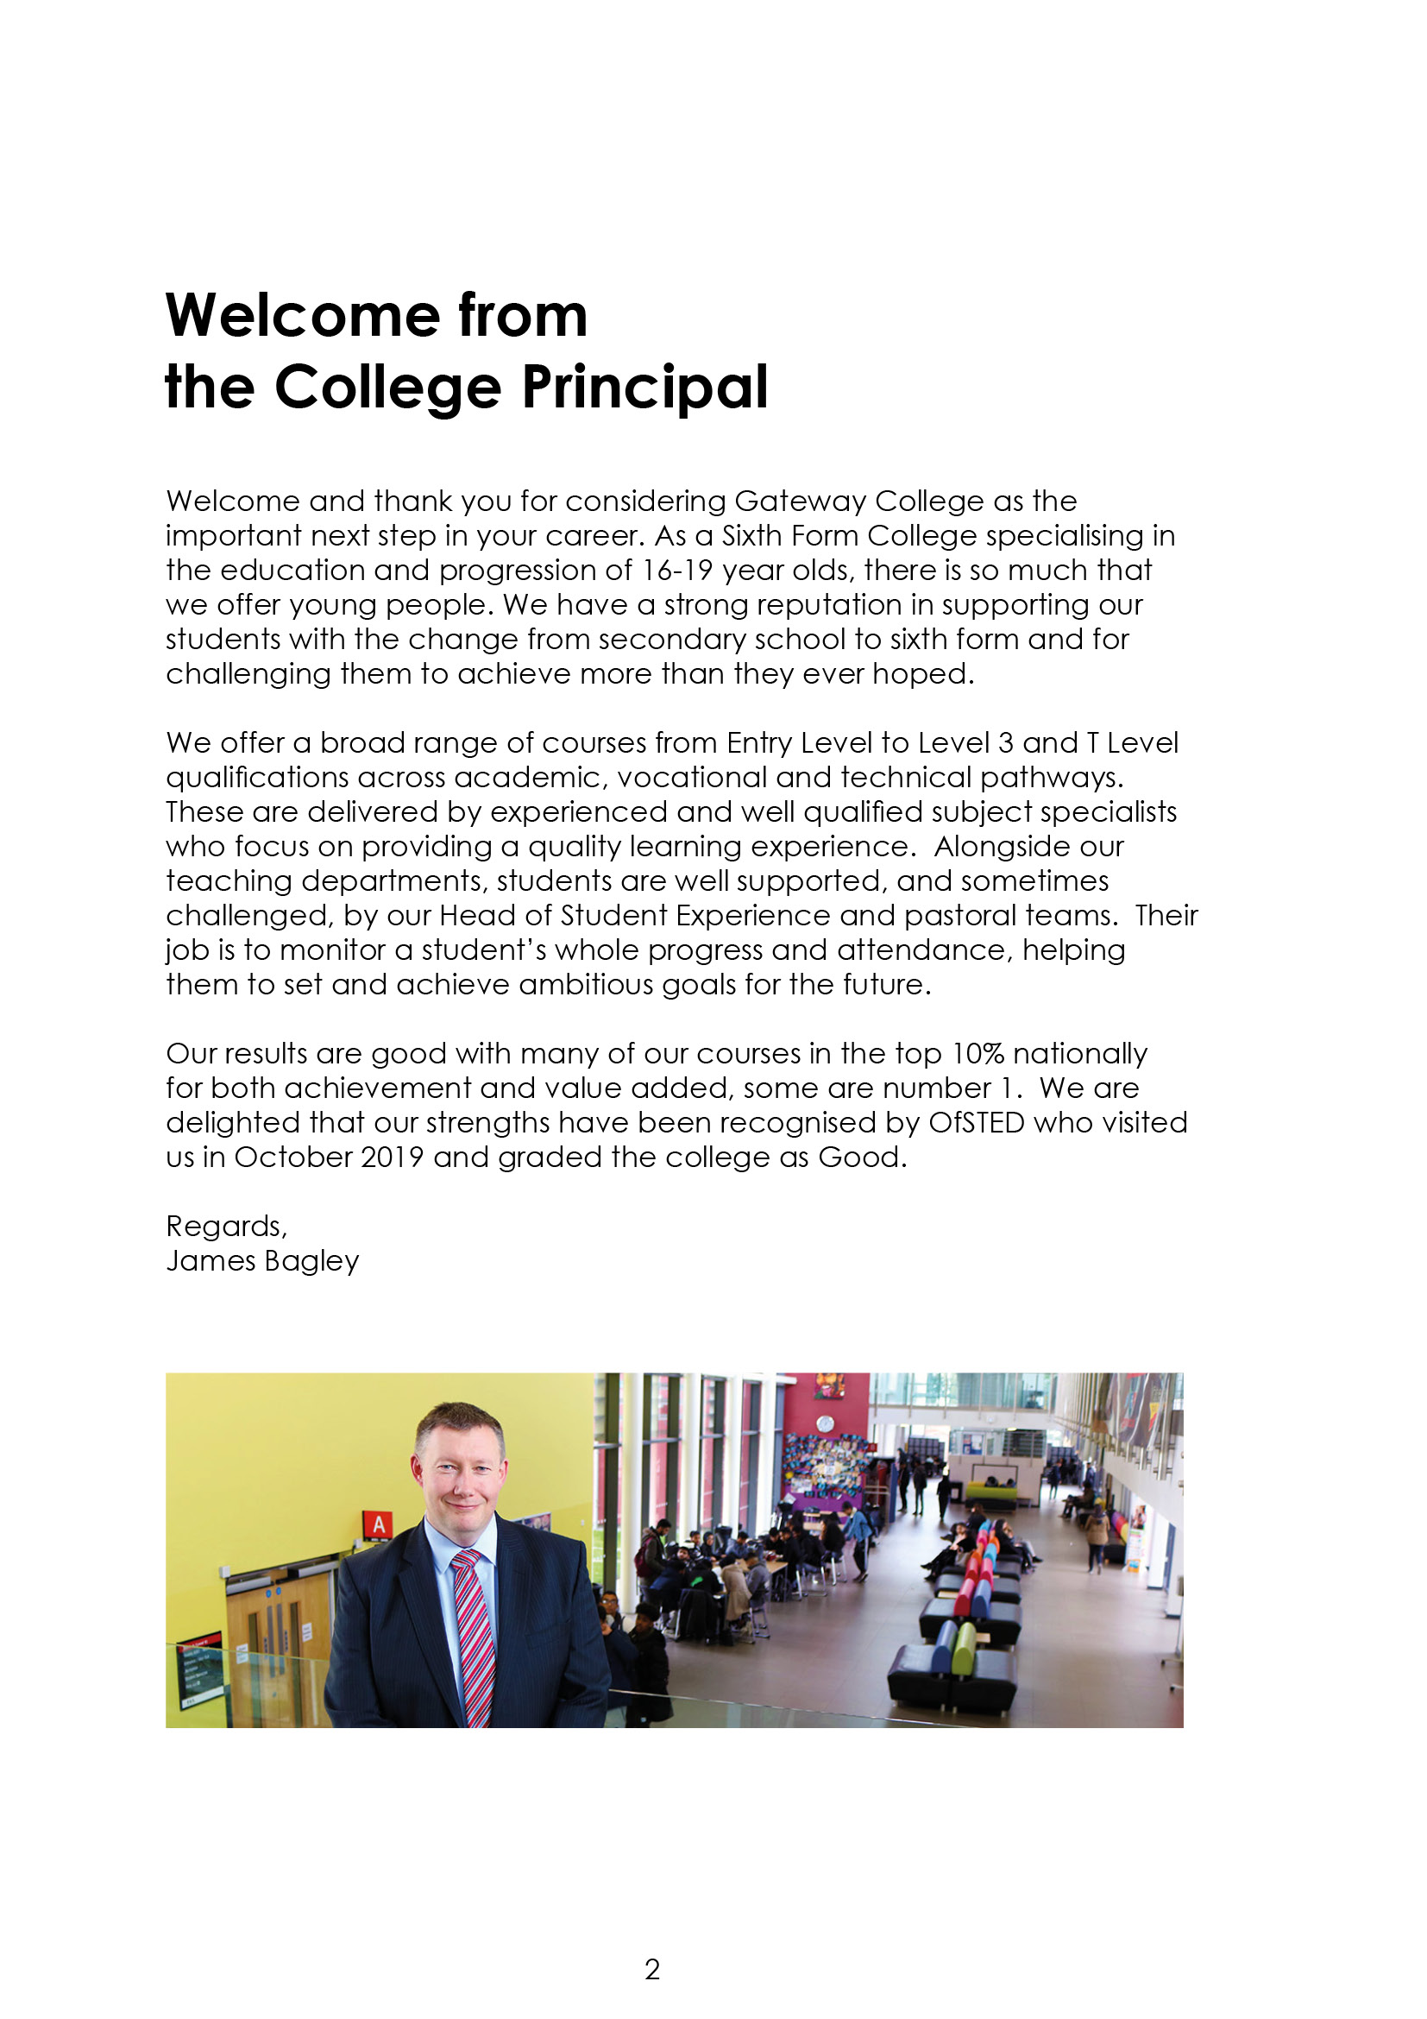

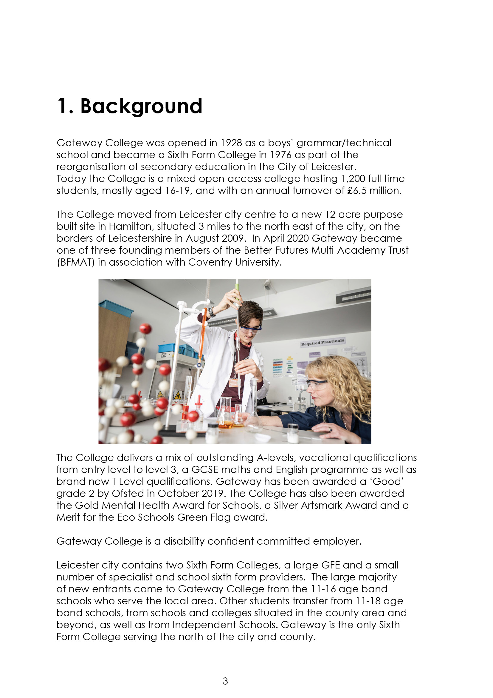

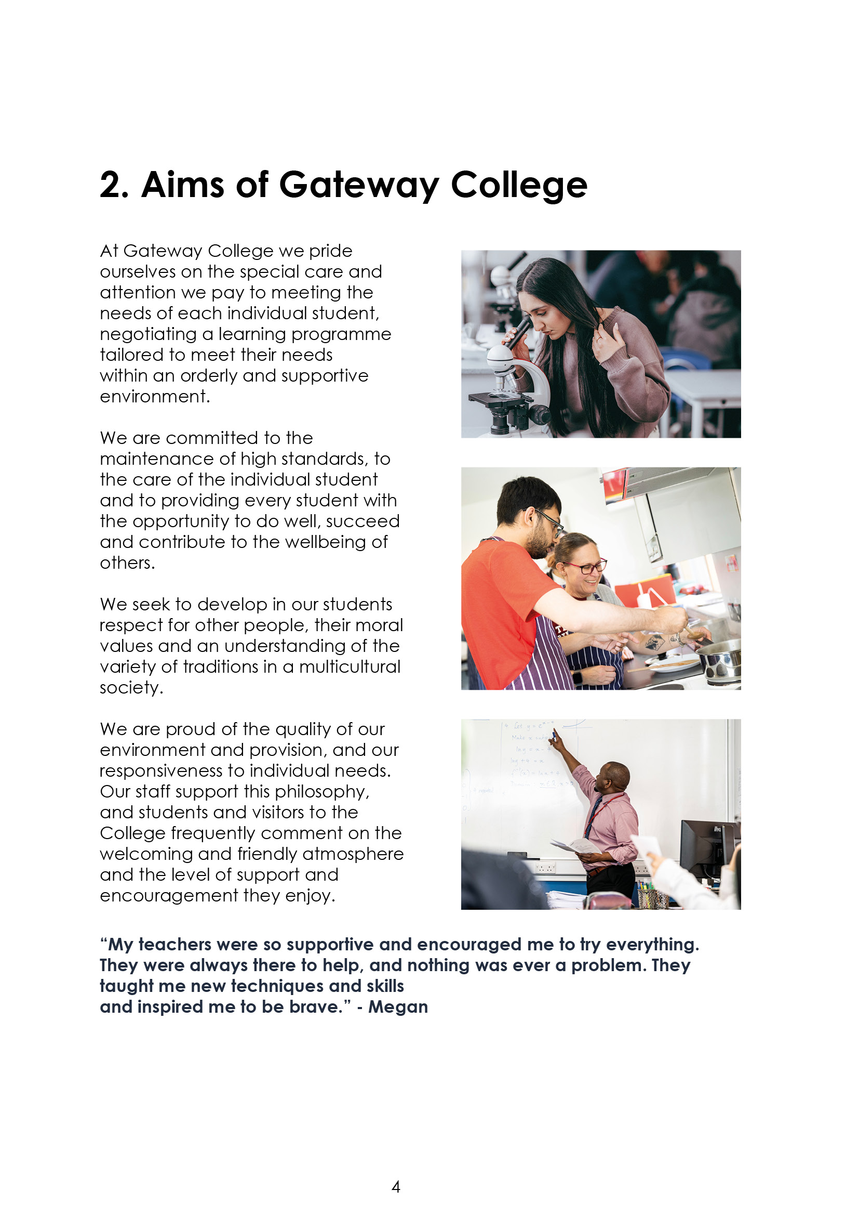

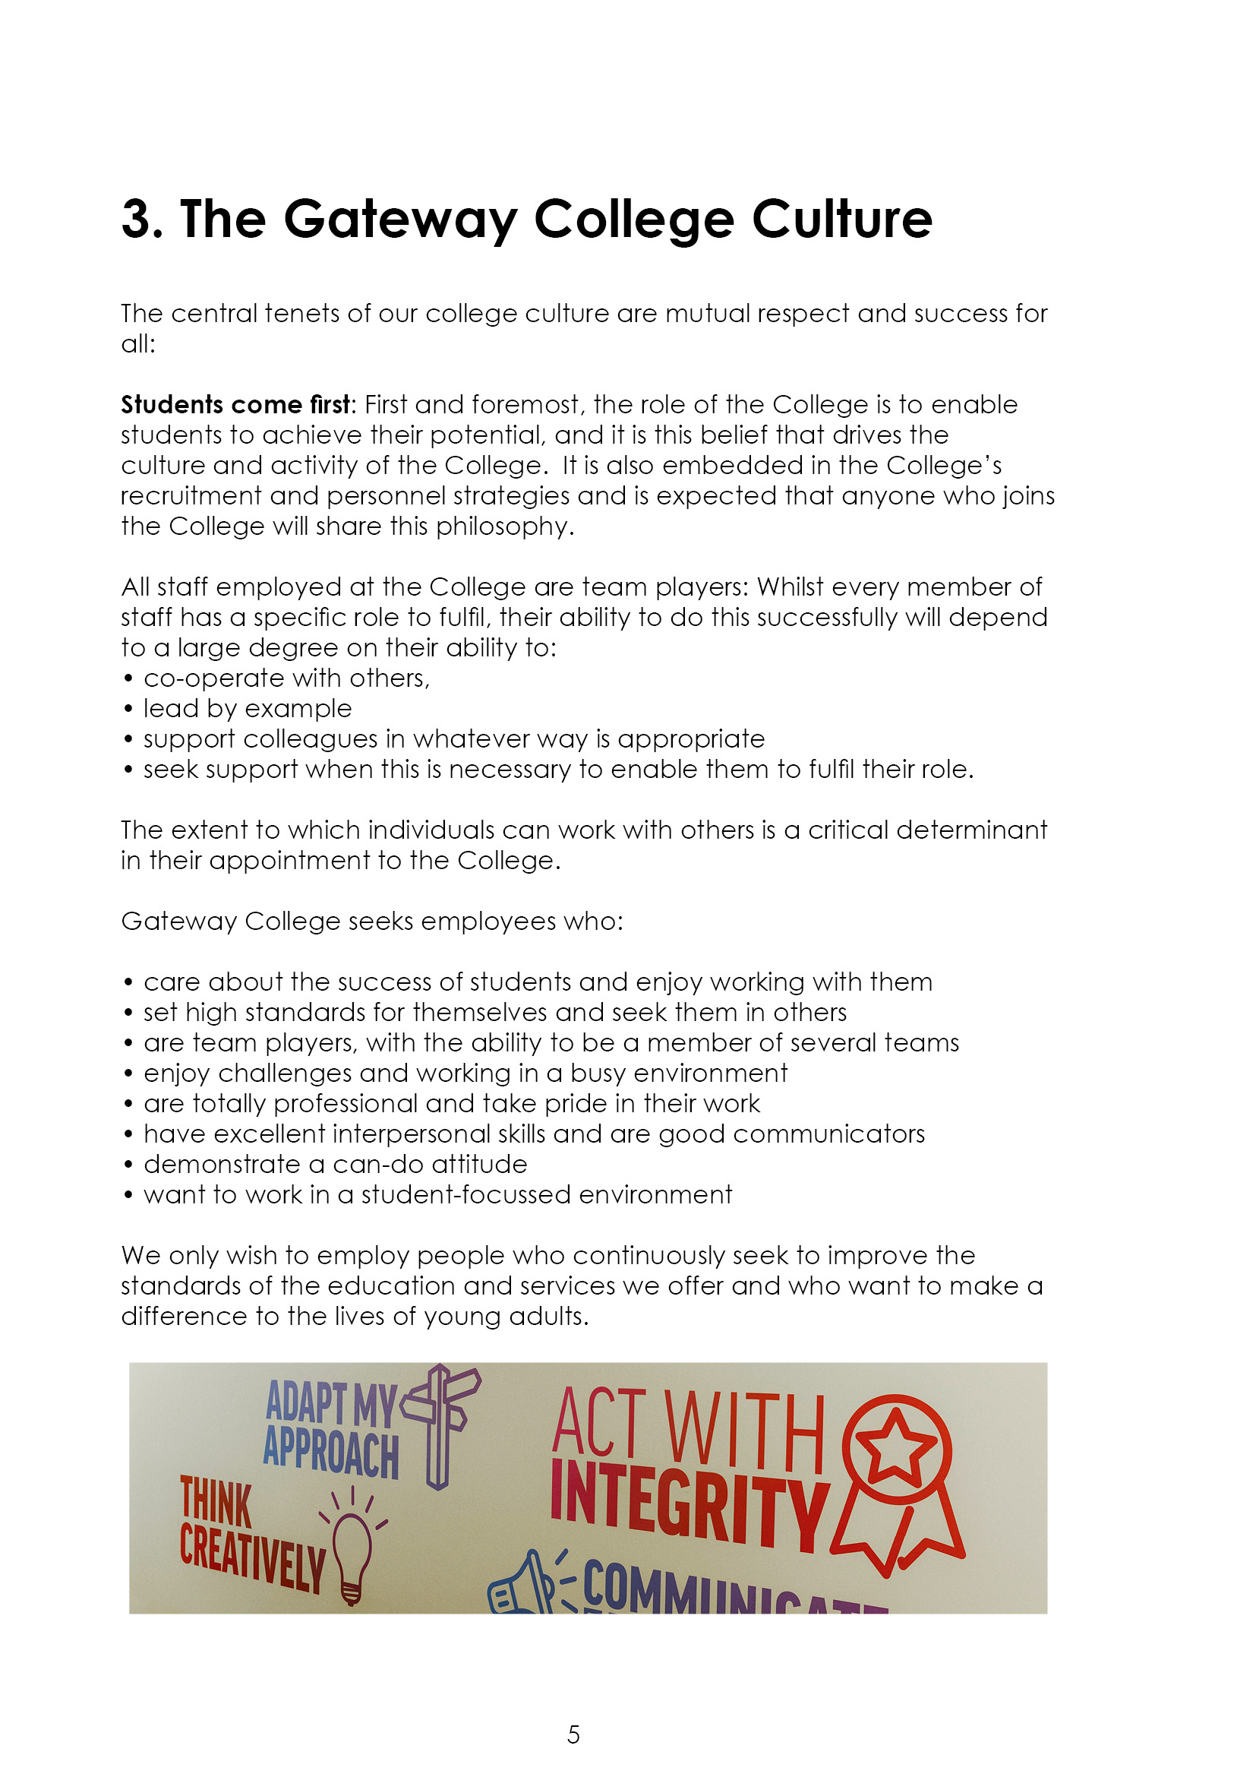





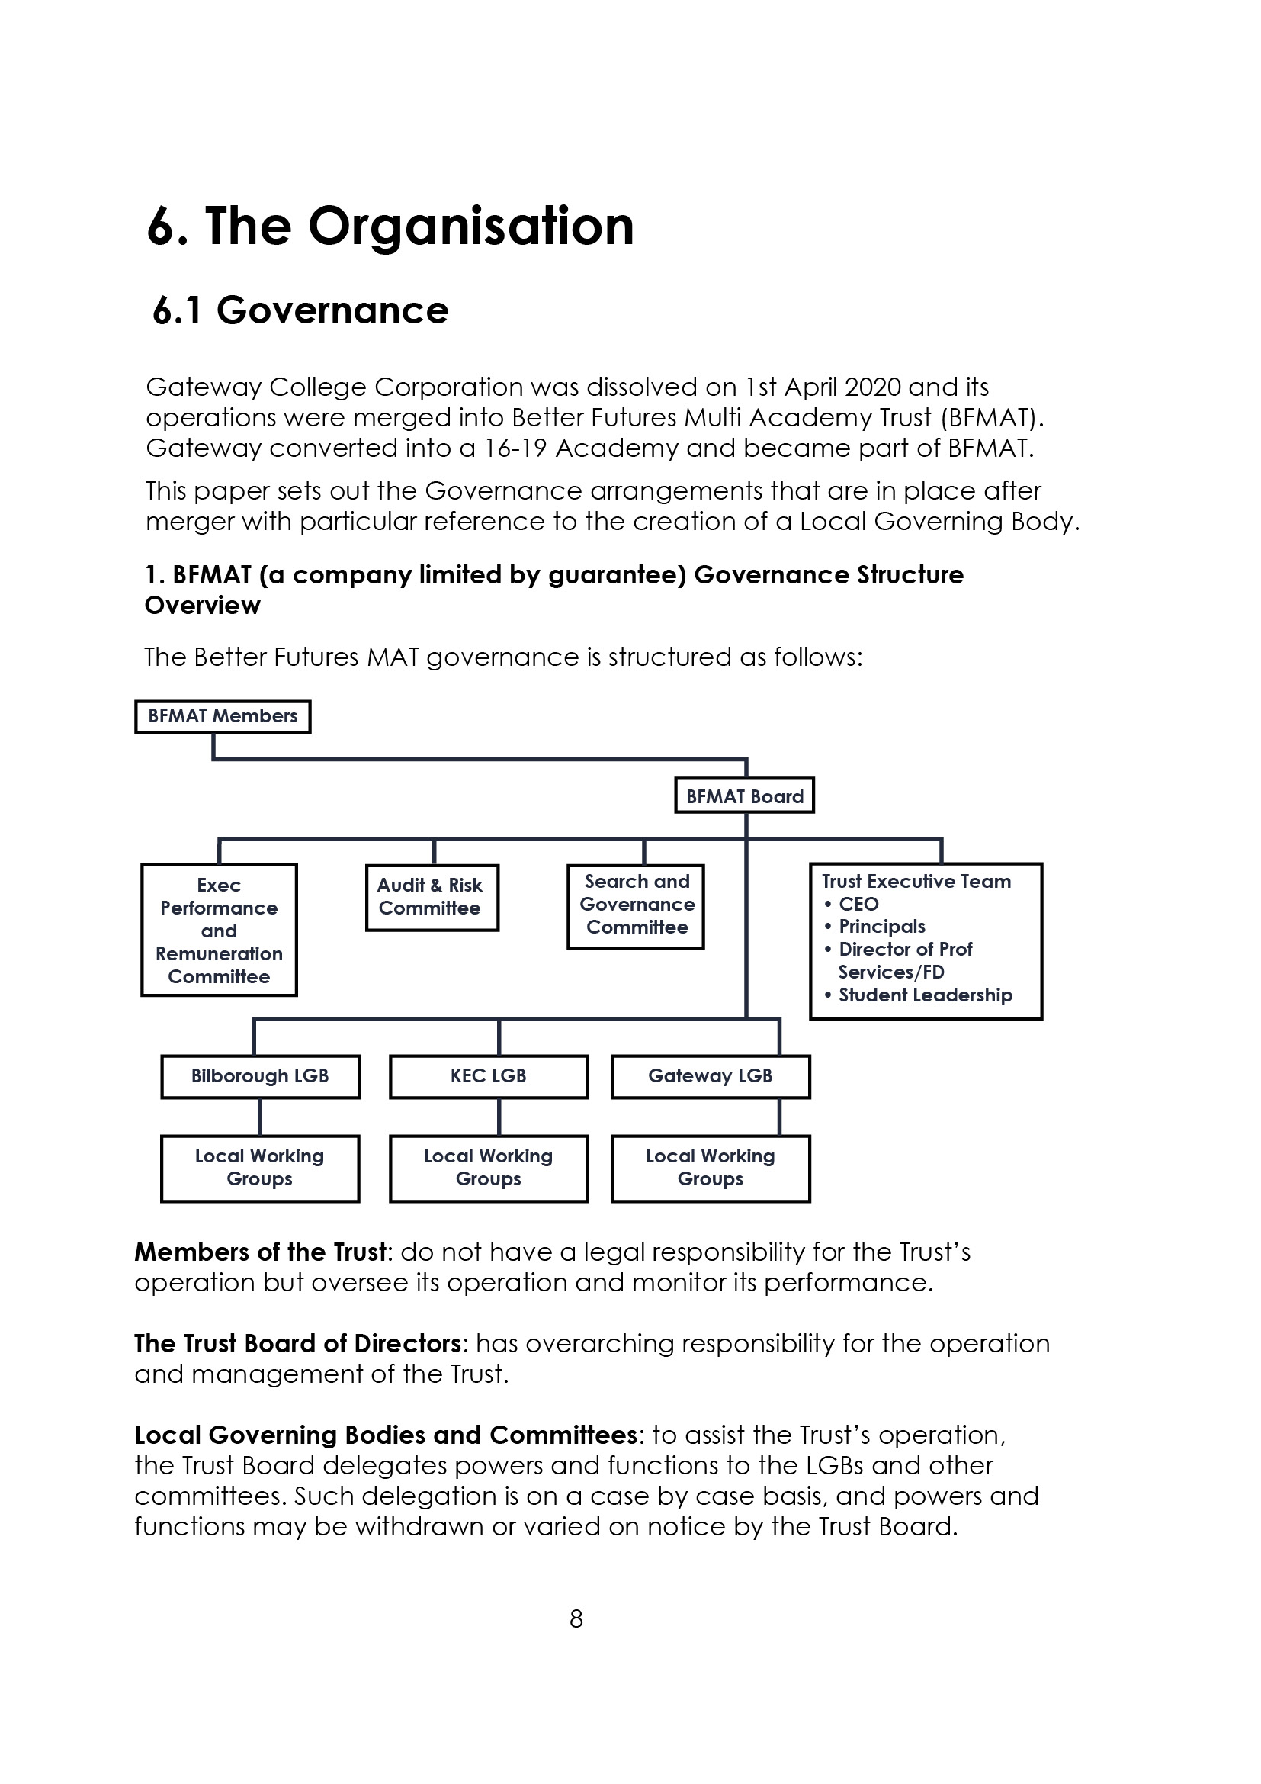



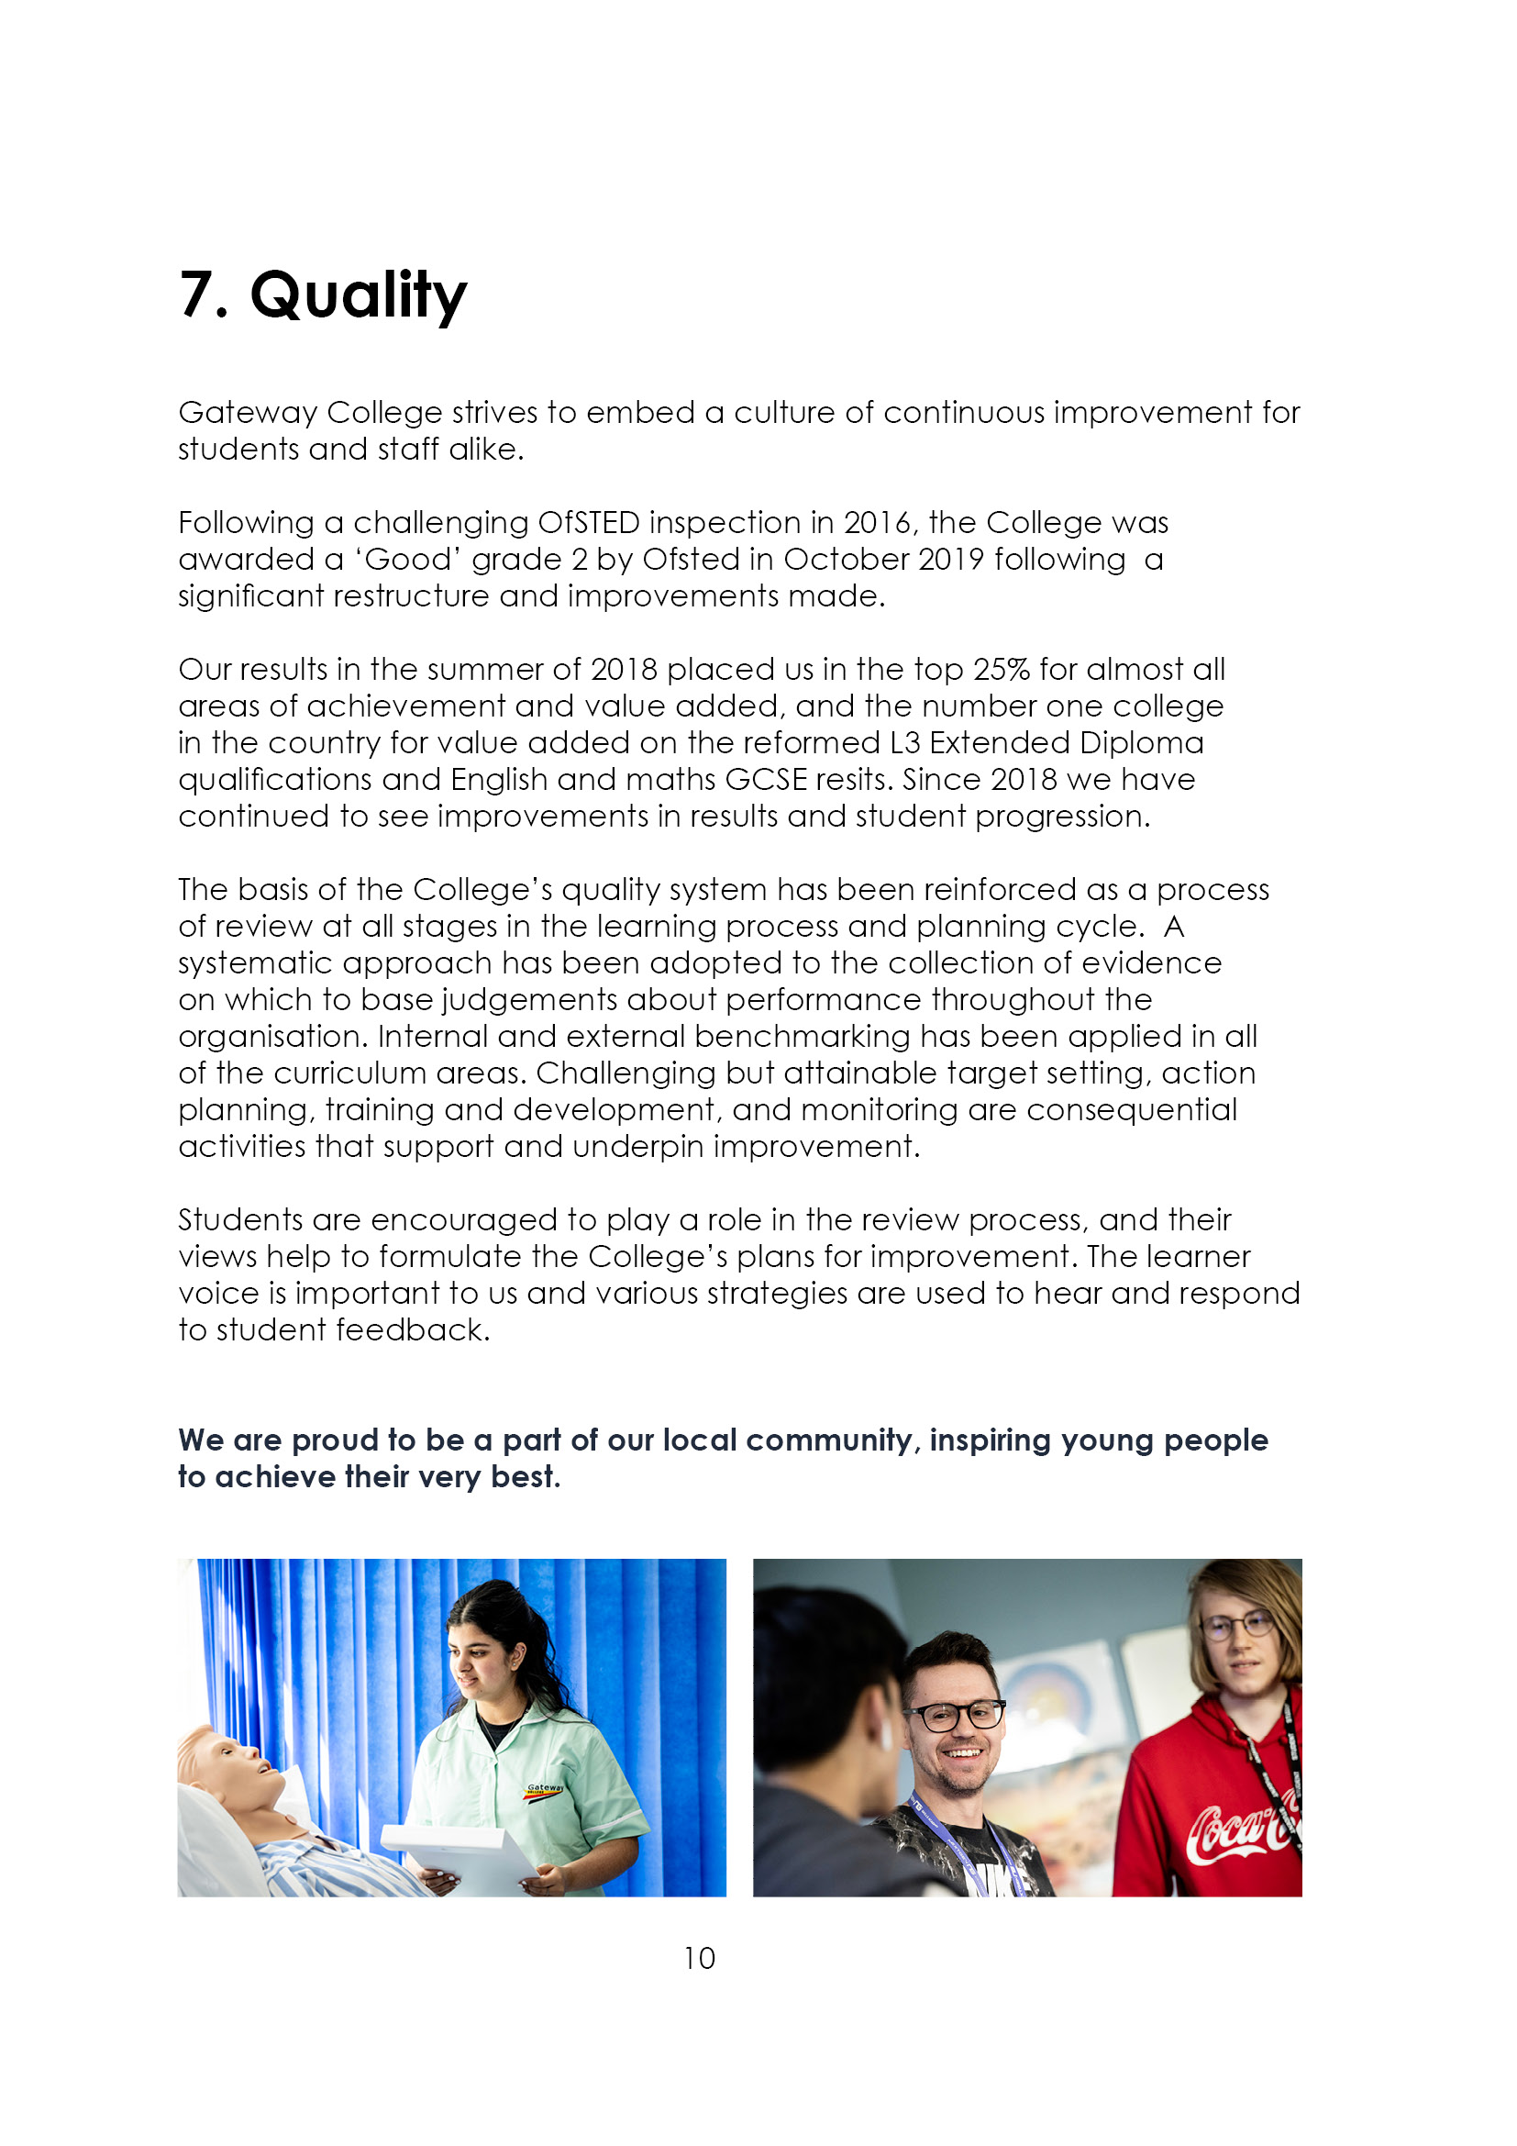



9. Job Advert

10. Job Description
Reporting to: Head of Department
Accountable to: The Principal
Tenure: Permanent, part time
Salary: SFCF Pay Spine Points 1 – 9 (£32,178 - £49,725 FTE)

Duties and Responsibilities:

The generalised duties and responsibilities laid down in the Teachers Statement of Conditions of Employment apply to all staff. These should be read in conjunction with this outline job description.

- To undertake the teaching and support of students working on Psychology and Sociology courses up to A level, or any other programmes, using a variety of teaching methods and learning styles.
- To participate under the direction of the Head of Department (HoD) in the development of appropriate specifications, schemes of work, supported self-study material and the use of information technology.
- To participate as a member of a team in the organisation of course material, resources and stock maintenance and the general management of subject areas.
- To ensure that in the teaching room assigned to the teacher, displays are regularly updated and that the room is generally kept in good order, with any problems reported using the normal College procedure.
- To take part, where appropriate, in the College personal guidance programme and recreational activities.
- To participate in appropriate meetings with colleagues, pastoral mentors and parents.
- To set appropriate work/homework for students and independent study tasks.
- To maintain detailed records of each student's attendance and progress.
- To discuss progress regularly with students and to refer, as appropriate, to the HoD, Assistant Principal (AP) or Tutors.
- To provide students with tutorial opportunities for individual/small group discussion as required within the College's published time budget.
- To participate in appropriate CPD.

- To undertake such other duties relevant to and connected with the teaching and running of the College as the Principal may reasonably require, which may include the teaching, or a contribution to the teaching of, other subjects or teaching elsewhere.
- To negotiate an appropriate range of courses for each student during the induction period and monitor and adapt this provision whenever necessary in consultation with other staff and the student.
- To liaise with subject teachers and other colleagues as necessary.
- To liaise closely with the HoD and/or AP and refer students as appropriate.
- To liaise with parents/guardians/external agencies as appropriate.
- To monitor and develop each student's profile and to prepare initial drafts of references and reports as required.
- To provide information and data as and when required.
- To attend parents' evenings and discuss students' progress.
- To participate in appropriate meetings with colleagues in addition to those specified in the College calendar.
21. To undertake other reasonable duties as required by the Principal.

ESSENTIAL | Method of Assessment | Shortlisting Column
- Graduate in a social science subject, with a PGCE or recognised teaching qualification. | A
- Experience of teaching ‘A’ level Psychology and Sociology. | A
- Organisational skills and the ability to develop new resources as part of a team. | I
- Ability to work as a member of a team. | I
- Experience of post-16 teaching. | A
- Awareness of the needs of students in the post-16 education sector. | I
- Professional competency and ability to teach post-16 using a broad range of teaching and learning styles. | I
- Good practical skills involving IT within division/subject areas, including IT applications. | I
- Willingness to contribute to the extra-curricular life of the College. | I
- Awareness of recent educational developments in the post-16 sector. | I
- Recognition and support for the Gateway College educational philosophy of individual support, personal choice and positive achievement. | I
- A sense of humour, patience, resilience and energy at all times. | I
- A commitment to all students and a clear understanding of all equal opportunities. | I

DESIRABLE | Method of Assessment | Shortlisting Column
- The ability to offer a further social science subject – preferably Criminology. | A
- Experience of College’s present specifications. | I
- Evidence of curriculum resource development. | I
- Evidence of team player activities. | I
- Successfully taught a wide range of student abilities and experience of curriculum development. | A
- Experience of 16-19 role of pastoral tutor. Experience of individual action planning and target setting. | A
- Recognition of quality standards and procedures in teaching and learning. | I
- Outstanding practical skills involving IT within division/subject areas, including IT applications. | I
- Ability to offer an ‘additional study’, enrichment and/or recreational activity. | I
- Knowledge of inclusive learning, widening participation and lifelong learning philosophies. | I

Notes:

The above responsibilities are subject to the general duties and responsibilities contained in the statement of conditions of employment and our equal opportunities policy.

This job description allocates duties and responsibilities but does not direct the particular amount of time to be spent on carrying them out and no part of it may be so construed.

This job description is not necessarily a comprehensive definition of the post and is subject to review following consultation.

This post is subject to enhanced disclosure from the Disclosure and Barring Service (DBS).

Gateway College is subject to the Safeguarding Vulnerable Groups Act 2006 which requires that any candidate appointed must produce:

- A DBS clearance certificate
- Proof of identity
- Proof of qualifications
- Proof of the right to work in the UK.

All of these documents must be produced BEFORE commencement of employment.



