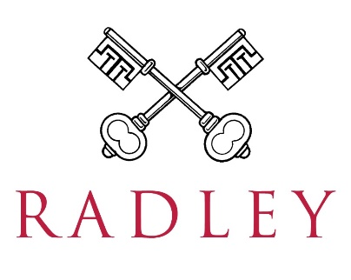

Appointment of
Chef de Partie
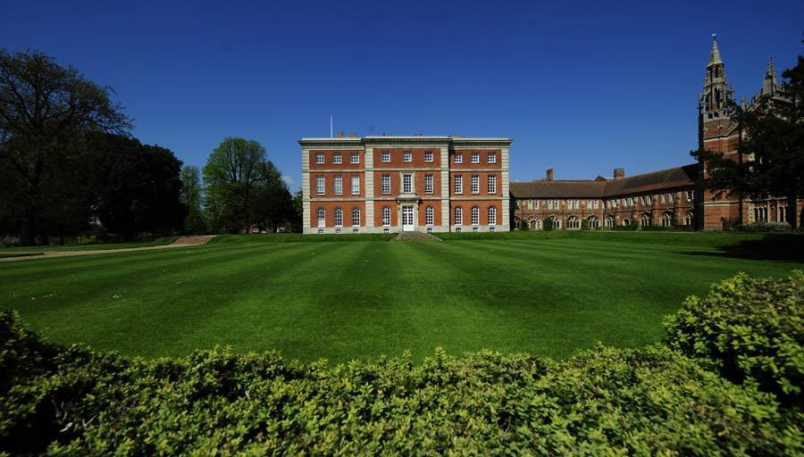

Radley College, Abingdon, Oxon, OX14 2HR
01235 543000
www.radley.org.uk/about-radley/employment
Culture and Background
_______________________________________________

Radley College is an independent boarding school of 690 boys situated five miles south of Oxford. Founded in 1847, the vision was to offer a different education from that offered by most Victorian public schools. A strong emphasis was to be put on the aesthetic and the beauty of the estate and the buildings contribute significantly to the atmosphere. Selective, but not ruthlessly so, the College is proud of its academic achievements both in and beyond the classroom. We care about results in all areas of College life – we believe very much in the pursuit of excellence and have high expectations of ourselves and the boys – but care even more about the development of the character of each Radleian: culturally, emotionally and spiritually.
The hallmark of Radley remains its warmth, generosity and kindness. It is an extraordinarily busy and vibrant place: everyone in Common Room is expected to be fully involved in a wide variety of activities outside the classroom as well as in the pastoral side of the school. Further information about the school may be found on our website.
The Catering Department within Radley College offers a wide range of food services across the 200 acre campus. All of the services are controlled from the main catering building. There are currently approximately 690 boys and 125 dons (teachers) and their families resident on site, together with 330 operational staff. During the school holidays the department supports various residential courses.

The facilities are used seven days a week for approximately 48 weeks of the year and seek to provide a friendly yet efficient environment in which the boys and College staff can both work and relax. The College also provides a range of function and conference facilities which are used primarily for Radley College functions & events; however the College does also extend this to external clients and customers, and also hosts residential courses in the school holidays.

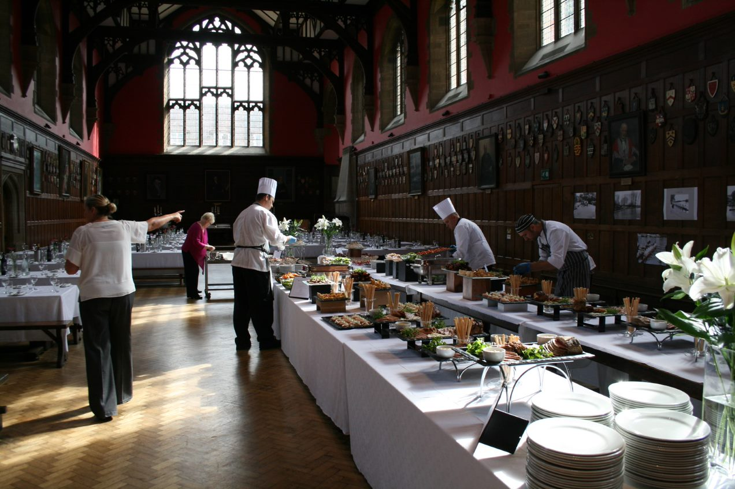

To be responsible for preparing, cooking and presenting a range of daily menu items ensuring the required quality & presentation standards are achieved. Responsible for compliance with food safety & hygiene, portion and wastage control. Ensuring superior health & safety procedures and processes are observed and maintained.

Our focus is to provide a first class catering service to all areas of the College

The services consist of:
- Main dining hall: breakfast – luncheon – supper
- Dons dining: breakfast and dinner
- Hospitality for College sports events – year round
- Food and beverage supplies to boarding houses
- Business lunches & beverages to the campus
- Conference and hospitality
- Various food & beverage provision for satellite buildings including sports pavilions, music school, the School’s theatre
- Residential commercial courses throughout vacation periods
- Junior Common Room

The Catering Department, under the Catering General Manager, also has responsibility for running a school shop and a coffee shop.

The Main Dining Hall - Seating Capacity 250/280

The Catering Department provides a full meal service for all boarders and lunches for College staff.

Average breakfast service numbers: 500
Average lunch service numbers: 1000+
Average supper service numbers: 600+

Our approach
_______________________________________________

Top quality food from local suppliers. We are committed to delivering a high standard of food, from sourcing to cooking and presentation.
Nutritious, healthy food. We care that our food is healthy and nutritionally balanced and we check that our dishes are providing the boys with the healthy food and balanced diet they need.
Food at the heart of the school. Food plays a vital part in the life of the school and we listen to the boys’ views, with a regular food committee meetings. These meetings influence the meals we offer and flexibility allows us to adapt our menus to they can reflect any trends and dietary requirements. We run regular theme days reflecting what is happening in the wider world.
Responsibilities
_______________________________________________

This job description reflects the core activities of the role.

- To ensure compliance to both the College’s expected standards and statutory regulations relating to food safety and cleanliness, in any task undertaken.
- To be responsible for the preparation, provision and service of food production for the Dining Hall, Deli Bar and Common Room Dining.
- To ensure that all ingredients are used correctly to achieve good portion control, always adhering to the recipe specification.
- To support food production for Hospitality, Coffee Shop and Shop.
- To be responsible for internal ordering (via an internal requisition process) all stock in the area you are responsible for at any given time.
- To be responsible for the stock control and rotation within your section ensuring stock is stored safely in accordance with the Food Safety Management System.
- Assist with stock control, rotation and stock takes in other areas, such as Coffee Shop and Shop, under the guidance and direction of the Head Chef
- To assist with receipt of deliveries of goods and assist with the storage of goods, if necessary.
- Adhere to all cleaning schedules and routines and constantly check the cleanliness of your area.
- To ensure that all kitchen hygiene standards are maintained at all times to the specifications by the Head Chef and Catering General Manager. Report any shortfalls immediately to the Head Chef or Senior Chef
- To follow the policies and procedures as laid down in the Food Safety Management system, including the completion of all necessary paperwork and record keeping.
- To be committed to and demonstrate the department’s high standards of personal presentation and behaviour at all times.
- To demonstrate a positive attitude to team work, contributing to the smooth running of the department. At all times demonstrate a pride in the food produced and in the workplace.
- To report for duty punctually and wearing the correct uniform.
- To attend the daily team briefings.

Working with Radley College is always exciting and rewarding. Playing your part in delivering outstanding service, and the smooth operation of running the department. We’ll give you the chance to shine, whether that’s contributing to exciting projects, learning new skills, or just working with a great group of people every day.

All staff are expected to conduct themselves in line with the College’s three strategic pillars and values, which are People, Place and Purpose.

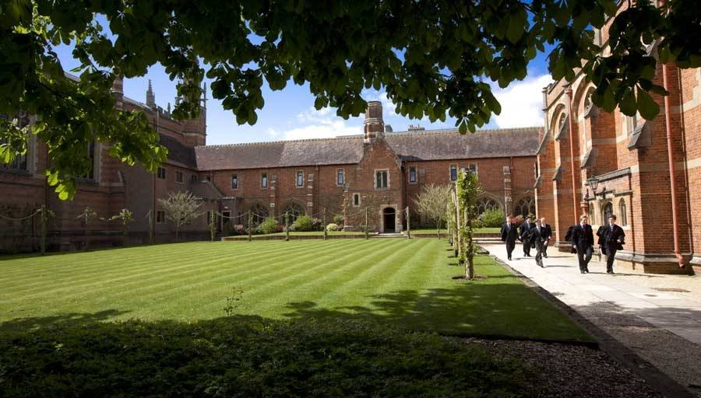

Person Specification
_______________________________________________

- A minimum of 2 years’ experience in a similar role.
- Full knowledge of Health & Safety, HACCP & COSHH Regulations and associated Codes of Practice.
- Good reading, writing, mathematics and computer skills.
- Minimum Level 2 Food Hygiene Certificate.
- City & Guilds 706/1 or 706/2 or NVQ equivalent catering qualification.
- Enthusiastic with a ‘can do’ attitude.

Hours of work: This is a full time 52 week position, 42.5 hours per week (5/7). Flexibility is key and work will involve evenings and weekends to meet the needs of the service.

How to Apply
_______________________________________________

Candidates may, if they wish, informally chat to the Head of Catering, Pam Dickens. Please contact the HR Department to arrange this (hr@radley.org.uk).

Applications must be submitted on the official application form which can be downloaded from our website and sent, together with a covering letter explaining your reasons for applying, to Mrs Sarah Ballard, Head of HR, Radley College, Abingdon, Oxfordshire OX14 2HR or by e-mail to applications@radley.org.uk.

SELECTION PROCESS
If shortlisted, you will be invited for interview. Your interview visit will involve a brief session with our Human Resources department, in order to undertake a number of identity checks. A list of valid identity documents will be sent to you prior to your interview.

In the event of not being successful, please be assured that all copies of identification will be destroyed.

Safeguarding
_______________________________________________

Radley College is committed to safeguarding and promoting the welfare of its pupils and expects all employees to share this commitment. Employees must, at all times, have regard to the need to safeguard and promote the welfare of children in line with the provisions of the Children Act 2004 (as amended) and Keeping Children Safe in Education (as amended) and be fully aware of, and understand, the duties and responsibilities that apply to their role in relation to these requirements. All employees must attend appropriate training in accordance with College and local Safeguarding Board stipulations. Applicants must be willing to undergo child protection screening appropriate to the post, including checks with past employers and the Disclosure and Barring Service. A disclosure, at the enhanced level, will be requested from the successful applicant but a criminal record will not necessarily be a bar to obtaining this position. S/he will also be required to produce original evidence of qualifications as well as evidence of the right to work in the UK.

Staff Benefits
_______________________________________________

When you join, you can tailor your benefits depending on what you need. You will get:

- 5 weeks’ holiday per annum
- Pension plan
- Life assurance
- Free lunch
- Free parking

You can also get extra benefits like:
- Discounted sports membership
- Discounted golf membership
- Discounted dry cleaning

