

Assistant Director of Learning & Achievement
Bath Hub
Application Pack
December 2017


ng

Message from the Board of Directors

Dear Applicant,

Thank you for your interest in the post at Bath & Wells Multi Academy Trust.

The Trust was established in 2012 with four schools, all of which needed sponsored academy conversion following inadequate Ofsted judgements. As of September 2017, the Trust has increased to 19 schools, with a total of some 5000 pupils; of these only 2, recent joiners, are in Special Measures and 2 Require Improvement, a radical transformation.

The Trust is at a key point in its development, with a clear vision and strategic plan for the future, and is continuing to expand in size with 11 new schools joining in the Spring of 2018, with both church and community schools. Good and Outstanding schools are keen to join us and work within the supportive but aspirational Christian environment that we are developing. This offers enormous opportunities and significant change to oversee.

Our leaders share our vision of the Trust as an outstanding provider of education, but education that is not only excellent academically, but also offers every child the opportunity to develop as an individual in mind, body and spirit. The Trust works in partnership with the Diocesan Education Department.

As part of the teaching team, you will be bringing your educational expertise and experience to this role with an approach rooted in excellence, best able to meet the needs of every child within the Trust.

The candidate appointed will play a pivotal part in the development of the Trust both as an outstanding educational provider and delivering its Christian mission to ensure that we provide the opportunity for every child and member of staff to experience ‘Life in all its Fullness’. We look forward to receiving your application.

Yours sincerely

Nigel Daniel
Chair of the Board of Directors
Bath & Wells Multi Academy Trust

Bath and Wells Multi Academy Trust Mission, Aim and Objectives

Mission Statement: John 10:10
‘That they may have life, life in all its fullness’

The Bath & Wells Multi Academy Trust’s mission is to provide an education which is life-enhancing for every child.

We promise an experience which is lovingly inclusive and inspired.

Aim
To ensure that every school within the Trust provides an outstanding education for every child, enhanced by its distinctively Christian ethos.

Objectives
- That every school in the Trust is able to progress to SIAMS and Ofsted ‘Outstanding’ and to remain outstanding

- To provide outstanding leadership at every level of the Trust

- To ensure high quality teaching and high-quality learning environments for all

- To provide high quality governance at every level

- That the distinctively Christian ethos underpins all the work of the Trust and every aspect of curriculum delivery

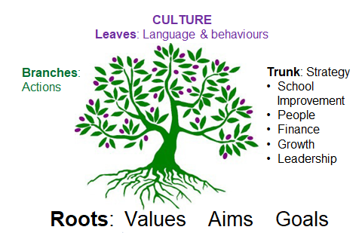

Our Ethos and Values


Church schools are integral to the ministry and mission of the Church and can offer a genuine witness to the incarnation and the creative, redemptive and transforming purposes of God. They do this by loving and valuing all humanity equally, and the quality of the community life and concern for individuals. Church schools are called to bring fullness of life to their pupils, whatever the beliefs of the children and young people or their families.

Each school within the Trust is unique and distinctive and we are committed to celebrating the local context and purpose of each school. Our vision is for all of our schools to become highly successful and meet the needs of the community which they serve. Our vision is for all of our schools to be something in which children, parents, staff and the community can take pride.

In May our schools come together at Wells cathedral for a ‘Together in Voice, Together in Faith, Life in All Its Fullness’, where children from all of our schools came together for an evening performance of singing, thoughtful readings and prayers. To listen to one of the children’s songs please click on the below link:

https://drive.google.com/file/d/0B-8x22DIBpBhWVhFSzI4eFBpZ2M/view?usp=sharing



We are bound by a number of guiding principles:

- To promote an educational community based on love and inclusivity, providing a beacon of hope where all can flourish

- To foster, maintain and celebrate Christian distinctiveness in our schools

- To ensure that our academies are centres of excellence with a focus on the nurture of all their members

- To promote mutual support, encouragement and benefit between all our academies

- To develop future and aspirational thinking based on our educational heritage and to make use of the latest research in pedagogy and child development

- To support the nurture and respect of God’s creation with a close focus on the sustainability agenda


- Each child is a unique human being and worth the highest possible standards of education and care and the closest attention to what will enable them to flourish

- We must ensure that ‘every child and young person has a life enhancing encounter with the Christian faith’

- To recognise those who often remain invisible, through ethnic or cultural disadvantage, or through disability or poverty

- Church schools have a particular vocation to the poor, to enable them through education to change their lives

The purpose of the Trust is to secure the rapid and sustained improvement of all its academies. The Trust will enable schools to work together, share expertise and maximise resources. Our vision is for a family of Bath & Wells academies that offers a great learning experience for every child.

We seek to ensure the best possible educational outcome for every child. The Trust believes that every child has the right to a good education and this will be achieved within a distinctively Christian context, valuing each child as an individual and enabling them to discover and develop their God given gifts.

As academies within the Trust grow and develop, they will be expected and required to share their journey, skills and expertise with other Bath & Wells academies. The Trust will encourage and nurture the dissemination of good practice, fostering a self-sustaining culture of aspiration for educational excellence across all schools.

Pupil Outcomes

2016 : 14 Schools (not organised into Hubs)
2017 ; 18 schools organised into three Hubs

Key Stage 2 100+
 |  | Reading |  | Writing |  | Maths |  | SPAG |  |  | RWM
 |  | 2016 | 2017 | 2016 | 2017 | 2016 | 2017 | 2016 | 2017 | 2016 |  | 2017
National |  | 66% | 71% | 74% | 76% | 70% | 75% | 72% | 77% | 53% |  | 61%
BWMAT |  | 67%  (+1%) | 74%  (+3%) | 76%  (+2%) | 79%  (+3%) | 68%  (-2%) | 72%  (-3%) | 70%(-2%) | 79%  (+2%) | 53%  (0) |  | 61%  (0)
% improved 2016-2017 | % BWMAT | 7.5 % |  | 3.3 % |  | 3.9% |  | 8.8% |  | 7.8%
% improved 2016-2017 | % National | 5 % |  | 1% |  | 5% |  | 5% |  | 8%

Key Stage 2 110+

 | Reading |  | Writing |  | Maths |  | SPAG
 | 2016 | 2017 | 2016 | 2017 | 2016 | 2017 | 2016 | 2017
National (2016) | 19% | 25% | 15% | 18% | 17% | 23% | 23% | 31%
BWMAT | 21%(+2%) | 24%(-1%) | 18%(+3%) | 24%(+6%) | 13%(-4%) | 19%(-4%) | 23% = | 31% =
Key Stage 1 ARE

 | Reading |  | Writing |  | Maths
 | 2016 | 2017 | 2016 | 2017 | 2016 | 2017
National | 74% | 76% | 65% | 68% | 73% | 75%
BWMAT | 73% | 80%(+4%) | 74% | 65% (-3%) | 81% | 80% (+5%)

Key Stage 1 GD Year 1 Phonics

 | Reading | Writing | Maths
 | 2017 | 2017 | 2017
National | 25% | 16% | 21%
BWMAT | 33% (+8%) | 22% (+6%) | 25% (+4%)
 | Year 1 Phonic Screener
 | 2016 | 2017
National | 81% | 81%
BWMAT | 81.1% (+0.1) | 81%

EYFS

 | GLD
 | 2016 | 2017
National | 69.3% | 70.7%
BWMAT | 68.7% (-0.6%) | 74%

The Application Process

We hope you find this pack provides all the information you need in order to consider your application for this post. If, however, you have any further questions or require for any reasonable adaptations under the Equality Act in the application process please contact Joanne Moore in Human Resources by e-mailing joanne.moore@bwmat.org or calling 01749 372700.

For a more detailed discussion about the role please contact Teresa Wheeler Director of Learning and Achievement; teresa.wheeler@bwmat.org or call on 07733102704.

Applications

Applications are to be received by the 28th January 2018. If you would like to apply for this post, please download a copy of the application form from the website. Please return your completed application form by the 28th January 2018 by e-mail to: christine.richardson@bwmat.org

Unfortunately, we are unable to accept applications after this time unless the recruitment process is reopened.

Please note that CVs will not be accepted.

Shortlisting

To ensure the fairness of the selection process, shortlisting will be based upon the information which you provide in your application and assumptions will not be made about your experience or skills. We will look for demonstrable evidence that you meet the criteria set out in the person specification.

All applicants will be notified of the outcome of the shortlisting process.

Interview

Interview dates: 19th and 20th February 2018

The first day of the interview process will take place in The Old Deanery, Wells, and the second will take place within a school based in Bath. Further details regarding the selection process will be communicated at the time applicants are invited for interview. The appointment will be subject to satisfactory pre-employment checks.



Assistant Director of Learning and Achievement – Bath Hub

Bath & Wells Multi Academy Trust, The Old Deanery, Wells
Salary: up to £65,363 per annum. This is currently under review.
Full time, Permanent

This is an exciting opportunity to work for an Academy Trust committed to high expectations, high standard and excellent provision for all learners.

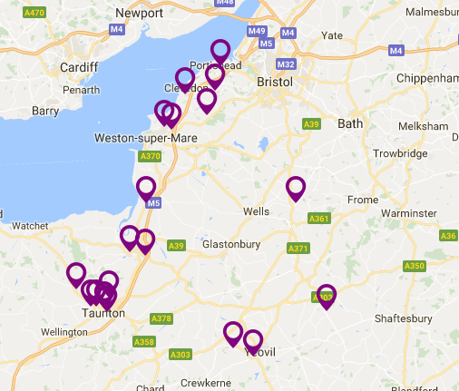
Due to continuous success and expansion of the Trust an opportunity has arisen for the role of Assistant Director of Learning and Achievement within the Central Support Team. We are currently home to 19 Primary Schools, and are increasingly sought after as a unique and distinctive option for schools within the Bath & Wells Diocese.
As the Assistant Director for Learning and Achievement you will have a responsibility for School Improvement under the management and guidance of the Director of Learning and Achievement.
As an inspirational communicator, and innovative leader with strong educational background, you will provide strategic focus on attainment and progress ensuring our Schools have the highest quality support, challenge and intervention.
We want the successful applicant to lead and inspire others, to build upon previous successes and address remaining challenges, making a real difference for our children.
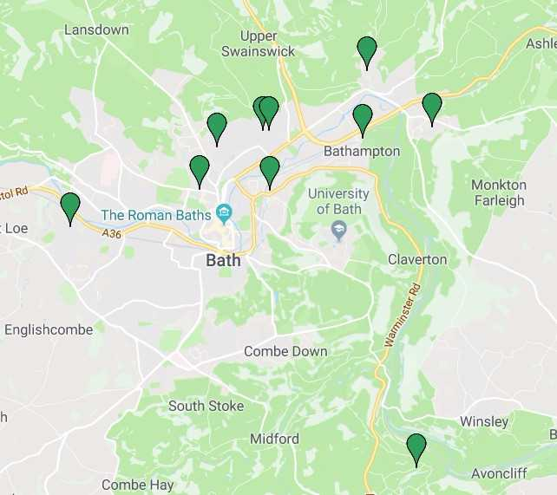
The successful candidate will have a responsibility for a number of schools within the Bath Hub and will provide overall effectiveness and an aspirational culture for all. You will be able to demonstrate a proven ability to lead and implement strategies for School Improvement and have excellent research, data analysis and reporting skills.

In return we can offer a competitive salary and benefits including; Access to the Teacher’s Pension Scheme with excellent training opportunities and CPD.
The Trust is committed to safeguarding and promoting the welfare of children and expects all staff to share this commitment. All posts are subject to satisfactory pre-employment checks.
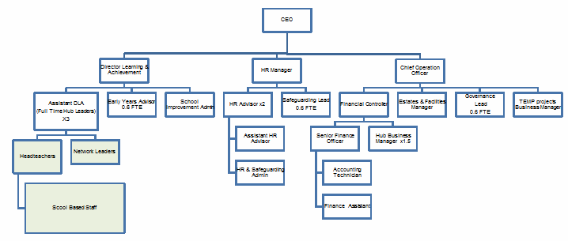
Our current organisational structure of which you will be a part of is:

For full vacancy details and to apply please visit http://www.bwmat.org/vacancies/ For informal enquires please contact Teresa Wheeler teresa.wheeler@bwmat.org or all on 07733102704.

Closing date: 28th January 2018

The post holder will be required to regularly travel to schools within the Trust and will be allocated a given number of schools to oversee. It is anticipated that this particular post will have a focus on schools in the Bath area.



Bath & Wells Multi Academy Trust
Job Title: | Assistant Director of Learning and Achievement
Location: | The Old Deanery, Wells, with regular travel to schools predominately within the Bath area.
Salary Range: | Up to £65,363 per annum, under review
Reports To: | Director of Learning and Achievement

The Aim of The Bath & Wells Multi Academy Trust:
To ensure that every school within the Trust provides an outstanding education for every child, rooted in its distinctively Christian ethos.

Bath & Wells Multi Academy Trust Mission Statement: John 10:10 ‘That they may have life, life in all its fullness’ The Bath & Wells Multi Academy Trust’s mission is to provide an education which is life-enhancing for every child. We promise an experience which is lovingly inclusive to all pupils.

Job Purpose
- To report to the Director of Learning and Achievement and CEO regarding the education outcomes, standards and overall performance of a group (hub) of delegated schools.
- To provide professional challenge and support to schools and ensure the offer to pupils enables all to achieve high standards across a broad and balanced curriculum.
- To ensure effective school to school support has a high impact upon outcomes, both within the Hub and across the Trust.
- To provide line management and support to Head teachers.
- To work with Headteachers to identify personal areas of development.
- Organising professional development across the hub
- Formulate support plans as appropriate.
- To be responsible for the collation, management and dissemination of the Trust’s assessment and attainment data and report this to the CEO, DLA, Trust Directors and other members of the Central Team.
- To champion and promote the mission, vision, values and culture of the Trust, creating a sense of belonging and linking with the wider Trust family.

Main Responsibilities and Duties
- Develop and deliver innovative school improvement processes across allocated schools based on the latest research.
- Monitor and challenge the performance, progress, standards, and quality of education within schools.
- Agree challenging and meaningful targets for improved attainment by supporting schools in self-evaluation and improvement planning.
- Report to the DLA on pupil outcomes and the progress of school priorities across the hub.
- Report on school, hub and Trust priorities during and following visits.
- Develop and inspire collaborative working and sharing of best practice between schools within hubs and across the Trust, striving to achieve a broad and balanced curriculum across all schools.
- Identify, challenge and support professional development needs of leaders and teachers and contribute to Trust-wide CPD.
- Lead and model CPD activities for schools across the Trust in order to meet identified priorities.
- Support and oversee the development of hubs with the DLA.
- Analyse and report on hub, school and pupil level data, providing support and challenge for Headteachers in the interpretation and use of data to raise standards.
- Work with Headteachers and the DLA to draw up school development plans and ensure that the necessary actions needed to bring about improvement are implemented quickly and effectively, and have the required impact.
- Oversee intervention strategies across hubs and schools.
- Work with the DLA to develop and implement highly effective inspirational practice across the Trust.
- Work with school leaders to deliver effective safeguarding practices, ensuring actions are addressed in response to safeguarding audits.
- Contribute to and engage in pre-Ofsted and other learning reviews within schools as appropriate.
- Keep abreast of local, national, international policy, practice and research in relation to schools working in challenging contexts and advise accordingly.
- Line manage and support Headteachers in the hub.
- Conduct performance reviews of the Headteachers and to take part in strategic reviews as appropriate.
- Work with Headteachers to achieve economies of scale and ‘best value’.
- Contribute effectively to the School Improvement Team through a shared understanding of the Trust’s vision and strategic direction.
- To work closely with members of the central team to report on performance within delegated schools and contribute towards strategic planning and organisation initiatives.
- To oversee appointments of key roles within delegated schools.
- Work to ensure consistency of practices across schools.
- To be an advocate and role model of the Trust’s vision, culture and values, presenting these in all work undertaken.
- To be supportive to the wellbeing of Headteachers and staff.
- Take on other agreed responsibilities as instructed by the DLA.

Supervision and Management
The post holder will be managed by the Director of Learning and Achievement. The post holder will line manage the Headteachers of delegated schools. The post holder will carry most of their work unsupervised.

Problem Solving and Creativity
The post holder will be required to provide advice and deliver challenge on a range of school improvement activities. Issues will require high level problem solving skills and require innovative, and creative solutions. It will be essential for the post holder to embrace and contribute to the wide-ranging systems and processes that ensure effective school Improvement.

Key Contacts and Relationships
Chief Executive Officer
Chief Operations Officer
Director of Learning & Achievement
Financial controller
HR Manager
Multi Academy Trust Board of Directors
Head teachers of Academies
Lead Head Teachers from each Hub
Local Governing Boards
Diocesan Director of Education
Diocesan Education Department
Department of Education
Local Authorities
Decision Making
The post holder will manage their work load and priorities, deploy their time and in conjunction with the DLA decide upon what actions to undertake to support the work of the Local Governing Boards, Headteachers, Teachers and schools.
The post holder will make key decisions on school improvement issues in consultation with the DLA.
The Post holder will prioritise work to meet deadlines.
The post holder will frequently make decisions about, and deal with complex school improvement issues.

Resources
A laptop and mobile phone will be provided.

Working Environment
The post holder’s work environment will be varied and require working from and within schools, with days working from the central office in Wells.


PERSON SPECIFICATION

Job Tile: | Assistant Director of Learning and Achievement
Location: | The Old Deanery, Wells, with regular travel to schools predominately within the Bath area.

Key Criteria | Essential | Desirable
Qualifications | - General education to degree level (or equivalent)  - Professional teaching qualification  - Evidence of recent and relevant professional development | - NLE or LLE accreditation  - Postgraduate qualifications
Experience, Skills and Abilities | - Recent experience of leading and managing educational initiatives across more than one school.  - Experience of working in a collaborative and supportive capacity with school leaders.  - Senior leadership experience in school improvement.  - Ability to interpret complex quantitative and qualitative data and use this analysis to inform planning, support and challenge  - Demonstrable experience of raising and sustaining standards in schools  - Understanding and experience of system leadership  - Ability to develop processes that encourage the sharing of best practice across schools  - Ability to build capacity in colleagues through coaching or mentoring and brokering/delivering professional development/training  - Experience of leading strategic reviews and using the outcomes to inform resource allocation  - Experience of monitoring, evaluating and improving the quality of education provision  - Understanding of current issues in education regionally, nationally and internationally  - Ability to pursue challenging and rigorous questions and probe explanations  - Ability to provide professional challenge to Senior Leaders and schools governing boards.  - Experience of Performance Management processes to maximise the contribution of senior colleagues  - Experience of initiating business improvements, embedding efficient and lean systems that ensure a quality service and value for money  - Ability to work effectively with governing bodies  - Excellent written communication skills and ability to express ideas simply and clearly in writing  - Aware of the challenges faced by Headteachers | - Knowledge and experience of SIAMS  - Experience of leading and managing others.  - Headteacher  - School Improvement Advisor.  - Experience of working in a leadership capacity within Primary Education
Work-related Personal Qualities | - Commitment to the Trust’s aims and mission.  - Sympathetic to the Christian faith  - Commitment to Church schools  - Understanding of, and commitment to, the principle of social and educational inclusion  - Advocacy, facilitation, persuasion and negotiation skills  - Highest standards of personal integrity  - Emotional intelligence  - Calm and diplomatic  - Flexible with a capacity for hard work  - Thrives on change and enjoys working at pace  - Significant personal presence; enjoys being highly visible and meeting with a range of audiences  - Ability to grasp and communicate a complex vision in simple and easily understood terms to a variety of audiences  - A strong sense of accountability for ensuring performance targets are met  - Excellent interpersonal skills  - Determination to secure the sustained improvement of the region’s academies  - Ability to travel, across the diocese area in order to carry out duties  - Excellent time management skills to ensure deadlines are met and standards of reporting leads to highly effective support and challenge

Working and Living in Bath, Somerset & North-East Somerset

The Bath & Wells Multi Academy Trust works within the parameters of the Diocese of Bath & Wells, which is nearly coterminous with the traditional county of Somerset. It is a diverse region with:

- An extensive coastline along the Bristol Channel, often referred to as Somerset Coast
- Three Areas of Outstanding Natural Beauty – the Blackdown, Quantock and Mendip Hills
- A large part of the Exmoor National Park
- The wetlands of the Somerset Levels
- Bath is a world heritage city

Apart from the M5 from Bristol to Taunton, the county has no significant dual carriageways. The main A roads are radial routes from Bristol (A37, A38), and E-W crossings (A30, A303 in the south and A39, A361 across the centre). The main rail links are the London Paddington main line to the West Country through Taunton, and routes to London from Bath or Castle Cary. There is a significant but slower line that runs to London through the south of the diocese. Bristol Airport lies in the north of the diocese.


Bath has a distinct identity from much of the rest of the diocese, and the proximity of Bristol exerts a powerful influence on commuting and employment patterns.

The population of just over 909,000 has grown by 6.7% since 2001, faster than the national average, and is projected to grow to about 1 million by 2021. This is almost entirely through internal migration from other parts of the UK, and nearly all the increase in population in the last 10 years is accounted higher proportion of adults over 40 than the national average, and 20% fewer in their 20s-40s.

The main centres of population fall into three main clusters:

- In the north around Bath and the Bristol commuter belt - Keynsham, Portishead, Nailsea, Clevedon
- The A38/M5 corridor in the west - Weston-Super-Mare, Bridgwater, Taunton and Wellington (now mostly concurrent with the M5)
- Along the A30 and A303 in the south of the diocese - Yeovil, Chard, Crewkerne and Ilminster.

Other significant towns are Frome in the east; and Wells, Glastonbury and Street in central Somerset.

Between them, Bath, Weston, Taunton and Yeovil account for nearly 1/3 of the population of the diocese.

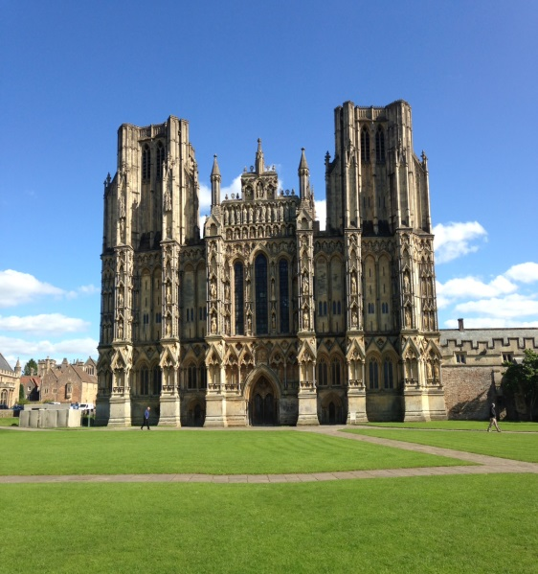
Church schools are a significant activity of the diocese. 36,000 children attend Church of England schools or academies. 50% of primary aged children attend a Church of England school.

There are six Church of England secondary schools and three middle schools.

State schooling in the diocese is provided by three Local Education Authorities: Bath and North-East Somerset (BANES), North Somerset, and the larger Somerset County Council.

Bath and Wells is overwhelmingly ‘White British’ (95%), with significantly lower rates of ethnic diversity and international immigration than England as a whole, even though these are slowly rising. BANES is closer to the national profile (83% ‘White British’, 8% black, Asian or mixed race), but still below average. ‘White other’ is the only other ethnic group to register above 2%, with pockets of European immigration in some urban centres.

In the 2011 census, 64% of Somerset people put their religion as ‘Christian’, significantly higher than the national average, but still a drop of 11% over the decade. Over the last 10 years the number specifying ‘no religion’ has doubled to 250,000. Other religious groupings are small: at 3,500 the Muslim population is the next highest, followed by Buddhists and Pagans.


Local sport and leisure ranges from the all-conquering (Paul Nicholls’ stable in Ditcheat) to the successful (Somerset CCC, Yeovil Town FC and Bath Rugby), with a thriving local club scene in many sports. There are three local racecourses at Wincanton, Bath and Taunton.

The diocese is rich in cultural opportunities - with literature and music festivals in the well-known centres such as Bath and Wells, as well as in the smaller towns and communities.

The Glastonbury Festival draws 180,000 visitors each year and Somerset’s autumn cycle of carnivals is the biggest of its kind in Europe.

