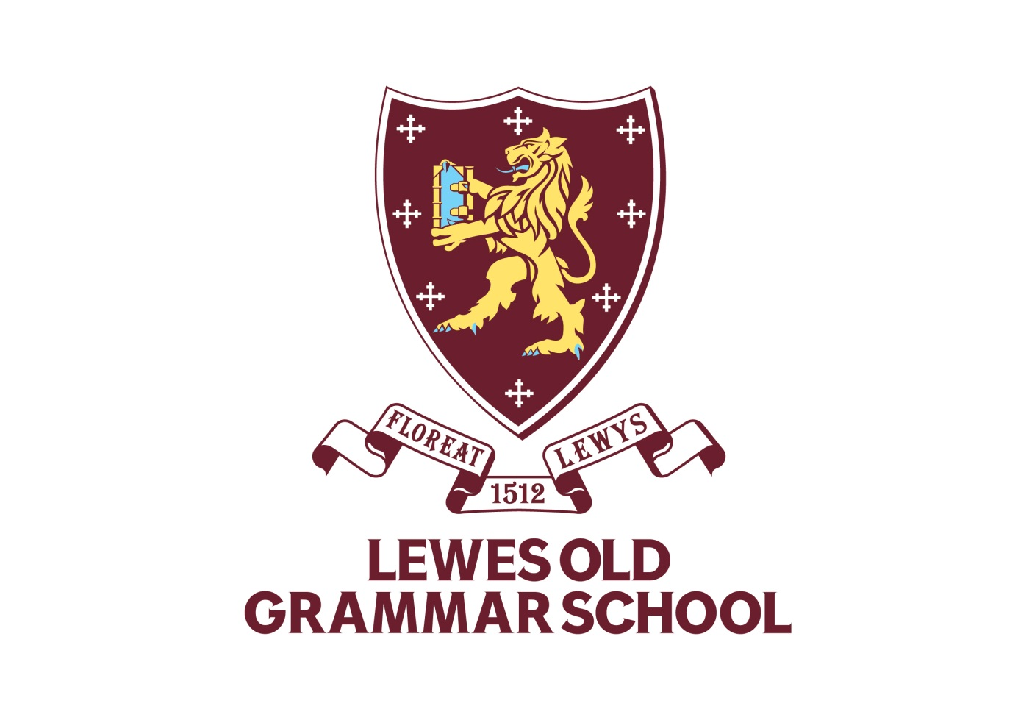Recruitment Pack

4. Equal Opportunities Monitoring

EQUAL OPPORTUNITIES MONITORING FORM

This section of the form will be detached from your application and will be used solely for monitoring purposes. This form will be kept separately from your application.

Lewes Old Grammar School recognises and is committed to ensuring applicants and employees from all sections of the community are treated equally regardless of race, gender, disability, age, sexual orientation, religion or belief, gender reassignment, marital and civil partnership status, or pregnancy and maternity.

We welcome applications from all sections of the community.

You are not obliged to complete this form but it is helpful to the School in maintaining equal opportunities.

All information provided will be treated in confidence.

Please complete the form as you feel is most appropriate for you.

Position applied for:

White: | British | Any other White Background

Mixed: | White and Black Caribbean | White and Black African
 | White and Asian | Any other Mixed Background*

Black/Black British: | Caribbean | African
 | Any other Black Background*

Asian/Asian British: | Indian | Pakistani
 | Bangladeshi | Any other Asian Background*

Chinese/  other Ethnicity: | Chinese | Other Ethnic Group*

*please specify

Gender: | Date of Birth:

Do you consider yourself to have a disability:

Yes No

If yes, please state the nature of the disability:

The Equality Act defines disability as, "A physical or mental impairment which has a substantial and long-term effect on a person's ability to carry out normal day-to-day activities"

If you wish, you may disclose information about yourself in this section:

Religion:

Sexual Orientation:

How did you become aware of this vacancy?
Media: | Date: | Reference:

