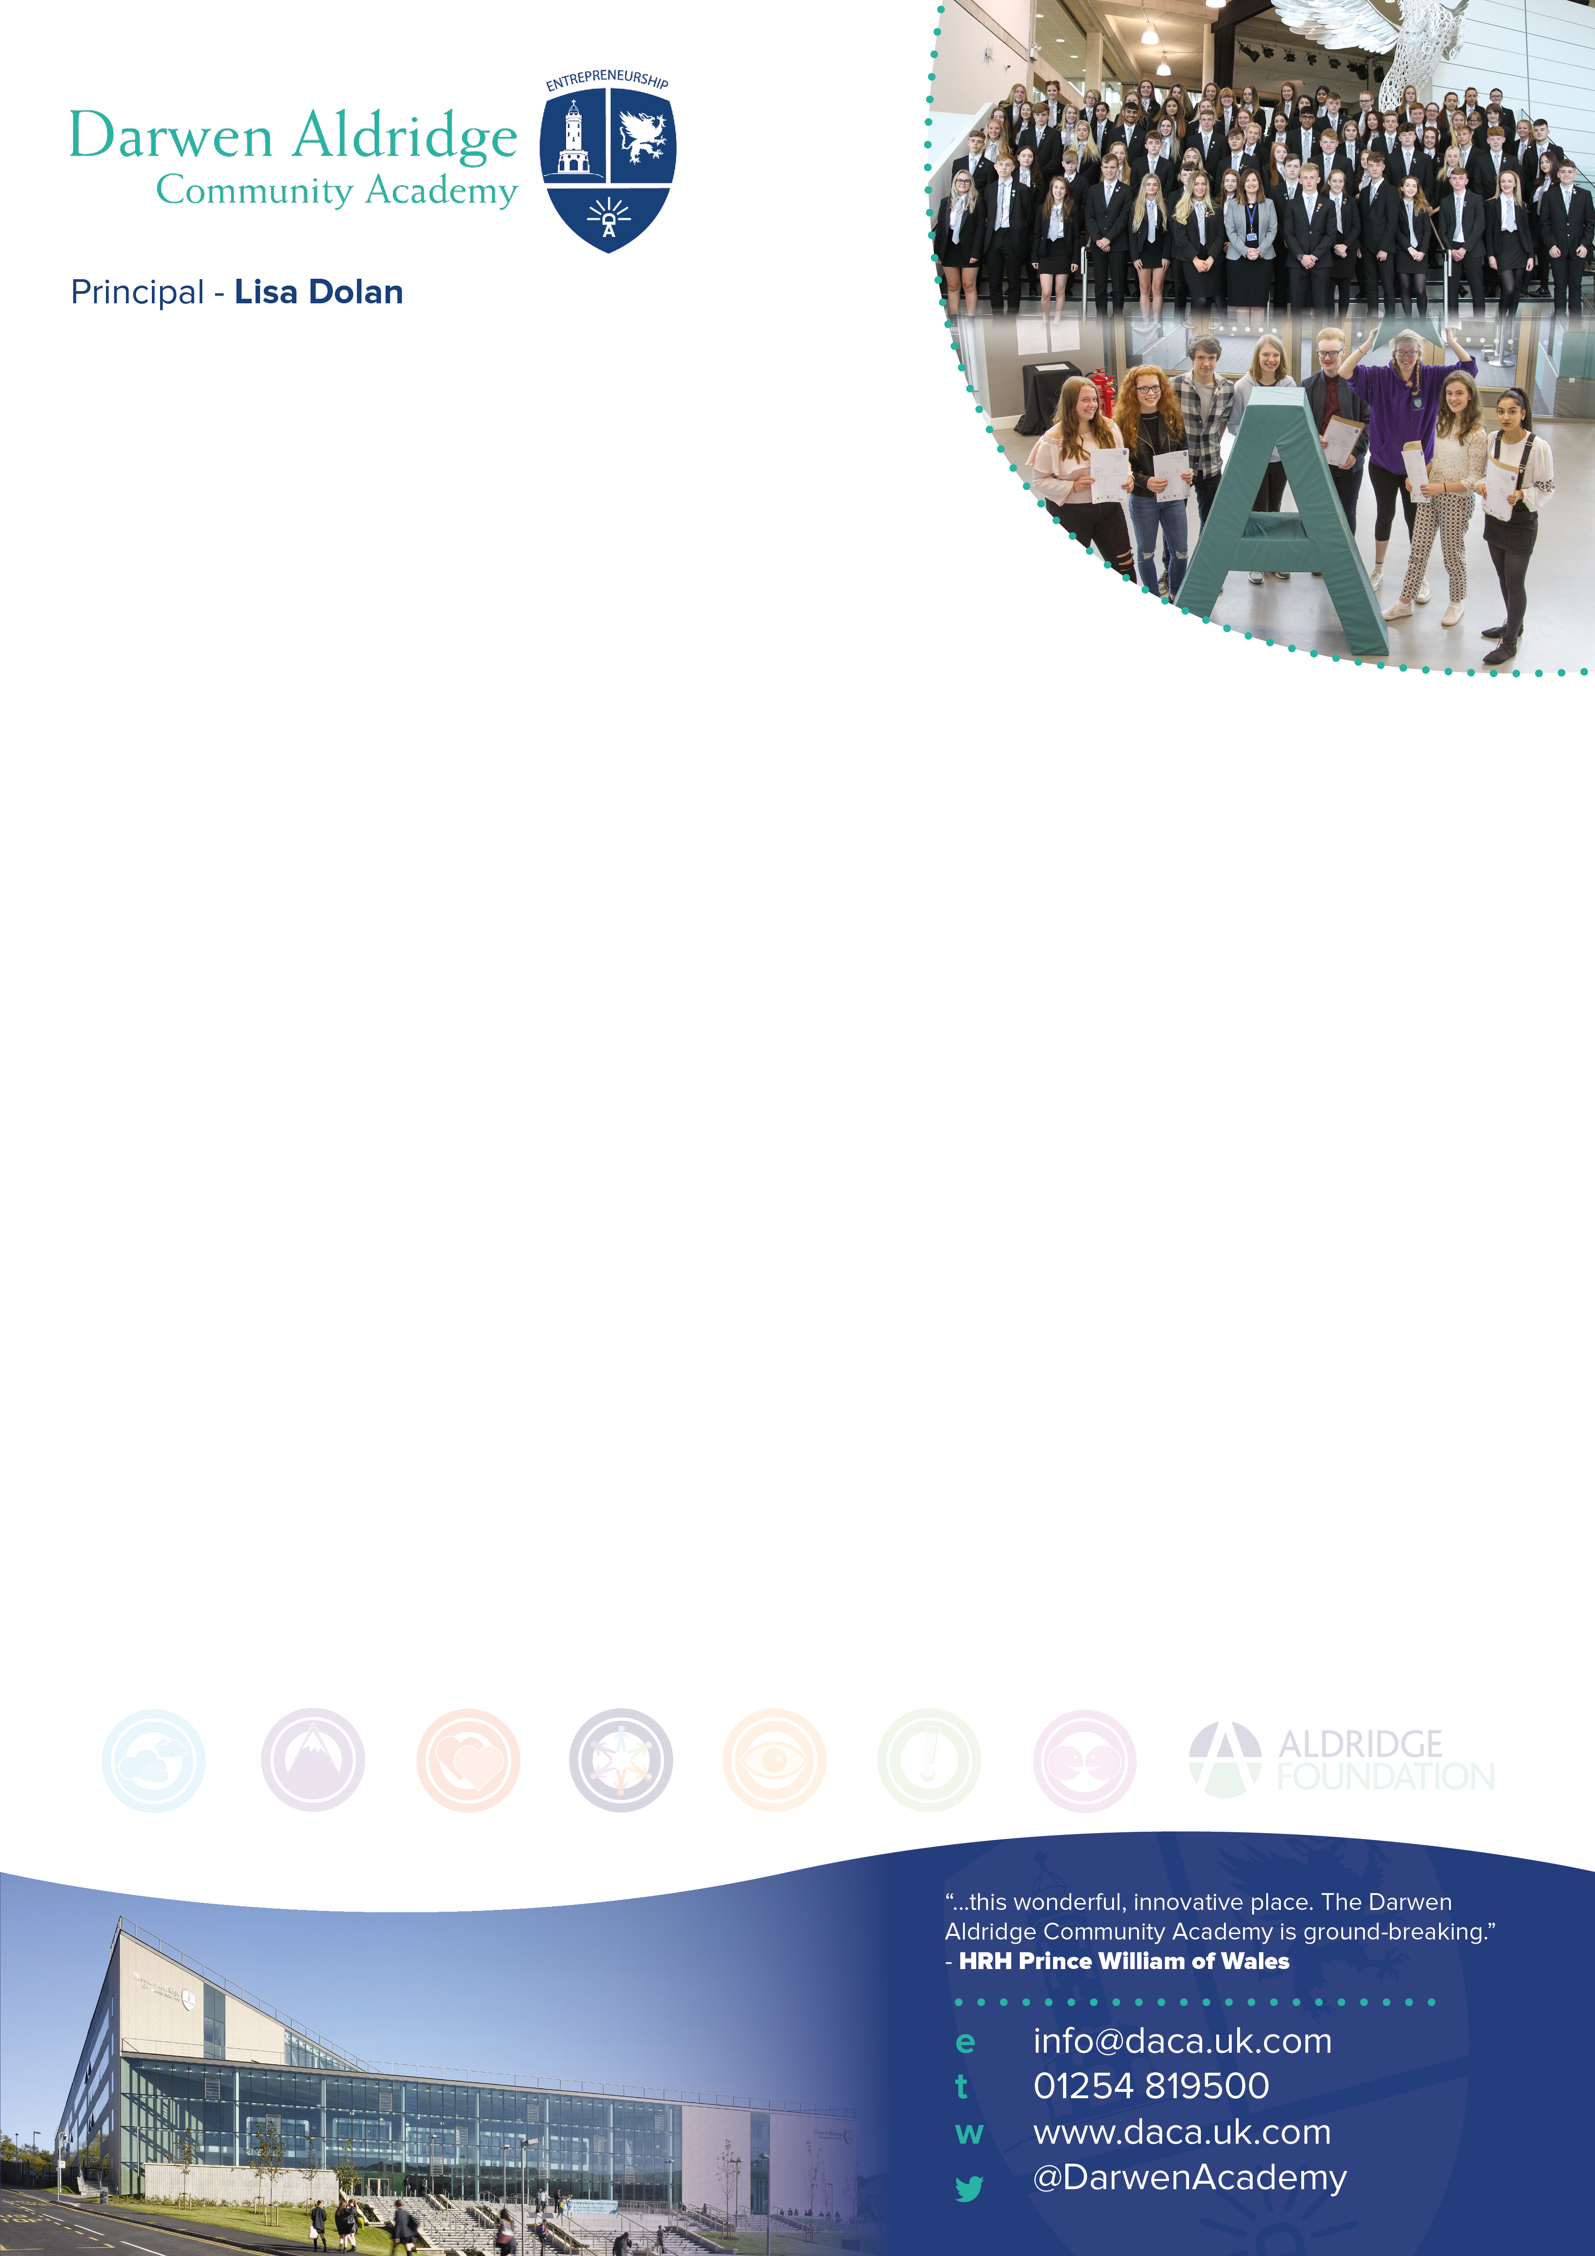

Teacher of MFL

Information for applicants
Required 1st September 2018



June 2018

Dear Applicant,

Thank you for your interest in the post of Teacher of MFL at Darwen Aldridge Community Academy.

I want the study of foreign languages to broaden our students’ horizons, to prepare them for a world in which they can compete in any employment sector because they possess not only entrepreneurial skills but also the ability and confidence to communicate in more than one language.

The number of students choosing to study either French or Spanish has grown year on year. Results have continued to improve to be above national average in French (2017) and in line with national Value Added for both French and Spanish. French and Spanish are taught to KS5 and the number of students taking languages at A level is increasing. The Academy was awarded International School status in 2016 and has been involved in two Comenius partnerships.

We are looking for an exceptional teacher who is deeply committed to raising standards, ensuring students make progress and who radiates enthusiasm and passion for the subject, to join our Modern Languages Faculty. The successful candidate will play an important role in working with our experienced Director of Languages Mr Charruau, in contributing to the faculty as a whole, engaging and motivating students and raising aspirations. There is a strong sense of teamwork within the faculty and staff strive to develop creative approaches to learning to improve attainment and progress. This is an exciting time to be joining The MFL faculty as we seek to expand the number of students studying MFL at GCSE and A level.

Ofsted say ‘Students clearly enjoy and very importantly value their education’ and we will be oversubscribed in September for the fourth consecutive year. We are particularly proud of the opportunities we provide in MFL; the faculty has a comprehensive enrichment programme, with annual visits to the University of Manchester and the University of Lancaster and there have been recent trips to France, Italy, Germany and Norway.

As a leading member of the Aldridge Education Northwest Cluster, our provision is broadening. We work in partnership with Darwen Aldridge Enterprise Studio School, who provide a complementary Key Stage 5 curriculum. There are many opportunities to work in partnership with our family of schools and our staff benefit from professional development opportunities, which are exclusive to our trust. Our founder, Sir Rod Aldridge, shares our passion for social mobility and is as committed as we are, to ensure our students are successful.

If you are able to be part of a team, empower others, be collaborative, share good practice and are committed to securing high standards of learning and teaching, as well as able to relate to our ethos, then we would be delighted to hear from you.

Please find enclosed with this letter:

- General information about the Academy
- A job description for the post
- A person specification for the post
- An application form

I hope that this information will encourage you to apply for this key post. The closing date for applications is noon on Thursday 28th June 2018 with interviews to be held on Tuesday 3rd July 2018. To arrange an informal visit prior to this, please contact my PA, Sam Grimshaw (sam.grimshaw@daca.uk.com) at the Academy.

The Academy is committed to safeguarding and promoting the welfare of children and young people. References will be taken up for all shortlisted applicants, and successful candidates will be subject to satisfactory enhanced disclosure from the Disclosure and Barring Service. If you do apply for the above position and have not heard anything within one week of the closing date, you can assume that you have not been short-listed on this occasion.

Yours faithfully,
Lisa Dolan
Principal

Darwen Aldridge Community Academy Information

Potential applicants will find useful details about the Academy at http://www.daca.uk.com, and our sponsor Sir Rod Aldridge at http://www.aldridgefoundation.com/. We operate as a northwest based cluster which is one part of a single national MAT, Aldridge Education. The cluster and the MAT are growing, creating opportunities for new partnerships and school to school support and learning.

The Sponsor
The sponsor of the Academy is Sir Rod Aldridge, providing funding through his charitable trust, and on-going support through the Aldridge Foundation. The Aldridge Foundation brings extensive expertise from the public and private sectors to support our schools.

The Multi Academy Trust
The MAT is a national MAT; Aldridge Education. We operate in clusters across the country and DACA is the lead in the north-west cluster. Our plans are for growth of the MAT and the cluster, so this is an exciting time to join us.

The Academy is committed to working in partnership with other organisations to support the development of provision, care and achievement for 14-19 year olds. In collaboration with the Aldridge Foundation we sponsor the Darwen Aldridge Enterprise Studio. In the north-west cluster, our partner schools in the MAT are Darwen Vale High School, Sudell Primary School and we co-sponsor the Media City UK UTC at Salford.

Darwen Aldridge Community Academy
Job description – Teacher of Languages MPS

You are to carry out the professional duties of a school teacher as set out in the current School Teachers’ Pay and Conditions Document.

All colleagues are expected to demonstrate a wholehearted commitment to the development of the Faculty and a willingness to assist the Faculty Director of Learning in preparing for, and adapting to, the changing needs of the Faculty.

Your primary role as a Teacher of Languages is to assist in raising standards in Languages.

You will model the entrepreneurial traits of having a determination to succeed and a positive attitude in all aspects of your work. You will endeavour to instil these attitudes in colleagues and students. You will be sincere in the belief that no barrier can prevent a student from achieving.

PURPOSE OF POST:
To teach a timetable of Languages at Key Stages 3 and 4, and where available Key Stage 5, and across the ability range of the Academy, delivering agreed Schemes of Work, and to carry out the duties of a classroom teacher. As part of an on-going review of monitoring of student progress, you have three core roles within the faculty:
Making judgements about the standards of students’ achievement.
The teaching and learning of students in your care.
Contributing to sustainable improvement by achieving those targets for improvement set by the head of the faculty.

Judging standards
You will work with the Director of Learning for Languages to make secure judgements about the standards of students’ attainment, rates of progress and personal development within your classes, on the basis of evidence gathered from:
- Analysis and interpretation of data on students’ attainment.
- Reviews with your Director of Learning of your assessments of progress for classes, identified groups and individual students.

Teaching and learning
You are accountable for the quality of teaching and learning within your classroom. Your understanding of what makes effective teaching in Languages and the sharing of that with other colleagues is a core part of this role.
As a classroom teacher you are to carry out the day to day duties which include:
- using knowledge of academy policy, plan, deliver, evaluate and assess lessons differentiated to meet the needs of individuals and groups promoting progression, continuity and quality of learning;
- using a variety of suitable teaching and learning styles and clearly communicate learning objectives and expectations;
- taking every opportunity in all academy activities to raise standards of literacy, numeracy, ICT and other key skills to give students access to all curriculum areas as well as enabling them to become lifetime learners;
- using relevant classroom management strategies to ensure a purposeful environment for teaching and learning to take place;
- using agreed procedures for assessing, recording and reporting on progress and attainment of students;
- preparing students for internal and external tests and examinations informing and using whole-school data to raise expectation and standards of achievement;
- setting and effectively marking homework;
- working as a team member, planning co-operatively, sharing information, ideas and expertise;
- playing an active part in school meetings and working groups.

Sustainable improvement
You will need to ensure that the review, construction and resourcing of your lessons bring about improvements.
- You will agree targets for raising students’ attainment in the classes you teach.
- You will work with other subject and Faculty staff in the development of the new Programmes of Study, Schemes of Work and lesson plans for the Academy lesson delivery structure in preparation for the new qualifications at Key Stages 4 and 5.

General Duties
- You will work in accordance with current health and safety requirements: Governing Body, DFE, and Government policies.
- You will abide by the Conditions of Employment set out in the relevant paragraphs of the School Teachers’ Pay and Conditions document in operation at the time when you are carrying out your duties.
- You will carry out any other duties relevant to your post designated by Senior Staff and Director of Learning.
- To participate in induction and / or Teacher Appraisal arrangements.
- To take an active part in the pastoral care and discipline of students within your classes and set appropriate sanctions as set out in Academy policies.
- To carry out the role of Form Tutor, according to the Academy policy.
- To carry out a share of supervisory duties in accordance with the duty rota schedules.

Relationships
- You are responsible to the Principal or Vice Principal as delegated.
- You are responsible to the Director of Learning within the faculty.

Additional Note
The above represents a broad outline of the duties and responsibilities currently attached to the post of Teacher of Modern Foreign Languages. Depending on the needs of the Academy, these may be altered from time to time in accordance with the conditions set out in the currently operating School Teachers’ Pay and Conditions Document and the relevant Governors’ Policy Documents.

Darwen Aldridge Community Academy
Person Specification – Teacher of Modern Foreign Languages
s
 | Essential | Desirable | Evidenced by
Experience |   Relevant teaching experience 11-16/18  Experience of teaching French and Spanish  Recent experience of delivering consistently good and outstanding lessons | Recent, relevant teaching experience 11-18, or KS2-3  Recent experience as a form tutor | Application form  Interview
Qualifications | Qualified Teacher Status  Suitable qualification for the subject required | Higher degree or advanced qualification  A commitment to pursuing further qualifications | Application form
Professional Development | Evidence of responsibility for own professional development  Recent, relevant in-service training in current educational practice related to developments in Modern Languages | Evidence of successful and continuous Performance Management / Appraisal | Application form
Skills and abilities | Evidence of successful teaching which is consistently good or better  Excellent ICT and pedagogical skills  Excellent classroom management skills  Knowledge and use of a range of appropriate teaching and learning styles including strategies for differentiation  Enthusiastic and creative approaches to teaching and learning which maximise students’ abilities  Able to develop others’ capabilities and help them realise their full potential  Effective organisational skills and the ability to meet deadlines  Ability and willingness to work effectively in a team, planning co-operatively, sharing information, ideas and expertise  Proven ability to transfer enthusiasm and understanding of languages to students | Proven ability to inspire and motivate young people to achieve high standards  The ability to create and maintain a teaching environment which promotes effective learning and strives for achievement and excellence  Ability and willingness to initiate and participate in both cross curricular and extra-curricular activities, as well as demonstrating successful involvement in all aspects of Academy life  Evidence of excellent student achievement  A broad knowledge of relevant curriculum areas and current national initiatives including a sound understanding of assessment and monitoring | Application form  Interview  References  Lesson observation
Other | Commitment to the safeguarding and welfare of students  Commitment to the aims and values of the Academy  Commitment to academic excellence and high standards  Presentational skills, confidence and fluency to deal with students, parents and others  Awareness, understanding and commitment to inclusion and equal opportunities  An understanding of the needs of young people  Capacity to work hard with all students  Energetic, positive and cheerful attitude  Is a strong role model for staff and students including having  Excellent attendance and punctuality | Ability to contribute to the Academy specialism of Entrepreneurship  A good sense of humour, able to work under pressure and the ability to keep things in perspective  Has the potential for further promotion | Interview  Lesson observation

