THE MATHEMATICS DEPARTMENT

The Mathematics Department consistently achieves results above or in-line with the national average. In Summer 2019 our GCSE grades 4+ was 73.4% and 5+ was 46.4%. Our GCSE Maths Progress 8 was +0.21, placing us significantly above National figures. Our Disadvantaged outcomes were above the National for other students. A level grades A* - C was 100% and A level Further Mathematics 100% A* - E in the summer 2019 exam series.

The Mathematics Department is one of the largest in the School, housed on the ground floor of a purpose-built block, opened in 2004. We have 11 teaching rooms, an ICT suite and a staff work room. We employ 11 full time and 2 part-time teachers.
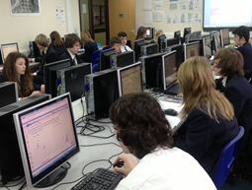

Plymstock School has a 50 period fortnight of hour long lessons. Students are currently allocated 8 hours of Mathematics a fortnight across years 7 to 11, and 10 hours per fortnight in years 12 and 13. We set classes according to student pathways and target grades which are both based on their prior data.

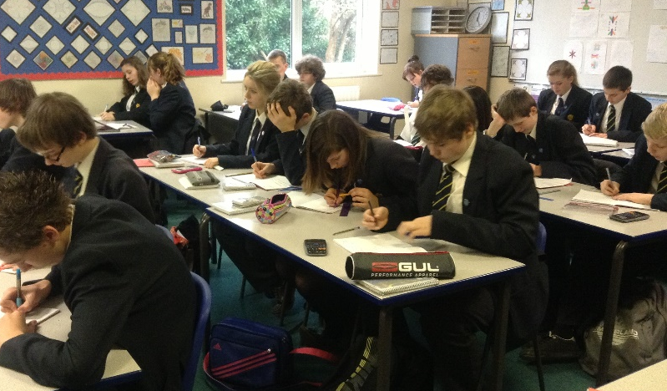
Students enter for Edexcel GCSE and AQA A level examinations. At GCSE our year 10 and 11 students use the Collins GCSE text books and at A Level, years 12 and 13 use the Oxford AQA textbooks.

Across all year groups we use a variety of teaching resources and subscribe to and use a number of online resources such as mymaths, mathswatch, mathsbox, timestable rockstars, to name but a few. We have embraced the use of Kagan co-operative learning strategies and use these regularly within our teaching.

We enter our more able groups in years 7 to 13 for the UK Mathematics Challenge and Team Maths Challenge. We encourage a bright and stimulating learning environment and there are relevant wall displays in all of our classrooms and along the Mathematics corridor.

We are a department committed to excellence in the teaching of Mathematics and giving each student every opportunity to learn and succeed, achieving their full potential at all levels.

