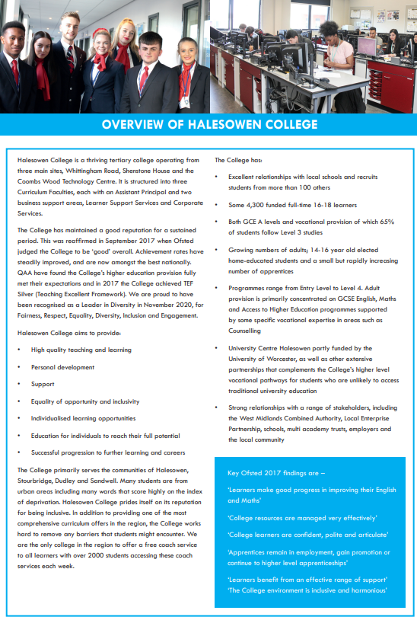

cid:image004.png@01D42A59.305379E0

# Resources Technician - Beauty

### Job Description

|  |  |
| --- | --- |
| **Responsible to:** | Hair and Beauty Senior Technician |
| **Line Manager:** | Hair and Beauty Senior Technician |
| **Job Purpose:** | Working in the Hair & Beauty department you will assist the team in ensuring an efficient and effective service is provided within the College Training Salons. |
| **Hours:** | Normally 18.5 hours per week, Monday to Friday. Occasional extra hours including evenings and weekends, may also be required, for which time off in lieu is given. Staff are expected to support College events outside of core business hours. |
| **Salary:** | Grade C on the Pay Spine (£18,350 - £19,507 FTE) |
| **Annual Leave:** | The leave year runs from 1 September to 31 August.  21 days entitlement, (after 5 years increasing to 26 days) and  8 days Bank Holiday, plus days for College Closure |
| **Pension:** | Local Government Pension Scheme  Employee contributions depend on your annual salary see:  <https://www.wmpfonline.com/members> |
| **Benefits:** | <https://jobs.halesowen.ac.uk/index.cfm?action=content&content=1> |

***Key Tasks and Responsibilities***

1. The preparation and laying out of equipment and other materials for demonstrations, which will include level 3 treatments, classes and assessments.
2. To help create an attractive, clean and safe environment that promotes the salons as a centre of excellence maintaining levels of hygiene and cleanliness appropriate to a professional level.
3. To be supportive of the links between students and clients using the salons and promote the use of the salons as a centre of excellence.
4. The cleaning, maintenance and simple repairs of equipment and their storage and labelling.
5. Ensuring the safe and proper working of equipment and facilities in the salons, either by informing others or rectifying the situation themselves.
6. Laundry of towels and other various items belonging to Hair and Beauty.
7. Checking and refilling of salon consumables i.e. shampoo, soaps, PPE, oils, etc.
8. Maintaining stocks in the dispensary and salons.
9. Assisting the lecturer in charge to maintain the security of the salons and their contents.
10. Maintaining up to date inventories and stock lists for the department.
11. To be responsible for the handling and safe storage of all chemicals in line with COSHH regulations.
12. Ensure all new products have appropriate COSHH information recorded before being issued for use within the salons.
13. In liaison with teaching staff, undertake risk assessments for activities contained in the schemes of work to ensure safe systems of work within the salons and curriculum area.
14. Maintaining health and safety requirements in the salons, including COSHH regulations to an appropriate level and ensuring staff and students adhere to them.
15. Carry out safety checks in accordance with instructions and codes of practice and /or college safety policy.
16. To be a First Aider and Fire Warden.

**Other Responsibilities**

1. To provide occasional cover for the reception desk as and when required.
2. To undertake any other duties which may from time to time be required, and which are commensurate with the level of the post held and the holder’s skills and experience.

**Under DBS legislation and guidelines this is a regulated activity.**

Any other duties, which may from time to time, be required and which are commensurate with the skills experience and grade of the post holder.

**Data Protection**

You are required to meet the specifications of the College’s Data Protection Policy as part of your conditions of employment. This will include information relating to past and prospective employees and students, suppliers and customers.

**Harassment and Discrimination**

You have a duty not to discriminate against or harass colleagues, contractors, students, parents, guardians or potential students or other College visitors, by reason of their age, sex, sexual orientation, gender re-assignment, marriage and civil partnership, pregnancy or maternity, race, disability or religion and belief.

**Safeguarding and Staff Code of Conduct**

You have a duty to abide by the Staff Code of Conduct and Safeguarding Policy.

**Health and Safety**

The College and its employees have legal obligations in respect of the health, safety and welfare of persons at work and the protection of others against risks to health and safety in connection with their activities. Specific health and safety responsibilities are detailed in the College Health and Safety Policy.

Other information for job holders/applicants:

**Disclosure and Barring Service Check**

This post, due to its nature, duties and responsibilities, will be subject to a check by the DBS. The level of check which will apply shall be an “Enhanced” level check.  Information about this disclosure can be found at [www.gov.uk](http://www.gov.uk).

To prevent abuse and implement good practice Halesowen College ensures that recruitment practices are robust and rigorous and that all staff employed have up to date and acceptable references, a full and complete employment history, an Enhanced DBS check and a check of the DBS barred lists.

**Safeguarding**   
Halesowen College is committed to safeguarding and promoting the welfare of young people and vulnerable adults and expects all staff and volunteers to share this commitment.  
Successful applicants will be subject to an enhanced Disclosure and Barring check.

**Equality and Diversity**

Halesowen College is proud of its work in embedding equality and diversity principles in its activities and welcomes applications from all suitably qualified people, irrespective of age, sex, gender reassignment, marital or civil partnership status, disability, race, ethnic or national origin, religion or beliefs, sexual orientation, unrelated criminal convictions or family responsibilities.

We welcome all sections of the community and value the contributions to the achievement of the College’s mission that are made by members of the College from a wide range of backgrounds and experiences. All staff must demonstrate an awareness of equality and diversity principles, as set out in College policies that includes **F**airness, **R**espect, **E**quality, **D**iversity, **I**nclusion and **E**ngagement. It is expected that all members of staff on appointment are committed to and include these principles in their work.

More information on our Equality and Diversity policy can be found at <https://www.halesowen.ac.uk/about/equality-diversity/>

**Childcare Facilities**

There is a day Nursery on the Whittingham Road campus for babies from 12 weeks and children aged 2 to 5 years. It is open 8.00 am to 5.30 pm Monday to Thursday and 8.30 am to 5.00 pm Friday. Further details are available from the Nursery staff on 0121 602 7677.

It is registered at present for 29 children in the early year’s age range. The baby room caters for 9 babies.

**Information Technology**

The College has approximately 2,600 computers across its sites including PCs, laptops, netbooks and Macs running a range of industry standard software. Equipment is available for long and short term loans, and guest access to our wireless network is provided for personal devices. We also run a PC booking system to ensure you can get access to a computer when you need it. A wide range of classroom technologies are in place such as the Moodle Virtual Learning Environment, cameras, voting devices and interactive whiteboards/data projectors.

All staff and students are given a personal computer account with access to email and storage which is available on and off site.

**Smoking**

Halesowen College is a designated smoke-free environment within the perimeter of all College property by order of the College Governors. This rule applies equally to staff and students, and to all categories of visitor. Acceptance of this rule is a condition of employment for staff, and a condition of being a student for students.

**Campus**

The College has three sites, Whittingham Road, Shenstone House and Coombs Wood. Staff can be asked to be based at and/or work across all campuses.

**Note: This job description is current at the time of issue. It should be recognised that, in keeping with organisational changes and developments, it may be necessary to review the duties listed from time to time and change them to meet organisational objectives.**

