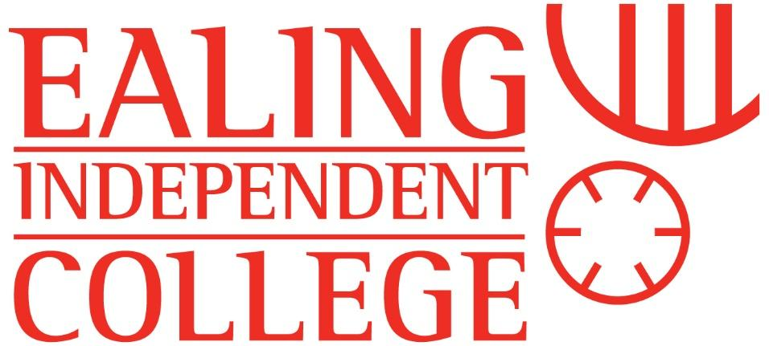


Assistant SENCo
Full Time
From September 2024
Recruitment Pack

Welcome from the Principal

Thank you for your interest in joining our small college, ideally located in one of the nicest parts of West London in the heart of Ealing. With demand for places at the College growing, expansion in progress, and a widening range of the needs of learners, we are looking to appoint a committed and talented Assistant SENCo to join our team from September 2024.

The College offers a friendly and personalised learning environment with small class sizes, where students have a strong support system in place, both through the teachers as well as their peers. The learning extends beyond the classrooms, with a selection of clubs and societies available to enrich and enhance the College experience.

Ealing Independent College is a wonderful place to learn and grow, supported by passionate and dedicated staff who ensure each and every student reaches his or her potential and leave with grades and university destinations that they could only have dreamed of.

With an average class size of eight, it gives our staff the chance to fully understand each individual student - to get to know how they best make progress - and to make a bespoke learning programme for them, geared towards ensuring that they perform to the very best of their abilities.
Founded over 25 years ago as a tutorial college specialising in entry into Medicine and Dentistry, we have consciously kept and maintained a focused study environment to allow our students the right atmosphere and support to reach their true potential. The College provision has expanded in order to deliver 16 courses at A Level and 12 courses at GCSE. The College is a close community, enabling regular and detailed communication between staff, students and parents regarding the process. Where issues arise, these are quickly addressed, and intervention is brought in to ensure students fulfil their potential.
It is because of this focused approach, combined with our dedicated staff and effective performance tracking that we are consistently ranked amongst the top London schools and colleges in the Government League Tables. Most notably, the College is amongst the top schools in the country in helping students improve their grades.
In the last seven years, the College has been placed in the top 15% of schools for improving value to student grades, and in two of those years, we have been in the top 5%. It is this level of consistency which ensures that Ealing stands out from our competitors, and gives everyone connected with the College a great deal of pride.

We look forward to receiving your application form, and meeting you in due course.


Allan Cairns
Principal

Working at Ealing Independent College
Ealing Independent College provides a welcoming atmosphere for staff, with a close-knit group of teachers, an excellent staff CPD programme, generous pension arrangements and extended summer holiday allocation.
Small class sizes ensure that teachers have the ability to teach rather than focus on discipline or student behavioural issues, and a lower marking workload enables staff to focus on quality feedback which encourages accelerated student progress.
Staff turnover is low and the College community is a harmonious and positive one.
School Vision
At Ealing Independent College we teach the individual. We strive to help all our students - from GCSE to A Level completion - be the best version of themselves and to live up to their true potential. We design bespoke learning programmes to allow every one of our students to reach their true potential and aim to provide an excellent education that opens doors to top universities across the UK and abroad. The College is non-denominational: students of all faiths are welcomed.
With a focus on the individual, we are committed to providing outstanding teaching in a supportive and friendly learning environment. Our passionate and dedicated teachers guide and motivate every student to work hard and achieve their goals.
At Ealing Independent College, the student body is very diverse. The successful candidate will be able to develop their expertise by teaching right across the ability spectrum, from students aspiring to the top Russell Group universities to students with EHCPs whose places are funded by the local authority.
Our mission is expressed through core values that form the guiding principles of everything we do at Ealing Independent College, whether that be academic support, student welfare and guidance or extra-curricular activities within the College community. At Ealing Independent College we aim to:
● Empower students to be the very best versions of themselves they can be
● Promote independence, inclusion and tolerance of all learners
● Embed within our students a sense of community
At Ealing Independent College, we take great pride in the support we provide in helping our students reach their goals and fulfil their true potential. As a small college we ensure a personalised learning experience combined with regular homework and tests, and close performance tracking against target grades.

What makes our approach to learning and ensuring academic success so truly unique, is the way we inspire and motivate students to perform their very best - and our approach has brought proven, consistent success. A Personalised Learning Experience, developed around each student’s academic goals and ambitions. Class Sizes are kept small to maximise learning time, a focused environment and ensure that marking and feedback is completed in a timely fashion.
Personal tutors are assigned to each student, holding daily meetings to track progress, set targets and provide invaluable guidance. A close relationship is also formed with parents. Teachers genuinely want their students to do well and go above and beyond to support each student’s learning journey.
We provide a friendly and intimate learning environment where all staff and students are on a first name basis, and students support and encourage each other’s efforts to achieve their academic goals.
In between lessons students will attend supervised study periods where they do their homework, prepare for tests and revise what they have learned in lessons.
We ensure that students always have sufficient work to do and their minds are firmly focused upon enhancing their learning. Students are tested approximately every two weeks in each subject.

Assistant SENCo
JOB ROLE
We are looking for an enthusiastic and thorough Assistant SENCo to work closely with the Vice Principal to ensure that the College provides an outstanding level of care for students within the College community who require additional support. With the growth of the College, and with it, the number of students with an EHCP rising to 18% of the student body and those on the wider SEN register now at 64% of the College population, the need has developed to support both students and staff to provide an excellent level of progress for students with additional needs at EIC.
The rising number of SEN students has also led to an expansion of the duties of the Vice Principal, and so a key part of the role will be to assist her in ensuring that all students at the College are supported appropriately.
At EIC, we are committed to providing the best possible opportunities to all. Our students come from all socio-economic backgrounds, with students with EHCPs having their places fully funded by their local authority. Many of our students have experienced a difficult educational journey before joining us. For example, we have students who have been home-educated due to being bullied in their previous school or whose additional needs, for example Autism or mental health conditions, have meant that they have struggled to attend a large mainstream school. At EIC, we aim to give these students a safe haven so they can grow both academically and socially, and the Assistant SENCo will be integral to this.
Opportunity will be provided for professional development.
The College is keen to support ambitious, committed individuals who seek to acquire further qualifications which can enhance their capacity to perform their roles to a high standard.
The successful candidate may already be a qualified and experienced SENCo, or they may be someone who has experience in working with students with additional needs who is keen to take the next step in developing their expertise in this area.

Job Description
Job Title: Assistant SENCo
Reports to: Vice Principal
RESPONSIBILITIES
Duties specific to the post
- Provide timely information to class teachers regarding students with additional needs
- Provide support to class teachers in working with students with SEND. This can involve providing advice or working with individual students in the classroom
- Provide support to students with additional needs. Examples of this may include mentoring students with SEMH needs, coaching students to help them develop their organisational skills and providing assistance with subject-related skills, depending on the teaching subject of the successful candidate
- Lead Annual Reviews and complete the relevant documentation
- Participate in meetings with parents, the local authority, social services and other agencies as required
- Alongside the Vice Principal, be available to parents as a first port of call for SEND issues
- Prepare documentation for exam access arrangements
- Track and monitor the progress of students with SEND and implement interventions as required
- Work with the Vice Principal to ensure that SEND provision is inspection-ready
- Any other reasonable duties required in order to provide the best possible outcomes for our students with additional needs
Classroom duties
- To plan and deliver effective teaching lessons which prepare students for external examinations in specialist subject
- Ensure that teaching meets the needs of all students, including the most able and students on the SEND Register
- To provide students with a high quality of feedback on their work
- Be responsible for tracking pupil progress
- Participate in lesson observations and work scrutiny
- Provide or contribute to assessments, reports and references
- Adhere to College policies and laboratory risk assessments, ensuring the health and safety of pupils is maintained at all times
- Set high expectations for student work ethic and behaviour, following College policies
- Work collaboratively with the Vice Principal to provide guidance for staff to support students with additional needs.
- Contribute to the pastoral care of students by being a Personal Tutor

Other responsibilities
- Actively promote the safety and welfare of pupils
- Adhere to and ensure compliance with the College Safeguarding Policy at all times, reporting all concerns about any actual or potential risk to the safety or welfare of students in the school to the Designated Safeguarding Lead
- Participate in the College appraisal process
- Participate in relevant training and professional development
- Work in a collegiate manner, supporting colleagues where possible, including providing cover for absent colleagues
- Contribute to our extra-curricular programme
- Contribute to, and attend, whole school events, parents’ evenings and open events
- Assist the Vice Principal with Annual Reviews, SEN student tracking and Exam Access Arrangements where necessary
- Work with the Vice Principal to lead staff CPD and support students in classes as the need arises.

Person Specification
Selection Criteria | Essential or Desirable | Source:  Application  Interview  References  Task  Observation
Qualifications
A good degree - At least 2:1 | D | A
QTS | D | A
The ability to teach a specialist subject at either GCSE, A Level or both | E | A
Relevant SENCo qualifications | D | A
Evidence of further professional study | D | A
Experience
Experience of working successfully with students with additional needs | E | A I
Experience of working successfully in a SEN department | D | A I
Effective practitioner in the classroom | E | O
A skilled communicator with students, staff and parents | E | T
Ability to use data to evaluate student performance and take effective action | D | T
Motivating and inspiring students, staff and parents | E | A I
Experience of teaching in more than one school setting | D | A
Personal Qualities and Character
Excellent professionalism | E | A I R
A genuine commitment to equality and inclusion | E | A I R
Excellent organisational skills and an efficient working manner | E | A I
Presence and confidence | E | O
Dedication to the ethos of the College | E | A I R
Resilience to manage own work pressure | E | T
Willingness to contribute to the wider life of the College | E | A I R

Application Process
Ealing Independent College invites applications from suitably qualified applicants for the post of Assistant SENCo. With demand for places at the College growing, and expansion in progress, we are looking to appoint a qualified and talented Assistant SENCo to join the College from September 2024.
If you would like to join our outstanding team and apply for this role, please complete the application form in full and attach a letter in support of your application to show your suitability for the post as outlined in the job description and person specification, making it clear why you want to work at Ealing Independent College.
The application process is detailed below:
Applications close on the 19th March 2024 at 12 noon.
Visits are welcome to the College. Please contact Catherine Alexander (Office Manager) to arrange at catherine.alexander@ealingindependentcollege.com.
Shortlisting will take place on the afternoon of the 19th March 2024.
Candidates will be notified from 19th March 2024, with interviews taking place the following week.
The College is committed to safeguarding and promoting the welfare of children and young people and expects all staff and volunteers to share this commitment. Shortlisted candidates will be subject to online searches as part of our due diligence process. The successful candidate will also be subject to a number of safer recruitment checks including an enhanced DBS check and Barred List as part of Keeping Children Safe in Education 2023.

