

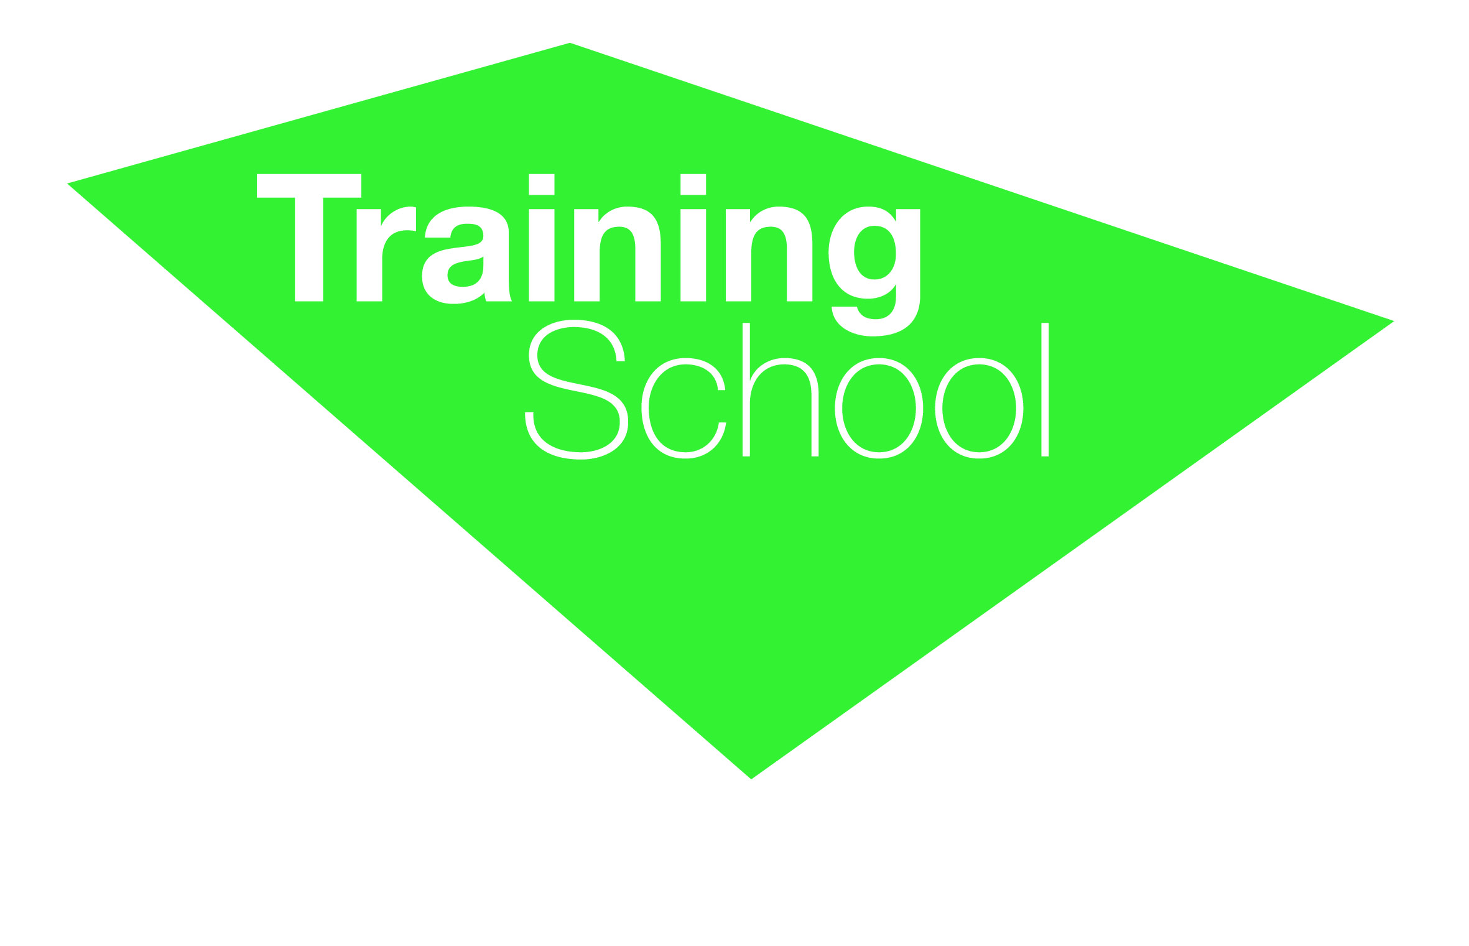

Job Description for 3i/c English

Brief
The successful candidate will work closely with the Head and Deputy Head of Department to ensure consistency across key stages. We are looking for someone who has the confidence and ability to ensure examination results in the subject continue to improve.
Skills
- Creative- showing, imagination
- Highly organised having the ability to work in a self-directed manner.
- Articulate, persuasive and commanding in a public setting
- Confident in leading and managing areas of the curriculum
- Effective at managing money and planning strategically

General roles and responsibilities
This will involve:

- Collating and analysing data at Key Stages 3, 4 and 5 at intervals during the year with a view to briefing the HoD on individual and groups of students who are not making expected progress
- To work with the HoD to devise and implement strategies to accelerate progress of underachieving students.
- To work with the HoD to monitor the progress of identified individuals or groups through tracking and regular updates from teachers
- To brief the department at meetings on those students targeted for intervention
- To liaise with the Data Manager regarding the department’s data needs

