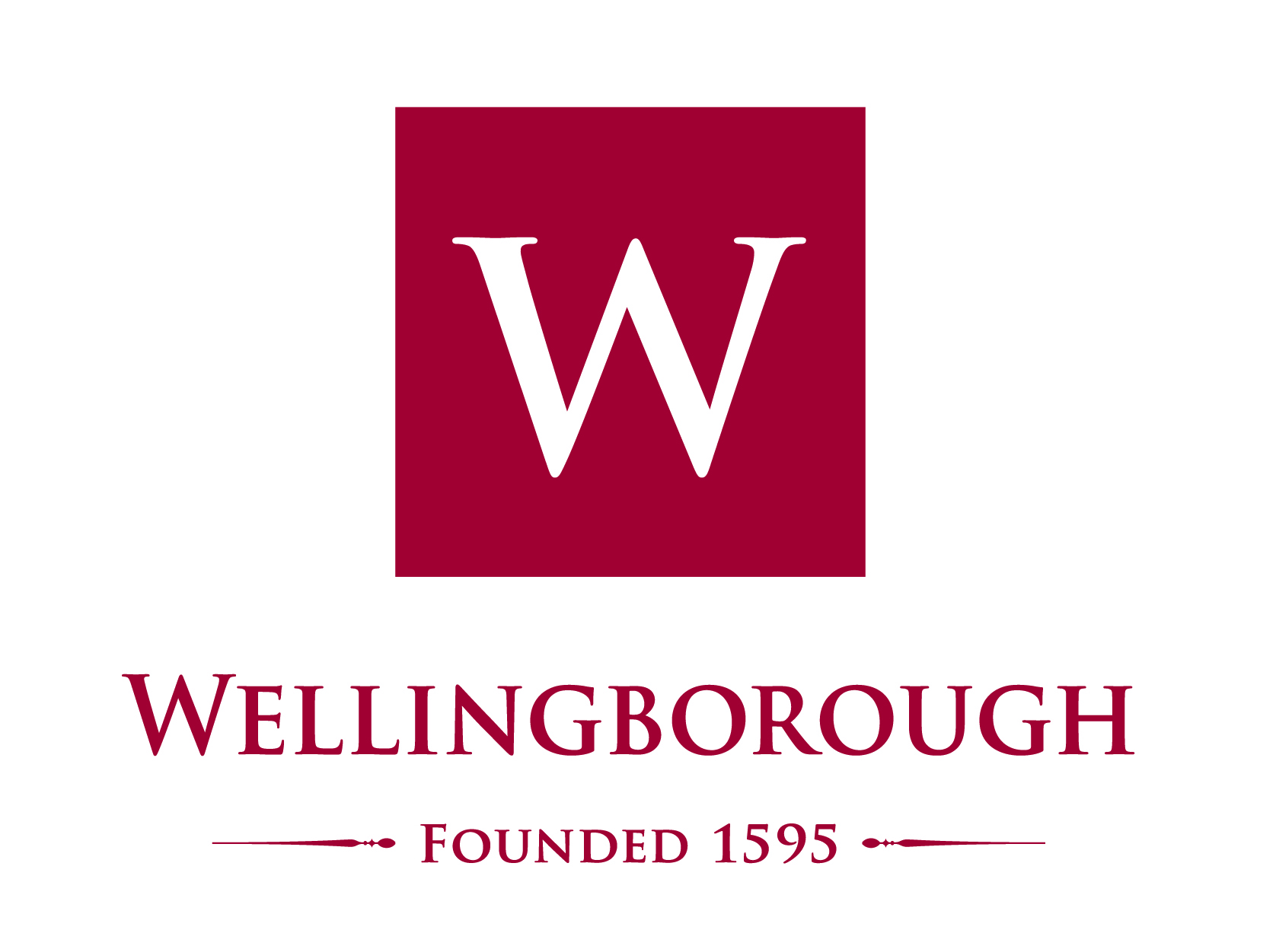

JOB DESCRIPTION

CHEMISTRY TEACHER

Post: Part-time Chemistry Teacher, (0.6) Wellingborough Senior School, Maternity Cover for November 2017 until May 2018

Wellingborough School was established in 1595 and is today an independent co- educational day school serving Northamptonshire, and adjacent parts of Bedfordshire, Buckinghamshire and Leicestershire. The School is a co-educational independent day School of some 850 pupils which comprises three elements, namely Pre-Preparatory (Age 3 – 8), Preparatory (Age 8 – 13) and Senior (Age 13 – 18). The School enjoys a strong academic tradition, which it is determined to maintain, combined with its extensive co-curricular programme.

A vacancy exists for a Chemistry teacher to deliver Chemistry from Year 9 to A level. The post would suit a well-qualified applicant who is a new or relatively new entrant to the profession, who would enjoy support from a departmental team committed to professional development, or a more experienced teacher looking for a part time role. There may be the possibility of additional hours for a competent sportsman/woman who could contribute to the extensive games programme of the School.

Chemistry at Wellingborough School
Chemistry is taught as part of the core curriculum up until the end of Year 11 and pupils begin working on the IGCSE Edexcel course in Year 9. A significant number of pupils opt to continue to study Chemistry at A level where they follow the OCR A specification. Results at all levels are good and a number of pupils go on to study Chemistry, Medicine and Chemistry related courses at prestigious universities following A levels. Results can be found on the School’s website, www.wellingboroughschool.org. The Chemistry Department undertake a number of activities additional to the teaching specification to include the Cambridge University C3L6 Challenge, visits to lecture days and exhibitions such as the Big Bang Fair, an essay competition with the Lower Sixth pupils and participation in CREST Awards.

In addition to the post being advertised, the Chemistry Department currently comprises 1 full time and one part time member of staff, each of whom is an experienced teacher, capable of teaching across the age range. There are many resources within the Department which can be used to give variety to lessons. The classrooms in the Department each have a networked PC and a ceiling mounted projector.

Responsible to: Headmaster of the Senior School who will undertake an annual review of performance against the specifics of the role description as set out below.

Salary: £ as per Wellingborough School teacher’s pay scale

Job purpose:
- To deliver an engaging approach to Chemistry teaching so that all pupils are encouraged to realise their full potential.

Relationships:
- Reports directly to the Acting Head of Chemistry of the Senior School.
- Works closely with the other Chemistry teachers in the Department.

Key Tasks and Responsibilities

Chemistry teacher:

- Prepare and deliver sequences of lessons to meet the collective and individual needs of the pupils. These will include:
- Specific learning needs eg gifted & talented, special educational needs.
- Subject specific needs.
- Use innovative new technologies to enhance learning for pupils.
- Maintain an exciting and stimulating learning environment.
- Assess pupils’ achievements and progress, inputting data and meeting deadlines in accordance with arrangements agreed within the School.
- Ensure that all classroom resources required are available and well maintained.
- Ensure that pupils are given Prep published on Show My Homework according to the homework schedule and monitor the standard of the work.
- Ensure that marking of pupils’ work is up to date and advise in a positive manner how work can be improved, in line with the School Marking Policy.
- Ensure that pupils are comprehensively prepared for examinations.
- Monitor and report to parents on the progress of pupils in the allocated set in line with the published schedule, including Parents' Evenings.
- Reinforce consistently high expectations for pupil behaviour in order to create a positive learning environment.
- Attend and contribute to Senior School Chemistry Department meetings.

Requirements of all staff:
- Pastoral care of pupils.
- Fully engage with professional development and appraisal.
- Participate in events and activities as per the Core Expectations for Senior School staff.
- Have proper and professional regard for the ethics, policies and practices of the School in which they teach and maintain high standards in their own attendance and punctuality.

Safeguarding:
The post holder’s responsibility for promoting and safeguarding the welfare of children and young persons for whom s/he is responsible, or with whom s/he comes into contact will be to adhere to and ensure compliance with the School’s Child Protection Policy Statement at all times. If in the course of carrying out the duties of the post, the post holder becomes aware of any actual or potential risk to the safety or welfare of children in the School s/he must report any concerns to the School’s Designated Person or to the Headmaster.

Wellingborough School will offer the successful candidate:
- Extremely friendly and vibrant staff and pupils
- Excellent CPD opportunities
- Supportive and aspirational parents
- Accommodation may be available for the successful candidate

Terms and Conditions:
- The School has its own salary scale
- Service is pensionable in accordance with the Teachers’ Pension Scheme and permanent members of teaching staff are entitled to a reduction in school fees
- School meals during term time
- Use of School sports facilities at staff allocated times

Applications
The application form should be returned together with a covering letter in which the applicant should explain what s/he can offer to the post. Applications by e-mail are welcome. Please send them for the attention of Mrs Karen Harrison, HR Manager to recruitment@wellingboroughschool.org by 1pm, July 2017.

