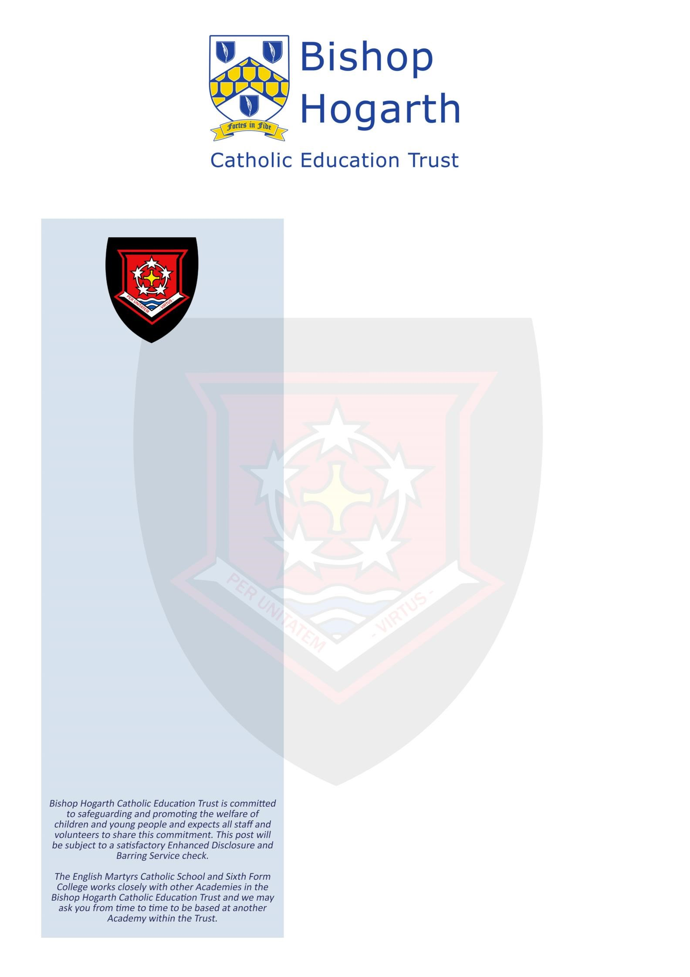

The Directors of Bishop Hogarth Catholic Education Trust and
Governors of English Martyrs are seeking to appoint Exam
Invigilators.

We require individuals to work on a casual basis durin
g our busy
examination periods.

Ho
urs are flexible by agreement.

Invigilators will be required to assist in the supervision of
stude
nts taking examinations

and will ensure that they are
conducted in accordance with regulatory requirements
.

Working as a team, invigilators contribute to en
suring a calm
environment for the exams, giving candidate’s confidence in the
process. The public examination period is May and June,
however, Invigilators will be

required to attend during the year
for training and to assist with internal exams.

Readers/
Scribes are required to support individual students by
reading aloud and/or transcribing verbal answers to
examination questions.

Good spoken and written English are
essential for this role.

Previous experience of invigilation would be advantageous but
n
ot essential. You must be

reliable and punctual, highly flexible,
able to relate to learners of all abilities and be comfortable in a
high
-
pressure environment. It’s a part
-
time role, but one that
can make a real difference
.

For further information please
contact Margaret Harris, Exams
Officer on 01429 273790.

Applications are available from
s
www.bhcet.org.uk/vacancie

and should be returned to
recruitment@e
ms.bhcet.org.uk

or by
post to The English Martyrs Catholic School and Sixth Form
College, Catcote Road, Hartlepool, TS25 4HA.

The English Martyrs Catholic
School and Sixth Form College

EXAM
INVIGILATORS

£10.98 per hour

Casual

Closing Date
:
Open Adve
rt

The English Martyrs Catholic
School and Sixth Form College,
Catcote Road, Hartlepool,

TS25 4HA.

