Application pack information

Principal, Farney Close School

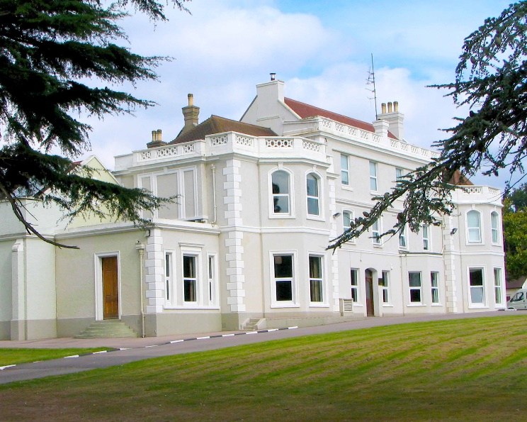

Terms and conditions of employment
Farney Close is a Group 2 school. Salary is offered on a Leadership scale between 18 and 25, plus residential schools allowance dependent upon the experience and skill of the candidate.

Accommodation in the school house or assistance with relocation
We have a recently refurbished charming 3 bedroom house positioned on the edge of the school grounds that can be offered at a reasonable rent to a suitable applicant either on a temporary or permanent basis. Alternatively, for applicants currently living more than 50 miles away from the school, we can offer a relocation allowance of up to £10,000 that can be used towards the cost of moving house, selling or buying a property. The terms of the relocation policy can be provided to applicants on request.

Living in the area
Farney Close is located equidistant between the cosmopolitan city of Brighton and Gatwick Airport, which provides easy access to national and international travel. Set amongst the South Downs in Mid –Sussex, the location provides ample opportunity to indulge in a range of activities and hobbies in beautiful countryside. National rail access is nearby and the coast is easy to get to, bringing opportunities for sailing, sea-fishing, coastal walks and rock-pooling. It’s a fantastic place for families and adults to live with a range of excellent maintained and private schools in the local area.

About the school and its environment.
Farney Close is an independent 5 day residential special school registered with the DFE for up to 70 girls and boys aged 9 -18 and has existed for over 70 years. The school is managed by a board of Governors and a board of Directors who oversee the running of the Company, which is a registered charity limited by guarantee. Set in 32 acres of mixed woodland, it has 3 fishing lakes, 13 residential houses and an extensive range of specialist classrooms, plus a sports hall and a new, large vocational building used for mechanics, construction and catering studies. Farney Close School is exceptionally well resourced.

Our staffing structure
The schools SMT currently constitutes a Head, Deputy Head and Head of Care. There are 13 teachers, including a Senior Teacher. In addition, there are 25 Residential Care Workers, plus a wide range of support workers for administration, catering, laundry, cleaning and maintenance.

Facilities and resources

The school is exceptionally well developed in terms of resources and accommodation and this reflects our determination to provide the very best resources for pupils and staff. It also supports our premise that outstanding physical and social environments provide a positive and stable model through which pupils have the best advantages to learn.

In addition to the quality of support offered by our staff, the unusually high level of therapeutic provision also reflects our commitment to meeting individual’s needs at all levels. As such, the range of therapy available includes Art, Drama, Speech and Language Therapy, Independent Counselling, and a Dyslexia specialist. Whilst we would not claim to be a therapeutic community we would say that the whole experience that a young person receives at Farney Close is therapeutic.

What’s it like to work at Farney Close?

Staff retention across the school is excellent and there are many amongst staff members that work directly with the pupils who have been employed for over 10 years at the school.

“Working at Farney Close provides me with a sense of achievement, in particular helping children with their development. My role here presents me with different challenges so that no one day is the same and that encourages me to be proactive”.

“I enjoy working with such a diverse group of young people and being able to be a part of their social development. I am also fortunate enough to be part of an incredibly supportive staff team who are able to keep each other laughing even on the harder days.”

“Farney Close is like no other job I have had, it has a wonderful community feel and is simply a great place to work”

“Everyone has a place at Farney Close – I enjoy the aspect of being tasked to motivate and inspire those around me. I feel I am appreciated and ‘allowed’ to take the initiative to get things accomplished. I am trusted.”

“Very supportive leadership team, with regards to professional training and welfare needs. I feel I make a valuable contribution and this is appreciated by school management. This is my eighth year working here and it is the happiest environment I have worked in.”

“I like being able to work with small groups of children. You get to know them well and so are able to address their individual needs. Staff are very supportive to each other, education and care. Management will listen to concerns and help resolve difficult situations.”

“I get a sense of “what I do, is making a difference” and I see that after the examination results come back in August. I feel that I am supported in building up each pupil’s self-esteem and self-belief. Even when behaviour deteriorates and learning becomes a challenge, again, I feel much supported by the school’s systems for positive behaviour management which is regularly practiced and taught in a real-life context.”

“I appreciate the level of support given from all the different departments within the school. Most members of staff will go out of their way to help whether a person is new or established in their roles. It is very pleasing coming to work knowing that the SMT will support and look after you”

The reputation and quality of the school.
The school has a consistently excellent inspection record, and over the last 16 years we have achieved 14 outstanding inspection reports for both our combined educational and care provision. The schools last joint inspection was in December 2018, and currently we are waiting for the written outcome from Ofsted (anticipated early 2019).

About our pupils
Pupils who attend are referred by Local Authorities from across the South of England and have a Statement/EHCP principally for SEMH, though we do also accept pupils with high functioning Social and Communication Difficulties (ASD), and those who experience cognitive or intellectual difficulties that affect emotions, behaviours and social interaction.

The school aims to develop young peoples’ educational and independence skills at all times and to make them aware of their personal and social responsibilities. Learning, whether it is social or educational, takes place in small groups and is laid out in step by step so as to be effective and clear. All packages put in place to support the young people are personalised and shaped to reflect the identified needs of the individual

Despite some pupils having attended many schools before coming to Farney Close or experiencing traumatic changes in home /life circumstances, they make good progress at Farney Close by comparison to other periods in their life. Pupils in year 11 will regularly sit between 10 and 13 GCSEs, or other types of external examinations, meaning that the possibilities of moving into further education are greater. Socially, it is observed that pupils and their families require increasingly less support from external agencies the longer they attend the school, and they become more socially aware and responsible during that time.

The school has 6th form provision that focuses mainly on three areas: College placement, Work Experience, and Independence Development. Our aim with this group of students is not necessarily to improve a pupil’s examination result, but to secure the next steps for the more vulnerable pupils who find an immediate move away from school at the end of year 11 very difficult to sustain.

December 2018

