February 2020

Dear Applicant

Thank you for your interest in the post of French Teacher. We are a friendly and collaborative department and would be excited to welcome forward-thinking and passionate teachers to the team. The successful applicant will be able to teach French to GCSE.

This position is suitable for either a newly qualified or more experienced teacher and has a start date of September 2020. Kennet has an excellent CPD programme and works closely with teachers at all stages of their careers to support their professional development and career progression.

Previously a specialist Language College, the school values the role of languages and this is evident in the curriculum as well as the uptake at GCSE and beyond. Taking an MFL at GCSE is compulsory for approximately 60% of pupils and we offer French and German up to A level.

The department is involved in thriving annual trips. Pupils are able to take part in a trip to France in Year 7. Sixth Formers are also encouraged to take part in a week’s work experience in the foreign country. The department is actively involved in outreach work (we offer master classes and teacher support) and liaison with local business and community.

If you’re undecided about applying, we would love to welcome you for an informal visit at your convenience. If you would like to discuss this or any possible job opportunities at Kennet School please contact Chris Ellison (Deputy Headteacher) on cellison@kennetschool.co.uk.

If you’ve already decided to apply, the easiest way to do so is by clicking the ‘Quick Apply’ button on the TES website. Alternatively, application forms can be downloaded from our vacancies page and submitted by email to office@kennetschool.co.uk Applications must be received by 9am, 24 February, with interviews the same week.

Yours sincerely

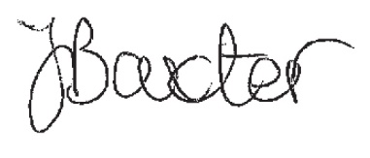

Ms J Baxter
Head of Languages

