

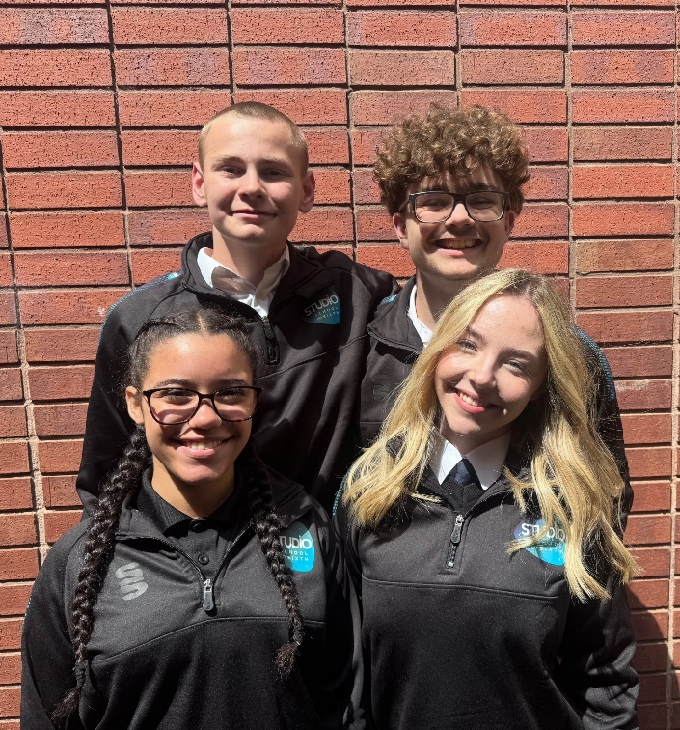

**Receptionist / Admin Support Assistant**

**Walsall Studio   
School & Sixth**

**Required for September 2025**

**Permanent, Full-Time.**

**Competitive Salary**

**(Grade 4 SCP 6-11: Actual Salary: £21,661-£23,455) )**

**Applicant**

**Pack**

**Deputy  
Headteacher**Quality of Education and Operations

**Walsall Studio   
School & Sixth**

**Required for September 2025**

**Permanent, Full-Time.**

**Competitive Salary**

**(Leadership L14 to L18)**

**Candidate Pack**

****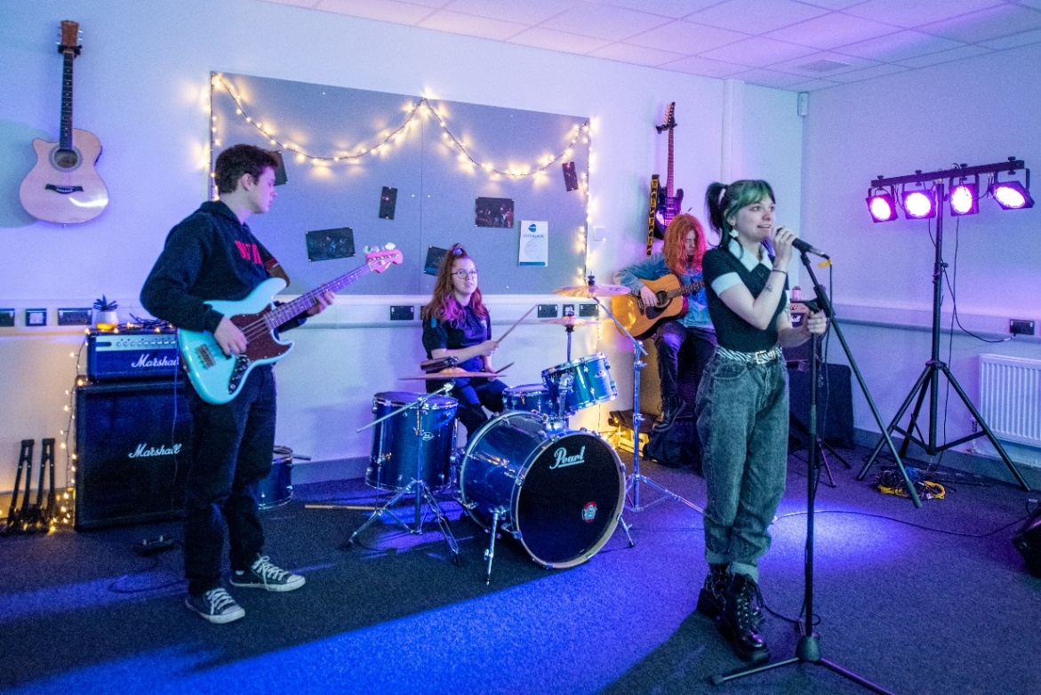

**WELCOME TO WALSALL STUDIO SCHOOL & SIXTH**

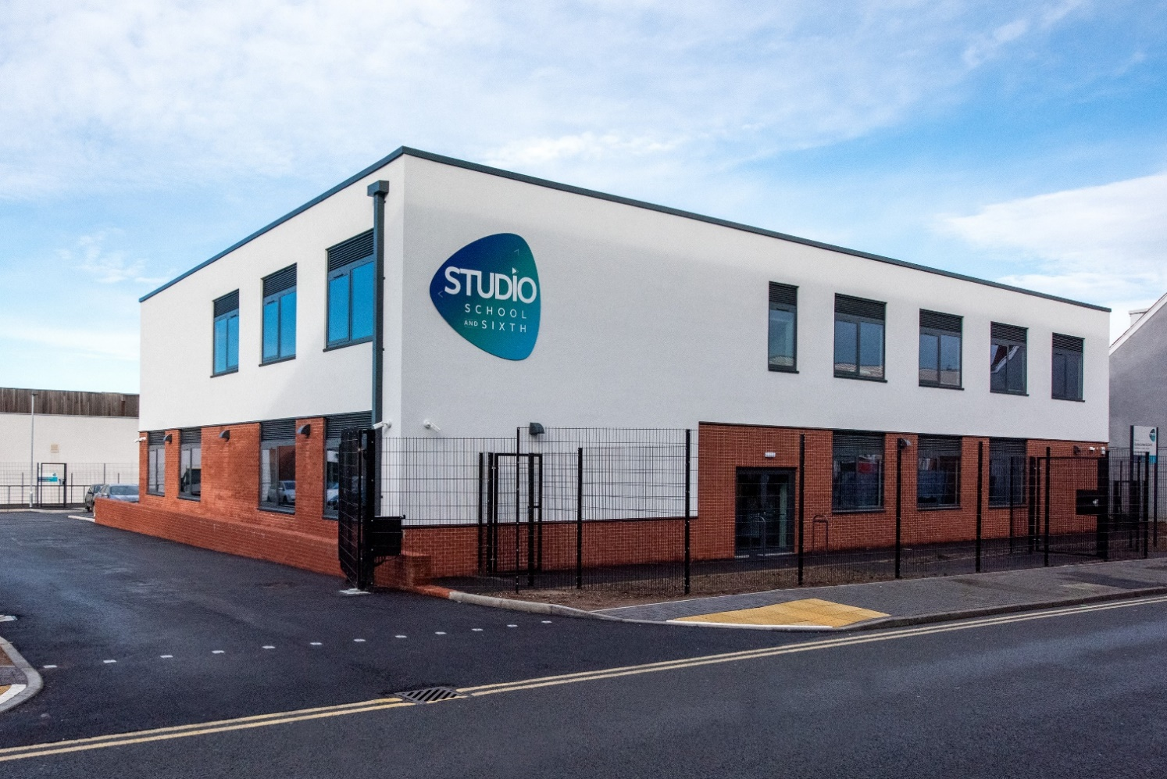

Dear Applicant,

Walsall Studio School and Sixth is a deliberately small, forward-thinking school serving young people aged 14 to 19 who are passionate about creative pathways in performance, music, and media. We offer a unique learning environment that looks and feels like a modern creative workplace rather than a traditional school, with flexible studio spaces and industry-standard facilities that reflect the real world our students are preparing to enter.

At the heart of our mission is a commitment to inclusion, aspiration, and professional standards. We believe in treating our students as young professionals, helping them to thrive both personally and creatively through high expectations, trauma-informed practice, and a deep understanding of the individual. Our culture is one where every student is known, seen, and supported.

As a founding member of *The Mercian Trust*, we are proud to be part of a family of schools that share our belief in partnership, collaboration, and community. We work closely with industry partners, creative professionals, and local organisations to ensure our students gain not just qualifications, but authentic experiences that prepare them for the world beyond education.

If you share our values and want to help shape the next generation of creative professionals, we would love to hear from you.

Yours sincerely,

Krissi Carter, Headteacher

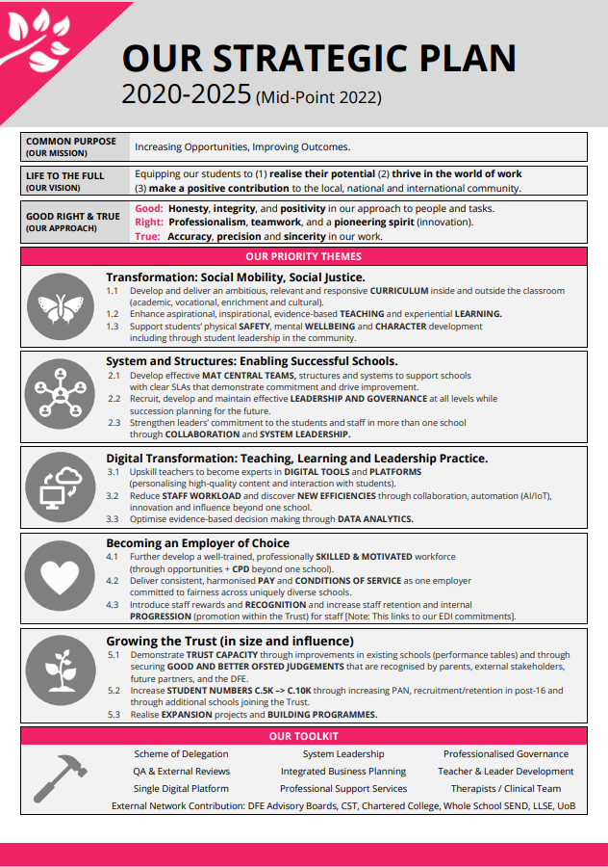

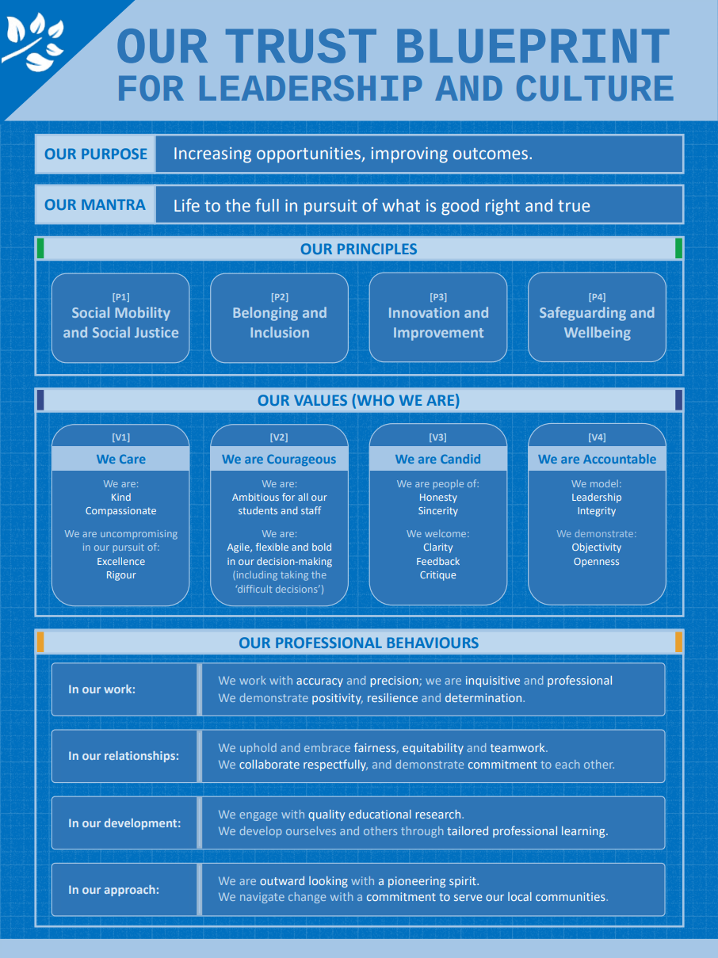

**THE MERCIAN TRUST**

The Mercian Trust is one of the largest regional Trusts in the West Midlands with 9 schools and more than 9,700 students. We are making strategic investments of time, focus, and resources into our people and organisational culture – and we are prioritising the development of leaders at all levels.

**About The Mercian Trust**

The Mercian Trust was incorporated in January 2018 and currently governs nine secondary schools, comprising selective grammar schools, large comprehensive schools, an alternative provision free school and a 14-19 specialist studio school.

In 2021, the Regional Schools Commissioner approved the merger between The Mercian Trust and Q3 Academies Trust. The formal merger transfer was completed on 1st May 2022 when all nine academies of the two Trusts became part of the same family of schools governed by The Mercian Trust.

* Aldridge School (11-18)
* Q3 Academy Great Barr (11-18)
* Q3 Academy Langley (11-16)
* Q3 Academy Tipton (11-18)
* Queen Mary’s High School (11-18, selective)
* Queen Mary’s Grammar School (11-18, selective)
* Shire Oak Academy (11-18)
* The Ladder School (Alternative Provision)
* **Walsall Studio School & Sixth (14-19)**

The Members of The Mercian Trust include The Vine Trust and the Queen Mary’s Foundation. Both are charitable organisations focused on improving the futures of local young people.

**Plans for the future**

We are nearing the conclusion of our current 2020-25 strategic plan:

1. **Leading students on a transformational journey** empowering social mobility and delivering social justice.
2. Develop and deliver an ambitious, relevant and responsive curriculum inside and outside the classroom (academic, vocational, cultural)
3. Enhance aspirational, inspirational, evidence based teaching and experiential learning
4. Support students’ physical safety, mental wellbeing and character development including student leadership in the community
5. **Establishing systems and structures** to enable successful schools
6. Develop effective MAT central teams and systems (finance/HR/Estates and more) to support schools with clear SLAs that demonstrate commitment and drive improvement
7. Recruit, develop and maintain effective leadership and governance at all levels while succession planning for the future
8. Strengthen leaders’ commitment to the students and staff in more than one school through collaboration and system leadership
9. **Driving the digital transformation**
10. Upskill teachers to become experts digital education (personalising high-quality content and interaction with students)
11. Reduce staff workload and discover new efficiencies through collaboration, automated operations, innovation, and influence beyond one school
12. Optimise evidence-based decision making through data analytics
13. **Becoming an employer of choice**
14. Further develop a well-trained, professionally skilled and motivated workforce (through opportunities and CPD beyond one school)
15. Deliver consistent, harmonised pay and conditions of service as one employer committed to fairness across uniquely diverse schools
16. Introduce staff rewards and recognition and increase retention and internal progression (promotion within the trust) for staff in all schools
17. **Growing the Trust in size and influence**
18. Demonstrate Trust capacity through improvements in existing schools (performance tables) and through securing good and better Ofsted judgements that are recognised by parents, external stakeholders, future partners and the DfE
19. Increase student numbers from c5k to c10k through increasing PAN, recruitment/retention in post 16 and through additional schools joining the Trust
20. Realise expansion projects and building programmes

***Areas of focus for the Trust board at the moment include:***

1. **Successful Growth**

Having consolidated following our successful Trust merger, we are now preparing for our next period of growth in size and influence including new schools joining our Trust, increases in PAN, and increases in sixth form numbers. Ensuring this growth enables us to develop and refine our structures, systems and staff to be even more successful for our schools and the communities we serve. We are well-positioned to make a significant contribution to a Trust-led education sector.

1. **Equality, Diversity and Inclusion (EDI) -** The Trust is passionate about its commitment to social mobility, social justice and inclusion in three significant areas.
2. **Students** - Closing the gaps in opportunity, attainment and progress for disadvantaged students, students with SEND, vulnerable students and others with protected characteristics that may mean they are more likely to face discrimination and prejudice.
3. **Staff** – Developing and nurturing opportunities for staff (including leadership development) particularly for those who are more likely to face discrimination and prejudice.
4. **Governance** - Increasing numbers of non-executive leaders and governors from underrepresented groups.
5. **Digital Transformation**

Delivering the digital transformation of how we teach, learn, lead and operate. The Trust is establishing a single consolidated digital ecosystem / infrastructure that facilitates ‘economies of scale’ and ‘network effect’ of being part of one charitable trust.

**Trust ethos & values**

Our name is rooted in history and expresses a geographical identity and ambition. The ancient kingdom of Mercia encompassed much of what we now recognise as the West Midlands – and crucially for us it included what we now call the Black Country. It was in Mercia that St Chad established an association of small monasteries which fostered unity through bonds of kinship.

Now, almost fifteen hundred years later, we look to demonstrate the same spirit in our approach. We are a family of schools committed to each other – diverse in nature, proud custodians of our history and success, but together, one charitable trust with a common purpose.

Our Trust exists to equip our students to:

* Realise their potential
* Thrive in the world of work
* Make a positive contribution to the local, national and international community.

Our mission is **increasing opportunities** and **improving outcomes**. Our mantra is Life to the full in pursuit of what is **good, right and true**.

Walsall Studio School  
**Receptionist / Admin Support Assistant**

**Job Title:** Receptionist/Admin Support Assistant

**Salary:**  (Grade 4 SCP 6-11: FTE: £25,183- £27,269 Actual Salary: £21,661-£23,455)

**Responsible to:** Office Manager/SLT PA

**Responsible for:** Front-of-House Services and Administration Support

**Role Type:** Support Staff

**Contract Type:** Term Time Only, 37 hours per week

**Working Hours:** Monday to Thursday, 8:00am – 4:00pm/Friday 8.00am – 3.30pm

**Job Purpose**

The Receptionist plays a vital role in ensuring the school provides a welcoming, efficient, and professional **front-of-house service** for all students, staff, visitors, and stakeholders. The postholder will act as the first point of contact at the school, providing a calm and courteous **reception and administrative support**. They will contribute to the smooth **day-to-day operation of the school, including admissions** and work collaboratively with the administration team to uphold safeguarding, communication, and organisational systems.

**Key Responsibilities**

**1. Reception and Front-of-House Services**

* Provide a professional, friendly, and efficient welcome to all students, parents, visitors, and contractors.
* Manage the visitor sign-in process, ensuring safeguarding protocols are followed at all times.
* Answer and direct telephone calls and emails, relaying messages accurately and promptly.
* Monitor the entry/exit of students during the day, ensuring procedures are followed for lateness, appointments, or early departures.
* Receive and distribute post and deliveries appropriately.

**2. Administrative Support**

* Provide general administrative support to the Office Manager/SLT PA, Senior Leadership Team (SLT), and wider school staff as required.
* Assist with daily communications, including issuing letters, emails, and text messages to parents and staff.
* Maintain accurate student information and contact records using the school’s MIS (e.g. SIMS).
* Assist in the preparation and distribution of documents and resources for meetings and events.
* Support with data entry, word processing, and the organisation of files, both electronic and paper-based.

**3. Student and Parent Liaison**

* Respond to student queries and needs at reception in a calm and supportive manner.
* Assist with administering first aid to students and liaise with parents regarding illness, injury, or welfare concerns.
* Support the coordination of parental communication and meetings, including helping with sign-ins at Parents’ Evenings and Open Evenings.

**4. School Operations**

* Provide cover for administrative staff where required, supporting key operational areas such as Attendance, Exams and Admissions (see below).
* Maintain a tidy, welcoming, and professional reception area.
* Ensure that health and safety, GDPR, and safeguarding expectations are upheld in all interactions and processes.
* Undertake any duties reasonably required to ensure the effective running of the school’s administrative and operational systems.
* Undertake any other duties commensurate to the role as directed by the Headteacher.

**5. Admissions Support**

* Provide administrative assistance to support the admissions process, working closely with the Office Manager/SLT PA to ensure a smooth and professional experience for prospective students and their families.
* Respond to initial admissions enquiries in a timely and courteous manner, signposting families to key information and recording interest on relevant tracking systems.
* Assist with the preparation and coordination of student recruitment events such as open evenings, induction days, and tours—including organising materials, confirming attendance, and supporting hospitality on the day.
* Help process admission forms and documentation, ensuring records are accurately maintained in line with the school’s data protection and safeguarding policies.
* Liaise with internal staff and external agencies to support transition arrangements and ensure prospective students are warmly welcomed into the school community.

**Safe Working Practices for Adults working with Children** – It is the responsibility of each employee to carry out their duties in line with Mercian Trust’s ethos and culture of safe working practices for adults working with children and be sensitive and caring to the needs of the disadvantage, promoting a positive approach to a harmonious working environment. Each employee should act as an exemplar on these issues and must, where appropriate, identify and monitor training for themselves and any employees they are responsible for.

***The School is committed to safeguarding and promoting the welfare of children.***

***All post holders are subject to a Satisfactory Disclosure & Barring Service Check (DBS) and satisfactory employment references, as well as identification and qualification, prohibition and barred list checks which will be required before commencing duties.***



Post Title:

Walsall Studio School

**Receptionist / Admin Support Assistant**

Person Specification

|  |  |  |  |
| --- | --- | --- | --- |
| **Criteria** | **Essential** | **Desirable** | **Assessment** |
| Qualifications | • GCSE English and Maths (Grade 4/C or above) or equivalent • Proficient in Microsoft Office applications (Word, Excel, Outlook) | • First Aid qualification • Relevant administration or customer service qualifications | AF (Application Form) |
| Experience | • Experience of working in a customer-facing or front-of-house role • Experience of using email and phone systems professionally • Experience handling confidential or sensitive information | • Experience working in a school or educational setting • Experience using SIMS or a similar MIS | AF, I (Interview), R (Reference) |
| Skills and Abilities | • Excellent verbal and written communication skills • Strong interpersonal skills; able to build rapport with students, families and colleagues • High level of accuracy and attention to detail • Ability to maintain confidentiality and demonstrate sound judgement • Confident using digital systems for record keeping and communication • Ability to remain calm under pressure and manage a busy workload | • Ability to work flexibly and respond to changing priorities | AF, I |
| Knowledge and understanding | • Awareness of safeguarding and data protection responsibilities • Understanding of professional conduct and customer service principles | • Understanding of school admissions processes | AF, I |
| Personal Qualities | • Warm, welcoming, and professional demeanour • Reliable, punctual, and well organised • Commitment to inclusive practice and supporting young people’s wellbeing | • Commitment to the school’s vision and values • Willingness to engage in further training or development | I, R |
| Other Requirements | • Willingness to undertake an enhanced DBS check and all pre-employment vetting |  | AF |

**OUR OFFER TO YOU**

* A superb staff team committed to doing their absolute best for all in our school community.
* Support from our Trust central teams and other schools in our Trust to ensure you have the tools to deliver success (our schools are all located close to one another, and we work better when we are working together).
* A wealth of support for your ongoing continuing professional development, including a Trust-wide programme for support staff drawing on expertise from across the Mercian Trust.
* A comprehensive employee assistance and staff benefits package including Simplyhealth (cash-back health plan and 24:7 video call and telephone access to GP and counselling), salary sacrifice schemes including our EdenRed discounts portal (ranging from gym membership to discount cards and vouchers for online and high street retailers).
* There will never be a dull moment; we never stand still, every day offers new challenges and opportunities within an ambitious, forward-thinking team.

**SAFEGUARDING AND SAFER RECRUITMENT**

* The Mercian Trust is committed to equal opportunities, safeguarding, and promoting the welfare of children and young adults. We expect all staff to share this commitment. As this post involves working in regulated activity unsupervised with children all post-holders are subject to satisfactory pre-employment checks including an online search check, Enhanced Disclosure and Barring Service check.
* You are required to uphold all relevant policies in respect of child protection and safeguarding, which are based on KCSIE (2024) and Working Together to Safeguard Children (2018).
* You are required to demonstrate and model the Nolan Principles (The Seven Principles of Public Life): Selflessness, Integrity, Objectivity, Accountability, Openness, Honesty, and Leadership. <https://www.gov.uk/government/publications/the-7-principles-of-public-life>
* You should demonstrate your commitment to our equality policy and all our related work to promote diversity, inclusion and belonging.

**KEY INFORMATION – HOW TO APPLY**



|  |  |
| --- | --- |
| **Post** | Receptionist / Admin Support Assistant |
| **Responsible to** | SLT PA / Office Manager |
| **Contract and Salary** | Full time, permanent  **(Grade 4 SCP 6-11: FTE: £25,183- £27,269 Actual Salary: £21,661-£23,455)** |
| **Closing Date** | Thursday 24th July 2025 |
| **Interview Dates** | Monday 28th July 2025 |
| **Start Date** | 1st September 2025 |
| **Informal Confidential Conversations and Visit of School** | To speak to someone about the post, please contact Angela Lingard, SLT PA and Office Manager at a.lingard@studio.merciantrust.org.uk |
| **How to apply** | Please complete the Online Application Form via our Mercian website. |