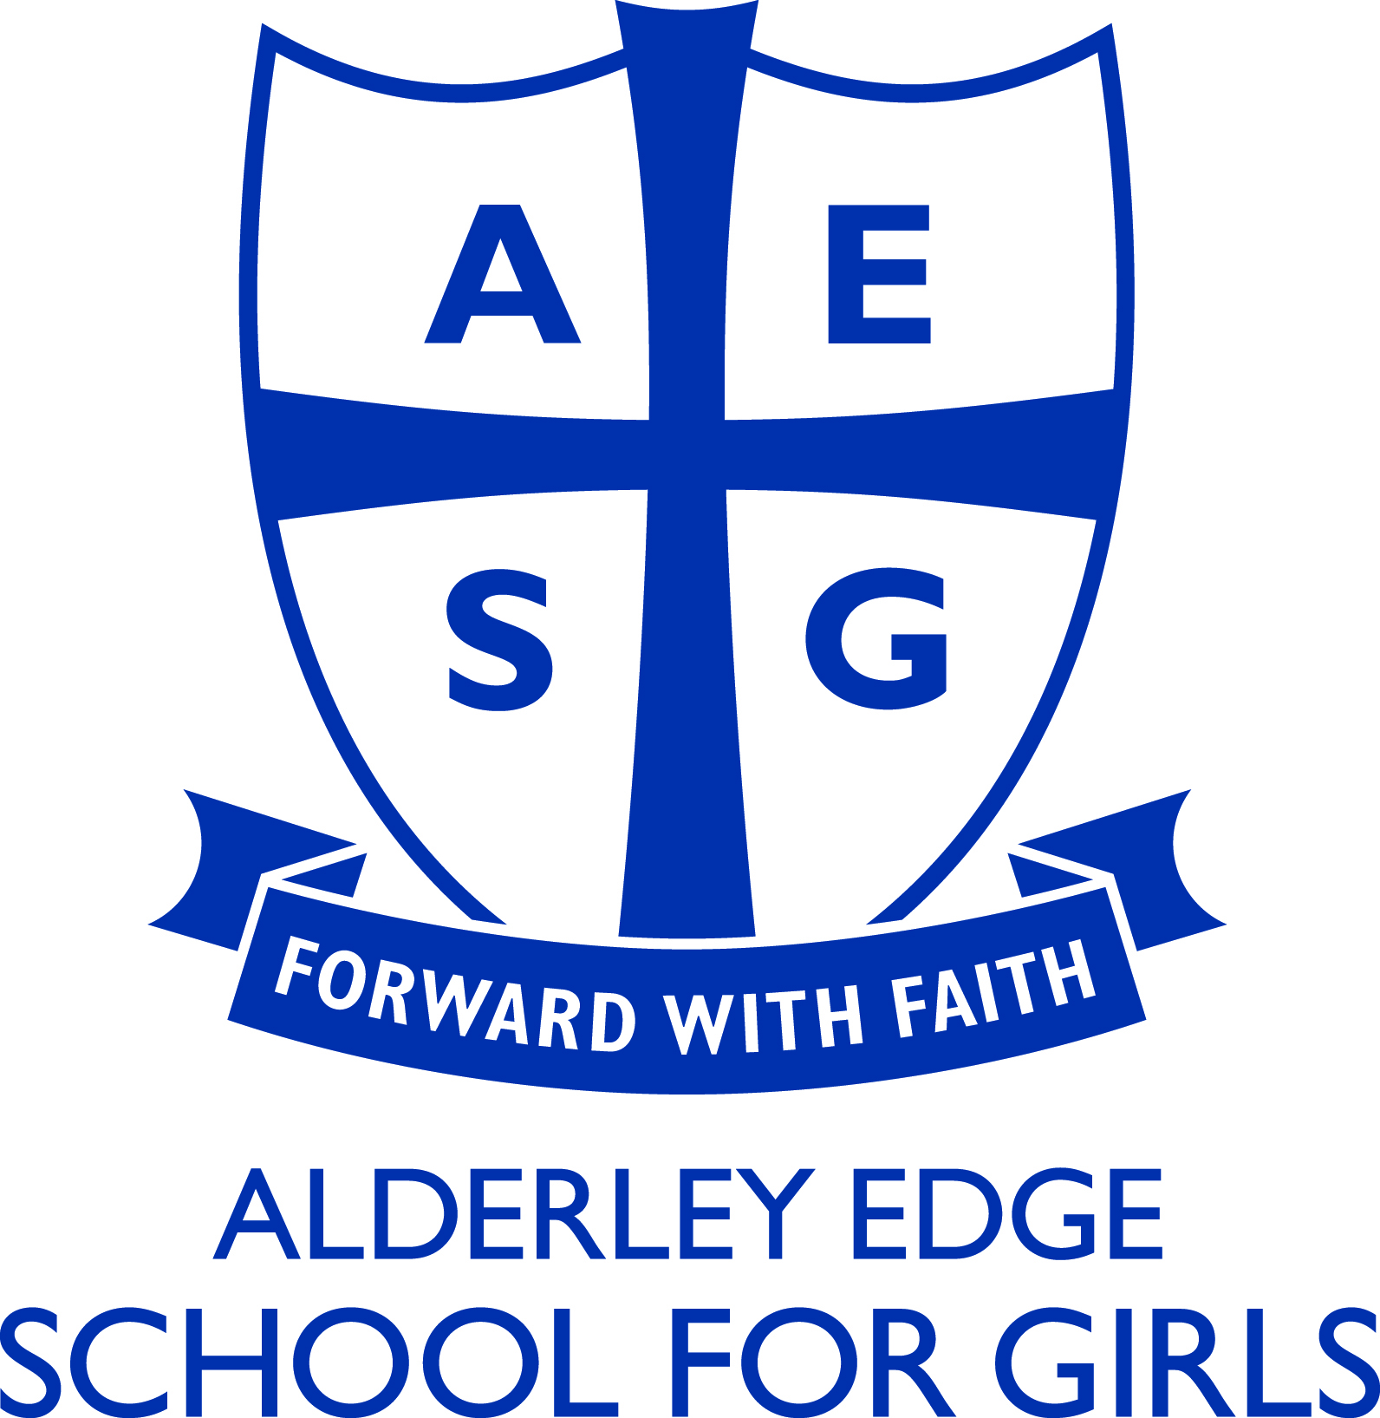

Modern Foreign Languages Department

Staffing

The Modern Languages Department consists of one full-time member of staff and 3 part-time members of staff who are teachers of French and Spanish. In addition, there is a part-time teacher in charge of German, as well as three language assistants for French, Spanish and German who work with Y10, Y11 and A Level classes. The Head of Modern Languages oversees French, Spanish and German.

Curriculum

All pupils have the opportunity of learning two languages until the end of Key Stage 3. Year 7 learn French, German, Spanish and Latin as part of a carousel until February. They then choose the 2 languages that they will carry on with in Years 8 and 9. At the end of Year 9, pupils opt for their preferred language(s) to study to IGCSE level. Every pupil must study at least one Modern Language at Key Stage 4 and good linguists can choose to do two languages, forming a dual linguists’ group in Years 10 and 11. The remaining single linguists are put into sets according to ability.

Facilities

Languages are taught in a suite of subject rooms which include a SANAKO Digital Language Laboratory and Promethean whiteboard. In addition, all other rooms are equipped with data projectors and computers.

Courses

In French, the Studio course is used at KS3 and the French IGCSE (cie) textbook by Hodder at Key Stage 4. At ‘A’ level, the ‘A Level French’ course by Hodder is used.

In German, currently Echo Express is the course used at KS3, together with the German IGCSE (cie) textbook by Hodder for Key Stage 4. For A Level we use the A Level German course by Hodder.

In Spanish, the Mira Express course is used at KS3 and the Spanish IGCSE (cie) textbook by Hodder at Key Stage 4. At ‘A’ level, the ‘A Level Spanish’ course by Hodder is used.

All pupils are encouraged to buy Mary Glasgow magazines to develop their independent learning skills.

Visits / The European Dimension

The Department has a history of exchanges with schools in Dax, France, and Eberbach, Germany, and currently offers educational visits to Spain, France and Germany.

In Year 8, all girls have the opportunity to spend a week in Normandy during the summer term, France and there is also a well-established KS4 trip to Madrid taking place in January. Pupils have also had the opportunity to visit the German Christmas Markets and visit our German partner school in a choir exchange.

Good links with several European countries have been established through our long-standing involvement in Erasmus+/Comenius projects, as well as personal links developed with Nîmes in France and Huelva in Spain.

Further Education

Sixth Form classes in languages have achieved great success in the past, with the vast majority of pupils obtaining good grades. There has been a steady number of pupils applying every year for degree courses in Languages and recently language students have obtained university places at Bristol, Sheffield and Birmingham.

