Deputy Headteacher  Mrs R Pindar | Assistant Headteacher  Mr R Mabbott | Assistant Headteacher  Mrs A Mackenzie | Assistant Headteacher  Mr M Burnitt | Business Manager  Mrs S Evans | Systems Manager  Mr S Petrow
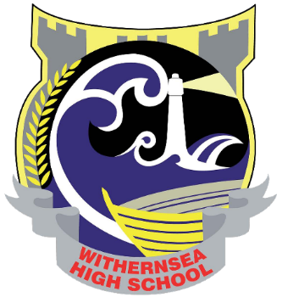

October 2022

Dear Applicant

Teacher of Science
Fulltime permanent post
MPS/UPS
Potential relocation payment

Thank you for your enquiry about the above position. This is an exciting position that would suit a teacher early in their career as well as a more experienced colleague.

This is a forward thinking and dynamic faculty that has broad appeal and ambitious goals for the future. Science is taught in seven specialist, well-equipped rooms within the newest part of our school.

To help you with your application please find enclosed with this letter the following items:

- Person Specification
- Job Description: Teacher
- General information for applicants about the faculty
- Brief notes relating to our recent Ofsted Inspection
- An Application Form

The closing date for receipt of completed application forms is 12 noon on Monday 17th October 2022. These should be addressed to Mrs K Burton (Headteacher’s PA).

Please feel free to call me for an informal discussion.

I look forward to receiving your application.

Yours faithfully

Mr M R Crofts
Headteacher

Working together, achieving more
Withernsea High School
Headteacher: Mr M R Crofts
Hull Road, Withernsea, East Riding of Yorkshire, HU19 2EQ
Tel: 01964 613133 Email: whstc@wscampus.net Web: www.withernseahigh.org.uk
24 Hour Attendance Line: 01964 611523

