
 Appointment
Information Pack








Vacancy | Principal
Location | Old Trafford Community Academy
Start date | September 2023
Closing date& time  Interview & Assessment | - Closing date for applications 27 March at 10am.  - Shortlisting – 27th March 2023.  - Interview and Assessment day 28.3.23
Salary | L18- L24
Return application to | Focus-Trust  Ram Mill Business Centre, Office 16, Gordon Street, Chadderton, Oldham, OL9 9RH  Chief Operating Officer  n.harris@focus-trust.co.uk  07733664904

Welcome from Helen Rowland, Chief Executive – Focus-Trust
Dear applicant,

Thank you for taking an interest in the Principal vacancy at Old Trafford Community Academy. The academy joined Focus-Trust in April 2014 and Mrs Stott, the substantive Principal, has been a valuable part of the school and Trust’s growth and development. We are very proud to have had Old Trafford Community Academy as part of our Focus-Trust family for almost 9 years; it is an exciting and diverse place to work with great children and a staff team who are passionate about providing all our children with a great education and always looking for the best ways to support individuals and accelerate their progress. The governing board are knowledgeable about the strengths and next steps for the school and are true partners in leading the school forward with the Principal and Trust.
We hope that you will find this information pack helpful in finding out more about this post. You are very welcome to make an appointment to visit the school on Tuesday 21st March 2023 and meet with Michael Rowland, Focus-Trust’s Education Director. If this date is not convenient, please do let us know so we can find a mutually agreeable time. Please contact Karl Elias, School Business Manager 0161 912 4875 to make an appointment.
If you would like a further conversation about any aspect of this post or about working as part of Focus-Trust, please do not hesitate to contact me directly by email h.rowland@focus-trust.co.uk or call Janet Berry (Executive Assistant) who will arrange a telephone call (07867 423870).

Please contact us if you require any further information.

Please return all completed documents to n.harris@focus-trust.co.uk by 27 March at 10am.

Welcome from Mike Cordingley, Chair of Governors

Dear applicant,
Thank you for taking the time to consider applying for the role of Principal of Old Trafford Community Academy. As Chair of the Governing Board, I would like to take this opportunity to tell you a little bit about the context of our school.
We are located in Trafford close to its border with Manchester and its city centre, and have over 400 children on roll. Our diversity is a real celebration as our children and families come from a wide range of backgrounds.
We converted to an academy on 1st April 2014. We value the highly skilled professional support and challenge that Focus-Trust provides. At the same time, we have maintained our place in the Trafford family of schools playing a full role in the Stretford and Old Trafford leadership cluster of primary schools. It is a feature of the educational dynamic in the area that Trafford has retained selection to grammar schools within its authority boundary.
Our children and our families are at the very heart of all that we do and the partnership with parents and the commitment of our staff, really allows our children to achieve well and become lifelong learners. The high quality of relationships that we develop with children, parents and colleagues allows everyone to feel a sense of community and belonging.
When you visit us, you will find children who are happy to be in school. We have a reputation for being friendly and welcoming with an exceptionally hardworking team of staff. Our recent Ofsted inspection recognised the progress we have made and confirmed we are working on the key areas for improvement. The full Ofsted report can be found on the school website.
I hope I have given you a flavour of Old Trafford Community Academy. We have every confidence that we will successfully recruit a Principal who would like to become a valued part of our school community and who will help us to continue to develop our vision to provide the best possible education for the benefit of our pupils, their families and the community in which they live.

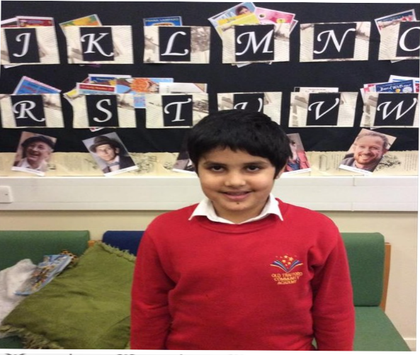

Academy details
3
Address Old Trafford Community Academy
Malvern Street
Old Trafford
Stretford
Manchester
M15 4FL
Telephone 0161 912 4875
Website www.oldtraffordcommunityacademy.co.uk

Job description

Job title | Principal
Academy | Old Trafford Community Academy
Grade | L18-L24
Accountable to | The Chief Executive Officer

Key Purpose
Provide consistently high-quality leadership and management which ensures continuing improvement and success with a focus on accelerating and sustaining pupil progress.
To play a leadership role in:
- Formulating and modelling the aims and the objectives of the school and the improvement plan
- Establishing the policies and guidance through which objectives are to be achieved
- Managing staff and resources to achieve the objectives of the school and the improvement plan
- Lead teaching, curriculum and assessment in order to achieve the best outcomes for all pupils
- Monitoring progress towards their achievement

Key relationships
- Children, parents and staff
- Local governing board
- Chief Executive and other members of the Focus-Trust team
- Other school Principals/Headteachers
- The members and trustees
- Other local Schools and stakeholders

Key responsibilities
The following information is not intended to be exhaustive but included to give an indication of the type of duties associated with the role of Principal in order to realise the school’s vision and outcomes of the school.

The key duties are set out under the following headings:
- School culture
- Teaching and learning
- Curriculum and assessment
- Behaviour
- Additional and special education needs and disability.
- Professional development
- Organisational management
- Continuous school improvement
- Working in partnership
- Governance and accountability
- Child protection and safeguarding
- Deputies
- Specific responsibilities

School culture
  - Establish and sustain the school’s ethos and strategic direction in partnership with those responsible for governance and through consultation with the school community
  - Demonstrates and articulates high expectation and ambition for the whole school
  - Develop a culture where pupils experience a positive and enriching school life
  - Uphold ambitious educational standards which prepare pupils from all backgrounds for their next stage of education and life
  - Promote positive and respectful relationships across the school’s community and a safe, orderly and inclusive environment
  - Work with staff to ensure a culture of high staff professionalism
  - Ensure that the school reflects a vibrant and inclusive ethos which actively values and promotes diversity, community cohesion, and supports pupils to become successful integrated citizens.
  - Actively challenge and address discrimination.
  - Ensure that monitoring takes account of different pupil groups and data is used to close gaps; ensuring equity for all pupils.

Teaching and learning
  - Work with staff and school leaders to establish and sustain high-quality, expert teaching across all subjects and phases, built on an evidence-informed understanding of an effective pedagogical approach to teaching and how pupils learn
  - Ensure teaching is underpinned by high levels of subject expertise and approaches which respect the distinct nature of subject disciplines or specialist domains
  - Ensure effective use is made of formative assessment

Curriculum and assessment
  - Work with school leaders to ensure a broad, structured and coherent curriculum entitlement which sets out the knowledge, skills and values that will be taught
  - Work with curricular leaders, to develop leaders with high levels of relevant expertise with access to professional networks and communities
  - Ensure that all pupils are taught to read through the provision of evidence-informed approaches to reading, particularly the use of systematic synthetic phonics.
  - Ensure valid, reliable and proportionate approaches are used when assessing pupils’
knowledge and understanding of the curriculum

- Behaviour
  - Establish and sustain high expectations of behaviour for all pupils, built upon relationships, rules and routines, which are understood clearly by all staff and pupils
  - Ensure high standards of pupil behaviour and courteous conduct in accordance with the school’s behaviour policy
  - Work with teachers and middle leaders to implement consistent, fair and respectful approaches to managing behaviour
  - Ensure that adults within the school model and teach the behaviour of a good citizen

Additional and special educational needs and disabilities
  - Ensure the school holds ambitious expectations for all pupils with additional and special educational needs and disabilities.
  - Establish and sustain culture and practices that enable pupils to access the curriculum and learn effectively.
  - Ensure the school works effectively in partnership with parents, carers and professionals, to identify the additional needs and special educational needs and disabilities of pupils, providing support and adaptation where appropriate
  - Ensure the school fulfils its statutory duties with regard to the SEND code of practice.

- Professional development
  - Prioritise the professional development of staff, ensuring effective planning, delivery and evaluation which is consistent with the approaches laid out in the standard for teachers’ professional development.
  - Work with staff to ensure they access high-quality, relevant professional development opportunities, aligned to balance the priorities of whole-school improvement, team and individual needs.

Organisational management
  - Ensure the protection and safety of pupils and staff through effective approaches to safeguarding, as part of the duty of care
  - Ensure staff are deployed and managed well with due attention paid to workload
  - Work with organisational systems, processes and policies that enable the school to operate effectively and efficiently

Continuous school improvement
  - Work with all staff to make use of effective and proportional processes of evaluation to identify and analyse complex or persistent problems and barriers which limit the school’s effectiveness, and identify priority areas for improvement
  - Develop and understand appropriate evidence-informed strategies for school improvement.
  - Work with all school leaders to implement effective improvement strategies, which lead to sustained school improvement over time

Working in partnership
  - Forge constructive relationships beyond the school, working in partnership with parents, carers and the local community
  - Commit the school to work successfully with other schools within the Trust and other organisations in a climate of mutual challenge and support
  - Establish and maintain working relationships with fellow professionals and colleagues across the Trust to improve educational outcomes for all pupils

Governance and accountability
  - Establish and sustain professional working relationship with those responsible for governance
  - Ensure that staff know and understand their professional responsibilities and are held to account
  - Work with school leaders to ensure that the school effectively and efficiently operates within the required regulatory frameworks and meets all statutory duties

Child protection and safeguarding
  - Ensure that the school complies with all national and local safeguarding requirements.
  - Ensure that the child protection policies and procedures are fully implemented and followed by all staff.
  - Ensure that sufficient resources and time are allocated to enable staff to discharge their child protection related responsibilities effectively.

Ethics and professional conduct
- selflessness
- integrity
- objectivity
- accountability
- openness
- honesty
- leadership
- optimism
- enthusiasm

This job description is not exhaustive and may be changed at any time to meet the changing requirements of the school or the Trust. This job description details responsibilities but does not direct any particular priorities or amount of time to be spent carrying out these duties.
The post holder is expected to:

- Actively support the work and ethos of the Focus-Trust.
- Undertake such additional duties as may reasonably be requested by the Chief Executive.
- Respect confidentiality of staff, pupils, families and visitors and not breach this trust.
- Participate in arrangements for appraisal and in the identification of areas in which s/he would benefit from training and undergo such training.
- Proactively keep abreast of developments in relation to the post, and whenever possible and appropriate, attend professional development opportunities.
- Comply with and support all policies of the Focus-Trust and school.
- Ensure that all statutory requirements are met.

Person specification

Key to assessment methods; A – Application form
I – Interview process
R – Reference
Qualifications | Essential | Desirable | Evidence
Qualified Teacher Status | √ |  | A
Graduate level qualification | √ |  | A
Evidence of continuing and relevant professional development in school leadership and management |  | √ | A
Skills and Experience
Ability to actively lead and promote the values and vision of the school | √ |  | A/I/R
Leadership experience across all Key Stages | √ |  | A/I/R
Knowledge and understanding of effective strategies for supporting the learning needs of higher achieving children, children with Special Educational Needs and disabilities and  disadvantaged children | √ |  | A/I/R
Experience of working within a culturally diverse community |  | √ | A/I
Experience of promoting a culture of children’s rights | √ |  | A/I/R
Strategic Direction and Development
A thorough knowledge of the major curriculum issues, current educational development and legislation | √ |  | A/I
Evidence of ambition and success for every child by setting and achieving challenging goals and targets bespoke to their needs | √ |  | A/I
A strategic approach to school improvement | √ |  | A/I/R
Experience of leading change effectively | √ |  | A/I
Leading People and The Organisation
Proven leadership experience capable of translating vision into concrete strategy, with a track record of delivery | √ |  | A/I/R
Ability to lead and inspire staff, governors, pupils and parents in shared expectations, vision and values | √ |  | A/I/R
The ability to lead and manage the school in a way that encourages the sharing of responsibilities and development of individuals. | √ |  | A/I/R

About our School

Academy vision
Old Trafford Community Academy is a very special place. We have a wonderfully diverse school community, with an equally diverse range of strengths and needs. We are ambitious for all our children and committed to going the extra mile to remove barriers to learning. We aim to be a community school in the widest sense of the word, supporting children within the context of their family and their wider communities.

Our pupils
Our pupils are the best advertisement for our academy! They come from a diverse range of backgrounds, and work and play well together. The proportion of children eligible for pupil premium is well above average. The majority of children speak English as an additional language.

Our staff
We have a large and talented staff team. We believe that our children and their families need the very best staff to support them. We are therefore committed to supporting ongoing staff professional development. All new staff will be offered training and support, through an agreed induction programme.

Our geographical area
Old Trafford Community Academy is an inner-city primary academy serving a multi-cultural area. We are situated in a pocket of high deprivation within Trafford, close to Manchester city centre.

Our facilities
We occupy a modern building, with good outdoor facilities. We are lucky to have facilities for a range of extended services to support children and their families.

Our school organisation
We are a two-form entry school. Year groups plan together, and support each other in delivering the whole curriculum. The academy leadership team consists of Principal, Vice Principal, three Assistant Principals and the Business Manager.

Our curriculum
Our curriculum is led by our Vice Principal, supported by our Leading Teachers. We use Focus English and Power Maths to support our teaching. Much of our learning is through our termly academy-wide topics. We are supported by specialist teachers and coaches in music and PE/sports. Our curriculum is designed to support our Big Three, which we believe are essential for all children: good communication skills; physical health and well-being; and emotional health and well-being.

Our extended services
We have a wide range of extended services to support children and their families. This includes universal services for the whole community, alongside more targeted support where needed. For example, we employ extended support workers and an independent social worker to help us provide early intervention to support our most vulnerable children and families.

School Quick Facts

Type of school | Primary
Age range | 4-11
Location/LA | Trafford
Number of children | 412
Number of teaching staff | 19
Number of support staff | 14
% FSM | 44.9%
% SEN | 20.9%
% EAL | 72.6 %

Background to the Trust
Focus-Trust was incorporated in May 2012 as a primary trust. The Trust has links with the sponsor, Focus Education, but is an entirely separate legal entity. As with all academy trusts, the Trust is a company limited by guarantee and an exempt charity. The Trust’s offices are situated in a newly converted historic mill conversion in Chadderton, Oldham with excellent motorway networks to access our schools.

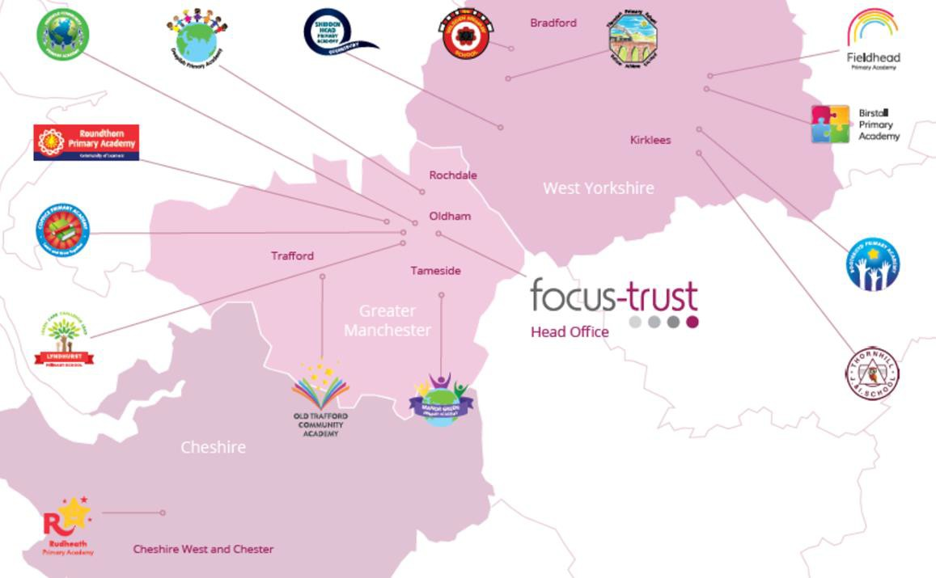

The defining feature of Focus-Trust is that it is a specialist primary phase trust. This means that the work of the Trust is driven by the distinctive needs of primary schools. Whilst the Trust has robust systems for accountability, each school has their own distinctive identity, ethos and culture, and this is a commitment to every school when they convert and join the Trust.
Focus-Trust currently has a small centrally employed team. The members of the team are highly skilled and committed to the vision, culture and values of the Trust.

All the schools within the Trust are willing partners who have actively chosen to join Focus-Trust and there is a very high degree of consensus, cooperation and commitment from within the group.
The Trust has robust policies and systems in place to govern and guide its work. These have been gradually implemented as the Trust has grown. The Trust has well-established productive relationships with trade unions and meets half termly with a group of national trade union representatives to discuss policy development. This has enabled us to introduce and change a range of policies in a streamlined and cooperative way.

Vision
‘Great schools at the heart of our communities’ - with our Community Champions and colleagues, we strive to ensure we are being civic leaders making a difference in the local and national communities and the community is supporting us.

Commitment
‘Learning together, making the difference’

Collective Efficacy
We have a well-developed and securely embedded culture of Collective Efficacy. By this we mean we have, ‘A shared commitment to work together on the things that matter to improve outcomes for all.’

The Focus-Trust Values
Professional honesty is at the heart of everything we do. The Trust knows the schools well because of the strong working partnership between academy leaders and the Trust Central Team. It is only by being honest and transparent with a balance of credible challenge and effective support, that we can move forward and get the best for all children and staff. Our work is underpinned by our values:
Care for children, adults and the learning environment
Dare to do things differently and have a go
Be fair, honest and inclusive – demonstrating integrity
Share expertise and best practice for the benefit of all learners
What you might want to know about Focus Trust

Pensions
Focus-Trust contributes to Teachers’ Pensions and Local Government pensions in the same way and with the same level of contribution as local authorities.
Continuous service
Focus-Trust recognises continuous service (as detailed within contracts of employments)
Employer Relations
Focus-Trust has a Trade Union agreement which recognises the teacher and support staff unions. This is further supported by an ongoing and productive relationship with key trade union officials.
Equality of opportunity
Focus-Trust is an equal opportunity employer, dedicated to a policy of non-discrimination in employment on any basis including age, gender, race, colour, nationality, ethnic origin, disability, gender, religion, age, marital status, sexual orientation and/or medical condition.
Safeguarding
Focus-Trust is committed to safeguarding and promoting the welfare of all children and young people. There is an explicit expectation that all employees share this commitment and adhere to all safeguarding policies and procedures. Applicants should be aware that the recruitment process will include an assessment of your suitability to work with children.
Dress code
We expect all colleagues to dress professionally and appropriately for the roles undertaken. We pride ourselves on the high standards of dress of both our pupils and staff; these standards are led by our colleagues who we expect to set an example.
Policies
Focus-Trust and the schools have a range of policies and handbooks that help to make clear our expectations and ways of working. These are always shared openly with staff and are accessible to everyone. There are several policies that prospective employees should be aware of when making an application. These can be found on the Trust website www.focus-trust.co.uk and school websites. All members of staff will be asked to sign a declaration as part of the induction process to acknowledge that they have read and understand the Code of Conduct and some of the key policies, e.g. Safeguarding and Child Protection, Health and Safety, Acceptable use of IT.
Right to work in the UK
Under the Asylum and Immigration Act 1996, it is a criminal offence to employ anyone who is not entitled to live or work in the United Kingdom. Applicants can expect us to ask for proof of this at interview stage, where you will be asked to provide some original documentation to confirm that you are eligible to work within the UK. Photographic proof of identity will also be required.
Validation of qualifications and identity
All shortlisted candidates will be asked to bring original certificates or relevant qualifications and identity documents to interview. These will be photocopied and kept on file and, if appropriate, may be confirmed as genuine with the relevant awarding bodies. The copies of the successful candidate will be retained on their personnel file. The copies of unsuccessful candidates will be treated as confidential waste and disposed of appropriately.
References and Social Media Checks
If you are shortlisted, we will take up references before the interview date. One of your referees must be your current or most recent employer. Two satisfactory references must be received before we can confirm any offer of an appointment. The information we request will relate to salary, length of service, skills and abilities, suitability for the job, disciplinary record and suitability to work with children. Copies of references or open references will not be accepted. On receipt of references, your referees may be contacted to verify any discrepancies, anomalies or relevant issues as part of the recruitment verification process.
In line with our safer recruitment policy, on line presence checks will be undertaken if you are shortlisted. This check is designed to complement the range of standard recruitment checks and allows us to identify a candidate’s online presence which potentially could damage the organisation’s reputation.

Knowledge and skills profile
This is an important part of your application and is your opportunity to explain how you meet the person speciation for the post. You should demonstrate your skills, knowledge and experience and give short examples. Describe how you match the requirement of the job; include experience gained from previous jobs, community or voluntary work. Ensure that the information you give is well organised, relevant and brief. You may find it helpful to use sub-headings in order to keep your statement well focused. If you do not submit this profile, you will not be considered for short listing.
Disability
To comply with the Equality Act 2010, we are legally required to consider making reasonable adjustments to ensure that disabled people are not disadvantaged in the recruitment and selection process. We are therefore committed to meeting, wherever possible, any needs you specify on the application form. Please contact Natalie Harris if you need to discuss this in any detail. We will consider any reasonable adjustment under the terms of the Act to enable an applicant with a disability (as defined under the Act) to meet the requirements of the post.
Disclosure of a criminal record
Employment in this role is subject to an enhanced check with the Disclosure and Barring Service (DBS). Checks will also be made against the lists showing people barred from working with children. All checks must be satisfactory before any offer of employment can be confirmed and before commencement of work can take place.
Please return all completed documents to n.harris@focus-trust.co.uk (Chief Operating Officer) by 27 March at 10am.
Thank you for taking the time to read this information pack.
We wish you every success in any application you may make.

