 | Vanguard Learning Trust  The Vanguard Learning Trust is a group of local primary and secondary schools in Hillingdon. We strive to be a Trust that serves its local community and is pioneering in its approach to broadening our students’ lives. We believe in effective teaching which allows our students to shine both in and out of the classroom and that intellectual curiosity is at the core of every learning experience. Whilst schools in the Trust have their own ethos and values, they share the common aspiration that all students can achieve their potential and life is a journey of discovery.

Higher level teaching assistant (HLTA)
Information for applicants

April 2023



Dear applicant

This is a rare opportunity to join Ryefield’s dynamic, enthusiastic and hardworking team. We are looking for an excellent HLTA to join our hardworking and friendly team of professionals.
We need a dedicated, ambitious individual who can enthuse, motivate and empower children, to help them make the best progress possible. We are a supportive and friendly team committed to providing high quality teaching and learning in welcoming and nurturing environment. We will invest in your professional development to ensure the very best for our students.
We are looking for a HLTA who:
- Is a reflective practitioners;
- Places the needs of the child at the heart of their decision making;
- Is committed to developing students’ rational and emotional mind;
- Works well with a team of professionals,
- Is committed to the inclusion of all children;
- Understands the importance of supporting and engaging with families and the wider community.
The school will:
- Equip you with skills to make long and lasting change in the classroom;
- Invest in your professional development and empower you to make your mark;
- Offer you a spacious and well equipped school;
- Support you with a team of experienced professionals who will provide you with high quality professional development, including peer support and opportunities for cross school/phase working.
Visits to the school are encouraged; please contact the school on 01895 547036 to arrange an appointment.

Contents

Trust information 4
Job description 6
Person specification 9
How to apply 11

Trust information

Vanguard Learning Trust is a cross-phase Trust in the London Borough of Hillingdon. Vyners Learning Trust was established in February 2015 when Ryefield Primary School and Vyners School formed the multi-academy trust. In September 2018, Ruislip High School joined the Trust which was renamed Vanguard Learning Trust. The Trust currently has five schools: Field End Junior School, Hermitage School, Ruislip High School, Ryefield Primary School and Vyners School. The history of Vanguard Learning Trust is available on the Trust’s website (click here).

School information

Field End Junior School
Field End Junior School is truly a community school and has been part of the Ruislip landscape for over 70 years. It is a four-form entry junior school, sharing the same site as the infant school. It is a genuinely happy and exciting place to be; the school’s community plays an important role in shaping the young people into the adults they become when they go out into the world. Staff strive to do all they can to help each child reach their potential. Staff believe that school days should be filled, not only with learning, but with fun, friendship and memories to last a lifetime.

Hermitage Primary School
On entering Hermitage Primary, visitors cannot fail to notice the warm, family feel that permeates the school. Hermitage is a happy, welcoming, stimulating environment where everyone cares about each other and all interactions are based on mutual respect. Hermitage opened in 1968 and is a community school located in Uxbridge. From their first tentative sessions in Nursery through to their final days in Year 6, staff strive to teach pupils their place in the school, the community and beyond.

Ruislip High School
Ruislip High School opened its doors to its first cohort of Year 7 in September 2006. It is a mixed, comprehensive secondary school situated in South Ruislip. Ruislip High School has evolved into a school of choice in the local area with circa 1100 students. The school has been designated outstanding in both Ofsted inspections in 2007 and 2011. Ruislip High School’s logo symbolises the school’s motto -from grass roots, to reaching for the sky- which represents high aspirations and students’ journey as they progress through the school.

Ryefield Primary School
Ryefield was established in 1960 and as a school community it strives for excellence. Ryefield is an excellent school where its children love learning and achieve the highest standards possible in a thriving multicultural learning environment. Above all Ryefield strives to touch the lives of all its children to ensure they grow up to be reflective, self-aware, and resourceful; they are empathetic towards others and confident young people.

Vyners School
Vyners School was established in 1960. It is a highly oversubscribed mixed secondary, comprehensive school based in Ickenham with circa 1200 students. Vyners is an extremely popular and successful school with an excellent reputation for academic achievement and extra-curricular activities. Underpinned by its school’s values -community, aspiration, respect and endeavour- Vyners prides itself on the positive relationships that exist in the school and the sense of being part of a happy community. In May 2019, Ofsted designated Vyners as outstanding as part of its Section 5 inspection.

The Trust’s vision, values and mission statement are as follows:
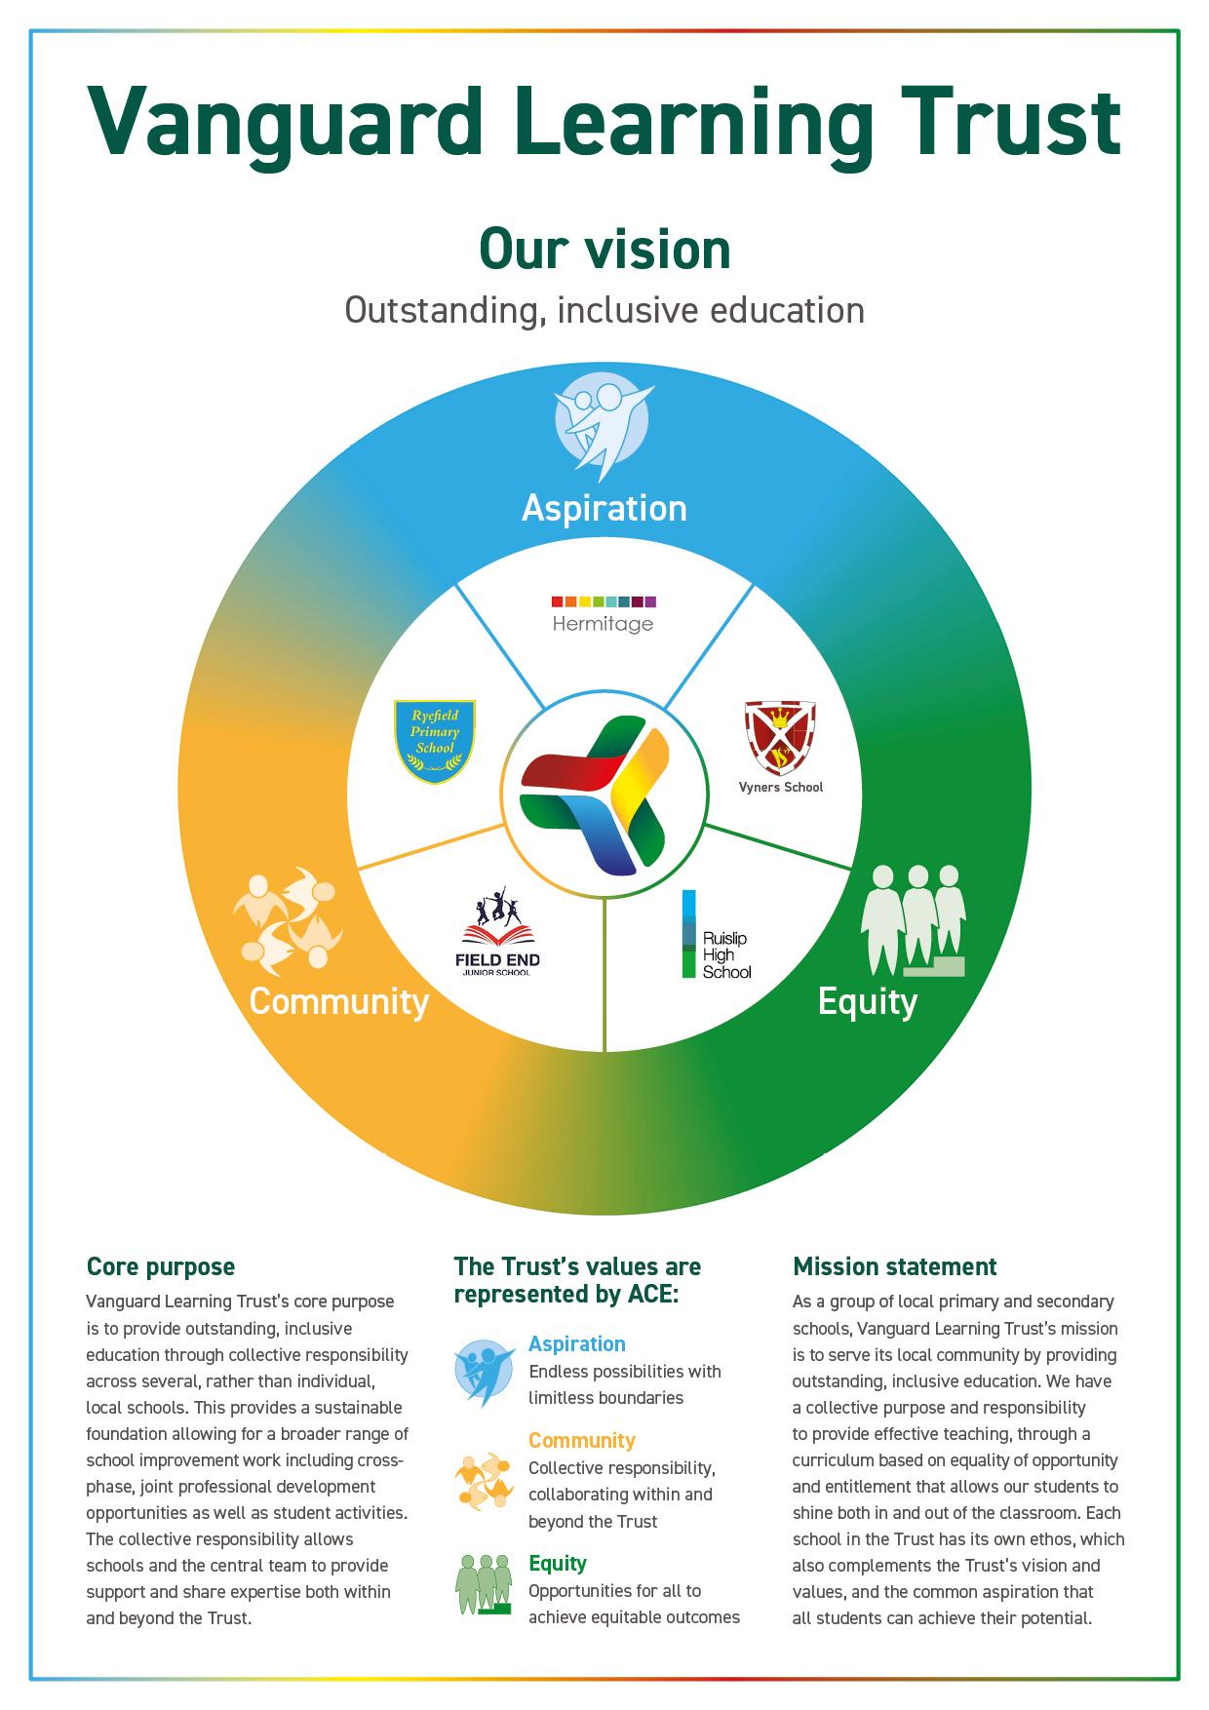

Job description

Job title: Higher level teaching assistant (HLTA)
Reports to: HLTA manager
Salary: NJC scale 6, points 18 - 22
(£30,699 - £32,805 full-time equivalent)
Starting: NJC scale 6, point 18. Actual salary: £26, 471.58
(£30,699 full-time equivalent).
Annual review and rising to the top of the range: NJC scale 6, point 22. Actual salary £28,287.57 (£32,805 full-time equivalent).
Working Days/hours: Monday - Friday (35.5 hours per week)
8am - 4pm on Monday, Wednesday, Thursday and Friday
8am - 4.30pm on Tuesday
One hour for lunch (unpaid)
Start date: 1 September 2023
Location: Ryefield Primary School

1. Core purpose
The postholder will:
- complement the work of teachers by taking responsibility for agreed learning activities under an agreed system of supervision;
- monitor pupils, assessing, recording and reporting on pupils’ achievement, progress and development as agreed with the teacher;
- plan, prepare and deliver learning activities for individuals/groups as well as covering whole classes for PPA and short-term absence; and
- work under the direction of the assistant headteacher to support the learning of pupils.

2. Core duties

Support for pupils
The postholder will:
- assess the needs of pupils and use detailed knowledge and specialist skills to support pupils' learning;
- supervise pupils while carrying out pre-prepared work and work that has been set in accordance with the school policy;
- establish productive working relationships with pupils, acting as a role model and setting high expectations;
- promote the inclusion and acceptance of all pupils within the classroom;
- support pupils consistently while recognising and responding to their individual needs;
- encourage pupils to interact and work cooperatively with others and engage all pupils in activities;
- promote independence and employ strategies to recognise and reward achievement of self-reliance;
- provide feedback to pupils in relation to progress and achievement, both verbal and written;
- understand issues relating to equal opportunities, bullying and harassment and be able to respond effectively to incidents and issues; and
- understand the use of behaviour management strategies and procedures, which contribute to a purposeful learning environment.

Support for teachers
The postholder will:
- within an agreed system of supervision, plan challenging teaching and learning objectives to evaluate and adjust lessons/work plans as appropriate;
- organise and manage appropriate learning environments and resources;
- monitor and evaluate pupil responses to learning activities through a range of assessment and monitoring activities against pre-determined learning objectives;
- provide objective and accurate feedback and reports as required on pupil achievement, progress and other matters ensuring the availability of appropriate evidence;
- record progress and achievement in lessons/activities systematically and provide evidence of range and level of progress and attainment;
- work within an established discipline policy to anticipate and manage behaviour constructively, promoting self-control and independence;
- support the role of parents in pupils' learning and contribute to meetings with parents to provide constructive feedback on pupil progress/achievement etc.;
- carry out assessments and track pupils’ progress in line with school policy; and
- produce lesson plans, worksheets etc as agreed with the teacher.

Support for the curriculum
The postholder will:
- deliver learning activities to pupils within agreed system of supervision, adjusting activities according to pupil responses/needs;
- deliver local and national learning strategies and make effective use of opportunities provided by other learning activities to support the development of pupils' skills;
- use ICT effectively to support learning activities and develop pupils' competence and independence in its use;
- select and prepare resources necessary to lead learning activities, taking account of pupils' interests and language and cultural backgrounds; and
- advise on appropriate deployment and use of specialist aid/resources/equipment.

Support for the school
The postholder will:
- comply fully with policies and procedures relating to safeguarding child protection, health, safety and security, confidentiality and data protection, reporting concerns to an appropriate person;
- be aware of and support difference and ensure all pupils have access to opportunities to learn and develop;
- contribute to the overall ethos/work/aims of the school;
- establish constructive relationships and communicate with other agencies/professionals, in liaison with the teacher, to support achievement and progress of pupils;
- recognise their own strengths and areas of specialist expertise and use these to lead, advise and support others;
- deliver out-of-school learning activities with guidelines established by the school;
- contribute to the identification and execution of appropriate out-of-school learning activities which consolidate and extend work carried out in class and attend in-house INSET sessions;
- attend assemblies in line with expectations;
- set high standards in terms of dress, language and behaviour; and
- understand health and safety issues relating to teaching space and resources and be able to organise and manage learning activities in a safe environment.

Other duties and responsibilities
The post-holder will be expected to undertake such tasks as are commensurate with the position and in the direction of the Head of School and the Executive headteacher (primary).

Health and Safety and safeguarding
All staff must:
- be familiar with our Trust’s policies that refer specifically to health and safety regulations; and
- have regard to health and safety across our Trust in all aspects of work, in line with our Trust’s policies and keep up to date with all relevant policies and risk assessments.

Vanguard learning Trust is committed to safeguarding and promoting the welfare of children and young people and expects all staff to share this commitment. An enhanced DBS disclosure is required for all posts.

Equality and diversity
All staff must support the school’s and our Trust’s commitment to equality including compliance with the Equality Act 2010.

Person Specification

Qualifications and experience: | Essential | Desirable
- Achieved a qualification in English and Mathematics to at least Level 2 of the National Qualifications Framework. | ✔
- Have achieved a HLTA qualification | ✔
- Training in relevant learning strategies e.g. synthetic phonics | ✔
- Specialist skills/training in curriculum or learning area e.g. bi-lingual, SEND, ICT | ✔
- Experience of working with relevant age groups within a learning environment | ✔

Professional knowledge and understanding, skills and attributes: | Essential | Desirable
- Understand and respect social, cultural, linguistic, religious and ethnic backgrounds. | ✔
- Be able to build and maintain successful relationships with pupils, treating them equitably with respect and consideration. | ✔
- Demonstrate a commitment and ability to raising educational achievement for all pupils and to promote positive values, attitudes and behaviour. | ✔
- Understand the roles of parents and carers in pupils’ learning and development and demonstrate ability to liaise with parents and carers sensitively and effectively. | ✔
- Demonstrate a willingness and ability to improve own practices and methodologies through the utilisation of available information, tools, evaluation, observation and discussion with colleagues, mentors and line-managers. | ✔
- The ability to promote the ethos, aims and objectives of the Trust | ✔
- The ability to work as part of a team and contribute towards its success | ✔
- The ability to prioritise own time and others, work under pressure and to deadlines with a sense of balance and perspective | ✔
- The ability to communicate effectively both orally and in writing | ✔
- The ability to build effective professional relationships | ✔

Personal skills and attributes: | Essential | Desirable
- Patient, tolerant, sympathetic and, fair but firm | ✔
- Reliability and integrity | ✔
- An integrated thinker | ✔
- Self-starter, with an ability to work independently and use own initiative to overcome obstacles | ✔
- Enjoy working with children and able to communicate effectively and sensitively with pupils to support their learning | ✔
- Hardworking and conscientious | ✔
- A willingness to be flexible | ✔
- A respect of confidentiality | ✔
- An understanding of and a willingness to promote equal opportunities | ✔
- To be a proactive member of the school community | ✔
- A willingness to contribute to the wider life of the school | ✔
- Able to interest, motivate and advance learning of pupils using clearly structured teaching and learning activities | ✔
- Appreciate the importance of inclusion and understand methodologies employed in promoting inclusion for a diverse range of learning activities | ✔

All aspects of the personal specification will be assessed through the recruitment process. Applicants should ensure that all aspects of the qualifications and experience section are explicitly referred to in their application form including using the statement if required.

How to apply

The deadline for applications is 10:00am on Friday 19th May 2023. Applications should be returned, via email to bhughes@ryefieldprimary.org.uk

Interviews will be held at Ryefield Primary School on Thursday 25th May 2023

The dates above are fixed and, unfortunately, alternative arrangements cannot be accommodated.

Questions and queries about the role should be directed to Bernice Hughes via email to: bhughes@ryefieldprimary.org.uk

