
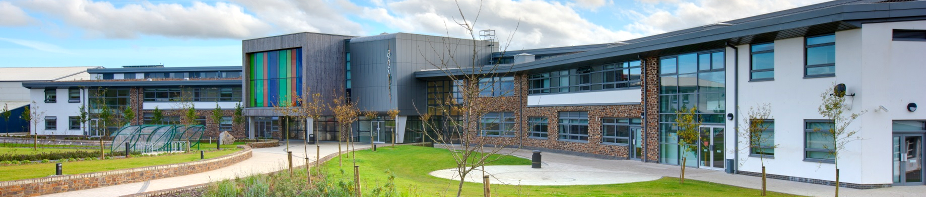

www.brannel.com
Brannel School
Why Teach at Brannel?

Dear Applicant

Thank you for taking the time to find out more about Brannel School. This pack is intended to give you information about our school’s vision, ethos and direction of travel.
When I was appointed as Headteacher of Brannel School in July 2013, my aim was for Brannel to become the best school it can be. In the first instance this meant designing and delivering a school improvement plan to move the school from Ofsted category ‘Requires Improvement’ to ‘Good’.

Ofsted has recognised that the school is making big improvements and that we have put in place a secure foundation for the future of the young people in the rural communities we serve. Since embarking on our school improvement journey in 2013 we have:
- Defined the vision and strategic direction of the school clearly.
- Established, and maintain, an ethos and culture where improving standards for all learners is the main priority.
- Ensured that improving teaching and assessment is seen as the key process contributing to improving and maintaining high standards.
- Increased the emphasis on analysing performance data to identify specific areas that need improvement.
- Implemented a consistent and sustained focus on improving literacy and numeracy.
- Improved student behaviour and attendance and embedded clear parameters for acceptable and unacceptable student behaviour.
- Established a culture of self-evaluation and high expectations for both staff and students.
- Made all staff, especially those in management roles, accountable for their areas of work, for example through the introduction of a performance management system and contribution related pay.
- Given governors a clear, understandable and honest analysis of how well the school is performing and encouraged them to fulfil their role of challenging the school to do better.
- Continued to deliver a curriculum that fully meets the needs of all learners.

Brannel School offers 750 places to pupils aged 11-16. The school was completely redesigned and rebuilt in 2011 as a ‘School of the Future’ at a cost of over £17m. Our facilities are second to none, and are underpinned by integrated technology befitting a 21st century working and learning environment. Brannel School is a welcoming and exciting place in which to teach and to learn.
At Brannel we develop students who have a passion for learning and enquiry, and the maturity to self-direct their studies and take control of their own futures. In addition to offering a broad and balanced curriculum, the school places particular emphasis on the development of enterprise skills. We want to develop links with employers both locally, nationally and internationally in order to provide mentoring to our students.
All students are encouraged to continue their education and to progress to university. We work closely with local universities and employers to achieve this vision, and to give students access to a level of expertise rarely seen in the state sector.
There is a real vision here for the school and for its community. This role represents a unique opportunity to join a school with the highest expectations for both students and staff - and to help shape the future of the school.
We are looking for someone who has the necessary skills and experience to excel in this role, and who can set the standard for teachers who join us year on year as the school moves forward. You will be working in a small department in a small school. You will see it develop, allowing you to put your own marker on it.
As Headteacher there is no greater priority for me than the recruitment and development of staff. My aim at Brannel is to create a school which is truly exceptional in everything it does. To do that I need an exceptional team. I understand that I will be asking a lot from the staff, but in return I can promise extensive support and development opportunities. We can offer you:
- An energising and supportive working environment with high expectations and standards.
- Students who are just beginning to make life goals; who are enthusiastic to look beyond the narrow confines of rural Cornwall.
- Colleagues who are reflective, committed professionals; who are motivated by challenge and willing to go the extra mile for our students to achieve the very best results.
- A unique opportunity to help build the school and the department.
- A well-resourced school with 21st century teaching and learning facilities.
- An excellent programme of CPD and opportunities to develop leadership and management skills.
- Opportunities to develop innovative co-curricular and enrichment activities within the school day as part of the ‘Brannel Challenge’ period each week.
On 1st November 2017, Brannel converted to become an Academy as part of the Newquay Education Trust (NET). We believe this presents exciting opportunities for Brannel as we continue our journey for improvement. We are excited and are very much looking forward to embarking on the next stage of our journey.
If, after reading the enclosed information you would like to apply, please complete the application form that can be found online at www.brannel.com and return it via e-mail to personnel@newquayeducationtrust.net.
If you have any queries or wish to visit the school in advance of the application submission date please contact me directly on 01726 822485.
Mr Andy Edmonds
Headteacher
November 2017

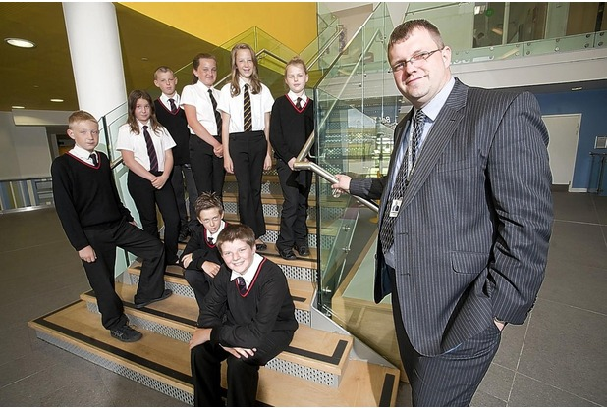
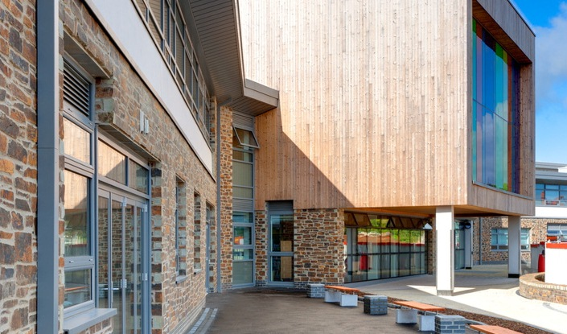
To teach and inspire

To reach and transform

Every Student

Every Year
Our Vision

At Brannel School we are passionate about learning. Our vision is to deliver a world class education that prepares our students fully for life by extending and refining their understanding and enjoyment of the whole curriculum, raising their standards of achievement and developing the skills that are essential for productive, rewarding, high-value employment in a modern economy.

Our Mission
We focus on communication skills
We provide our students with the opportunity to extend their communication skills beyond the classroom audience so that when they enter the workplace they can communicate confidently and coherently in a variety of different situations with colleagues at all levels.
We develop team players
We encourage teamworking; our students learn from experience what can be achieved when people work together. Teamworking also teaches them patience and tolerance – both important skills in the workplace.
We encourage problem-solving
We give our students the opportunity to problem‐solve in real‐life situations, so that they have the opportunity to fail without criticism, learn from that experience and try again.
We nurture creativity
We understand that creativity is essential in all areas of work and life, whether that is using creativity to solve a problem, design new processes or develop new ideas. Our students are given the opportunity to test their creative ideas in a range of different ways through ‘learning by doing’.
We foster resilience
We encourage students to value resilience and to develop humility, ‘grit’, self-management and tenacity – all important skills in work and life. We believe that young people need to experience challenge as part of their learning so that rather than give up when things do not go to plan, they can then apply that learning in new situations.


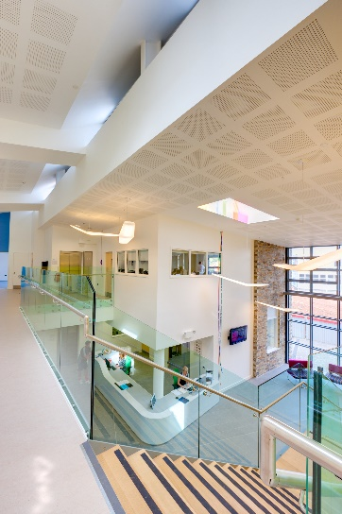

Our Values
High Expectations
We believe that, with the right support, every child can achieve. Our aim is for each and every one of our students – whatever their background or ability – to achieve their full potential.
Excellent Teaching
We understand that the quality of a school depends on the quality of its teaching. We prioritise learning and development, and make sure that our teachers have access to high quality career development opportunities at all stages of their career.
Depth before Breadth
We believe that English and maths are the building blocks for success across the curriculum. We dedicate more time to these subjects in the school day, providing targeted support in the basics which gives students a strong foundation on which to build.
Inspiring to Aspire
We have developed The Brannel Challenge to broaden students’ experiences and raise aspirations. Students are encouraged to participate in activities which challenge and inspire them.
Exemplary Behaviour
We are committed to establishing an orderly environment in our school so that teachers can focus on teaching and our students can focus on learning. We don’t accept excuses – and we don’t make any either.
Knowing every Child
We understand that positive relationships between young people and adults reinforce a culture of excellent behaviour and a commitment to learning. We structure our school so that every student knows, and is known by, a key group of adults which include their Head of House and form tutor.

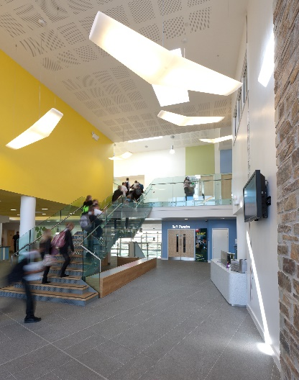
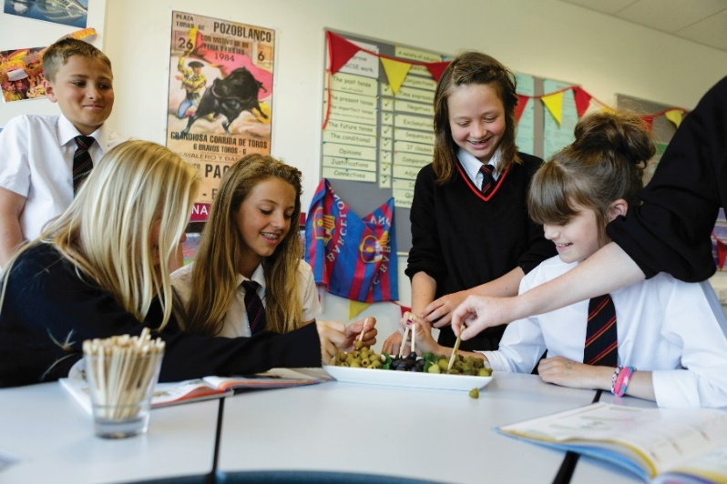
“To spend each day helping our students unravel their uniqueness is the best job in the world. I love teaching at Brannel. I can’t imagine doing anything else. I love seeing the light bulbs come on for the kids. ”
- Head of Science, Brannel School
Local Context
Brannel School is situated in the rural village of St Stephen-in-Brannel, which is four miles west of St Austell on the southern edge of Cornwall's China Clay Community Network Area. The area has a distinctive natural and historic environment with access to internationally admired countryside, coastline and tourist attractions such as the Eden Project and the historic port of Charlestown.
The area has a long tradition of community togetherness that was fostered by the China Clay Industry. There is a wealth of community and voluntary groups, churches and chapels, brass bands and numerous sports clubs. Communities are proud of their area and want to celebrate it.
The China Clay Community Network Area is widely recognised as having particularly significant economic and social disadvantages. Over the last decade the area has experienced some of the highest levels of population and housing growth across Cornwall. At the same time it has experienced a decline in major employment sectors in the last 20 years. A positive and innovative response is required that can bring wider social and environmental benefits.
Cornwall Council has identified the area as one of its main priority areas for strategic regeneration and investment. The Council is committed to securing economic growth in order to create jobs and prosperity. The vision is to establish the St Austell, St Blazey and China Clay Area as the ‘Green Capital’ of Cornwall, attracting investment in sustainable employment and communities, encouraging quality and innovation, and raising aspirations and community well-being.
Our Commitment to our Community
At Brannel School we are committed to uniting all of our stakeholders in delivering a shared goal of Brannel as the learning centre of our community. We will continue to build on our strong record of tackling inequality and reducing achievement gaps in order to nurture confident, independent learners who are active participants in the community. We firmly believe that the young people of the ‘clay country’ are as talented as you will find anywhere:
- Where they have ability, we will nurture it and ensure it is realised
- Where they have ambition, we will encourage it and provide the opportunities for it to grow
- Where social issues have led young people to have low expectations of themselves, we will raise their self-esteem, increase their self-reliance and extend their aspirations.


“Knowledge is power. I teach here because I want to hand the gift of knowledge to others. I want to empower the young people here to have high aspirations; to lift themselves out of poverty.”
- Teacher of English, Brannel School
Our Ethos
At Brannel School we believe success at school provides a strong foundation for young people to become engaged global citizens who believe in themselves and can bring about positive change - for themselves and for the society in which they live.
Education is the most effective tool for those seeking to better their quality of life. The solutions to poverty, social exclusion, disadvantage and deprivation lie not with others, but within an individual. Each individual has the power to make a positive difference and transform his/her life circumstances.
We believe that poverty and disadvantage cannot excuse a lack of high expectations amongst our students. Consequently we set clear aspirations on the achievements that we expect of our pupils.
In addition to achieving academic excellence, we aim to instil in every child the beliefs, behaviours and attitudes that will underpin success in life. Our school’s ethos supports this by creating a school that is sympathetic to the social background of our students and pro-active with respect to the unique opportunities this dynamic and well situated area of Cornwall affords.
We ensure that every student is equipped to:
- Create and seize opportunities for themselves and others.
- Contribute to Big Society.
- Bridge the skills gap faced by future employers.
Central to our school’s ethos is a student-centric and individualised learning approach designed to achieve personal success for each and every student, regardless of where their abilities lie. To fully equip our students as engaged citizens who will have the right skills to be active participants in British society, our focus is on:
- Academic excellence: Our school will provide a safe, caring and supportive learning environment in which every individual will beat their personal best. This will be achieved through commitment to excellence from all and no excuses.

- STEM: We will target specific areas of skill shortage faced by future employers.

- Enterprise: A can do attitude, creativity, informed risk-taking and a drive to succeed. These are all key ingredients to success whether in academia, business or social enterprise.

“I love teaching our students. They are amazing, and they just need someone other than their parents who has faith in them to be successful. Every day is a chance to make a difference. ”
- Teacher of Maths, Brannel School
