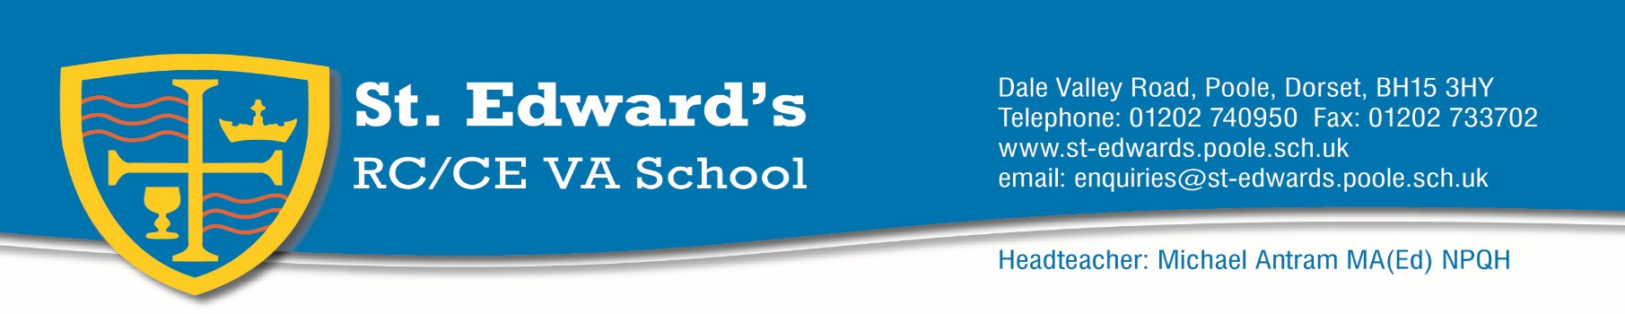

January 2019

Dear Colleague,

Thank-you for taking an interest in the role of Head of Technology in our school.

We are currently reviewing our curriculum to ensure that we do the best possible job of preparing our students for successful futures; and Technology subjects are key in this. This post presents an exciting opportunity to implement a renewed vision for Technology subjects, and we will want to support you in building and growing a passion among students for Technology.

You would be working with a team of highly competent, dedicated professionals; leading them to ensure that our students are fully equipped to pursue their aspirations in a range of industries.

St. Edward’s is a happy, caring and successful school. Our staff and students work together in building a centre of excellence, characterised by high expectations combined with a deep regard for the formation of people.

If you would like to be a part of our growth and development; and if you have a vision and passion for Technology, then I would very much like to hear from you.

Thank-you again for giving us your time, and if you would like to find out more about us, do please get in touch.

Yours sincerely,

Mr M Antram
Headteacher

