

**THE KING’S SCHOOL, GLOUCESTER**

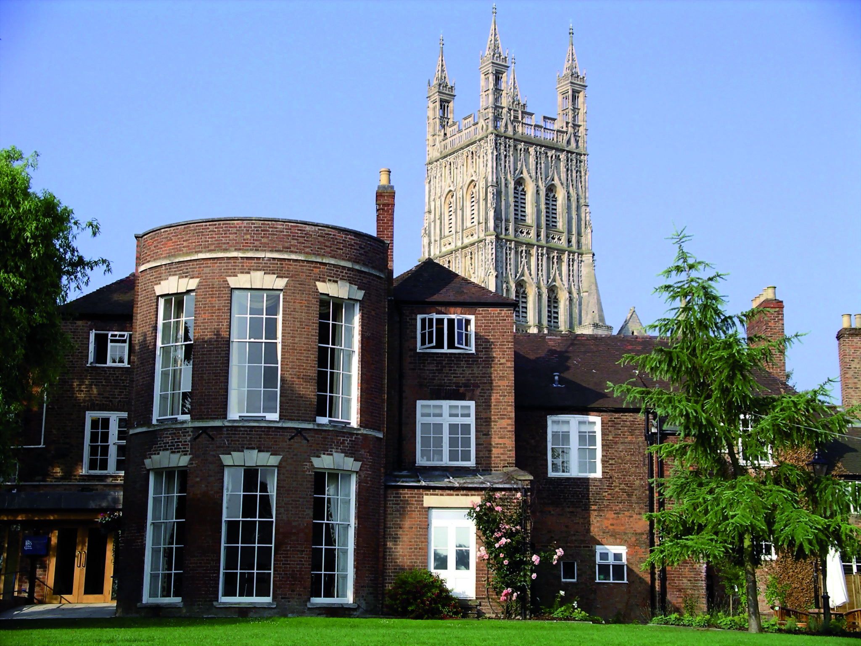

The King’s School, Gloucester is an independent co-educational school of approximately 550 pupils from the age of 3 to 18. Although there has been a school enfolded within the Cathedral for over a thousand years – and possibly even longer – it was refounded in 1541 by Henry VIII, hence the name of the school. The school has, as one of its tasks, the responsibility of educating the Cathedral Choristers. More generally, however, it is dedicated to producing the best in the individual, whether that be through academic work, Sport, Music, Drama or any of the wide-ranging activities that contribute so much to the life of the community.

Situated in the Cathedral Close, the school buildings are an interesting blend of medieval and modern. The King’s Junior School, which incorporates a Nursery, provides the principal route to Senior School, from 11 to 18. However, an even larger number come from a wide range of local schools. Increasingly the School is also seeing good numbers arriving beyond the First Form (Year 7), especially into the Third Form (year 9) and the Sixth Form (Years 12 and 13).

The School’s facilities are shared by pupils across the whole age range of 3 to 18 as well as by the local community generally. Assemblies and worship take place in the Cathedral on a daily basis.

The School has high academic aspirations whilst supporting pupils with specific learning difficulties. The School’s enrichment programme for the Gifted and Talented is much cherished, as is the School’s emphasis on independent learning. Recent academic results are a source of pride and repeatedly the School’s ‘value added’ measure is excellent. This arises out of the School’s ability to treat each pupil as an individual and is a reflection of the mutual support and respect which exists between staff and pupils. This is aided by small class sizes, with no Form or class being larger than 17/18 and many being smaller. Sixth Form classes in particular are invariably in very small groups, somewhat akin to university tutorials.

With its strong choral traditions, the School has a very active Music Department. Drama and Dance are also very strong, with regular productions that have a strong reputation for achieving the highest professional standards.

For its size the School is remarkably successful in sport, fielding teams in Rugby, Cricket, Netball, Tennis, Hockey, Rounders and Golf. Other sports are also encouraged. In recent years a large number of pupils have achieved county and national honours in a range of sports, though it is worth emphasizing that the School’s sporting ethos is chiefly about inclusion and participation at all levels and abilities. Archdeacon Meadow, the main sports field, is Gloucester’s only venue for first class cricket and is adjacent to indoor facilities which include a swimming pool. The School also has a flourishing programme in the Duke of Edinburgh’s Award Scheme and a wide range of trips is offered, both in the region, in other parts of the country and abroad.

In a recent Inspection by the Independent Schools Inspectorate the School was praised for its “excellent pastoral care” and “special sense of identity” and the pupils were found to have “a positive attitude to study and high standards of behaviour”.

**APPLICATION AND RECRUITMENT PROCESS**

# EXPLANATORY NOTE

**General**

The King’s School, Gloucester is committed to ensuring the best possible environment for the children and young people in their care. Safeguarding and promoting the welfare of children and young people is our highest priority.

The School aims to recruit staff who share and understand our commitment.

All queries on the application form and recruitment process must be directed to the Bursar.

**Application Form**

Applications will only be accepted from candidates completing the enclosed Application Form in full. CVs will not be accepted in substitution for completed Application Forms.

Candidates should be aware that all posts in the School involve some degree of responsibility for safeguarding children, although the extent of that responsibility will vary according to the nature of the post. Please see job description for the post.

Accordingly this post is exempt from the Rehabilitation of Offenders Act 1974 and therefore all convictions, cautions and bind-overs, including those regarded as ‘spent’ must be declared.

The successful applicant will be required to complete a Disclosure form from the Disclosure and Barring Service for the post.

If you are currently working with children, on either a paid or voluntary basis, your current employer will be asked about disciplinary offences, including disciplinary offences relating to children or young persons (whether the disciplinary sanction is current or time expired), and whether you have been the subject of any child protection allegations or concerns and if so the outcome of any enquiry or disciplinary procedure. If you are not currently working with children but have done so in the past, that previous employer will be asked about those issues. Where neither your current nor previous employment has involved working with children, your current employer will still be asked about your suitability to work with children.

You should be aware that provision of false information is an offence and could result in the application being rejected or summary dismissal if you have been appointed and Referral to the police and/or DCSF Children’s Safeguarding Operation Unit are also likely.

**Invitation to Interview**

If you are invited to interview this will be conducted in person and the areas which it will explore will include suitability to work with children.

All candidates invited to interview must bring documents confirming any educational and professional qualifications that are necessary or relevant for the post (eg the original or certified copy of certificates, diplomas etc). Where originals or certified copies are not available for the successful candidate, written confirmation of the relevant qualifications must be obtained by you from the awarding body.

All candidates invited to interview must also bring with them:

1. A current driving licence including a photograph or a passport or a full birth certificate;
2. A utility bill or financial statement showing the candidate’s current name and address;
3. Where appropriate any documentation evidencing a change of name;
4. Where the candidate is not a citizen of a country within the European Economic Area or Switzerland, proof of entitlement to work and reside in the UK.

**Please note that originals of the above are necessary. Photocopies or certified copies are not sufficient.**

Candidates with a disability who are invited to interview should inform the School of any necessary adjustments or arrangements to assist them in attending interview.

**Conditional Offer of Appointment: Pre-Appointment Checks**

Any offer to a successful candidate will be conditional upon:

1. Receipt of at least two satisfactory references;
2. Verification of identity and qualifications;
3. A check of the Children’s Barred List maintained by the ISA ;
4. A satisfactory enhanced DBS Certificate;
5. Verification of professional status such as GTC registration, QTS Status (where required), NPQH;
6. Verification of successful completion of statutory induction period (for teaching posts – applies to those who obtained QTS after 7 May 1999);
7. Where the successful candidate has worked or been resident overseas in the previous five years, such checks and confirmations as the school may require in accordance with statutory guidance;
8. Verification of medical fitness;
9. Satisfactory completion of the probationary period.

**References**

We will seek references for shortlisted candidates and may approach previous employers for information to verify particular experience or qualifications, before interview. If you do not wish us to take up references in advance of the interview, please notify us ASAP.

All referees will be asked if the candidate is suitable to work with children.

The School will compare any information provided by the referee with that provided by the candidate on the application form. Any inconsistencies will be discussed with the candidate.

**Criminal Records Policy**

The School applies for an Enhanced Disclosure from the Disclosure and Barring Service for all members of staff and volunteers. An Enhanced Disclosure will give detail of cautions, reprimands or final warnings as well as convictions.

It may also contain non-conviction information from local police records which a chief police offer believe may be relevant.

The School will refer to the DCSF document, ‘Safeguarding Children and Safer Recruitment in Education’ and any amended version.

The School complies with the provisions of the DBS Code of Practice, a copy of which may be obtained on request.

**POLICY ON CHILD PROTECTION (SAFEGUARDING)**

**Introduction:** The Children Act (1989) requires that children’s views should be heard, that their best interests should be the main consideration and that the child’s welfare be paramount in all dealings involving children. The King’s School recognises its responsibilities for safeguarding children. Our policy applies to all staff, governors and volunteers working in the School. In the event of any reported concern, The King’s School will follow the procedures set out by the multi-agency Gloucestershire Safeguarding Children Board (GSCB) and Gloucestershire LA.

**Statement of Intent:** The safety and well-being of all our pupils at The King’s School is our highest priority. Our business is to know everyone as an individual and to provide a secure and caring environment, so that every pupil can learn in safety. We expect respect, good manners and fair play to be shown by everyone so that every pupil can develop his/her full potential and feel positive about him/herself. Pupils should care for and support each other. There are five main elements to our policy:

* Ensuring we practice safe recruitment in line with DCSF guidance by using at least one NCSL accredited recruiter on all interview panels and by checking the suitability of staff and volunteers to work with children and ensuring any unsuitable behaviour is reported and managed using the Allegations Management procedures.
* Raising awareness of child protection issues and equipping children with the skills needed to keep them safe.
* Developing and then implementing procedures for identifying and reporting cases, or suspected cases, of abuse by logging welfare concerns and referring to the Children’s Helpdesk.
* Supporting pupils who have been abused in accordance with their agreed child protection plan
* Establishing a safe environment in which children can learn and develop.

The King’s School recognises that it has both legal and moral responsibilities for every pupil. Because of the day to day contact with children, members of School staff are well placed to observe the outward signs of abuse. In accordance with the Education Act (2002), everyone who works at our School, including volunteers has a duty to safeguard and promote the welfare of children (up to 19 years).

**To this end, The King’s School:**

**Empowers pupils by**:

* promoting agencies that can provide information and support
* providing an environment where children feel secure, are encouraged to talk and are listened to
* Ensures children know the adults in the School whom they can approach if they are worried.
* Includes opportunities in the curriculum for children to develop the skills they need to recognise and stay safe from abuse.

**Follows the procedures** set out by the Gloucestershire Safeguarding Children Board and takes account of guidance issued by the Department for Children, Schools and Families to:

* Ensure we have a designated senior person for safeguarding (child protection) who has received appropriate training and support for this role.
* Ensure that parents have an understanding of the responsibility placed on the School and staff for child protection by setting out its obligations in the School prospectus.
* Notify the relevant social worker if there is an unexplained absence of more than two days of a pupil who has a Child Protection Plan (previously known as being on the child protection register.)
* Develop effective links with relevant agencies and co-operate with their enquiries regarding child protection matters including attendance at child protection conferences and core groups.
* Keep written records of concerns on children, even where there is no need for immediate referral
* Ensure all records are kept securely; separate from the main pupil file, and in locked locations.
* Provide a safe learning environment for children and evaluate all activities on and off the School site through a formal process of risk assessment
* Follow procedures where an allegation is made against a member of staff or volunteer including supply or agency workers, contractors or governors.

**Supports Pupils by**: recognising that children who are abused or witness violence may find it difficult to develop a sense of self-worth. They may feel helplessness, humiliation and some sense of blame. The School may be the only stable, secure and predictable element in the lives of children at risk. When at school their behaviour may be challenging and defiant or they may be withdrawn. The School will endeavour to support the pupil through:

* The content of the curriculum.
* The School ethos which promotes a positive, supportive and secure environment and gives pupils a sense of being valued.
* The School behaviour policy which is aimed at supporting vulnerable pupils in the School. The School will ensure that the pupil knows that some behaviour is unacceptable but they are valued and not to be blamed for any abuse which has occurred.
* Liaison with other agencies that support the pupil such as social care, Child and Adult Mental Health Service, education welfare service and educational psychology service.
* Ensuring that, where a pupil who has a Child Protection Plan leaves, their information is transferred to the new school immediately and that the child's social worker is informed.

**Trains and Supports those Working with Children by**: every three years so as to ensure that staff:

* Understand their duties with regard to safeguarding and promoting pupil welfare.
* Are vigilant to individual children who are suffering/likely to suffer significant harm due to some form of abuse. The King’s School trains its staff to recognise the key behavioural indicators of all categories of child abuse (defined in the Department of Health document ‘Working together to Safeguard Children 1999 as Physical, Emotional, Sexual & Neglect)
* Know the procedures for recording, dealing with/referring on such issues within School including allegations against staff (including the Child Protection Officer and Headmaster) or other pupils.
* Understand the boundaries of their responsibilities in dealing with these issues in the best interests of the child including the limits of confidentiality
* Know the name and role of ‘School’s Designated Safeguarding Lead’
* Are familiar with all relevant policies and procedures related to this area which are found within the Staff Handbook
* New members of staff, Governors and volunteers are given copies of the School’s policy on Interaction with Pupils: Model Code
* The School has a designated member of staff on the Senior Management Team [Deputy Head Pastoral] who is trained every two years, and supported [Headmaster & Welfare Supervisor] in overseeing all child protection matters within the School

**Promotes Child Protection** through its website and makes the policy available to parents and other interested parties on request.

**Definitions:**

**Child:** young person attending the King’s School up to the age of 19 years.

**Child abuse**:The NSPCC defines child abuse as: *“the term used when an adult harms a child or a young person.. . . Child abuse can take four forms, all of which can cause long term damage to a child: physical abuse, emotional abuse, neglect and child sexual abuse. Bullying and* *domestic violence are also forms of child abuse.”*

*“Abuse is always wrong and it is never the young person’s fault.”*

**Physical Abuse:** may involve hitting, shaking, throwing, poisoning, burning, scalding, drowning, suffocating or otherwise causing physical harm to a child’.

**Emotional Abuse:** persistent emotional ill-treatment of a child such as to cause severe and persistent adverse effects on the child’s emotional development.’ *i.e. a psychologically undesirable parent-child relationship; conveying child as worthless, inadequate, unloved. It may feature age/developmentally inappropriate expectations being imposed or even over-protecting a child*

**Neglect:** persistent failure to meet a child’s basic physical and/or psychological needs (i.e. nutrition, clothing, access to medical care, unresponsiveness to child’s basic emotional needs), likely to result in the serious impairment of the child’s health or development’.

**Sexual Abuse**: involves forcing or enticing a child or young person to take part in or observe physical or non-contact sexual activities, whether or not the child is aware of what is happening.

**Information for Parents:**

Transparency is important when it comes to safeguarding the welfare of children. The King’s School prides itself on its mutual respect and tolerance. Parents/guardians have an important role in supporting the School. We hope that parents/guardians will always feel able to take up any issues or worries they may have with the School. We will never ignore an allegation of child abuse and will follow up concerns thoroughly.

If a concern about a possible risk to health and welfare of a pupil is reported to the designated teacher for child protection, the School will work as much as possible in partnership with parents. The School also has a legal duty to follow current child protection procedures and, thus, where required, the School will share its concern with Social Services or other agencies as advised by the Gloucestershire Safeguarding Children Board. As is the case when dealing with pupils on any matter, we will never promise to keep any matter confidential when it is relevant to the child’s welfare. The child will be made aware that the member of staff they talk to has a duty to pass on information but only to the person(s) who are authorised to deal with such matters.

Occasionally, a mistake may be made, but in the best interests of all children, we believe that it is better to risk being over cautious. We hope that parents share this philosophy and accept that The King’s School will not act maliciously or thoughtlessly in this regard.

The King’s School recognises the importance of high self-esteem and self-confidence in keeping children safe. Our curriculum includes activities designed to promote the well-being of children and give them personal safety information that is appropriate to their age and stage of development. We aim to monitor any pupils who may be especially vulnerable through sensitive monitoring and ensuring that they are supported by a network of people they can approach for help if necessary. We hope that you and your child do not have any complaints about our School; but copies of the School’s complaints procedure can be sent to you on request.

This document should be read in conjunction with the School’s policies on:

* Checking Employees, Temporary Workers, Governors, Volunteers and Contractors
* Induction of New Staff, Governors and Volunteers in Child Protection
* Procedures when a Member of Staff, Volunteer, Child Protection Officer or Headmaster faces Allegations of Abuse
* Policy for Pupils on Confidentiality
* Use of ICT, Mobile Phones and Other Electronic Devices (& digital technology)
* Taking, Storing and Using Images of Children
* Anti-bullying

**Other Information:**

**Induction and Training**

Every new member of staff, including part-timers, temporary, visiting and contract staff working in School, receives basic training on their responsibilities in being alert to the signs of abuse and bullying and on the procedures for recording and referring any concerns to the Designated Safeguarding Lead or the Headmaster. Child protection training is also given to new Governors and volunteers. Everyone attends refresher training at least every three years. Training in child protection is an important part of the induction process. More detail is set out in our policy on Induction of New Staff, Governors and Volunteers in Child Protection

**Interaction with Pupils: Code of Conduct for Staff**

New members of staff, Governors and volunteers are given copies of the School’s policy on Interaction with Pupils: Model Code of Conduct for Staff. The model code (in Staff Handbook) of conduct provides guidance for teachers and other members of staff when faced with handling any issue relating to child abuse including whistle-blowing.

**Raising Awareness with Pupils & the Promotion of Welfare**

The King’s School prides itself on its culture of open and effective communication between staff and pupils, and on its excellent pastoral support structures. We prepare all of our pupils to make reasoned, informed choices, judgments and decisions. Time is allocated in PSE for discussion of various aspects of child abuse and in developing in pupils the confidence which they require to recognise abuse and to stay safe.

All pupils know that there are adults to whom they can turn to if they are worried, including their form tutor, head of year, Welfare Supervisor and the School Chaplain. In particular:

* Every senior school child has a handbook which contains guidance on where to turn for advice, including confidential help lines and web addresses for external specialists such as ChildLine, Kidscape, Get Connected and the Samaritans.
* Our pupil notice boards and those in the Welfare Centre display information on where to go for advice or help
* We operate a peer mentoring scheme, whereby trained older pupils are encouraged to offer advice and support to younger pupils.
* Our Policy for Pupils on Confidentiality, which deals with the issue in more depth, was prepared by the whole community, including our pupils.

The ethos of The King’s School is to promote social and moral well-being, to teach pupils to take care of and to value themselves, and to think in terms of making a positive contribution to society as adults. All our pupils take part in a large number of charitable activities. Many of our older pupils are involved in helping younger pupils in our school or in local primary schools as part of our community service programme. We see this as making an important contribution towards the development of the whole person, who grows up to value society and to expect to make a personal contribution towards the general.

**Equal Treatment**

The King’s School is committed to equal treatment for all, regardless of an individual’s race, ethnicity, religion, sexual orientation or social background. We aim to create a friendly, caring and perceptive environment in which every individual is valued. We endeavour to contribute positively towards the growing autonomy, self-esteem and safety of each student.

**Bullying**

Bullying, harassment and victimisation and discrimination will not be tolerated. We treat all our pupils and their parents fairly and with consideration and we expect them to reciprocate towards each other, the staff and the school. Any kind of bullying is unacceptable. See the School’s Anti-bullying policy and the Pupil Charter on Bullying for more information.

Tel: 01452 337337

Fax: 01452 337319

Email: [reception@thekingsschool.co.uk](mailto:reception@thekingsschool.co.uk)

[www.thekingsschool.co.uk](http://www.thekingsschool.co.uk)

smartcrest.emf