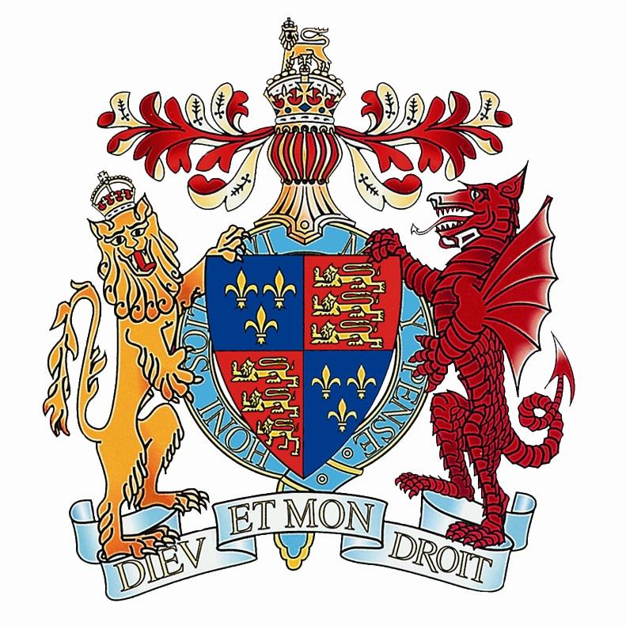 | KING EDWARD VI HANDSWORTH  SCHOOL  English Department

Staffing

Miss T Goodyear Head of Department
Mrs L McKee Second in Department (i/c KS3)
Miss J Glendenning Assistant Head/ Teacher of English
Ms E Gallagher Teacher of English (Part-Time)
Miss D Plante-Bekenn Teacher of English
Miss M McDonnell Teacher of English

Courses Offered

Key Stage 3:

In Years 7 and 8, students are taught in mixed ability groups and are placed in ability groups in Year 9. Students at Key Stage 3 receive lessons which inspire a love and passion for the subject, whilst also equipping them with the skills needed at Key Stage 4 and beyond. Each year group studies one or more Shakespeare play, collections of poetry, novels/ collections of short stories and non-fiction. Students are given regular opportunities to work collaboratively and to develop their aptitude for Spoken Language. In Year 9, schemes of learning are planned to prepare students for the demands of the GCSE specifications.

Key Stage 4:

At Key Stage 4, students follow the prescribed course for AQA English Literature and Edexcel English Language. The courses are taught simultaneously across the two years and students are assessed formally at the end of each unit. Students complete their Spoken Language Endorsement during Year 10.

Key Stage 5:

A level groups follow AQA English Literature Specification B. Students study the Comedy pathway.

Examination Results

The English Department celebrates consistently outstanding examination results both at GCSE and A-Level. Previous examination results place the department significantly above national averages and the subject continues to be a popular choice at A level, with many students pursuing the subject further at universities such as Oxford and Cambridge.

S

Timetable

The school operates a two week timetable. Key Stage 3 and 4 receive 6 lessons per fortnight and Key Stage 5 receive between 9 and 10 hours per fortnight. Some members of the department also teach Drama at Key Stage Three (between 2 and 4 hours per fortnight).

Accommodation

English is taught in 5 classrooms which are situated in the main building. Each classroom is equipped with a computer and interactive whiteboard. Students are usually sat in groups, as we see huge benefits of students working collaboratively. The department has access to bookable computer rooms, a class set of iPads and visualisers.

Extra-Curricular

The English department has a thriving extra-curricular provision. Currently, the department has a successful Book Club, Creative Writing Club, Beacon School Magazine Committee (Sixth Form only) and Debate Society.

All members of the English team contribute to the English Clinic, which is a weekly clinic where students receive additional academic support in the subject. This is run by English teachers and trained English Assistants from Year 12.

Each half term, all students are invited to take part in a series of competitions held by the department (all entries are posted in the department’s very own red post box!)

Further Information

The English department is forward-thinking, reflective and innovative in its practice and is constantly striving to enable students to reach their full academic potential. English is very popular amongst students who enjoy the lessons, the styles of teaching and relish the challenges presented to them during their study of the subject.
The subject is a popular option for Sixth Form students and many have gone on to study English at undergraduate level at universities such as Oxford and Cambridge.
English teachers at this school are passionate, hard-working, innovative and dedicated to securing the best possible outcomes for all students. The department celebrates a high profile within the school for its standards of teaching and learning and for its outstanding collaboration between staff. We would welcome a like-minded individual to join our successful team.

T Goodyear
Head of Department
January 2018

