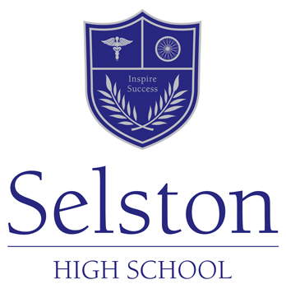
Geography

As part of The Humanities Department at Selston High School Geography develops pupils' understanding of the world around them.
The combination of History, Religious Studies and Geography allows students to consider the world around us, the impact we can have on the world and one another. We also consider the spiritual and moral decisions that people make whilst also consider the impact this has had on the history of the world.
In Key Stage 3, Geography is taught as discrete subjects in Years 7, 8 and 9 with one hour per week for each subject. Throughout the key stage a variety of teaching and learning techniques are used to encourage independent and critical thinking and enquiry. These include video news reports, presentations, model making, newsroom simulations, source exercises, fieldwork both in and out of school and leaflet making.
In Geography we cover topics such as map skills and exploring how and why the world is as such looking specifically at development and how change and time affect us all. We also investigate the impacts of tourism and how the world has changed economically, socially and politically in the last fifty years. Topics of crime, sport, shopping, Polar Regions, ecosystems and tectonics hazards are just some examples students will have the opportunity to study at Selston High School.

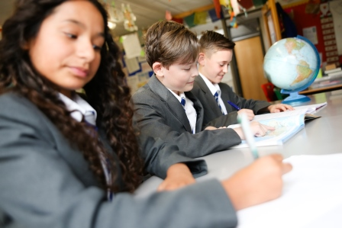

In Key Stage 4, Geography is a very popular option subjects offering six hours over a fortnightly period. We follow the OCR B Geography for Enquiring Minds. GCSE Geography helps you to understand what is happening in and around the world at various different scales. There are eight key themes within this specification, Global Hazards, Climate Change, Rivers and Coasts, Ecosystems, Urban Futures, Development, UK in the 21st century and Resource Reliance. Throughout the course a range of teaching methods are used including solving mysteries, watching videos, group work, note taking, individual research, presentation making and building models. Students will also be regularly assessed through mock exams throughout the year. Students will be assessed formally through three papers: a Decision-making Exercise exam (30%), Our Natural World (35%) and People and Society (35%). Students must also undertake two fieldtrips one physical and human allowing them to experience geography in the field putting theory into practice.

Extra-curricular activities within Humanities:
We incorporate a number of trips within our curriculum in order to further develop students’ understanding and love of Humanities. These include students visiting Beth Shalom to try and begin to understand the horrors of the Holocaust and the Thackray Museum in Leeds which charts the appalling conditions of bad Public Health in the Industrial Revolution to the developments of modern medicine. We also participate in a number of Coursework trips to Cromford Mill, Nottingham City Centre and the Holderness Coast in the East Riding of Yorkshire. Students are beginning to look at different places of worship including the local church in Selston and Mosques in Nottingham/Leicester in order to fully comprehend the different ways in which people worship, as well as understanding different places of worship. Students also experience the local community in order for them to understand the Geographical area of Selston and the surrounding villages, to really understand how everything they learn has an impact on where they live.

