[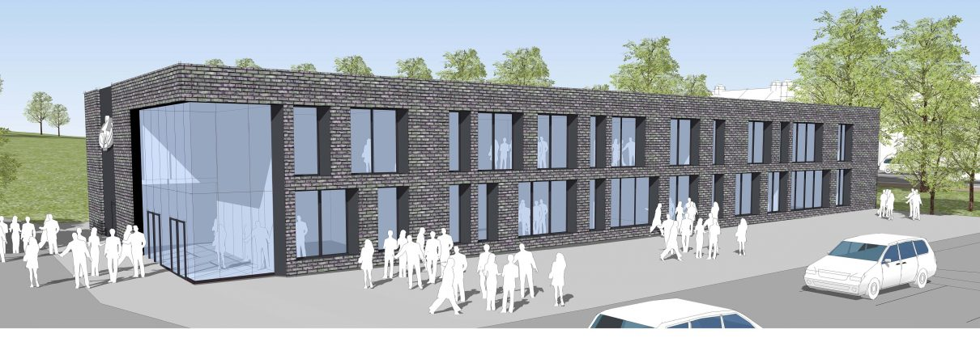](http://www.google.co.uk/url?sa=i&rct=j&q=&esrc=s&source=images&cd=&cad=rja&uact=8&ved=2ahUKEwjpmq6hz8PaAhVFkRQKHc_HDysQjRx6BAgAEAU&url=http://www.todhigh.co.uk/school-news/new-building-2017-update/&psig=AOvVaw1uAea0F1Of4QfqSppmHyWU&ust=1524133867918276)

**Todmorden High School**

**WE’RE HIRING, TO START AT EASTER 2019**

Come join us! We champion our whole school values which are **RESPECT, CARE AND HONESTY**

*We are a recently inspected GOOD school engaged in a period of significant growth. We are located in the beautiful Todmorden valley. We’re a thriving comprehensive school for 11 to 16-year-olds, with approximately 800 pupils and just over one hundred staff.* ***Workload and Wellbeing*** *is at the forefront of all we do. We are looking for several new colleagues who may be fulltime, part time, or come to us with flexible requests. We encourage working in every formation possible, we know one size does not fit all. We endlessly support working families and champion worklife balance, we’re so much more than ‘just another school’…*

**Our positions are paid on the Teachers’ Main Scale or Upper Pay Scale dependant on where you are in your career, there is the possibility of a Recruitment and Retention or Teaching and Learning points for outstanding applicants**

**Teacher of Drama and English**

**(full-time, part-time, flexible options considered)**

Look at our recruitment page on our website, find out more about joining our team, click WORK FOR US on the link below, *openings close 25 February 2019 at 9.00am*

[www.todhigh.co.uk](http://www.todhigh.co.uk)

**OfSTED, October 2018**

*‘The Headteacher and other Leaders, including Governors, are determined to provide the best possible education for pupils’.*

*‘Leaders seek out best practice from other schools and Advisers, and are keen to provide the best care possible’.*

Our Vision

Our school will provide a safe and happy environment   
where everyone aspires to make remarkable rates of progress,   
both personally and academically.We will inspire all to develop our core values of respect,   
care and honesty. We will support each other and celebrate   
our talents. Our students will be supported to grow into remarkable   
individuals, ready to thrive in the modern world.We hope to give Todmorden an Aspirational, Inspirational   
and Remarkable school.

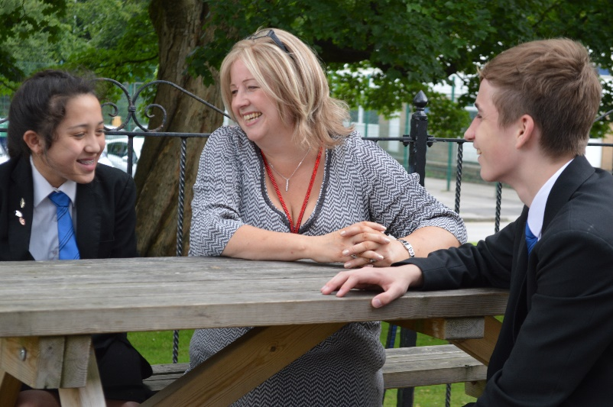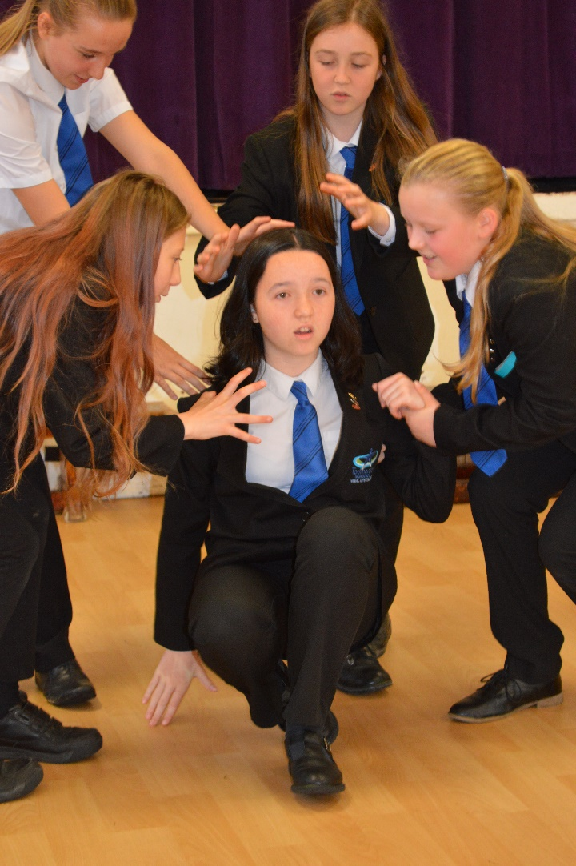

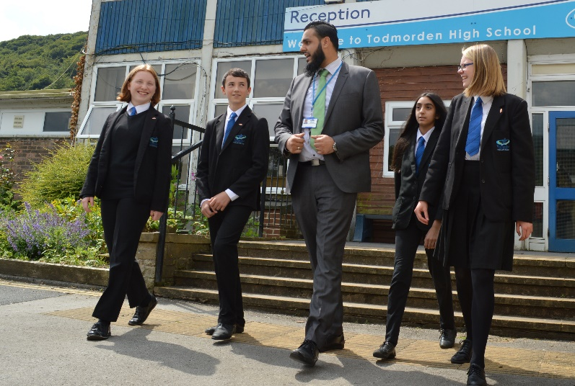

***February 2019***

Dear Applicant

Many thanks for your interest in working at Todmorden High School. This is a position for applicants who have qualified teacher status.

We remain passionate, and ensure our students have access to the very best educational experiences possible. In order to achieve this, it is vital that we attract and retain the right calibre of professional to work alongside our dedicated team. We are seeking colleagues who share the vision that our students are at the very heart of everything we do. A colleague who is able to enjoy positive, professional relationships with young people, and more importantly, a colleague who can demonstrate high levels of emotional intelligence and resilience when dealing with complex and sensitive situations. A colleague who models our core values of respect, care and honesty.

At Todmorden High School, our students are well behaved, respectful and polite. Students and staff work tirelessly to uphold our core values and behaviours. These provide the foundation for high aspirations and foster a love of learning from both staff and students. Our values underpin everything we do, on a daily basis, to ensure that we all know the role that we have to play in both our school, and our community as a whole.

We aim not only to foster a thriving climate for learning, but to provide the very best career opportunities for everyone; an environment where aspirations can be met and opportunities for personal development and growth remain a constant priority.

We are committed to creating a culture where all staff, at all levels, can feel proud of who we are, of our achievements and feel a sense of pride when they reflect on their individual contribution to our School development. All this in an environment where generosity and kindness can thrive.

In keeping with our values, we strive to create a workplace that celebrates difference. Somewhere we all feel responsible, valued, empowered and trusted to do the right thing for each other, our students and our community.

With very best wishes



**Gill Shirt**

**Headteacher**

**Teacher of Drama and English**

Salary Teachers’ Main Scale, Upper Pay Scale

(with possible R&R for an outstanding applicant)

Responsible to Head of Department and Senior Assistant Headteacher

**Closing date 25 February 2019 at 9.00am with interviews thereafter**

We are seeking to appoint a well-qualified and enthusiastic Teacher of Drama and English. We welcome interest from practitioners with the passion, commitment and ability to promote these subjects throughout our school. Applications from NQTs are supported. We can offer the successful candidate the chance to work alongside excellent teachers in an exciting and aspirational department. We are passionate about how we teach our subject and we are always looking at ways to develop our curriculum, we embrace and champion change.

Our High School is a warm and friendly environment where staff are supported to grow and develop. Our Executive team plays a crucial role in removing any barriers to teaching and learning allowing our teachers to focus on teaching and good outcomes for our students. Every member of our team plays a vital role in promoting and supporting good teaching and learning.

We welcome applications from our wider community. We are looking for someone who can hit the ground running and join our team as soon as possible. We are a supportive and friendly environment. You will play a significant part in our journey to becoming a truly ‘outstanding’ school. Please send all completed applications to [d.todd@todhigh.co.uk](mailto:d.todd@todhigh.co.uk).

If you would like to make an appointment to visit the school, or if you would like to discuss the role further then please contact the school via d.todd@todhigh.co.uk

Todmorden High School is an aware employer is committed to safeguarding and protecting the welfare of children and vulnerable adults as its number one priority. This commitment to robust recruitment, selection and induction procedures extends to organisations and services linked to the School on its behalf. This post is subject to an enhanced DBS check. We value variety and individual differences, and aim to create a culture, environment and practices at all levels which encompass acceptance, respect and inclusion.

**Job Description - Teacher**

***Purpose of the job***

To ensure the effective learning of all students across the ability and age range.

To structure the learning of students by planning and delivering good lessons.

To promote and be accountable for high standards of achievement.

***Responsibilities***

The appointment is subject to the appropriate conditions of employment of teachers contained in the School Teachers’ Pay and Conditions Document and other current employment and educational legislation.

Responsible to: Head of Subject

Responsible for: The learning of all students across the ability and age range.

***Main duties***

To teach good lessons.

To ensure that students make good progress as reflected in value added data and in examination results.

To assess and record student progress.

To report to parents as required.

To ensure that lessons offer a wide range of learning opportunities to meet individual student needs.

To evaluate lessons in relation to student learning and plan future lessons accordingly.

To take responsibility for personal professional development through:

* classroom observation
* shared lesson planning
* promoting classroom learning
* taking part in regular professional development discussion
* attending INSET as required
* keeping abreast of relevant national, local and school based initiatives that will positively impact on learning

To promote pedagogical dialogue throughout the school.

To be a good role model.

To develop and maintain good professional relationships with colleagues.

To undertake school supervision duties as required.

To carry out any other reasonable task at the request of a member of the Leadership Team.

To work flexibly and undertake additional responsibilities when requested to do so in supporting the day to day running of the faculty.

To uphold teachers’ standards and uphold and adhere to school and local authority policies and procedures.

This is not an exhaustive list of duties and is indicative of the type of work required by this post holder. The post holder will be expected to work closely with the SLT and deliver the operation provision required to work with groups of young people in learning environments. The Headteacher may also require the post holder to fulfil other duties, as required.

**Job Description**

**Form Tutor**

***Purpose of the job***

To ensure the effective learning of all students within the tutor group through effective support and challenge.

To structure the learning of students during tutor periods.

To monitor the academic and social progress of each student within the tutor group and effectively intervene where necessary.

To ensure that students are ready to learn on a daily basis and that barriers to learning are removed.

***Responsibilities***

Responsible to: Learning Manager

Responsible for: The social and academic progress of each student within the tutor group.

***Main duties***

To manage daily routines within school relating to uniform, equipment, time-keeping and readiness to learn.

To ensure that students hit target grades as reflected in interim and annual reports by:

* using data to assess students’ academic progress
* challenging students and make e-mail or telephone contact with parents where forecast grades are significantly below target grades
* intervening directly with students where forecast grades are significantly below target grade in more than three subjects

To oversee the behaviour of each member of the tutor group.

To monitor and promote the good lesson attendance of each member of the tutor group.

To monitor the social, emotional and physical well-being (including social integration) of each member of the tutor group.

To listen to and develop student voice within the tutor group.

To be a good role model to students.

**Person Specification**

|  |
| --- |
| **Characteristics** |
| **Professionalism – a core of strongly held and enacted values** |
| Respect for others – The underlying belief that individuals matter and deserve respect |
| Challenge and support – A commitment to do everything possible for each student and enable all students to be successful |
| Confidence – The belief in one’s ability to be effective and take on challenges |
| Self-Learning – A commitment to developing understanding and learning new skills to become a better teacher |
| Creating trust – Being consistent and fair. Keeping one’s word |
| **Thinking – the drive to ask ‘why?’ and see patterns** |
| Analytical thinking – The ability to think logically, break things down and recognise cause and effect |
| Conceptual thinking – The ability to see patterns and links, even when there is a lot of detail |
| **Planning and setting expectations – targeting energy and effort where it will make the most difference to students** |
| Drive for improvement – relentless energy for setting and achieving challenges |
| Information seeking – a drive to find out more and get the full story. Intellectual curiosity |
| Initiative – the drive to act now to anticipate and pre-empt events |
| **Leading – directing, inspiring and motivating others** |
| Flexibility – The ability and willingness to adapt to the needs of a situation and change tactics |
| Holding people accountable – The drive and ability to set clear expectations and parameters and to hold others accountable for performance |
| Managing students – The drive and ability to provide a clear direction to students and to enthuse and motivate them |
| Passion for learning – The drive and ability to support students in their learning and to help them become more confident, independent learners |
| **Relating to others – managing one’s interactions and relationships effectively** |
| Impact and influence – The ability and drive to produce positive outcomes by impressing and influencing others |
| Empathy – The drive and ability to understand others and why they behave as they do |
| Team working – The ability to work with others to achieve shared goals |
| **General** |
| Qualified teacher status |
| Capacity to be a good role model for all members of the school community |
| Willingness to accept both support and challenge leading to improved practice |
| Ability to teach good lessons |