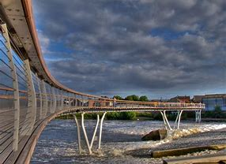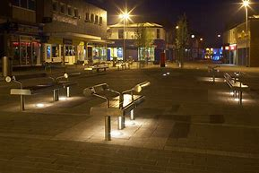

Background Information on Castleford, West Yorkshire

Castleford is a rapidly expanding town, the Riverside Housing Development is bringing a large number of families with children into the area.

Castleford’s history dates back to Roman times, archaeological evidence points to modern day Castleford being built upon a Roman army settlement which was called Lagentium (thought to mean 'The Place of the Swordsmen'). Roman funeral urns have been found in modern-day Castleford, giving further evidence to this theory. A Roman milestone was unearthed in Beancroft Road, now believed to be in Leeds City Museum.

Queen's Park in Castleford provides evidence of Roundhouses used by the Anglo Saxons. This was a strategic area due to the views of the entire settlement. The history of the area includes Oliver Cromwell’s encampment in nearby Knottingley and Ferrybridge (originally thought to be in Castleford itself) whilst his forces laid siege to Pontefract Castle.

In the 19th century, Castleford became a boomtown with the population growing from 1,000 to 14,000 as collieries opened around the town; however, these collieries closed in the 20th century. Ferrybridge Power Station and Kellingley Colliery have also closed (in 2015 and 2016 respectively) and used to employ Castleford residents. The newer warehouses and distribution centres in Glasshoughton have brought in many new jobs to the area. In 2008 Grand Designs presenter Kevin McCloud and Channel 4 led a community regeneration scheme to redevelop Castleford.

The town contains a Junction 32 multi-store shopping village and the Xscape Leisure Complex, both in the Glasshoughton suburb at the south of the town. In Xscape is Snozone, which used to have Britain's largest indoor real snow slope (but this was edged out by Chillfactore in Manchester) and contains Frankie & Benny's and Nando's restaurants. Castleford has an open and an indoor market, a shopping centre on Carlton Street, a retail park, and Asda, Morrisons, Aldi and Co-operative supermarkets.

In December 2013 the Forum, a library and heritage museum, opened in a new building. The town's library had been in temporary accommodation for two years while the old site was redeveloped. The existing frontage was kept, while the building further back was demolished. A new three-floor building was then constructed.

Castleford is a rugby league town. The local team, Castleford Tigers was formed in 1926, Castleford was one of the twelve founder members of Super League when the new league format was introduced in 1996. The 'Tigers' nickname and logo were introduced in 1992 and the clubs honours include four Challenge Cup and one Super League leaders shield. The club have been based at Wheldon Road since 1927. Castleford also has two other lower league rugby league teams, Castleford Lock Lane and Castleford Panthers. Rugby league in the town was originally represented by Castleford, unrelated to Castleford RUFC, who did not participate in The schism in English rugby and still exist, nor were they predecessors of the current Castleford Tigers who were founded in 1926. The original Castleford rugby league club played in the Northern Union (Rugby Football League) from 1896–97 to 1905–06 and it had one player named Isaac Cole who won a cap for England in 1906 against Other Nationalities.

The town's primary schools for infants and children are Wheldon Infant School, Castleford Park Junior, Smawthorne Henry Moore, Airedale Juniors, Oyster Park Primary, Fairburn View Primary, Three Lane Ends Academy, Acton Pastures and Half Acres. The town's secondary schools for children aged 11–16 are Castleford Academy and Airedale Academy. The town has a small further and higher education college on the Castleford Campus of Wakefield College in Glasshoughton.

Castleford is only 0.93 miles (1.5 km) away from the M62 at Junction 32 via the A656 road. It has other A roads that criss-cross the town and provide access to Junction 31 on the same motorway.

