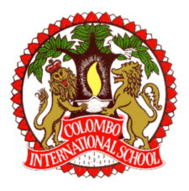

C O L O M B O I N T E R N A T I O N A L S C H O O L, S R I L A N K A
Colombo International School is a long established premier private day school, with branches in the heart of Colombo and in the historic hill-town of Kandy. The school delivers a unique purpose designed holistic English medium education from Nursery through to A Level, to a diverse community of Sri Lankan and expatriate students who are academically motivated, ambitious and disciplined.

In the recent Edexcel IGCSE, AS and A Level examinations, the results produced by the school were exceptional. All students aspiring for university education were successful in gaining admission to quality universities overseas, mostly in the UK, USA and Australia. Currently, there are former students at a host of elite universities, including Cambridge, Oxford, LSE, Imperial, Harvard, Stanford, UPenn, Melbourne and many others across Europe, USA, Australia and Asia.

In addition to an outstanding academic programme, the school offers a plethora of extra-curricular activities of global relevance and a wide range of sports opportunities with a legacy of excellence in terms of achievements and recognition in local and international events and competitions.

The staff (of over 220) consists of a harmonious blend of local and expatriate teachers. The latter are initially assigned to two-year contracts, though many choose to extend their engagement with the school much longer. The Principal and Chief Education Consultant of the school are both well qualified highly regarded expatriate professionals of British nationality.

There are openings for the 2020/21 academic year commencing in August 2020 in the Secondary and Junior Sections of the School.

1. Secondary Section Subject Teachers A- Level
French History English
German Physics
Geography Mathematics

2. Junior School Class Teachers

This invitation is open to single teachers and teaching couples.

Please visit our web-site www.cis.lk for further details. Applications and inquiries should be addressed to The Chairman, Board of Governors, Colombo International School, 28, Gregory’s Road, Colombo 07, Sri Lanka on email : management@cis.lk or (0094) 11 2697587 (Tel) 2699592(Fax).

