The Mathematics Department

3 – 2 = 1 | → | sin²θ + cos²θ = 1 | →
The Department is one of the school’s strongest departments. Academic performance at all levels is excellent and continues to set new records.

Facilities

The Department is housed in its own suite of teaching rooms with Interactive Whiteboards available in each classroom – and used extensively. The Mathematics block was opened in February 2003 and provides an exceptional working environment with easy access to ICT facilities.

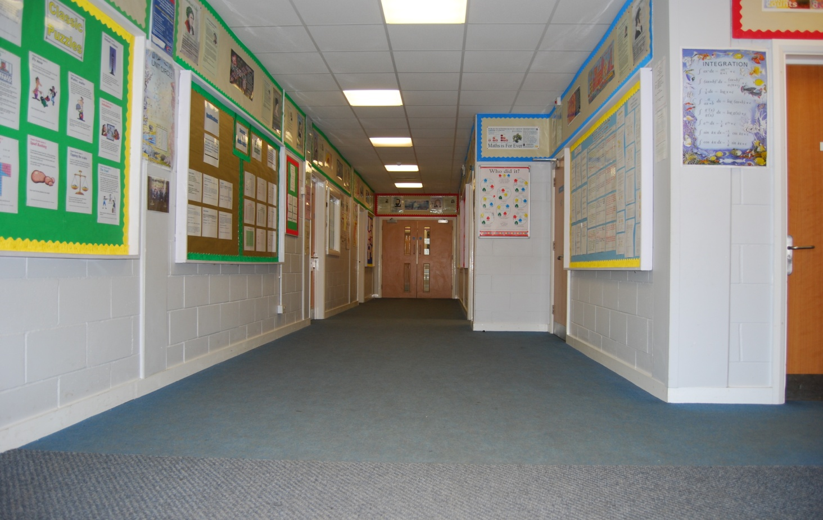

The Teaching Staff at the Department

There are ten full-time and one part-time teachers and the generous teacher pupil ratio allows ample time for additional support to be provided for individual students. Teaching colleagues give freely of their time over and above their contractual commitment and are determined to ensure every student enjoys success in the subject. Below is a list of all teachers in the department.

Dr I L Karam PhD, BSc, MSc, PGCE | Assistant Head Teacher / Head of Mathematics
Miss K Stewart BSc, PGCE | Subject Leader of Mathematics / KS4 Co-ordinator
Mr N Daniels BSc, QTS | Subject Leader of Further Mathematics
Mr R Davidson MEng, GTP | Teacher of Mathematics and KS5 Co-ordinator
Miss AE Wheeler BA, PGCE | Teacher of Mathematics and KS3 Co-ordinator
Mr D Owen BSc, MA | Teacher of Mathematics
Mrs R Fashion BSc, PGCE | Teacher of Mathematics
Miss N Keyes BSc, PGCE | Teacher of Mathematics
Miss K Mahomed BSc, PGCE | Teacher of Mathematics
Mr J Townsend BSc, PGCE | Teacher of Mathematics

The challenge in this school is to secure the highest academic standards, taking into account the nature of the area which the school serves, with the Medway Towns being the largest urban conglomeration in the south east outside London. The atmosphere in the school is often commented upon by visitors to the school in very favourable terms. Ofsted paid particular tribute to the school’s ethos suggesting that “relationships throughout the school are excellent”.

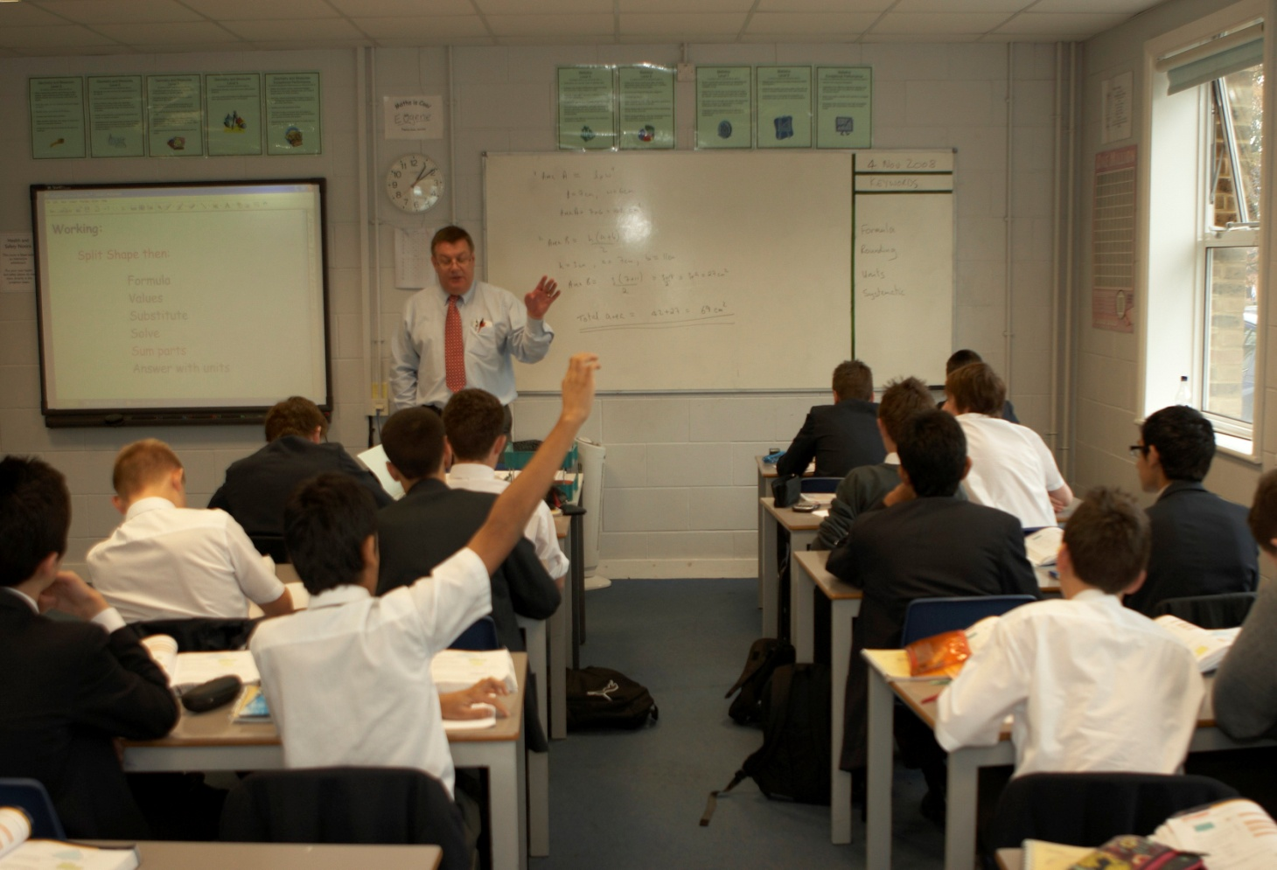

Curriculum

In Year 7 pupils are taught Mathematics as a form unit. In Years 8 and 9 pupils are divided into two parallel groups. In each group there is a top set and two parallel sets. In Years 10 and 11 pupils are divided into two parallel groups set according to their Mathematical ability. All groups study GCSE Mathematics and the more able will study GCSE Further Mathematics as well. The sets into which pupils are placed are dependent upon their work throughout the year and their performance in the end of year examination. No setting takes place in Years 12 and 13.

In Years 10 and 11 each class has eight periods of Mathematics a fortnight and Year 9 has six periods. Year 7 and 8 classes have seven periods and the length of a period is 1 hour. Pupils in Years 7, 8, 9, 10 and 11 have two homework assignments per week. Years 12 and 13 have ten periods of Mathematics a fortnight for a single A Level and another ten periods for Further Mathematics.

Generally it is the policy of the department that members of staff taking a Year 8 set continue with that set until the end of Year 9 in Key Stage 3 and similarly for Years 10 and 11 in Key Stage 4. In Key Stage 5 the same policy applies and a given class is usually taken in both Year 12 and Year 13 by the same members of the department. It is believed that continuity of teaching is of great value and although this is not always possible it is undertaken whenever circumstances permit.
The department consists of eight full time and two part time members of staff. The Head of Department, who is also an Assistant Head Teacher, is supported by a Subject Leader of Mathematics and three Key Stages coordinators.

At Key Stages 3 and 4 schemes of work are based upon the new National Curriculum and the new GCSE Mathematics (9–1) respectively. The school has invested in new resources for years 7 to 11 which include on-line materials for use at home, electronic display materials for use in class and text books. These new resources are providing the challenge needed to match the ability of the boys. Weekly mathematics clubs, run by departmental colleagues and mathematics prefects also provide enrichment for students.

At Key stage 3 we set our own end of term tests but these are strongly linked to the new GCSE specification. At Key Stage 4 we follow the Edexcel syllabus linear specification and all students follow the Higher Level course. In Years 12 and 13 we currently follow the new Linear A Level course from Edexcel. This new course consists of Pure Mathematics, Mechanics and Statistics based topics.

For our most able students we also offer the new A Level Further Mathematics and we currently are one of the only schools in the south east to have a Subject Leader for Further Mathematics. Mathematics is a very popular choice at A Level and we have a number of pupils in Years 12 and 13 who are studying A Level Further Mathematics in addition.

The Mathematics Department is housed in its own suite of teaching rooms in which much of Key Stage 3 and Key Stage 4 teaching occurs. The department has access to ICT facilities and there is an Interactive White Board in every classroom. The use of ICT in teaching mathematics is encouraged within the department. The department has invested in a number of Dynamic and Interactive Puzzle Solving Software.

The examination results for Mathematics have been outstanding at all levels; including the percentage of Grade 6 in Year 9 and the percentage of grades A*/A in A Level Mathematics and Further Mathematics is exceptional. The number and percentage of 9/8 grades at GCSE Mathematics and A*/A in GCSE Further Mathematics have been the highest on record, simply outstanding.

Examination Results

The school has a strong tradition in mathematics as demonstrated by public examination results. The results for 2016 are shown below.

Key Stage Three – Internal Assessment

 | Grade 6 | Grade 5 | Grade 4 | Grade 3
Totals | 63 | 88 | 34 | 1
Percentages | 34 | 48 | 18 | 1

Key Stage 4 – GCSE Mathematics

 | Grade 9 | Grade 8 | Grade7 | Grade 6 | Grade 5 | Grade 4
Totals | 44 | 45 | 43 | 21 | 20 | 2
Percentages | 25 | 26 | 25 | 12 | 12 | 1

Key Stage 4 – GCSE Further Mathematics

 | A* | A | B | C | D
Totals | 43 | 8 | 4 | 0 | 0
Percentages | 78 | 15 | 7 | 0 | 0

Key Stage 5 – A Level Mathematics

 | A* | A | B | C | D | E
Totals | 25 | 22 | 17 | 19 | 17 | 4
Percentage | 27 | 24 | 18 | 20 | 18 | 4

Key Stage 5 – A Level Further Mathematics

 | A* | A | B | C | D | E
Totals | 10 | 5 | 4 | 1 | 0 | 0
Percentage | 50 | 25 | 20 | 5 | 0 | 0

Pupils

Entry to the school at the age of eleven is by examination. A Mathematics paper comprises one element of the test. The school admits a number of students at the age of sixteen from other local schools. The pupils are extremely well behaved and very well motivated.

