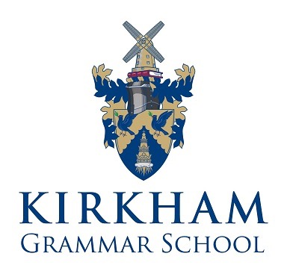

TEACHER OF BOYS' PHYSICAL EDUCATION AND GAMES

The Department

The Physical Education and Games department consists of six members of staff, supported by academic colleagues who coach rugby, hockey, cricket and athletics.

Physical Education

At KS3 the boys’ PE curriculum aims to develop physical capacities and fundamental movement skills. Boys take part in a varied programme of activities including swimming, gymnastics, strength and conditioning, cross country and athletics. PE lessons for KS3 are one hour in duration and are in addition to the pupils’ Games allocation of one afternoon a week. Core PE is replaced with GCSE options at KS4, however, pupils continue to participate in one games afternoon per week.

Standards of behaviour and appearance are extremely high in PE and Games lessons. All pupils are expected to work as hard as they can in order to achieve their potential.

Games

Rugby is the main sport for boys and the school runs twelve teams from the first year to the sixth form. The 1st XV’s schedule includes some of the most challenging fixtures in the country. In addition, 7 a side rugby is a major part of the schools rugby culture with teams being entered in the National Schools Sevens at U14, U16 and 1st VII level.

The Department also provides a wide range of activities in the hope that each boy will achieve success in at least one area of the curriculum. These activities include rugby, hockey, volleyball, basketball and handball in the Autumn/Spring Term. We compete in cricket, athletics and tennis in the Summer Term.

Extra-Curricular Activities

The school places great importance on the involvement of pupils in extra-curricular activities. Sporting activities and practices take place at lunchtimes, after school and at weekends. Pupils are expected to train and represent the school when selected. Standards of sports teams are exceptionally high, especially in rugby.

In rugby and cricket, most matches take place on Saturday mornings, with some afternoon and weekday fixtures. Rugby squads train three times a week in addition to Games periods.

In hockey, basketball, volleyball and tennis, fixtures are on weekdays and the teams train on average twice a week.

Academic Physical Education

The department follows the AQA syllabus at GCSE and A Level.

Role

The successful candidate will be expected to teach Boys' PE and Games throughout the 11 – 18 age range. The ability to offer academic physical education and rugby coaching will be a distinct advantage.

Responsibilities

The person appointed will:

- Teach Boys' PE and Games throughout the age range.
- Be a trained and qualified graduate teacher of Physical Education.
- Have successful experience of teaching Physical Education in secondary schools, including teaching PE at GCSE and A Level
- Have experience in coaching at least one of the school’s major sports at a high level.
- Help to support and develop the inclusive ethos of sport and fitness at the school.
- Have a personal commitment to Physical Education and Sport and be prepared to make a significant contribution to the extra-curricular life of the school.
- Have clear aims and objectives for all lessons and ensure effective progress is made by pupils.
- Contribute to curricular developments within the department and beyond.
- Promote high standards of behaviour, effort and attainment.
- Take part in the school's appraisal system and undertake professional development (with the possibility of taking responsibility for one of the main school sports or academic PE).

Salary: Teachers' Standard National Pay Scale, according to qualifications and experience, plus Kirkham allowance

Closing date for applications: Friday 16 February 2018 at 12 noon

Interview date: w/c 26 February 2018

Applications: By supporting letter/CV to:
Mr D H Berry
Kirkham Grammar School
Ribby Road
Kirkham
PRESTON
PR4 2BH
D H Berry
Headmaster

The post is ultimately subject to completion of the school’s own application form, two satisfactory references, DBS clearance and verification of qualifications.

Kirkham Grammar School is committed to safeguarding
and promoting the welfare of children and young people
__________________________________________________________________________

January 2018

