
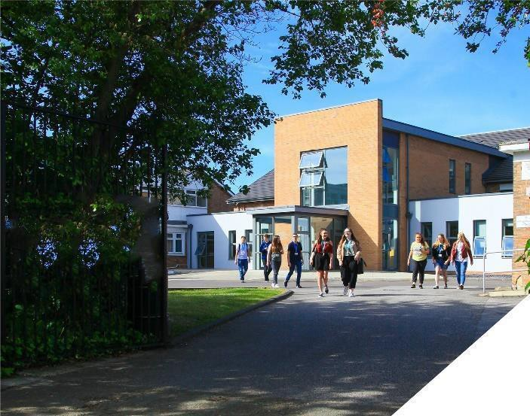

job description
caretaker.

about the role.
reports to: Senior Caretaker
hours: Full time, 35 hours per week Mon – Fri, 6.30am – 2pm
salary: Sixth Form Colleges National Pay Spine Point 05 £20,584
holidays: 23 days plus national bank holidays
start date: As soon as possible

The main purpose of the role is to work under the direction of the Senior Caretaker to ensure the maintenance, security, safety, cleanliness and good order of the College environment, buildings and external space.
- Security of Premises / Facilities Management
- Planned and reactive maintenance
- Regular testing of equipment
- Liaise with the Trust Health & Safety Officer for Risk Assessments and Health & Safety
- First Aid

main duties.

Security of Premises

- To carry out security procedures for College buildings and grounds including (but not limited to);
  - Security of premises (including opening / closing of College premises and grounds)
  - Checking buildings to ensure premises has not been disturbed
  - Switching on/off appropriate alarms
  - Monitoring of CCTV
  - Liaising with external security companies

- To provide access to the College in the event of emergency situations, including those at which attendance is required as keyholder

- To deal with enquiries from Staff, Students, Parents, contractors and members of the public as required

Facilities Management

- To carry out first line repairs to property fixtures and fittings

- To work with the Senior Caretaker to maintain College grounds to an appropriate standard

- To take delivery of stores, materials and other goods received by the College and move and store them as instructed

- To undertake regular monitoring checks / audits of College equipment and facilities to ensure cleanliness, maintenance tasks and safety standards are all maintained to a high level (e.g. Fire Doors, Evacuation Chairs). This also includes making sure documentation is kept up to date

- To work under the direction of the Senior Caretaker to ensure that reactive and planned maintenance is undertaken to maintain accommodation to the highest standard

- To carry out recognised procedures in the event of fire, flood, breaking and entering, accident or major damage

- Carry out emergency cleaning during normal session e.g. paint spillage, breakages, water, etc

- To ensure the Senior Caretaker is aware of necessary repair and maintenance work

- Supply cleaning materials (soap, toilet rolls or any associated cleaning material) and distribute as necessary

- To ensure all gutters, pipes and drains are free-flowing and clean. To clear blockages where these occur, including toilets

- Assist in preparation for College and after College activities

- To direct contractors to the sites of repairs and maintenance work, when appropriate

- To act as Mini Bus driver as required in accordance with College policies

Health & Safety

- To assist the Trust’s Health & Safety Officer, monitoring and maintaining a healthy, safe and secure environment

- Reporting on the safety and security of the sites, including liaising with local Fire and Health & Safety officers as required

- To ensure premises and cleaning materials are stored and used strictly in accordance with instructions

- To act as fully qualified First Aider as required for staff and students

- Ensure all appropriate documentation is kept up to date

To be flexible and responsive and take on additional responsibilities and duties commensurate with the post, as directed by the Principal / CEO.

person specification.

Qualifications | essential | desirable
Appropriate Level 2 or equivalent qualifications |  | 
Management qualification |  | 
First Aid Certificate (full certificate) |  | 
Experience / Knowledge / Skills / Abilities
Proven experience of caretaking role | 
Proven experience of maintaining Health & Safety standards | 
Ability to work both alone and in a team | 
Clean Driving License | 
Appropriate practical / DIY Skills | 
Excellent organisational and ICT skills |  | 
Ability to work well under pressure and maintain a sense of humour and perspective | 
To demonstrate a commitment to
The Colleges values of Positivity, Ambition, Resilience & Thoughtfulness | 
Personal development and training | 
Safeguarding & promoting the welfare of students | 
Equality & diversity | 

how to apply.

If you are ambitious and determined to make a meaningful difference in one of the country’s leading
sixth form Colleges then we would be thrilled to have you join our team.

Please complete the support staff application form.

closing date: 12 noon, Monday 2nd October 2023

