‘Learn, Achieve, Succeed’  Job Description for the post of Headteacher  Main Purpose  - The Headteacher of Sir Francis Hill Primary School is a visionary leader who inspires and motivates colleagues to provide outstanding teaching and learning.  - The Headteacher engenders respect and trust throughout the school and plans and delivers improvements through effective management and delegation, empowering senior leaders.  - The Headteacher works closely with staff and the governing body to ensure that all children in our inclusive school are eager to learn, reach their full potential and grow as emotionally intelligent individuals.  “We’ve been on quite a journey, but there’s always more to do. Are you our new head who believes in our approach to learning; will help us maintain our Ofsted grading of ‘Good’ and continue our exciting journey?” | 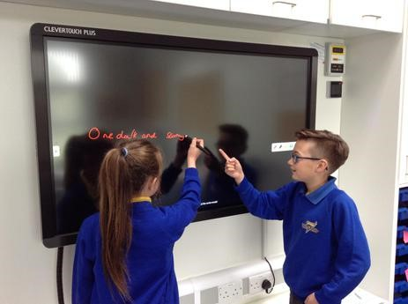  Job Title Headteacher  Location Sir Francis Hill Primary School  Reporting To Governing Body and Local Authority  Start Date January 2018  Salary Range L19- L25  - The Headteacher has high expectations of themselves as well as colleagues, parents and pupils and is a clear thinker and good communicator.  - The Headteacher is visible, welcoming and friendly.

Main duties and Responsibilities  In addition to the Conditions of Employment for Headteachers laid down in Part 9 of the School Teachers’ Pay and Conditions Document 2008  (section 2, paragraphs 57 to 64), the Headteacher provides strategic leadership of the school and has overall accountability for direction, standards achieved and quality of provision.  This is achieved by;  - Working with the Governing Body to provide the leadership and management which enables Sir Francis Hill Primary School to give every pupil high quality education, and which promotes the highest possible standards of achievement.  - Securing the long-term success of the school by maximising potential  through the skills and resources held within the school.  - Building leadership capacity and developing staff and providing leadership opportunities for staff at all levels.  - Developing a range of family support services, and ensuring that these are integrated with the school across the primary age range and their families. | 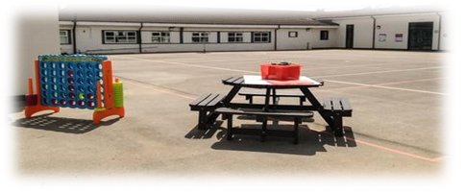  - Leading the schools within the context of Every Child Matters, including providing a full, integrated range of extended services and ensuring that every child has a happy and fulfilling school experience.  - Developing to a high level positive links with the local community, including parents and carers.  - Maintaining and raising achievements and standards.  - Working with staff in developing the school from Good to Outstanding.  - Ensuring that policies and practices take account of the national, local and school data, inspection and research findings.

Key Accountabilities  - Work with the Governing Body to develop and maintain the strategic vision and promote our values and ethos to pupils, staff, Governors, parents and the wider community and ensure that all involved are committed and engaged.  - Translate the vision into agreed objectives and operational plans.  - Create and promote positive strategies ensuring Equality.  - Motivate others to create a shared learning culture and positive environment through distributive leadership and an environment which enables everyone to work collaboratively.  - Ensure individual staff accountabilities are clearly defined. | - Work with the Governing Body to enable them to meet their statutory responsibilities  - Set appropriate priorities for expenditure, allocation of funds and effective administration and control by;  - Effective management of the school budget  - Ensuring funding and staffing match educational priorities  - Ensuring effective and safe arrangements for the siting and storage of resources and equipment  - Present coherent, up to date and accurate accounts of the school performance in an appropriate format to the range of audiences including governors, the LA, Ofsted, DfE and others, to allow them to play their role effectively

Shaping the future  The Head teacher will demonstrate the vision and values of the school in everyday work and practice. They will be willing to innovate, take on new challenges and be a leader in the field of education, especially with regards to research in primary schools, ensuring our school reaches its full potential.  Leading teaching and learning  - Ensure outstanding teaching and learning is at the core of strategic planning  - Provide inspiration and strong strategic leadership to the teaching team to ensure that the school continues to deliver the highest standards of learning for all.  - Drive a continuous and consistent focus on pupils’ achievement, using data and benchmarks to monitor and evaluate progress, attainment and the quality of provision. | “The essence of the independent mind lies not in what it thinks, but in how it thinks”  - Promote an exciting and challenging curriculum using the principles of a Thinking School to build creative, responsive and effective approaches to learning and teaching inspiring children to learn.  - Set high expectations and challenging targets for the school community.  - Ensure that differentiated learning opportunities and strategies are in place to support those pupils with additional needs (including EAL, SEND and EBD) and stretch those who are gifted and talented.  - Create a culture and ethos of challenge and support where all pupils can achieve success and become engaged in their own learning. | - Communicate and work closely with families to ensure that learning is supported at home.  - Ensure policies promote good conduct and behaviour and reinforce the schools approach to positive behaviour management.  - Ensure that good attendance of staff and pupils is maintained and appropriate and timely action taken when required.  - Ensure that the curriculum is regularly reviewed, evaluated and updated, taking account of local and national initiatives, policies and statutes.  - Combine the outcomes of regular school self evaluation with external evaluations in order to develop the school.  - Ensure a broad range of extra-curricular activities are offered to provide opportunities for all.

Developing self and working with others  - To lead, motivate, challenge and support staff in order to secure and sustain continuous improvement and a commitment to staff well-being and CPD.  - Ensure there are effective processes for staff induction, professional development and performance reviews.  - Treat people fairly and with dignity to maintain a positive school culture.  - Acknowledge the responsibilities and celebrate the achievements of individuals and teams.  - Ensure effective planning, allocation, support and evaluation of work of teams and individuals.  - Regularly review own practice, set personal targets and take responsibility for own development, seeking advice and support.  - Effectively manage own workload and that of others to allow an appropriate work/life balance. | - Actively engage with other schools (both Primary and High schools) to support joint learning, share best practice and in the case of High Schools to ensure a secure and happy transition for pupils.  - Promote and maintain a culture of high expectations for self and others.

Managing the organisation  - Manage the schools’ financial and human resources effectively and efficiently to achieve the schools’ educational goals and priorities, and ensure systems are in place for the effective administration and control of school budgets.  - Ensure the on-going development of an organisational structure which reflects school’s values, and enables effective and efficient operations.  - Work with the governing body and senior leaders to ensure evidence based improvement plans and policies promote continuous school improvement.  - Participate in the recruitment and selection of the highest quality teaching and support staff who are able and willing to contribute to the ethos of the school.  - Work with senior colleagues to retain and deploy staff appropriately.  - Develop effective relationships and communications which underpin a professional learning community that enables everyone in the school to achieve.  - Create an inspiring, professional work environment consistent with the school’s values and aspirations  - Ensure effective team communication mechanisms to ensure that all staff are involved in and kept informed of key priorities and developments. | - Provide effective organisation and management and seek ways of improving organisational structures and functions based on rigorous self-evaluation.  - Use and integrate a range of technologies effectively and efficiently.  - Ensure that when working with computerised systems all staff are completely aware of their responsibilities at all times under the Data protection Act 1984 for the security, accuracy and significance of personal data held on such systems.  - Manage and organise accommodation efficiently and effectively to ensure that all school buildings meet the needs of the curriculum and health and safety regulations.

Strengthening community links  - Sustain and further develop partnerships  with other schools and agencies and with the wider community in order to share expertise and bring mutual benefits to enhance provision and promote positive relationships.  - Ensure a range of community based learning experiences.  - Support and engage with the PTA /Friends of Sir Francis Hill  - Collaborate with other agencies to ensure pupil and community needs are met.  - Create and maintain effective partnerships with parents, Governors and the Local Authority to support and improve pupils’ achievements and personal development.  - Develop effective links with the community to extend the curriculum, enhance teaching and broaden learning opportunities.  - Build a school culture that takes account of the richness and diversity within the community.  - Ensure effective supervision and security of the school building, contents and grounds.  - Ensure any maintenance, repairs or moderations are acted on promptly and in accordance with Health and safety regulations.  - Maximise the potential of the site to provide stimulating learning environments, sport and play provision and community facilities.  - Ensure employees work in compliance with the schools’ Health and Safety policies and under the Health and Safety at Work Act (1974), ensuring the safety of all parties they come into contact with, such as members of the public, in premises or sites controlled by the school.  - Ensure compliance of procedures at all times under the provision of safe systems of work through safe and healthy environments, including information, training and supervision necessary to accomplish those goals. | Safeguarding and Equality  - To have due regard for safeguarding and promoting the welfare of children and young people and to follow the Child Protection procedures adopted by the LA and to act as one of the designated Safeguarding Leads for the school.  - To actively promote, implement and monitor equal opportunities across all aspects of the school.  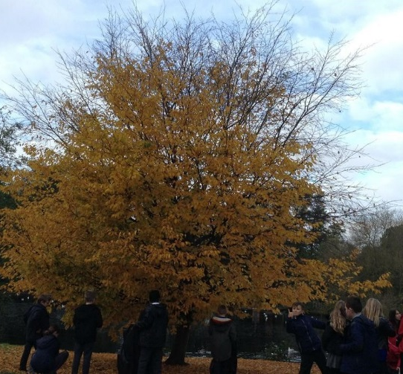  - To value all members of the school community; to celebrate diversity and promote social inclusion.

