The Friary School  PROSPECTUS BOOKLET  School Aims:  The Friary has five key aims for every student in our school:  - To take pride in everything they do.  - To achieve the highest possible standards and qualifications.  - To develop the knowledge, skills and understanding which will prepare them for life.  - To develop enquiring, creative minds and enjoy learning.  - To be happy, respectful, healthy and safe.  Letter from the Headteacher  Welcome to The Friary and thank you for considering our school for the next step in life. It is not so long ago that I came and looked around the school to see if it was the right place for me, so I can well understand how you are feeling as you make your choice.  Clearly, my choice was that The Friary was the best place. I was impressed by so much as I looked around that it became an easy decision to take on my post and to come to the school. Without doubt, since joining in September 2016, it is a choice that I have never regretted for a second. |  | 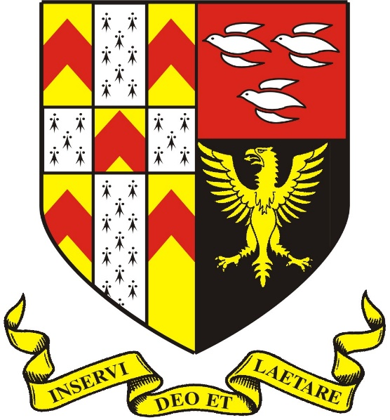
 |  | School Name | Founded
 |  | The Friary | 1892
 |  | School Motto
‘Inservi Deo at Laetare’
‘Serve God and Be Cheerful’

 |  | Headteacher
 |  | Matt Allman
 |  | Chair of Governors
 |  | Iain Liston-Brown
 |  | Website
 |  | www.friaryschool.com

The friendly and enthusiastic students helped me to make my choice as I saw this was a school where students wanted to make friends together, work together and learn together. They have been positive about all of the exciting changes happening at the school and have demonstrated a real will to succeed. They are motivated to do well so that they have the best possible choices open to them when they move on at 16, or for most at 18.

Similarly, the teaching staff made my choice straight-forward as they were clearly passionate and committed in doing all they could to help our students to succeed. They wanted to try new things and to take on new ideas so that the school could get better and better. The staff at The Friary are exceptionally strong, I am fortunate to work with them and their dedication and commitment to the school is ensuring it is one I grow ever more proud of everyday.

You would expect me to say good things about the school and to tell you how important the school is to me. Even so, I can assure you that I am genuinely excited about the chance of you coming to our school. I know that when you visit you will see a school with momentum, energy and drive. One where not only will you get the opportunity to succeed, but where everything will be put in your way to make you succeed.

Mr Matt Allman
Headteacher

School Life Brainstorm

There are a million-and-one things to tell you about daily life at The Friary but if we describe it all here you will be reading for weeks and weeks.

Instead, here is a quick brainstorm of all the exciting venues, events, principles and themes that you can look out for with us:

THE FRIARY (LEARNING) FRAMEWORK… FOCUS WEEKS… DUKE OF EDINBURGH… FINE DINING… MULTI-GYM… PRIMARY SCHOOL TRANSITION PROGRAMMES… UNIVERSITY VISITS… SUMMER SCHOOL… SPECIAL NEEDS SUPPORT… UCAS GUIDANCE… ONLINE LEARNING… DANCE STUDIO… THEATRE… RAISING ASPIRATIONS PROGRAMME… SPORTS HALL… SIXTH FORM STUDY CENTRE… SUMMER SIZZLER… RAG MEETINGS… ORCHESTRAL TOURS… PROM… NATIONAL CITIZENSHIP SCHEME… SCHOOL CHOIR… GYMNASTICS… PHOTOGRAPHY… BOOK CLUB… SKIING TRIP… SWIMMING POOL… ICT FACILITIES… ACE MEETINGS… LIBRARY… MASTERCHEF… STEM… SATURDAY SCHOOL… APRENTICESHIP SCHEME… LEARNING HUB… SPORTS TEAMS… LEISURE CENTRE… JAZZ CLUB… INTERNATIONAL STUDENTS… SCHOOL SHOWS - BILLY ELLIOTT… CHARITY FUND-RAISERS… CAREERS ADVICE… UNIVERSITY PARTNERSHIPS… MENTORING SUPPORT… COMMUNITY PROJECTS… BATTLE OF THE BANDS… SCHOOL TRIPS - HOME & ABROAD… POTTERY… REWARDS SCHEME… CATHEDRAL LINKS… OXBRIDGE ACCESS SUPPORT… SCHOOL COUNCIL… ACCELERATED READING… LAMDA… HOMEWORK CLUBS… PTA… AND MUCH, MUCH MORE…

OFSTED Report (March 2014):

The Friary School was last visited by OFSTED in March 2014 and was judged to be a ‘GOOD’ school:

Leadership & Management | Teaching, Learning & Assessment | Personal Development, Behaviour & Guidance | Outcomes | Sixth Form
GOOD | GOOD | GOOD | GOOD | GOOD

Key comments included:

- The proportion of students achieving five or more good GCSEs including English & Mathematics at the end of Year 11 is now well above national average.

- Teaching is typically at least good and an increasing proportion is outstanding.

- Senior leaders and governors provide good leadership.

- Students report they feel very safe at the school… (and)… Behaviour throughout the school is typically good.
KEY INFORMATION

Admissions  In September 2017 the school will have 210 places available and applications should be made online at www.staffordshire.gov.uk/ admissions or by phone to 01785 278 593.  The School Day  The school runs with a 5 period day which allows us to deliver 25hrs 50mins teaching per week. The school day operates to the following schedule: |  |  |  | Behaviour  We operate a strong system of rewards and sanctions which helps us to maintain high standards of behaviour at school. It works well because it sets out clear expectations and boundaries, and offers a wide range of rewards for those who deliver.  Equally, the system succeeds because our parents support us in what we do; whether that be celebrating with their child as they receive certificates, reward trips or prom vouchers; or talking things through at home when they get comments in their planners, reports or detentions.  Attendance  We cannot help your child to succeed if they are not in school so we have a minimum expectation that every student will be in school at least 95% of the time.  There are occasions when children are not in a position to come to school, and we look to support you at this time. However, we use a mixture of rewards, targets and tutor mentoring to make sure your child meets their 95% target.  Equally, we set clear standards on punctuality and again offer a mix of rewards and sanctions to maintain standards.  Safeguarding  The school’s joint Lead Safeguarding Officer is Mr Ian Rose (Deputy Headteacher) and Mrs Gill (Inclusion Lead).  The school takes its safeguarding responsibilities very seriously and ensures we train our staff to a high level and that we liaise effectively with outside agencies to make sure our students are kept safe.  Our strong provision is maintained by an annual external review to keep us up-to-date and on our toes.
8.50-9.05 | Tutor Time | We run a 2-week timetable (Week A & Week B) as this allows us to fit more into our curriculum and our enrichment period brings a wide range of clubs and activities throu-ghout the school year for all ages.
9.05-10.05 | Period 1
10.05-11.05 | Period 2
11.05-11.25 | Break
11.25-12.35 | Period 3
12.35-1.25 | Lunch
1.25-2.25 | Period 4
2.25-3.25 | Period 5
3.25-4.25 | Enrichment
The Student Planner

Every child is provided with their own planner and this is a central pillar for school information, personal planning, homework and home-school communication.

We encourage every student to take great pride in this resource and ask all parents to check and sign it on a weekly basis.

School Uniform

All students are expected to wear full school uniform at all times and to demonstrate pride in their appearance. This includes the controlling of jewellery and extreme hairstyles.

We are fortunate that parents are very supportive in maintaining uniform and, whilst teenagers can try to push the boundaries, we are able to hold a firm and consistent line with our parents behind us.

Curriculum  The school provides a broad and balanced curriculum that thoroughly prepares every student for their exams and life outside of education.  Key Stage Three (11-14) sees a focus on English & Maths but includes learning skills programmes, a modern foreign language, traditional academic subjects, but also practical subjects including science, sport, design, new technologies and performing arts.  Key Stage Four (14-16) sees a pathway approach designed to steer all students of differing abilities to fulfil their potential. This ranges from Triple Science to withdrawal support, and Masterclasses to high-quality vocational courses.  Sixth Form  The school has an excellent Sixth Form house in a newly re-furbished Sixth Form Study Centre. The curriculum offers a mixture of A-Level and Level 3 BTEC courses which steer students to university, higher-level apprenticeships or gainful employment.  In addition, Sixth Formers benefit from an extensive enrichment programme which includes Extended Projects, Sports Leaders, Duke of Edinburgh Awards, Young Enterprise, LAMDA and much more.  Aspirations  Every school says they want students to aim high and hit the heights. However, our school informs students every single step of the way and through our wide-ranging Raising Aspirations Programme we seek to avoid hoping for a success, but rather making a success.  This may involve a targeted careers talk, parent events, mock job interviews, university trips, apprenticeship programmes or external mentors. Every support is given every time. |  | Personal Guidance  We have a full Personal, Social, Health & Economic Education programme which runs via tutors and covers a wide range of themes ranging from enterprise to sex education, decision-making to self-awareness, healthy choices to careers.  In addition, we have a clear tutorial and assembly programme and bring fun and imagination to school life - with recent weeks including bush-tucker trials, pedalling for smoothies, peace competitions for tablets and European face-painting!  Extra-Curricular  We recognise the crucial importance of academic success at school but also seek to capture that primary feeling of: “You’ll never guess what I did at school today”.  Extra-curricular clubs are in abundance at the school and we seek to ensure that every student has the chance to develop their own unique areas to shine. It could be one of the numerous sporting teams, or on the stage of a school show, or in a band or orchestra. It could be computer programming, or being a student leader, or a charity fund-raiser. It could be skiing down an American mountain, or ploughing through a Flanders trench, or admiring a Gaudi masterpiece in Barcelona.  Flying high in exam results is vital, but so is flying high in life.  Local Community  Our school prides itself for being at the heart of the local community and we run numerous events to tie into our special city. This could be a fund-raiser for a local charity, carol singing, a service at the cathedral or work with local businesses.  In addition, we have an active PTA and are targeting a £10,000 fund-raising pot for 2016-2017 to further improve the school environment and facilities.

The Friary Framework  The school operates a clear and consistent system for learning that means your child will enjoy high-quality lessons and a clear learning structure every step of the way.  This package is backed by top-level academic research, is externally verified and is supported by a full training programme so that teaching standards consistently improve in all subject areas. It includes a Plan-Do-Review Cycle which carefully checks that students understand their learning and a student-friendly marking system which tells them how to improve their work.  Homework  We believe that homework is an important part of making sure that students understand their classroom learning, as well as a great opportunity to independently broaden their knowledge and expertise after-school.  Our homework is tailored to support all abilities and is backed up by online materials after-school homework clubs, study support and Saturday School.  Saturday School  Later this school year, we will be opening the doors to our Saturday School (most Saturdays 10.00-12.00) for targeted exam and coursework groups, as well as for general study and homework projects.  The sessions are run in non-school uniform, include refreshments, and at the busiest times will see over 100 students voluntarily in school at the weekend boosting their grades.  Parent Communication  Naturally, parents receive formal reports from the school about their child’s progress, but we prioritise a genuine dialogue by working face-to-face to ‘make’ your child succeed.  These meetings run throughout the year and will provide access to class teachers, tutors, pastoral staff, senior staff and governors. |  | Student Support  We have a dedicated team working to support your child on every step of their journey through The Friary.  This team offer a wide range of back-up; ranging from medical care to organisational support and personal education to 1-to-1 mentoring.  Beyond this team, we have the Learning Hub which is a specialist facility targeted at supporting KS4 students in successfully negotiating their GCSEs and provides the personalised support which allows every student to thrive.  Special Educational Needs & Disabilities (SEND)  Every student with specific learning needs benefits from our Class Support Plan package which ensures that each lesson offers them personalised support which is tailored to their individual needs.  This in-class support is backed up by Teaching Assistants, withdrawal programmes for literacy and numeracy, and social and emotional workshops to support in day-to-day dealings with others.  The SENCO at the school is Louise Mayland and she can be contacted via school reception.  Student Leadership  The school values the voice of its students and works hard to ensure that they have a genuine say in the development of the school.  Consequently, we have dedicated Year Councils which filter into a whole-school Student Council. On top of this structure we have a Sixth Form Leadership Team which includes a Head Boy and Head Girl. Elsewhere, we have charity and anti-bullying reps.  Not only do these student leaders voice their ideas for school improvement but the system also develops skills in decision-making, team-building and assertiveness.

Exam Results Summer 2016

This summer saw some fantastic results across the school and though there is always room for improvement there was so much to celebrate and tears were of happiness rather than despair.

Year 11 Results - Headline Measurements:

Measurement | School | National (2015)
5 A*-C with English and Maths | 69% | 56%
5 A*-C | 72% | 65%
GCSE English (A*-C) | 79% | 60%
GCSE English - Expected Progress (3LoP) | 87% | 69%
GCSE English - More Than Expected Progress (4LoP) | 49% | 30%
GCSE Mathematics (A*-C) | 77% | 67%
GCSE Mathematics - Expected Progress (3LoP) | 73% | 66%
GCSE Mathematics - More Than Expected Progress (4LoP) | 27% | 30%
E-Baccalaureate | 37% | 24%

Year 13 Results - Headline Measurements

Measurement | School | National (2015)
Average Point Score Per Student | 96.85 | N/A
Average Point Score Per Entry | 30.65 | N/A
Average Grade Per Student | C | C
Progress Score | + 0.02 | 0.00
Progress onto Post-18 Placement | 100% | Unknown

* NB - National averages for Summer 2016 are not yet fully available from the DfE.

Summer 2016 - Headline Grabbers

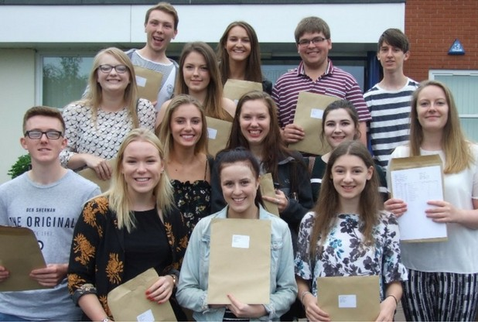  Sixth Form students grab the grades to take them to top universities across the UK. |  | 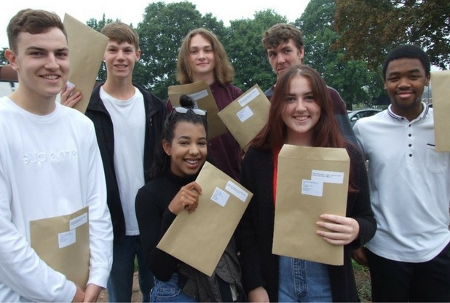  Y11 students grabbed results that compare well with the very best in Staffordshire.
LOOKING AHEAD

Building Renovations  The arrival of the new Headteacher has coincided with a commitment to a major re-development of school facilities.  Despite only officially starting in September 2016, this has already seen a brand-new Sixth Form Study Centre, the creation of a Learning Hub to provide targeted support for KS4 students, and the refurbishment of three Maths classrooms.  The next stage of the programme will see an extension to the School Library, the rejuvenation of main lobby areas, further redevelopment of classrooms and an upgrade to the exterior of the school site. |  | 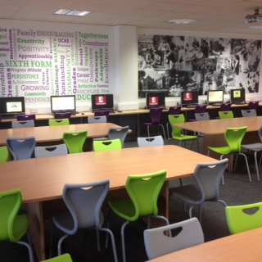  The brand new Sixth Form Study Centre (opened September 2016)

Curriculum Development

September 2018 will see the launch of a new curriculum model which will maintain the strong academic traditions of the school, but also provide a wide range of vocational pathways to support all students in wholly fulfilling their potential.

This will include courses in the major growth sectors in the UK economy including creative technologies, design, social care and business management.

Further down the school, there will be the development of a learning skills programme to enhance students’ study skills and personal organisation so that they are well-prepped to flourish as they enter their exam courses in later years.

Academy Status  Stafford Local Authority has echoed the government’s plan for all schools to move towards academy status in the near future.  The Friary is investigating all options and is committed to maintaining the special ethos and standards of the school, whilst also developing the wider partnerships and peer support to continue to maintain the highest education standards for every student.  All parents will be kept up-to-date with developments and any changes will include a full consultation with all stakeholders. |  | All local schools that have not yet converted to academy status are actively exploring their options.

APPLYING FOR A PLACE AT THE FRIARY

Applying as a New Year 7

If you are applying to start as a Year 7 at the beginning of the academic year then all applications must go through the Local Education Authority (LEA).

The main application process is done online at www.staffordshire.gov.uk/ admissions or they can be spoken to by phone on 01785 278 593.

Historically, The Friary School has accepted students from a wide range of primary schools and several of these have been outside of the direct catchment area of the school; for example for September 2015, new Year 7 students arrived from the following:

* Chadsmead, Lichfield | * Chancel, Rugeley | * Chase Academy, Cannock
* Chase View, Rugeley | * Christchurch, Lichfield | * Etchinghill, Rugeley
* Abbots Bromley School | * Gentleshaw, Rugeley | * Greysbrooke, Shenstone
* Hayes Meadow, Armitage | * Henry Chadwick, Hill Ridware | * Highclare School, Birmingham
* Hob Hill, Rugeley | * Lichfield Cathedral School | * Little Sutton Primary, Sutton  Coldfield
* Mere Green Primary, Sutton  Coldfield | * Pelsall Village School, Pelsall | * Redbrook Hayes, Rugeley
* Scotch Orchard, Lichfield | * St Peter & St Paul's, Lichfield | * St Chad's, Lichfield
* St James', Longdon | * St Jospeh's, Lichfield | * St Mary's, Colton
* St Mary's The Mount, Walsall | * St Michael's, Lichfield | * St Peter's, Stonnall
* St Stephen's, Fradley | * The Croft, Armitage | * John Bamford, Rugeley
* The Knoll School,  Kidderminster | * Western Springs, Rugeley | * Whittington Community,  Whittington
* Willows, Lichfield

Applying Mid-Year or as a New Year 8-11

If you are applying for any other age group at any point in the school year then applications must come directly into the school.

The application form is available from the Local Education Authority (LEA) or via the school website at: www.friaryschool.com/content/view/481/318/.

Application Support

If you require any support in completing your application, or wish for an application to be considered then please contact Mrs Charlotte Hearn (Assistant Headteacher) via School Reception on 01543 267 400.

The Friary School,  Eastern Avenue,  Lichfield,  Staffordshire,  WS13 7EW.  Telephone - 01543 267 400  Website - www.friaryschool.com |  | 