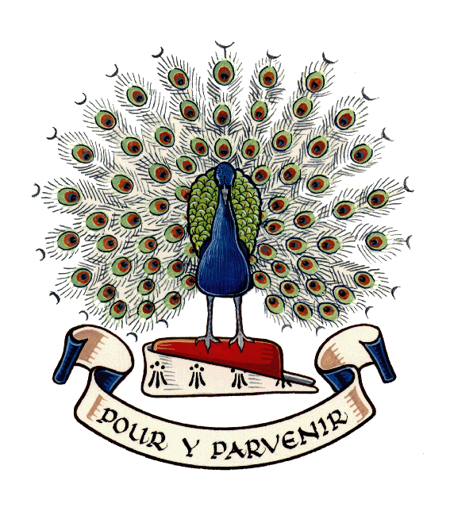
Lady Manners School

At Lady Manners School we strive to attain the highest standards in our work, have respect for others and develop our individual talents.

PERSON SPECIFICATION

 | Essential | Desirable
Title of Post | Deputy Headteacher  (Curriculum and Achievement)
Qualifications and Training | - Qualified teacher status  - Good honours degree or equivalent  - Strong commitment to continuous professional development | - Nationally-recognised leadership qualification or training that suggests preparation for senior leadership  - Additional qualifications and training relevant to the role
Experience and Knowledge | - Significant leadership experience at senior level  - Outstanding classroom practitioner with at least 5 years highly successful teaching experience  - Experience of Key Stage 3, 4 and 5, including GCSE and A Level courses  - Successful experience of bringing about change  - Experience of leading at least one whole-school project (with evidence of impact)  - Proven track record of raising achievement  - Extensive knowledge of curriculum models and pathways  - Comprehensive knowledge of achievement data and experience of data-related systems and software  - Track record of leading successful teams and of developing the professional practice of others  - Detailed understanding of achievement information (e.g. IDSR)  - Knowledge and experience of action planning and monitoring to ensure the high achievement of different groups of students  - Knowledge of a range of assessment and reporting practices  - Experience of using technology to communicate information effectively to a range of audiences | - Practical experience of developing and evaluating innovative learning across key stages  - Detailed knowledge of curriculum flexibilities and initiatives  - Experience of leading a whole-school curriculum project  - Experience of implementing a whole-school timetable  - Experience of liaising with primary partners to facilitate curriculum progression  - Detailed knowledge of different data tracking systems, eg ALPS, SISRA  - Membership of cross-school groups linked to curriculum development or raising achievement  - Knowledge of current and emerging national developments and practice in educational leadership

 | Essential | Desirable
Skills | - A strategic thinker  - Strong written, oral and interpersonal skills  - Ability to analyse and interpret a range of data at a whole-school, group and individual student level  - Ability to ensure the reliability of data and predictions  - Ability to readily identify areas of underachievement  - Highly developed teaching and learning skills  - Ability to communicate information to a range of audiences in a coherent and accessible manner  - Ability to liaise effectively with parents and carers  - Ability to solve problems and implement decisions  - Ability to use computer software with confidence | - Ability to develop, implement and evaluate evidence-backed ideas  - Ability to work collaboratively with colleagues in other schools to the benefit of Lady Manners School students  - Excellent ICT skills, including the ability to use mobile technology innovatively
Personal Qualities | - Commitment to the school values and policies  - Ability to inspire and motivate  - Drive, energy, commitment and positivity  - Resilience and proven capacity for hard work  - Ability to work effectively with a wide range of colleagues, including teaching and support staff  - Proven ability to work as a team member and accept corporate responsibility  - Ability to remain calm and communicate effectively under pressure  - Ability to stay balanced and measured when faced with potentially stressful situations  - Ability to act as a positive role model for staff and students  - Ability to actively listen to the views of others  - Capacity to meet deadlines  - Good sense of humour | - Personal 'presence' and self-confidence  - Capacity to be reflective and self-critical  - Ability to be empathetic

