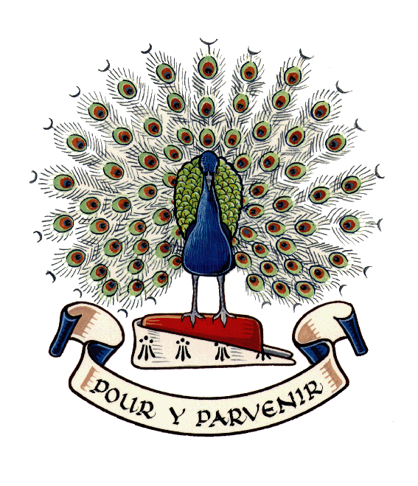
Lady Manners School

At Lady Manners School we strive to attain the highest standards in our work, have respect for others and develop our individual talents.

DEPUTY HEADTEACHER
(CURRICULUM and ACHIEVEMENT)

Group 7: Salary Range L20 - L24
11-18 Comprehensive
NOR: 1328

Required for April 2020 or September 2020

We want to appoint an outstanding Deputy Headteacher to make a significant contribution both to the leadership team and to the school as a whole at this exciting time in our development. Lady Manners School is oversubscribed and has a large Sixth Form. Results in public examinations are a considerable strength and we offer an impressive programme of extra-curricular activities to support the wider development of our students. The school is situated in exceptionally beautiful surroundings in the Peak District.

The successful candidate will:

● be an inspirational leader and teacher;
● be a strategic thinker;
● be able to enhance the school’s existing achievements;
● demonstrate excellent communication skills and a consistently positive attitude;
● support the school's high profile with parents and in the community;
● have a record of highly effective leadership in a senior post and a proven ability to manage change;
● be able to help effective staff to develop further;
● have the personality to motivate students and staff;
● work well within a highly experienced leadership team and contribute to all discussions in a calm and professional manner
● accept corporate responsibility in all decision-making
● maintain a good sense of humour at all times

Application packs are available from the Headteacher’s PA, Lady Manners School, Shutts Lane, Bakewell, Derbyshire, DE45 1JA, telephone 01629 812671 extn 102, e-mail jobs@ladymanners.derbyshire.sch.uk, or from the school's website www.ladymanners.derbyshire.sch.uk.

Applications should be returned to the Headteacher at the school address, by 4 pm on Monday 27 January 2020.

Ref 20/01

