Head of Business Studies & Economics (Senior School)

January 2021

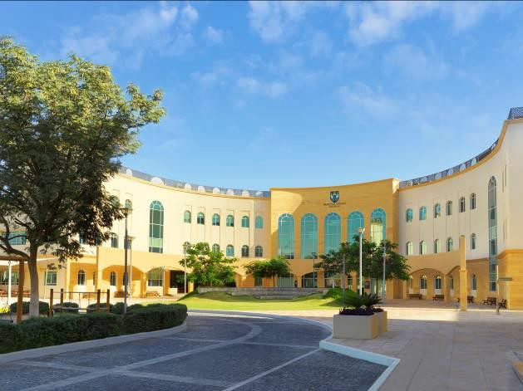
Brighton College Abu Dhabi wishes to recruit a Head of Business Studies & Economics

Brighton College Abu Dhabi, a sister school of
Brighton College UK, is a leading Independent-
style British International School located in the
United Arab Emirates. Founded in 2011 at a prime
location on Abu Dhabi Island on a purpose-built,
state-of-the-art campus, the College is heavily
over-subscribed and was rated outstanding in all six categories at the most recent ADEK inspection (2018). The full report is available on the website.

The school is a member of COBIS and BSME and
the Head Master is an international member of HMC.

Brighton College Abu Dhabi benefits from a strong partnership with Brighton College, the UK’s top
co-educational independent school, and with Brighton College Al Ain, Brighton College Dubai,
Brighton College Bangkok and as of this year, Brighton College Singapore. The Brighton family of
schools currently educates more than 5,000 pupils.

A key component of Brighton’s internationalism is the importance it places upon ensuring that its sister schools are authentically interpreting its values and ethos. Each school combines academic excellence with a wealth of co-curricular opportunities, all underpinned by a deep commitment to the individual needs and enthusiasms of every child. All pupils in the Brighton family of schools are valued for their own sake and encouraged to develop their talents to the full, in a community where there are no stereotypes and every achievement, however small, is noticed.

Brighton’s success is built upon recruiting genuinely inspirational teachers who can enthuse about their subject and will maintain an exciting and vibrant intellectual environment in which children are able to explore their interests, develop their existing talents and acquire new ones.

This is a unique opportunity to join an exceptional and hardworking team with the united goal of ensuring that every child reaches their potential both academically and socially, by pushing boundaries and broadening horizons. Our positioning as one of the leading academic schools in the Middle East, is testament to the dedication and hard work of our Common Room.

Packages are amongst the best globally with an excellent basic salary and comprehensive benefits. We also offer exceptional levels of financial support for Continuing Professional Development.

Senior School

Brighton College Senior School delivers an innovative and exciting curriculum leading to GCSEs and A Levels. Our external examination results in Years 11, 12 and 13 are ‘well above curriculum and world averages’ (ADEK Inspection Report 2018).

PERSON SPECIFICATION
- The successful candidate for this challenging and rewarding position will have at least two years’ experience of teaching.
- Essential qualities will include the ability to think strategically, work collaboratively and to present to parents, pupils and colleagues a warm, engaging and approachable personality.
- The successful candidate will have a university degree and teaching qualification from a good UK University.
- A distinguished record of teaching.
- A strong record of professional development.
- Excellent knowledge of GCSE and A Level as relevant

JOB DESCRIPTION
Responsible for: | Brighton College is a dynamic and exciting school looking for enthusiastic and passionate teachers. This is a unique opportunity to join an exceptional and hard-working team with the united goal of ensuring that every child reaches their potential both academically and socially, by pushing boundaries and broadening horizons.
Consulting with: | All staff
Reporting to: | Head of Senior School

RESPONSIBILITIES OF POSITION
In the Senior School, the successful candidate will:

• To be an ambassador of the College at all times, in school and the United Arab
Emirates
• To teach a maximum of a 70% teaching timetable, carry out duties (up to four per week) and actively support the CCA Programme leading a minimum of two activities per week
• To encourage each pupil to reach their academic potential through enthusiastic and personalised teaching, tailored stretch and challenge, rigorous record keeping and follow up
• To be aware of and comply with all the College policies including those for marking and assessment, teaching and learning and reporting
• To develop and share schemes of work and resources, using the agreed formats
• To assist with covering colleagues as required
• To attend all meetings and INSET as required
• To prepare, invigilate and assess, as required internal and external tests and examinations
• To work within a House team as a Tutor in either Years 7-11 or Years 12-13
• To show an active interest in each child’s personal and domestic circumstances and to foster the personal and social developments of each pupil in your care
- To actively promote the social, moral and cultural ethos of the College community
- To create an atmosphere of support by being aware of, and fully complying with, all the College policies; including the Code of Conduct, School Rules, and the Anti- bullying Policy
- To be familiar with in all the College’s policies on Health and Safety and be proactive in ensuring the safety of all members of the College community at all times
- To promote exemplary behaviour and a responsible attitude amongst all pupils at all times
- To be aware of and act upon all policies regarding the safeguarding of children
- To promote pride in the College among the pupil body through high standards of dress, behaviour and commitment
- To ensure that all communication is acted upon appropriately and in a timely manner
- To attend Parents’ Evenings, Assemblies, Productions, Sporting and Special Events
- To be responsible for all College resources particularly those in your care, reporting damage or loss to your line manager or the facilities manager, as appropriate
- To contribute to the College website, social media and publications as necessary
- To contribute to the College’s Self Evaluation and Development Plan
- To foster a close partnership with parents, initiating contact in appropriate circumstances and ensuring that there is a record of this
- To be in School prior to 7.00 am and until at least 4:00pm
- To carry out any reasonable professional request made by the Head Master, Head of Senior School or member of the SLT

REMUNERATION
- An attractive salary
- Company provided accommodation
- School fee remission
- Private medical insurance for the post holder and his/her dependants

All of the above in line with specific school policies

APPLICATIONS
All applications must consist of the following completed documents:
1. Letter of application (maximum one and a half sides of Garamond 12) addressed to Mrs Emma Parsons, Head of Senior School, Brighton College Abu Dhabi
2. Completed teacher application form (available on website)
3. CV (maximum 2 sides)
NOTE: We reserve the right to interview and offer to a strong candidate prior to the closing date. It is strongly recommended that candidates submit their applications as soon as possible.

